Frequency vs gamma

X=frequency

y=gamma

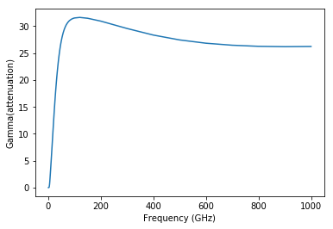

Before data processing

Frequency vs gamma

X=frequency

y=gamma

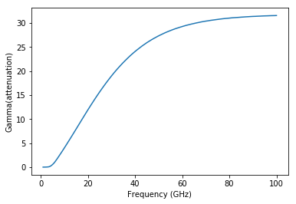

After data processing

Frequency vs gamma

X=frequency

y=gamma

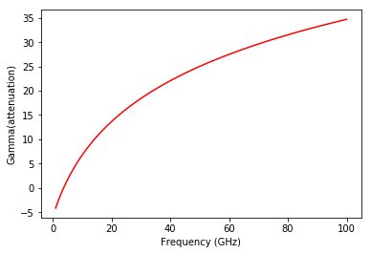

Optimised curve

Frequency vs gamma

X=frequency

y=gamma

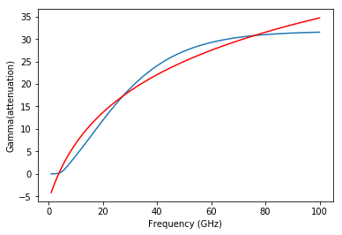

METHODS USED:

1. curve_fit : used curve_fit function to fit training data using function :

Theta + np.log (7.9+t)*tau

1. Matplotlib.pyplot to visualise the data.
2. Numpy and pandas to process the data.
3. Sklearn.metrics to calculate the efficiency of data and calculate its accuracy.

Training curve vs Optimised curve