1. new page within "Support CPH" tab about Drive Around Safe and Sound" initiative; include logo and links. Name for the page in the drop down menu: "Drive Around Safe and Sound" --add "Initiative" if it fits.

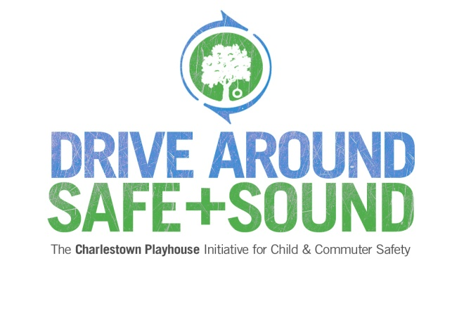

The goal of **Drive Around Safe and Sound: The Charlestown Playhouse Initiative for Child and Commuter Safety** is to create a new, safer drop-off area for children at Charlestown Playhouse and a safer driving experience on Charlestown Road for all community members and commuters during the twice-daily drop off and pick up time periods at the school.

At the end of 2012, the Pennsylvania Turnpike opened a new entrance less than 2.5 miles from our school. This created a dramatic increase in commuter traffic, which accompanied by the coming expansion of Route 202, has created a projected outcome by PennDOT of up to a 100% increase of commuter traffic on Charlestown Road. As a result, the school's current parking and drop off areas have become increasingly hazardous, especially in severe weather.

**What can you do to support the Drive Around Safe and Sound Initiative**

1. [Make a tax-deductible donation](http://www.charlestownplayhouse.org/#donations). Drive Around Safe and Sound is the key focus of all strategic planning and fundraising beyond basic operating expenses for 2014.
2. [Contact us about other kinds of community support](http://www.charlestownplayhouse.org/#contact). Make an in-kind donation or notify us if you know a company that may donate materials, have expertise in construction, marketing or development. Every volunteer in this capacity keeps our administrative costs at a minimum so that all money raised goes directly to construction.

It is not often that we get to make such a big difference in our surroundings. Let’s create a new drop-off and parking area that we can tell our kids we helped create as a community and will sustain the Playschool for another 75 years!

**Learn about the progress of this initiative**

This capital campaign represents the biggest undertaking Playschool has ever taken in its 75-year history. The work began in 2011 and continues. **Our goal is to have the project completed in time for the first day of school, September 9, 2014.**

2011-2012:

* Parent volunteers researched feasibility, created an initial engineering plan, and engaged a consultant. Thousands of dollars of in-kind work went into the research and design.

2013:

* Playschool Board began to inform the entire Playschool community.
* At the Spring 2013 Auction, “Launch A Cause” raised $15,000 from families, staff, supporters and 100% Board participation, enabling Playschool to pay for the initial phase: permitting fees, PennDOT Studies, escrow fees and engineering fees.

2014:

* The architectural plans were approved by the Charlestown Board of Supervisors in February.
* Parent volunteers have researched and submitted several grant applications.
* Parent volunteers began planning in support of Charlestown Community Day on October 4th, where Playschool will be the beneficiary of sponsorships and runner registrations for the 5K race.
* The Board has received bids by outside contractors for the construction project.
* The Board is investigating financing options from local banks.

************************************************************************************

2. additional text for the existing "Donations" page within the "Support CPH" tab; include link for EITC

[add the following after the second bullet point: "Send a check . . . . " ]

* Make the most of a corporate matching gift program. Many corporations will match contributions to non-profit organizations. If yours does, contact your employer for the appropriate paperwork so that your donation makes an even larger impact.
* [Participate in the Educational Improvement Tax Credit program (EITC](http://www.newpa.com/find-and-apply-for-funding/funding-and-program-finder/educational-improvement-tax-credit-program-eitc)). The EITC program provides tax credits to eligible businesses who contribute to schools that qualify. Charlestown Playhouse uses these contributions to provide tuition assistance in the form of scholarships to eligible students. Tax credits may be applied against the tax liability of a business for the tax year in which the contribution was made.

************************************************************************************

3. "Banner" text for every page --please make this a link to the new page within the "Support CPH" tab. If the DASAS logo can be used in the banner, that's even better!

Pave it Forward-- Support the Drive Around Safe and Sound Initiative

[**If the text above can't all be a link**, or isn't going to **look** like a link, how about . . .

Click here to Pave It Forward -- Support Drive Around Safe and Sound