Breast Cancer Recurrence Prediction System
MCA Project Documentation

Abstract
This project develops a Streamlit-based Breast Cancer Recurrence Prediction System using a Logistic Regression model. The system predicts the likelihood of recurrence from nine clinical features and provides prediction results, confidence scores, charts, patient summary, and downloadable reports.

Introduction
Breast cancer recurrence prediction assists healthcare professionals by estimating recurrence risk using machine learning techniques.

Problem Statement
Develop an interactive web application to predict breast cancer recurrence from clinical data.

Objectives
- Predict recurrence using Logistic Regression.
- Build a Streamlit dashboard.
- Visualize prediction confidence.
- Generate downloadable reports.

Tools and Technologies
Python, Streamlit, Scikit-learn, Pandas, Matplotlib, Joblib.

Dataset
Nine clinical features: Age, Menopause, Tumor Size, Involved Nodes, Node Caps, Degree of Malignancy, Breast, Breast Quadrant, Irradiation.

Methodology
Encode user input, apply feature selection, predict using the trained Logistic Regression model, and display results on the dashboard.

Model
- Algorithm: Logistic Regression
- Accuracy: 74.74%

Dashboard Features
Professional dashboard, charts, patient summary, confidence score, CSV report download.
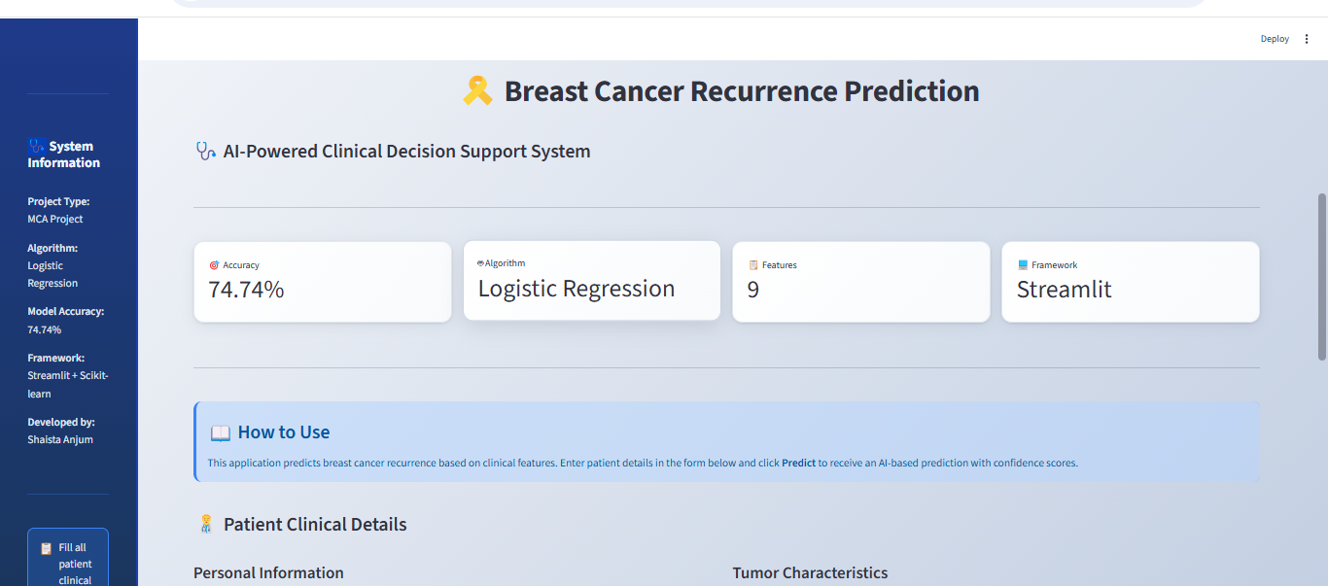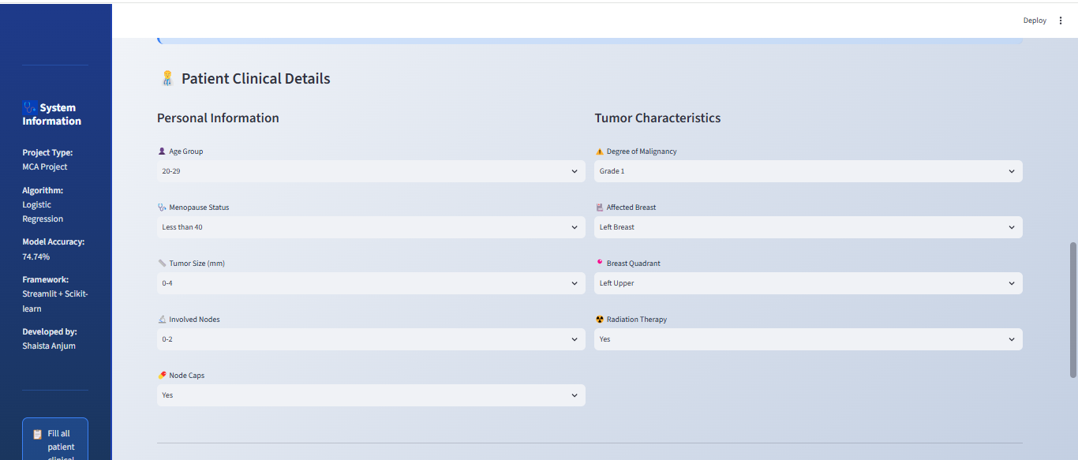

Results
The model predicts recurrence status and provides confidence visualization.
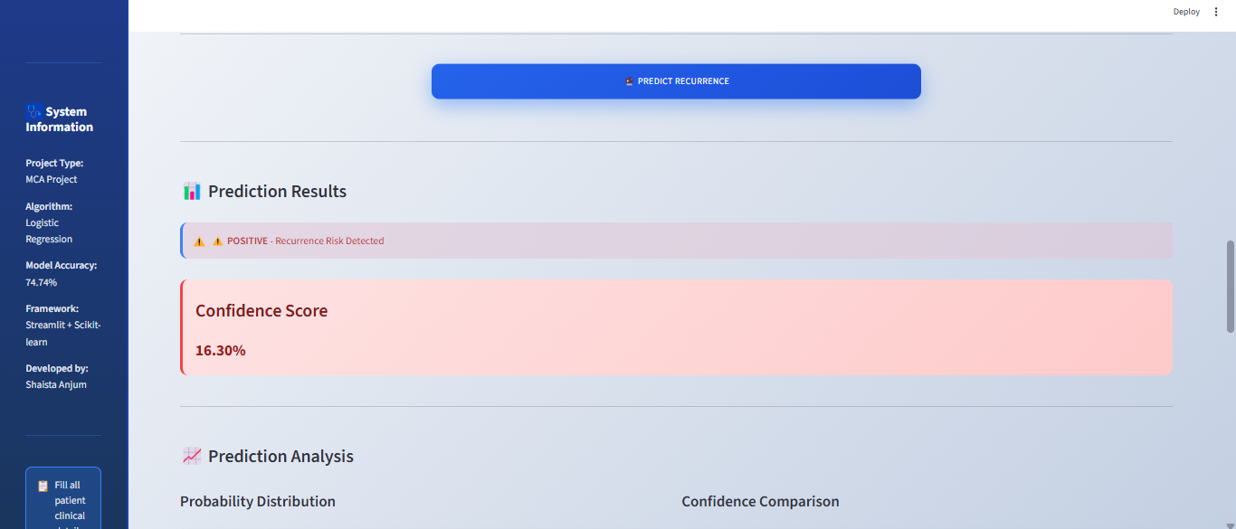
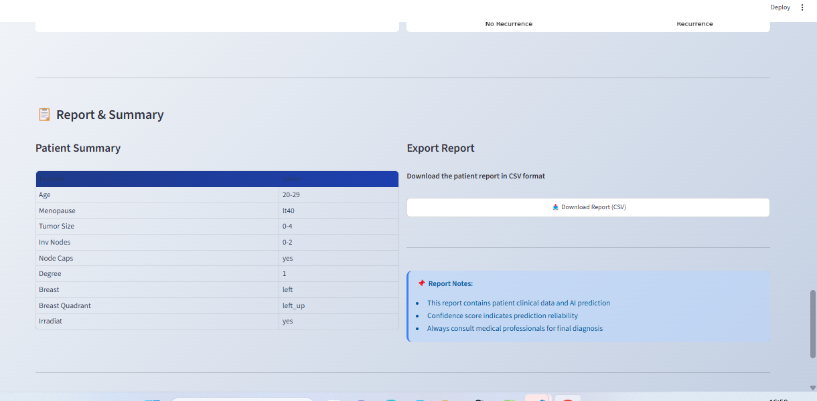

Advantages
Interactive, fast, educational, easy to use.

Limitations
Educational use only; not a substitute for clinical diagnosis.

Future Scope
Advanced models, cloud deployment, authentication, explainable AI.

Conclusion
The project demonstrates practical application of machine learning in healthcare using Streamlit.

References
Scikit-learn, Streamlit, Pandas, UCI Breast Cancer Dataset.

