1.1.1

select staff_name as name_of_staffs ,

design_code as designation_code_of_staffs

from staff_master where hiredate<'01-jan-03'

and staff_sal between 12000 and 25000



1.1.3

select STAFF_CODE,STAFF_NAME,DESIGN_CODE,DEPT_CODE,HIREDATE,STAFF_DOB,STAFF_ADDRESS,STAFF_SAL

FROM STAFF_MASTER

WHERE MGR_CODE is null

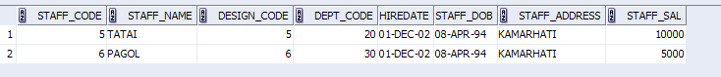

1.1.4

select * from BOOK_MASTER

WHERE BOOK_PUB_YEAR BETWEEN 2001 AND 2004

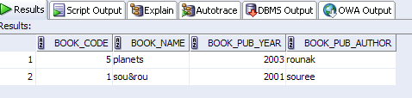

SELECT * FROM BOOK_MASTER

WHERE BOOK_NAME LIKE '%&%';

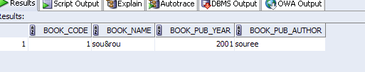

1.1.5

SELECT STAFF_NAME FROM STAFF_MASTER

WHERE STAFF_NAME LIKE '%\_%' ESCAPE '\';

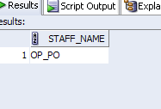

1.1.2

SELECT STAFF_CODE,STAFF_NAME,DEPT_CODE

FROM STAFF_MASTER

WHERE months_between(sysdate,HIREDATE)/12>18

ORDER BY months_between(sysdate,HIREDATE) DESC;

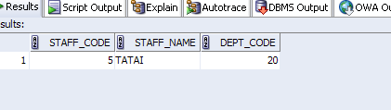

2.1.1

SELECT STAFF_NAME,

LPAD(STAFF_SAL, 15, '$') STAFF_SAL

FROM STAFF_MASTER;

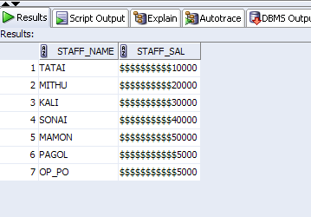

2.1.2

SELECT STUDENT_NAME,TO_CHAR(STUDENT_DOB,'MONTH DD YYYY') AS STUDENT_DOB FROM STUDENT_MASTER WHERE TO_CHAR(STUDENT_DOB,'DAY') LIKE ('%SATURDAY%') OR TO_CHAR(STUDENT_DOB,'DAY') LIKE ('%SUNDAY%') ;

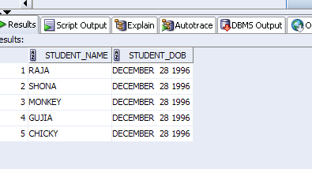

2.1.3

SELECT STAFF_NAME,ROUND(MONTHS_BETWEEN(SYSDATE,HIREDATE)) AS MONTHS_WORKED FROM STAFF_MASTER ORDER BY MONTHS_WORKED DESC;

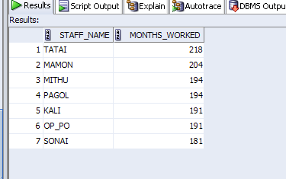

2.1.4

SELECT * FROM STAFF_MASTER WHERE TO_CHAR(HIREDATE,'DD') BETWEEN 1 AND 15 AND TO_CHAR(HIREDATE,'MONTH') LIKE '%DECEMBER%' ;

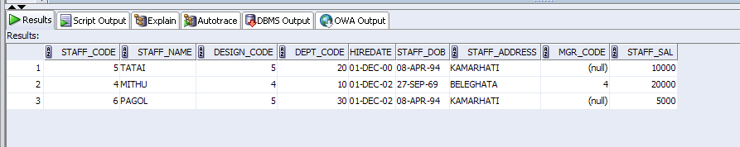

2.1.5

SELECT STAFF_NAME,STAFF_SAL,

CASE

WHEN STAFF_SAL >=50000 THEN 'A'

WHEN STAFF_SAL >25000 AND STAFF_SAL<50000 THEN 'B'

WHEN STAFF_SAL >10000 AND STAFF_SAL<25000 THEN 'C'

ELSE 'D'

END CASE

FROM STAFF_MASTER;

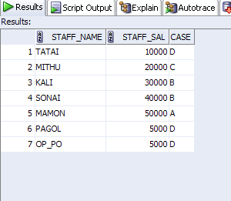

2.1.6

SELECT STAFF_NAME,TO_CHAR(HIREDATE,'DD MONTH YYYY') AS HIRE_DATE,TO_CHAR(HIREDATE,'DAY')AS DAY FROM STAFF_MASTER ORDER BY TO_CHAR(HIREDATE,'DAY') DESC;

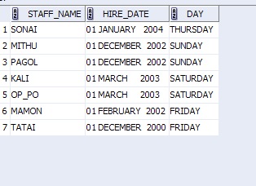

2.1.7

SELECT INSTR('Mississippi','i',2,3) FROM DUAL;

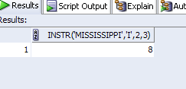

2.1.8

SELECT TO_CHAR(NEXT_DAY(SYSDATE,'TUESDAY'),'DD MONTH ,YYYY') AS DAY FROM DUAL WHERE NEXT_DAY(SYSDATE,'TUESDAY')<LAST_DAY(SYSDATE) ;

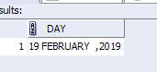

2.1.9

SELECT STUDENT_CODE,STUDENT_NAME,DECODE(DEPT_CODE,20,'ELECTRICALS',30,'ELECTRONICS','OTHERS') DEPARTMENT_NAME FROM STUDENTMASTER;

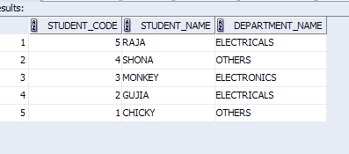

3.1

SELECT S.STAFF_NAME,D.DEPT_CODE,D.DEPT_NAME,S.STAFF_SAL

FROM STAFF_MASTER S,

DEPARTMENT_MASTER D

WHERE S.DEPT_CODE=D.DEPT_CODE

AND STAFF_SAL >20000;

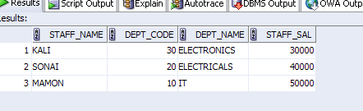

3.2

SELECT S.STAFF_CODE AS STAFF# ,

S.STAFF_NAME AS STAFF,

D.DEPT_NAME,

S.MGR_CODE AS MGR#

FROM STAFF_MASTER S,

DEPARTMENT_MASTER D

WHERE S.DEPT_CODE=D.DEPT_CODE;

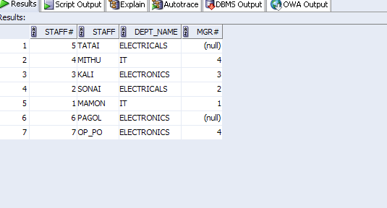

3.3

SELECT S.STUDENT_CODE,

S.STUDENT_NAME,

B.BOOK_CODE,

BB.BOOK_NAME

FROM STUDENT_MASTER S,

BOOK_TRANSACTIONS B,

BOOK_MASTER BB

WHERE S.STUDENT_CODE=B.STUDENT_CODE

AND TO_CHAR(B.BOOK_EXPECTED_RETURN_DATE,'DD MM YYYY') LIKE TO_CHAR(SYSDATE,'DD MM YYYY');

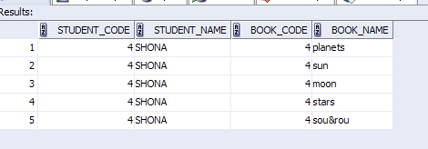

3.6

SELECT Staff_Code, Staff_Name,STAFF_SAL FROM STAFF_MASTER WHERE STAFF_SAL<(SELECT AVG(STAFF_SAL) FROM STAFF_MASTER);

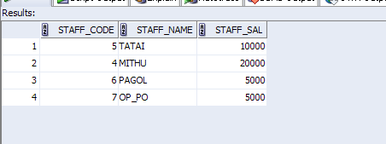

4.1

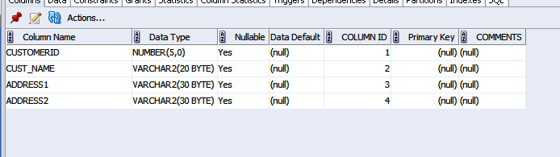

4.2

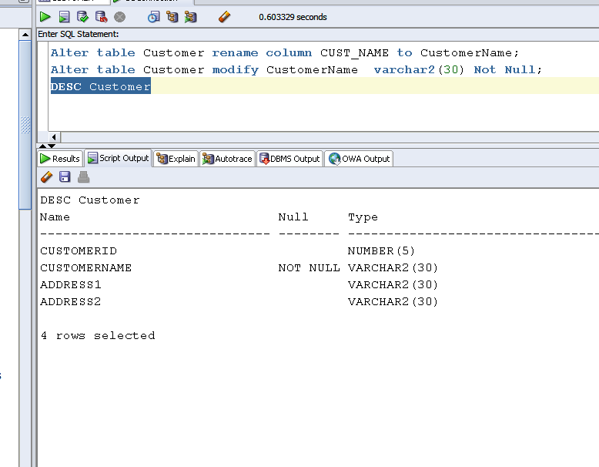

4.3(a)(b)

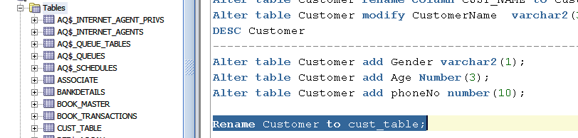

4.4

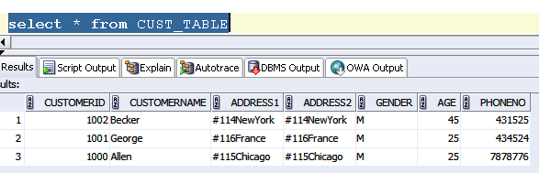

4.5

Alter table CUST_TABLE add constraints Custid_prim PRIMARY KEY (CUSTOMERID);

4.6

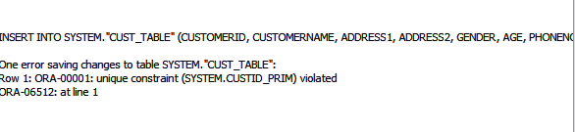

4.9

ALTER TABLE CUST_TABLE

DROP PRIMARY KEY

Insert into CUST_TABLE VALUES(1002, 'Becker', '#114 New York', '#114 New york' , 'M', 45,431525);

Insert into CUST_TABLE VALUES(1003, 'Nanapatekar', '#115 India', '#115 India' , 'M', 45, 431525);

4.10

TRUNCATE table cust_table;

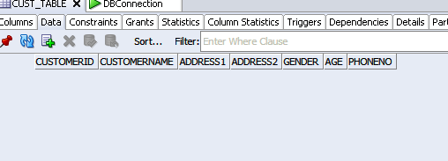

4.11

Alter table CUST_TABLE add e_mail varchar2(30);

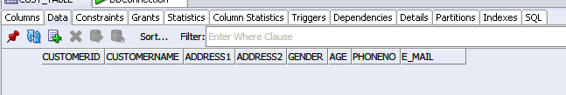

4.12

Alter table CUST_TABLE DROP COLUMN E_MAIL;

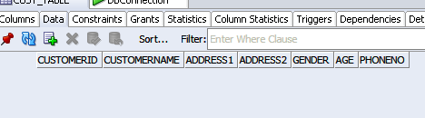

4.13

create table Suppliers as select(CUSTOMERID as SuppID, CUSTOMERNAME as SName,ADDRESS1 as Addr1,ADDRESS2 as Addr2,PHONENO as ContactNo);

from CUST_TABLE;

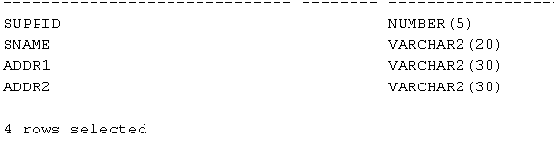

4.15

Create table AccountsMaster(customerId number(5),AccountNumber number(10) primary key(acno),AccountType char(3),LedgerBalance number(10) Not Null);

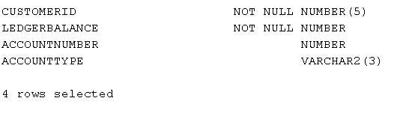

4.16

Alter table ACCOUNTMASTER ADD constraint CUST_ACC FOREIGN KEY(customerid) REFERENCES CUST_TABLE(customerid);

4.18

alter table ACCOUNTMASTER add constraint ck_ac check(ACCOUNTTYPE='NRI' or ACCOUNTTYPE='IND');

4.19

alter table ACCOUNTMASTER add constraint Balance_check CHECK(LEDGERBALANCE > 5000);

4.20

Delete from ACCOUNTMASTER,CUST_TABLE where CUSTOMERID=1001;

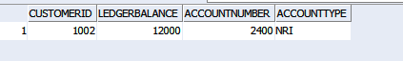

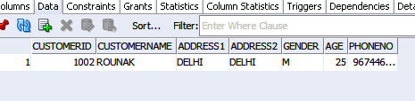

4.21

Create table AccountDetails as select * from ACCOUNTMASTER;

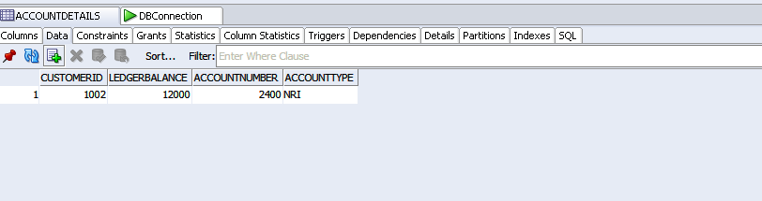

4.22

CREATE VIEW Acc_view AS SELECT(CUSTOMERID,CUSTOMERNAME,ACCOUNTNUMBER,ACCOUNTTYPE,LEDGERBALANCE)

from AccountMaster;

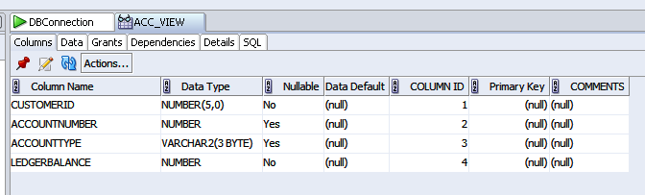

4.23

CREATE VIEW vAccs_Dtls

AS SELECT ACCOUNTTYPE,LEDGERBALANCE

from ACCOUNTMASTER

where ACCOUNTTYPE = 'IND' and LEDGERBALANCE< 10000;

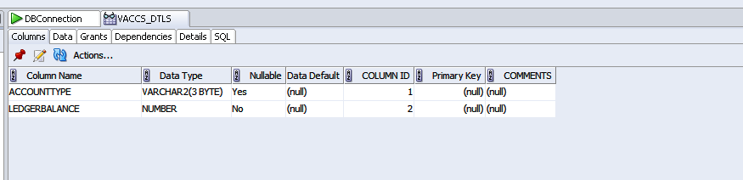

4.24

CREATE VIEW accsvw10

AS SELECT ACCOUNTTYPE,LEDGERBALANCE

from ACCOUNTMASTER

where ACCOUNTTYPE = 'IND' and LEDGERBALANCE< 10000;

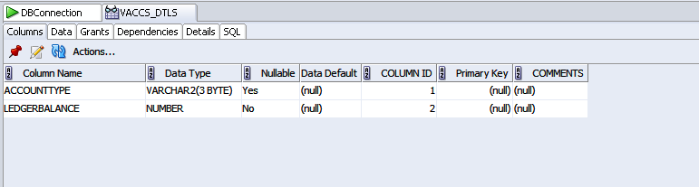

4.25

CREATE sequence SEQ_DEPT minvalue 40 start with 40

increment by 10 MAX VALUE 200 cache 40;

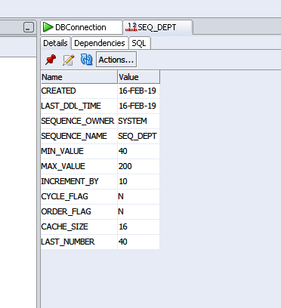

4.26

insert into department_master values(seq_dept.NEXTVAL,'MARKETING','NEW DELHI');

insert into department_master values(seq_dept.NEXTVAL,'SALES','chennai');

insert into department_master values(seq_dept.NEXTVAL,'RESEARCH','BOSTON');

4.27

DROP sequence seq_dept;

4.28

CREATE INDEX no_name on emp(empno);

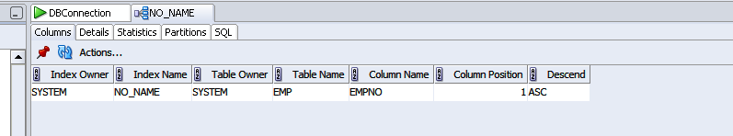

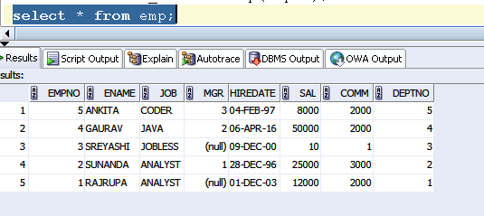

4.29

create SYNONYM synemp for emp;

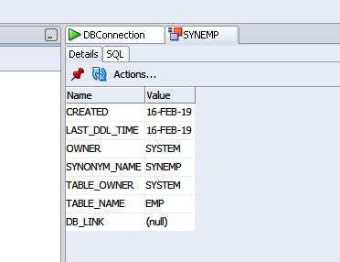

4.30

CREATE INDEX IDX_EMP_HIREDATE on emp(HIREDATE);

4.32

CREATE sequence SEQ_EMP minvalue 1001 start with 1001

increment by 1 cache 1001;

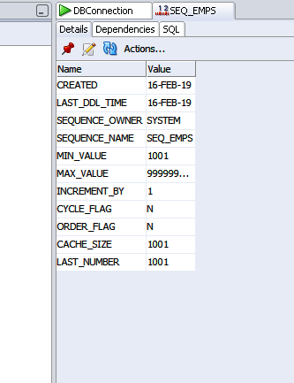

5.1

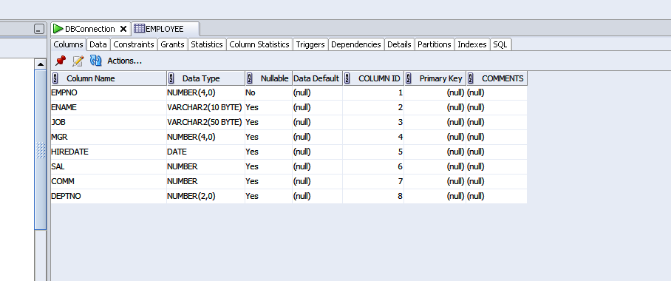

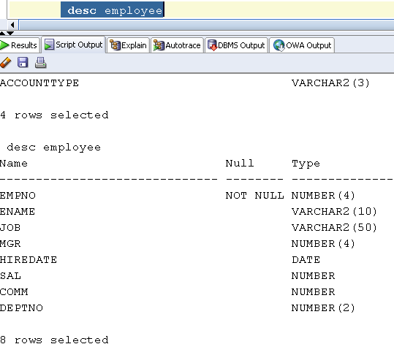

5.2

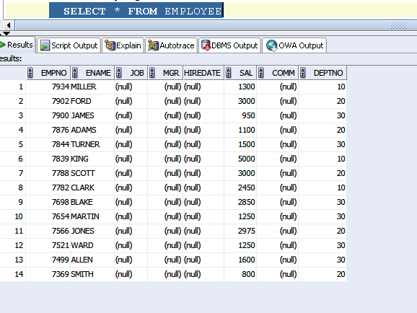

5.3

update table EMPLOYEE

set JOB=(select JOB from EMPLOYEE where EMPNO=7788, DEPTNO=(select DEPTNO from EMPLOYEE where EMPNO=7788)

where empno=7698;

5.4

delete from employee where departmentname like '%sales%'

5.5

update table employee set deptno=(select deptno from employee where deptno=7788) where deptno=7698;

5.6

insert into employee (empno,ename,job,mgr,hiredate,sal,comm,deptno)

values (1000,'Allen', 'Clerk',1001,'12-jan-01', 3000, 2,10);

insert into employee (empno,ename,job,mgr,hiredate,sal,comm,deptno) values (1001,'George', 'analyst', null, '08 Sep 92', 5000,0, 10);

insert into employee (empno,ename,job,mgr,hiredate,sal,comm,deptno) values (1002, 'Becker', 'Manager', 1000, '4 Nov 92', 2800,4, 20);

insert into employee (empno,ename,job,mgr,hiredate,sal,comm,deptno) values (1003, 'Bill', 'Clerk', 1002, '4 Nov 92',3000, 0, 20);

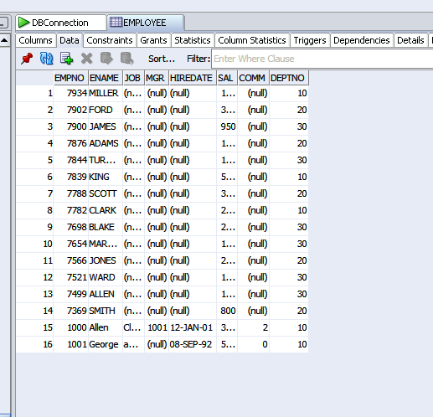

6.1

insert into cust_table (customerid,customername,address1,address2,gender,age,phoneno)

values ( 6000, 'John', '#115 Chicago', '#115 Chicago', 'M', 25, 7878776);

insert into cust_table (customerid,customername,address1,address2,gender,age,phoneno) values (6001, 'Jack', '#116 France', '#116 France', 'M', 25, 434524);

insert into cust_table (customerid,customername,address1,address2,gender,age,phoneno) values (6002, 'James', '#114 New York', '#114 New York', 'M', 45, 431525);

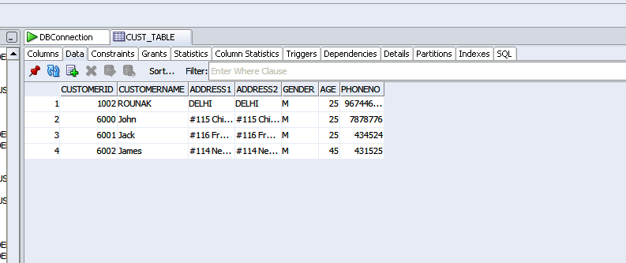

6.2

insert into cust_table (customerid,customername,address1,address2,gender,age,phoneno)

values ( 6000, 'John', '#115 Chicago', '#115 Chicago', 'M', 25, 7878776);

insert into cust_table (customerid,customername,address1,address2,gender,age,phoneno) values (6001, 'Jack', '#116 France', '#116 France', 'M', 25, 434524);

insert into cust_table (customerid,customername,address1,address2,gender,age,phoneno) values (6002, 'James', '#114 New York', '#114 New York', 'M', 45, 431525);

savepoint p1;

6.3

insert into customermaster (customerid,customername,address1,address2,gender,age,phoneno) values ( 6003, ‘John’, ‘#114 Chicago’, ‘#114 Chicago’, ‘M’, 45, 439525);

6.4

rollback p1;