NSSL-S2024-WIKIPEDIA SMART EDITOR

Team: Eliyahu Wiener, Shai Tayar

Advisor: Hovav Gazit, Orna Agmon Ben-Yehuda

Table of Contents
Abstract 4
Introduction 5
The Israeli-Palestinian Conflict and Its Global Impact 5
Wikipedia War Edits and Their Importance 5
Wikipedia’s Efforts in Mitigating Conflict Edits and Fake News 6
Key Terms in Wikipedia Relevant to This Study 6
Access to Wikipedia API 7
Overview of Wikipedia API 7
Using Scripts to Access the API 7
Challenges in API Access 7
Ethical Considerations 7
Architecture 8
The Project 9
The Features 9
Contribution to EC pages 9
Reverts war 10
Revert war on EC pages only 10
EC tag 10
Measurements 11
Scatter and ECDF 11
Measurements using the General Population 14
Comparing the features to the General Population 17
Optimization 22
Observations 27
Mapping the Surface 27
Results 28
Conclusion & Further Work 29
Votes on controversial pages: 29
Appearance and disappearance of users 29
The code 30
Overview 30
Configuration 30
Main 30
Unit Tests 30
Amoeba 30
How to run the project? 31
Bibliography 33
Appendix 34

Abstract
The Israeli Palestinian conflict has long been a contentious issue, influencing geopolitical landscapes and public opinion worldwide. With the advent of the internet, platforms like Wikipedia have become pivotal in shaping the global narrative. This project seeks to delve into the dynamics of Wikipedia edits related to the Israeli Palestinian conflict. Specifically, it aims to study the phenomena of "Wikipedia war edits," where editors align themselves with ideologies to influence the content of articles.
By creating an algorithmic approach to identify suspiciously biased pro-Palestinian users, this research contributes to understanding the subtle mechanisms that shape online narratives in contentious global topics.

Introduction

The Israeli-Palestinian Conflict and Its Global Impact
The Israeli-Palestinian conflict is a decades-long struggle over territorial, political, and cultural rights in the Middle East. Its roots trace back to the early 20th century, and it continues to manifest in geopolitical disputes, military confrontations, and humanitarian crises. Beyond the local implications, the conflict has significant international ramifications. The global public opinion plays a crucial role in shaping policy decisions, financial aid, and diplomatic strategies. Thus, controlling the narrative becomes a strategic objective for involved parties.
In the digital age, the battle over public opinion extends to the internet, where platforms like Wikipedia serve as primary sources of information for millions. Ensuring the accuracy and neutrality of these narratives is crucial, as the content can influence individual perspectives and international policies alike.

Wikipedia War Edits and Their Importance
Wikipedia is a free, collaborative online encyclopedia, hosting over 60 million articles in various languages. Its decentralized nature allows anyone to edit content, which democratizes knowledge but also exposes it to manipulation. During political or military conflicts, "Wikipedia war edits" emerge, where editors actively push particular narratives to influence the perception of events.
The Israeli-Palestinian conflict is one of the most controversial topics on Wikipedia, with numerous pages subjected to constant revisions. Editors may add biased information, propagate fake news, or remove content that challenges their viewpoint. These actions have far-reaching consequences: they can distort historical records, mislead readers, and escalate tensions between communities.
For example, during escalations in Gaza or the West Bank, Wikipedia pages on related events may experience hundreds of edits per day. Each edit represents an attempt to control the narrative, whether by clarifying facts, adding bias, or spreading misinformation. This underscores the importance of monitoring and analyzing editing patterns, particularly in politically sensitive contexts.

Wikipedia’s Efforts in Mitigating Conflict Edits and Fake News
Wikipedia, managed by the Wikimedia Foundation, has implemented several measures to ensure the integrity of its content. These include:
- Page Protection: Pages on contentious topics are often semi-protected or fully protected, restricting edits to experienced users or administrators.
- Extended Confirmed (EC) Editors: Certain pages require editors to have "extended confirmed" status, which is granted to users with a minimum number of edits and account age. This reduces the risk of vandalism by new or unverified users.
- Talk Pages: Wikipedia provides a discussion space for editors to deliberate on contentious edits, fostering transparency and collaboration.
- Conflict Tags: Articles under frequent dispute are tagged as "pages in conflict," alerting readers to potential bias or ongoing debates.
- Fake News Policies: Wikipedia’s guidelines mandate reliable sourcing and verifiability, with a strict prohibition on using fake news as references. Editors frequently patrol articles to enforce these standards.
Despite these measures, challenges persist. Determined actors can bypass protections, and the subjective nature of "reliable sources" often leads to disagreements. This necessitates additional research into automated detection and analysis of suspicious editing behaviors.

Key Terms in Wikipedia Relevant to This Study
To understand the dynamics of Wikipedia war edits, familiarity with the following terms is essential:
- Talk Pages: Dedicated discussion pages accompanying each article, where editors can discuss proposed changes, resolve disputes, and justify edits.
- Extended Confirmed (EC) Editors: Users with higher levels of trust based on their activity, granted privileges to edit semi-protected and extended-confirmed-protected pages.
- Extended Confirmed (EC) Pages: Pages protected due to their contentious nature, editable only by EC editors.
- Pages in Conflict: Articles experiencing frequent disputes or biased editing, often tagged to inform readers and editors.
- User Contributions: A log of edits made by a specific user, which can reveal patterns in editing behavior.

Access to Wikipedia API

Overview of Wikipedia API
The Wikipedia API is a powerful tool that allows developers to interact programmatically with the platform’s data. Through the API, users can retrieve article content, edit histories, user contributions, and other metadata. This accessibility enables researchers to analyze large datasets efficiently.

Using Scripts to Access the API
In this project, Python scripts were used to interact with the Wikipedia API. The following key functionalities were implemented:
- Fetching Recent Changes: Scripts retrieved logs of recent edits to monitor activity on pages related to the Israeli-Palestinian conflict.
- User Contributions: Scripts accessed detailed records of individual user edits, including timestamps, edit summaries, and affected pages.
- Page Metadata: Scripts extracted metadata such as page protection levels, categories, and linked articles.
- Revert Detection: By analyzing edit summaries and comparing versions, scripts identified reverts and flagged users with high revert activity.

Challenges in API Access
Accessing the Wikipedia API involves certain limitations, including rate limits and data filtering. To address these:
- Rate Limits: Scripts were designed to use efficient pagination and throttling to avoid exceeding API request limits.
- Data Filtering: Only relevant edits and metadata were processed, reducing computational overhead.
- Data Storage: Results were stored in a Neo4j database, facilitating complex queries and network analysis of editing patterns.

Ethical Considerations
Analyzing Wikipedia edits involves handling publicly available data. The project adhered to Wikipedia’s Terms of Use and ensured that no private or personally identifiable information was accessed or stored.

Architecture
- Python - most parts of the project are written in python (.py / .pynb) because of python’s simplicity and built in libraries (neo4j, requests, pandas, numpy, etc..).
- Matlab - the optimization part is written in Matlab (.m) because matlab has built-in fminsearch (amoeba) function. This function has very good documentation in matlab and on the internet.
- Neo4j - is a graph DB. We chose this graph because the project contains nodes (users, pages, userboxes) and connections with weights between them. The neo4j can query large amounts of graphic data efficiently. It also has nice visualization.
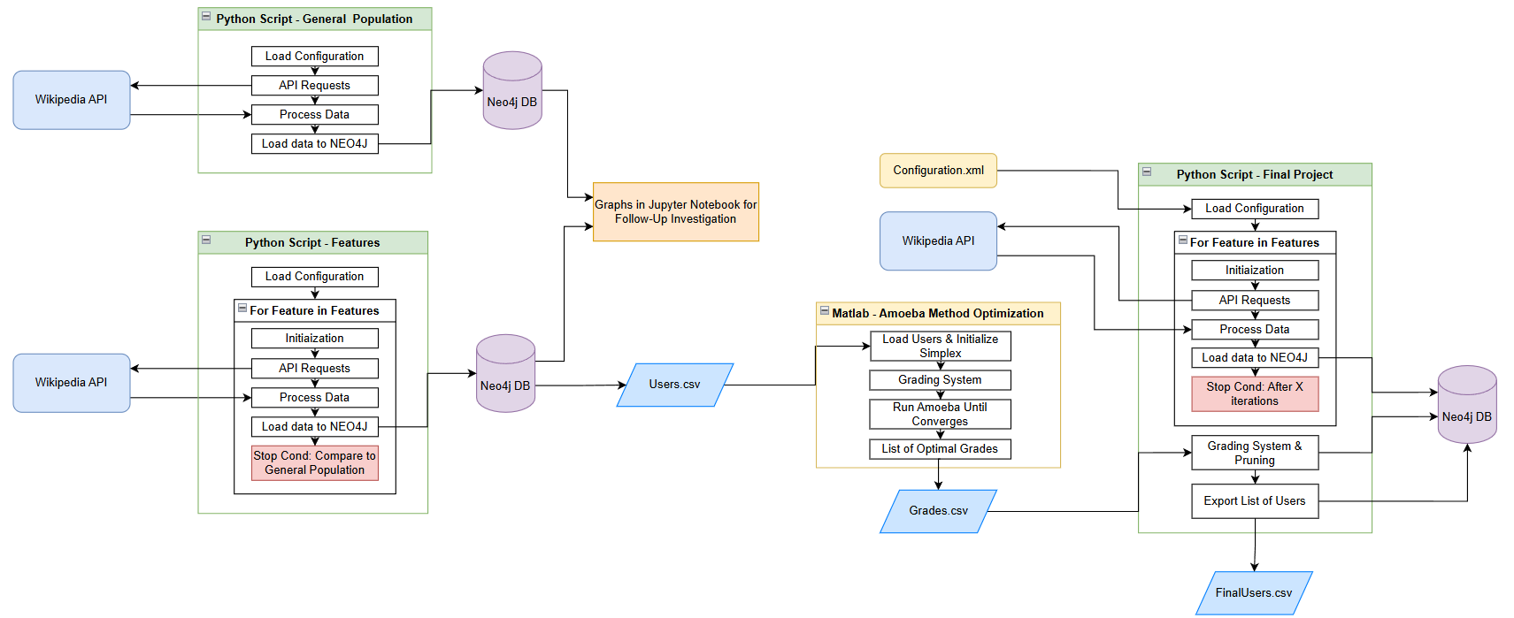
- Wikipedia REST Api – a service provided by WikiMedia, allows to query the server and extract data from Wikipedia using HTTP requests.

The Project
This is a big chapter, and it will discuss the components of the project.
In this chapter, we will also try to describe the process we went through in building the project: our initial assumptions, the observations after running the project on a small amount of data and eventually the conclusions that will reflect the final product.

The Features
When we started to research the English Wikipedia, we tried to find features in Wikipedia which can be relevant to our project. Each of these features will be characterized, tested and eventually will receive a grade.
The final list of users will contain only the users that their total grade is bigger than the threshold grade. Other users will be pruned.

Contribution to EC pages
Every Wikipedia page has two interesting features that implies the page’s security level:
- Edit Protection
- Move Protection
We have noticed that pages related to the Israeli-Palestine conflict have EC protection on them, which means only specific users can edit or change them.
Therefore, we expanded from the kernel users to the pages they contributed to in the last 30 days, then from the EC pages in the DB to the users that contributed to those pages and so on until convergence (not new users or EC pages).
$$Kernel Users\overset{contributes in 30 days}{\overbrace{→}}EC Pages→Users→EC Pages→…$$

Reverts war
Users in Wikipedia can also revert other users. This is a negative connection between users. Therefore, we assumed that if a Pro Palestine user has reverted another user, the other user is probably Pro Israel user. We call this Reverts War.
In this feature we ignored self-reverts (when user reverts his own edit) and focused on reverts that happened closely to each other.
$$u1-\left[reverted\right]→u2-\left[reverted\right]→u3→\left[reverted\right]→u4→…$$

Revert war on EC pages only
It is important to note that in EC Pages a user can revert only once a day. Which means, if user1 contributed to EC Page and user2 reverted its changes, then user3 reverted user2’s changes, maybe user1 and user3 are from the same side of the barricade.
$$u1-\left[reverted on EC page\right]→u2-\left[reverted on EC page\right]→u3→\left[reverted on EC page\right]→…$$

EC tag
Users can get EC (extended confirmed) tag only when reached to 500 edits and minimum 1 month from registration. We assumed that biassed users may try to gain the EC tag fast, in order to vote, edit and revert protected EC pages.

Measurements
The following chapter will discuss the methods we used in order to evaluate the quality of each feature.

Scatter and ECDF
Scatter Plot: investigate the relationship between the user’s total contribution to the user’s contribution to protected pages.
ECDF: understand cumulative distribution of percentages of contributions to protected page.

Users Contribution to Wikipedia Pages
For one expansion: took all the users in the DB,
Scatter:
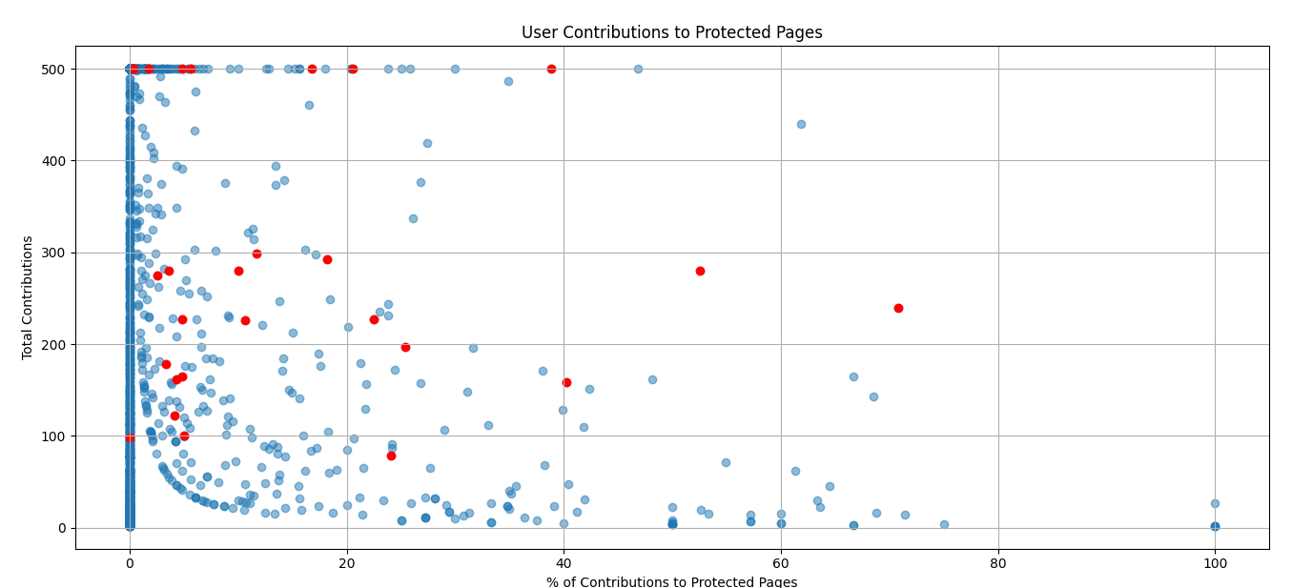
ECDF:
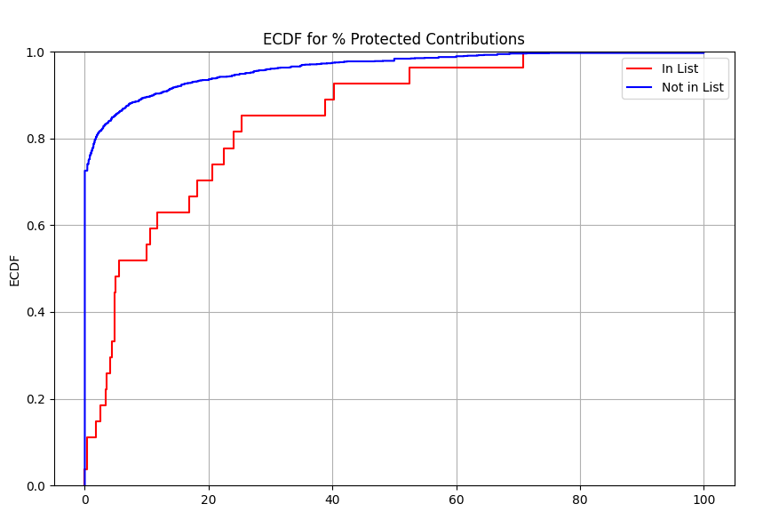
Observations:
- Users not in kernel: About 80% of the users edited 0% of EC pages.
- Users in kernel: about 90% of the users in the kernel edited less than 50% of EC pages. The other 10% edited 50-80% EC pages.

Users Reverts
Scatter:
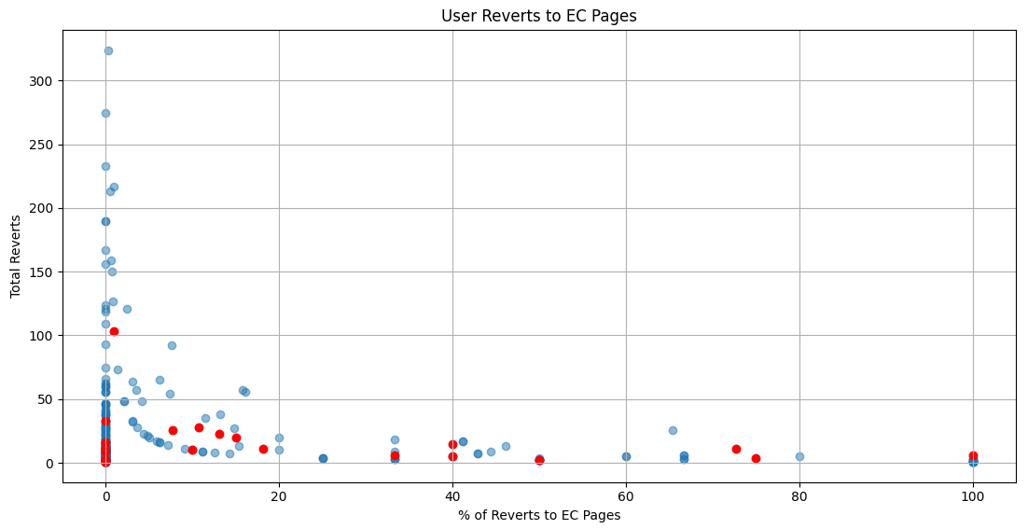
ECDF:
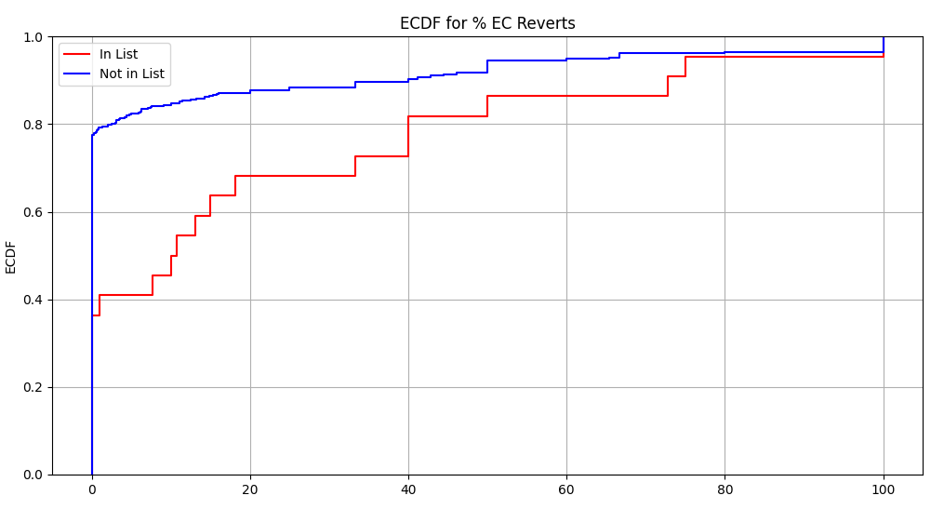

Measurements using the General Population

UserBoxes
Users in Wikipedia can share their emotions, features and groups they are associated with using the userBoxes feature.
We have noticed that the userBoxes found in each user’s UserPage are good indicators to find biased users, therefore we tried to classify the Pro Israel userBoxes and Pro Palestine userBoxes.

Pro-Palestine UserBoxes
- This user supports the struggle for a free independent Palestine.
- This user supports the Boycott, Divestment and Sanctions (BDS) campaign against Israeli apartheid.
- This user supports Palestine.
- Apartheid: wrong for South Africans; wrong for Palestinians.
- This user supports one democratic state in historic Palestine from the river to the sea.
- This user recognizes the Palestinian right of return
- This user deeply and utterly loathes people who deny the Gaza genocide.
- This user supports the right of all individuals and groups to violently resist military aggression and occupation by other parties, but due to an illegal consensus he is disallowed from naming particular individuals or groups which certain administrators find to be unacceptable.
- This user supports the independence of Palestine.
- This user participates in WikiProject Arab World.
- This user participates in WikiProject Palestine.
- This user is a participant in WikiProject Islam.
- This user wants the Palestinians to join the EU.

Pro-Israel UserBoxes
- This user is strongly against the terrorism of Hamas.
- This user supports Israel.
- This user supports the rights of the nation of Israel to exist freely, within defensible borders.
- This user is Jewish.
- This user participates in WikiProject Israel.

Username in Arabic / Hebrew
After examination of users in the general population we found that users with Arabic username often have Pro Palestinians traits.
We extended the conclusion to the Pro Israeli group with Hebrew username as well.

Usernames associated with “WikiProject Palestine”
WikiProject in Wikipedia is a group of contributors who work together as a team.
We have noticed that most of the articles in WikiProject Palestine are related to the Israel-Palestine Conflicts. Moreover, from the about us section in wikiProject Palsetine: “Be thorough and watch for POV in particularly controversial articles” - this is a violation of Wikipedia's neutrality POV.
Therefore, we extracted active members in WikiProject Palestine and tagged them as pro-Palestinian users for the measurements.
Symmetrically for users associated to WikiProject Israel and pro-Israel users’ tag.

General Population
In the project we used the general population as a tool to measure the features.
From all the editors in recent changes in the last four days, we sampled 50 samples every 15 minutes (a total of 400 samples per 1 hour) and characterized the group to which the user belongs, using the measurement features discussed in this chapter.
Pro Palestine and Pro Israel users in General Population as function of hour (utc):
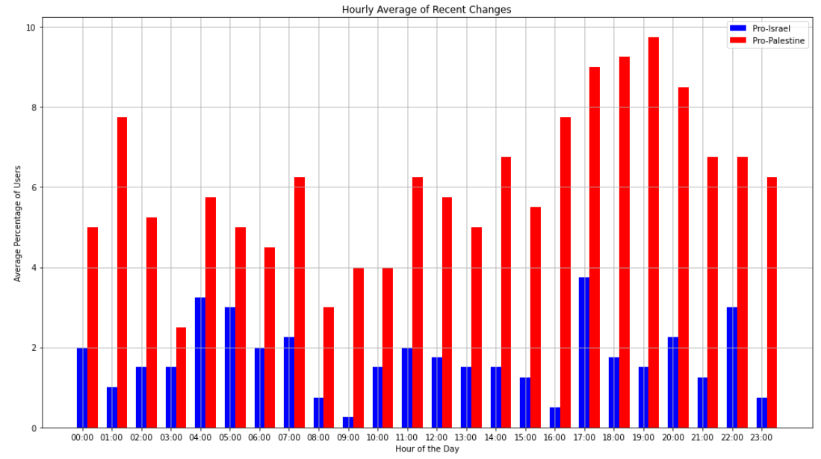
Pro-Palestine: Mean: $66e^{-3}$, Variance: $1.1e^{-3}$
Pro-Israel: Mean: $18e^{-3}$, Variance: $0.2e^{-3}$

We will evaluate each feature by comparing the mean Pro-Palestine users in the feature to the mean Pro-Palestine $±$ variance. Same to the mean Pro-Israel users.
From now and on, mean Pro-Palestine $±$ variance will be marked on the graphs in green constant line and mean Pro-Israel $±$ variance will be marked in purple dot line.

Comparing the features to the General Population

Contribution to EC Pages
Starts from the Kernel (0 iteration), expand to all the pages the user contributed to in the last past month. Extract the edit_protection tag from all the pages.
Expand from all the extended confirmed pages to all the users that have contributed to them in the last month. Keep expanding until it converges.
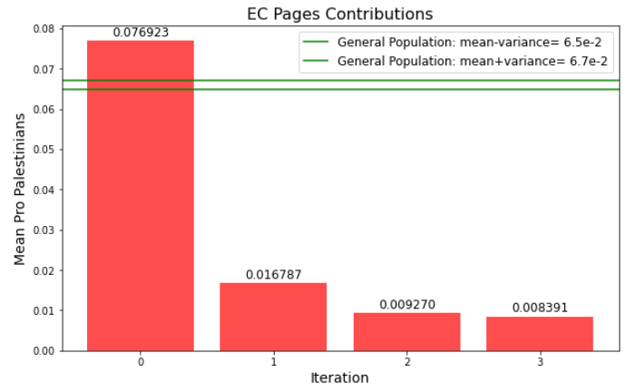
Great Feature – works as we expected.

Contribution to EC Pages with a threshold of 20%
The user will be taken in count in the next expansion only if:
$$\frac{User^{'}s Contribution to EC Pages}{User^{'}s Total Contributions}∙100\%≥20\%$$
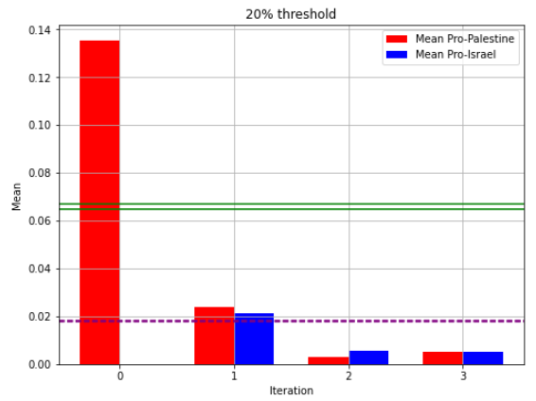

Reverts War
Starts from the Kernel (0 iteration), expand to all the users that the kernel reverted. We assumed that the users in iteration 1 will be only pro-Israelis. Keep expanding, in even iterations assumed to be only Pro Palestine and in odd iterations only Pro Israels.
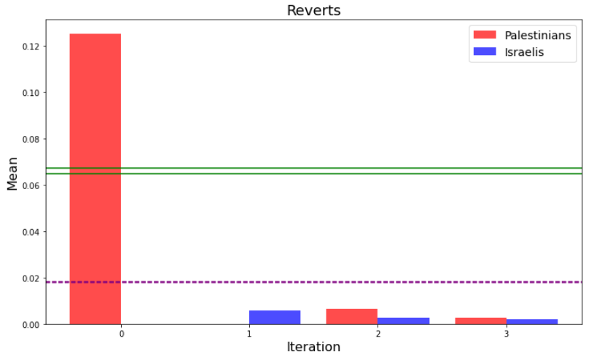
Not good enough feature – like good Israelis, we noticed that Pro Israel users may revert other Pro Israel users.

Reverts war on EC pages
Just like reverts war, but expanding only on reverts in EC pages.
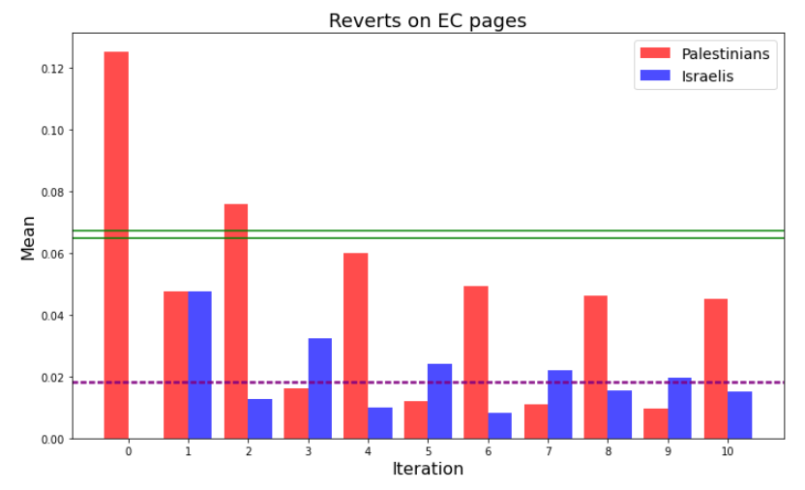
As assumed, the even iterations have high numbers of pro-Palestine users, while in odd iterations higher numbers of pro-Israel users than pro-Palestine users.
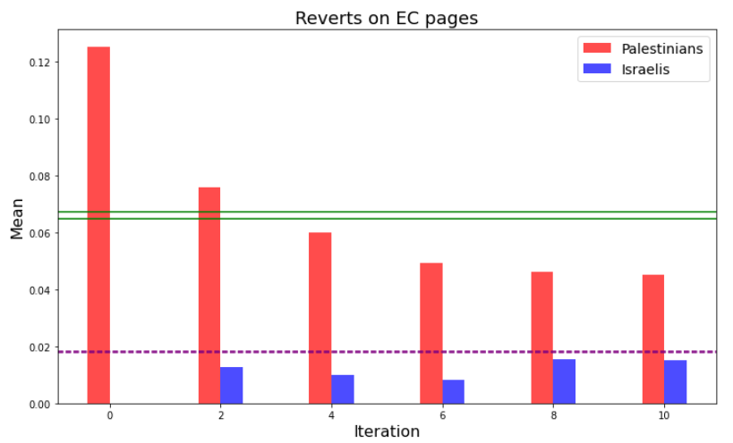

EC Tag
In this feature we checked the number of months from the user’s registration until achieving EC tag.
This is a feature with no expansions, so we ran it on all the users in the DB (which were received from the features EC contributions and reverts).
The following graph shows the connection between the mean Pro-Palestine/ Pro-Israel users and the months it took for them to gain their EC tag.
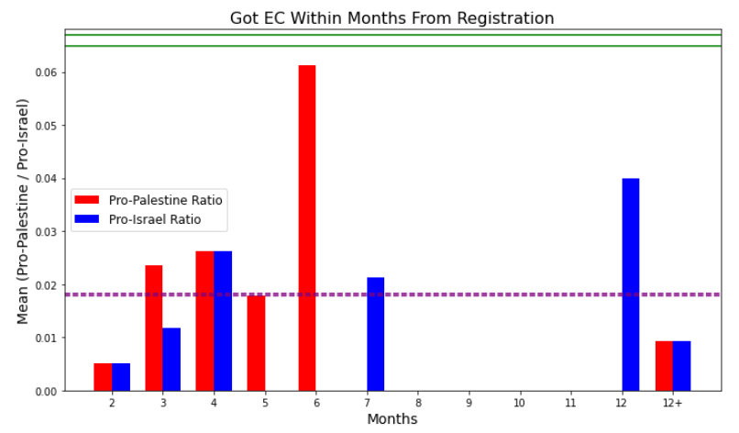
The results are pretty good: as assumed, users that we marked as Pro Palestine (according to our index) gained their EC tag much faster than Pro Israel users.
It is very interesting to compare this graph to the general population:
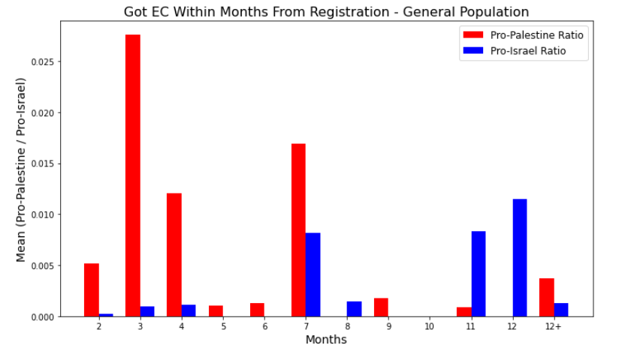
Also in the general population, most of the users that have gained their EC Tag within less than 7 months are classified as Pro Palestine.
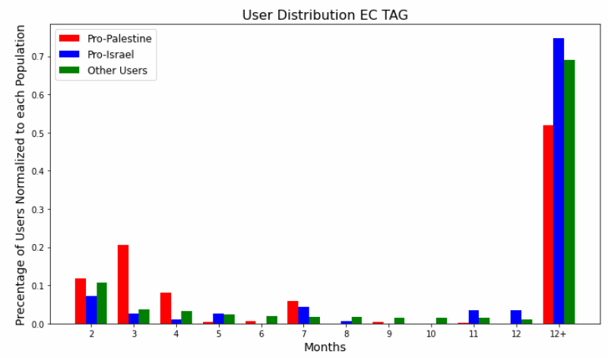
Normalized:

Optimization
To find the optimize grade for each feature, we used the Amoeba method optimization. We used the fminsearch function in Matlab.
The data that we keep in the DB for each user, and were used for optimization:
Feature | Data
EC Tag | Registration date | EC tag received date
EC Pages Contribution (Last 30 days) | Total contributions  (Last 30 days) | Contributions to EC Pages (Last 30 days)
Reverts | Total reverts  (Last 30 days) | Reverts in EC Pages  (Last 30 days)
Also, we save the is_pro_palestine and is_pro_israel tags according to the index we presented (which weights userBoxes, username in Arabic/Hebrew and affiliation with wikiProject Palestine).
In the Amoeba algorithm, we are given initial grades $grades[3]$ , a threshold score by which the pruning will be determined $prune$ and the function $objective=meanProPalestine$.
During the algorithm run, the scores will be refined, bringing the objective function to the optimal value (in our case, a population after pruning in which the average number of pro-Palestinians is the largest).
The grade for each feature will be calculated as follows:
- EC Pages Contribution
$$\frac{contributions_to_EC_pages}{total_contributions}*grades(1)$$
- EC Tag
$$\frac{1}{1+months_untill_EC_tag}*grades(2)$$

- Reverts War
$\frac{reverts_to_EC_pages}{total_reverts}*grades(3)$
Results of running Amoeba Algorithm from different initials:
Graph | Mean of pro-Palestine in pruned list | Optimized Grades | Prune | Initial grades
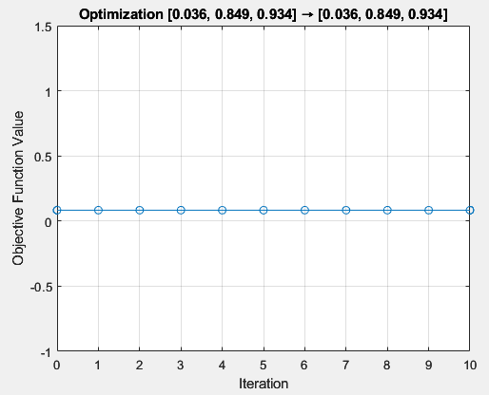 | 0.0833 | 0.0357, 0.8491, 0.9340 | 0.5 | 0, 0.9, 0.9
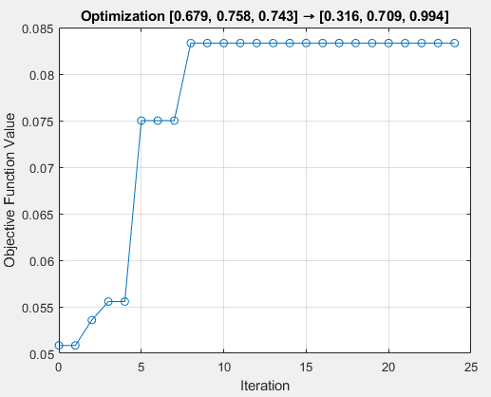 | 0.0833 | 0.3159, 0.7086, 0.9936 | 0.5 | 0.7, 0.8, 0.7
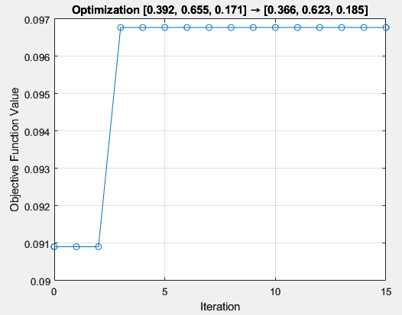 | 0.0968 | 0.3661, 0.6227, 0.1855 | 0.5 | 0.4, 0.7, 0.2
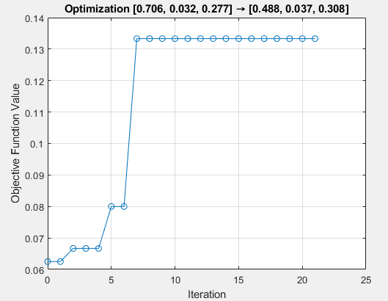 | 0.1333 | 0.4881, 0.0369, 0.3079 | 0.5 | 0.7, 0, 0.3
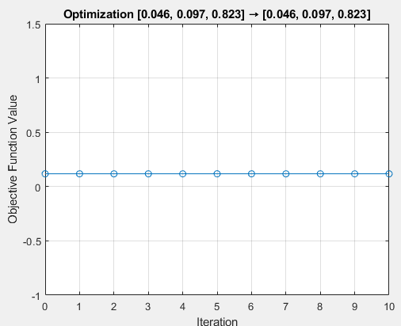 | 0.1176 | 0.0462, 0.0971, 0.8235 | 0.5 | 0, 0.1, 0.8
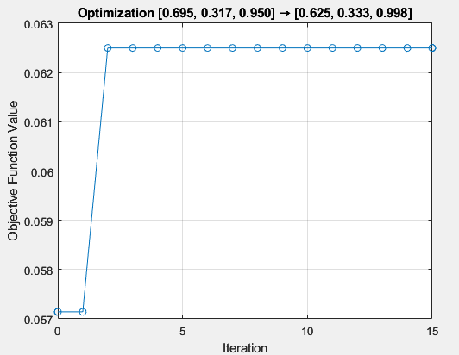 | 0.0625 | 0.6253, 0.3330, 0.9977 | 0.5 | 0.7, 0.3, 1
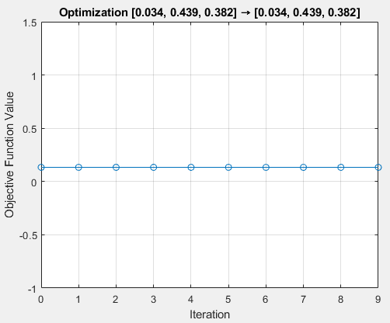 | 0.133 | 0.0344, 0.4387, 0.3816 | 0.5 | 0, 0.4, 0.4
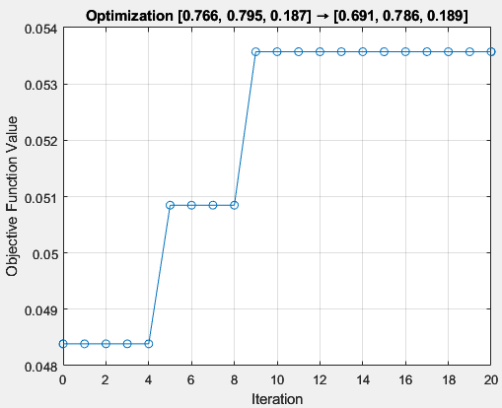 | 0.0536 | 0.6909, 0.7856, 0.1893 | 0.5 | 0.8, 0.8, 0.2
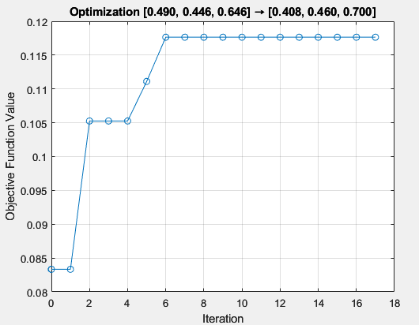 | 0.1176 | 0.4081, 0.4604, 0.7002 | 0.5 | 0.5, 0.5, 0.65
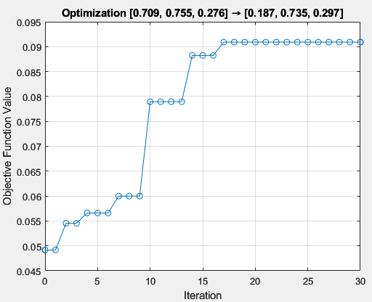 | 0.0909 | 0.1875, 0.7354, 0.2974 | 0.5 | 0.7, 0.75, 0.28

Observations
- The amoeba algorithm manages to avoid "shoulders" and local minima in most cases.
- The fminsearch accepts negative score.

Mapping the Surface
We ran the Amoeba algorithm on 200 random initials between [0,1].
Then draw the objective function using linear interpolation, in order to get a smooth surface function.
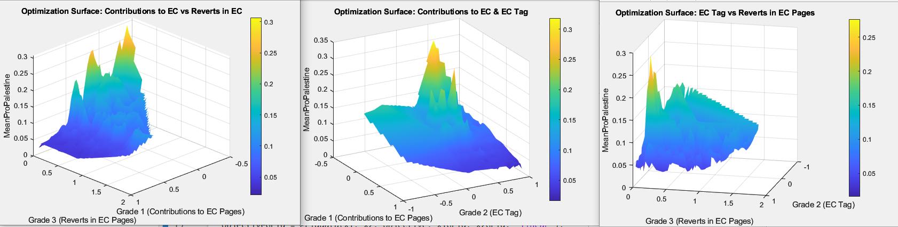

2
1


3

We have noticed that in graphs 1 and 3 the optimum is obtained for Grade3 = 0.
Therefore, we ran the amoeba algorithm again, this time with Grade3=0.
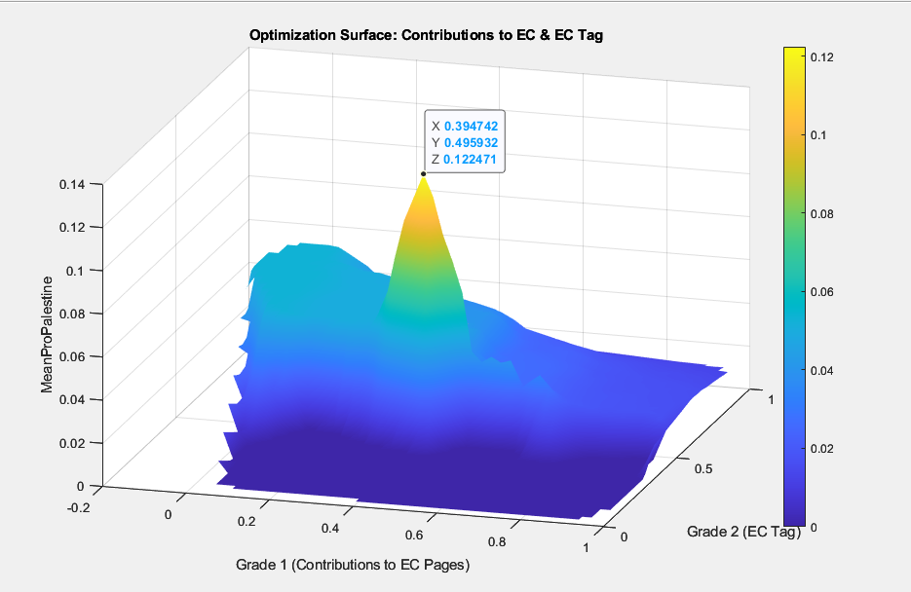
We got a global maximum in [0.4,0.5,0] and prune=0.5. Therefore, this will be the final grade.

Results
We ran the grade on data extracted 6 months ago, before some of the kernel users were blocked.
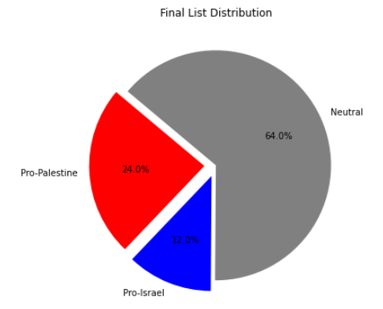
Pro Palestine Users
HuntersHistory
Noble Attempt
Est. 2021
IntrepidContributor
M Waleed
AnarchistHistory

Conclusion & Further Work
The algorithm managed to find 24% of new pro Palestinians users, who stayed “under the radar”.

Votes on controversial pages:
In WikiProject Palestine there are many votes on controversial pages, sometimes more pronounced and sometimes less.
We tried to understand how to classify editors according to their vote (for example oppose/suppose for a certain issue) but it was difficult to understand the essence of the vote.

Appearance and disappearance of users
We noticed a phenomenon in some of the pro-Palestinian users who were accepted into the shortlist after pruning.
Users registered many years ago (at least 5 years), made a small number of edits and "disappeared from the radar" for many more years. Suddenly, around October 2023, they returned to making a huge number of edits. We began to think that perhaps these users are biased users, but due to time constraints we will propose this feature for further research.
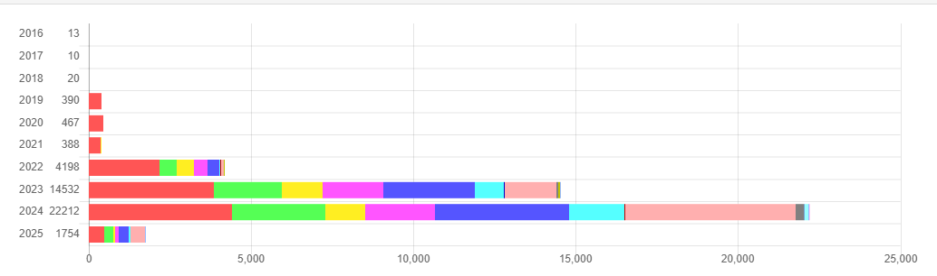

The code

Overview
We combined all the python scripts we described on “Architecture” section, thus the final code contains all the classes and methods we wrote for the project.
Note: not all the functions and classes are called from main (for example main calls the class RevertsEC but doesn’t call Reverts).

Configuration
The configuration file contains all the variables that can be changed by the user. It is important to notice which flags are on, because different functionalities need different databases (to avoid data merges, for example general population and expansions).
Moreover, if “graph” only is checked in the configuration, it is not necessary to turn on the DB because all the functions read data from exports.

Main
The main function reads the configuration and calls the relevant classes and methods in the project, inserts the data to the DB, processes and exports it to the “exports” folder under the main directive. If you don’t want to run NEO4J, we left some of our exports in the “exports” folder.

Unit Tests
We created Unit Tests that combine all the tests and scenarios we ran during the last 8 months. This can be useful if you want to run specific test / scenario and not to change the configuration file. For each test, the relevant requirements are in the test’s documentation.

Amoeba
We left the Amoeba algorithm as Matlab code. Measurements run will export list of users to insert the amoeba (explained later in this section).

How to run the project?
- Follow the Follow the Installation Guide in the appendix.
- After the installation, there are 2 ways to run the project:
- Using main
  - Edit the configuration file with the wanted parameters.
  - Make sure that the neo4j DB is on (if necessary)
  - Run the main method and wait until it finishes.
- Using the tests
  - We have already run the tests and exported json files into exports folder.
  - For convenience, you can run only the following tests that read data from the json files and draw the graphs:
    - Tests.TestMeasurements.test_draw_graphs
Draw Scatter and ECDF for 1 iteration of contributions & reverts.
    - Tests.TestGraphs.test_general_population_graph
Draw all the graphs that are relevant to the general population.
    - Tests.TestGraph.test_expansions_graph
Draw all the graphs that are relevant for the features, i.e: contributions, reverts, ecTag…
Note: The tests import the last json inserted into exports\graph_type folder. If you want to draw another data, you can change the filename in configuration. For example, to run general_population_graph on exports\general_population\exports_20250316_1351.

  - If you want brand new data, you can run specific tests but note to turn on the neo4j DB.

- To run the Amoeba optimization algorithm:
  - Run the tests: measurements or the main with the configuration: measurements: on.
  - Finally, a new file will be inserted into exports\measurement.
  - Run the amoeba: 'amoeba_final.m' and the visualization: ‘amoeba_graph.m’ (we’ve already ran the amoeba algorithm, so it is possible to run only the visualization).

Exports folder:
- Expansions_Final_UserList.csv – final userList created after running the expansion with the grades outputted from Amoeba optimization algorithm.
- Amoeba\users_to_amoeba.csv – list of users after running measurements, that amoeba reads from.
- Amoeba\optimization_results.csv – the visualization reads from this file
- Expansion_grades and expansion_no_grades – contains json files with data to draw the results after expansions.
- General population – contains json files with data to draw the general population results.

Bibliography
- " Palestine and the Arab-Israeli Conflict: A History with Documents" (ninth edition). Smith, Charles D.
- " Writing the Revolution: Wikipedia and the Survival of Facts in the Digital Age". Ford, Heather.
- "Wikipedia:Neutral point of view". Wikimedia Foundation, 2023.
- "How Wikipedia fights against fake news". Realfonzo, Ugo.
- https://www.brusselstimes.com/1080893/how-wikipedia-stops-fake-news
- "Getting to the source: where does Wikipedia get its information from?".
- Heather Ford, Shilad Sen, David R Musicant, Nathaniel Miller.
- https://www.academia.edu/download/31667811/WikiSym_2013_srcs.pdf
- "Edit Wars in Wikipedia". Robert Sumi, Taha Yasseri, Andr´s Rung, Andr´s Kornai, J´nos Kertesz.
- https://ieeexplore.ieee.org/abstract/document/6113205
- "Dynamics of conflicts in Wikipedia‏". ". Robert Sumi, Taha Yasseri, Andr´s Rung, Andr´s Kornai, J´nos Kertesz.
- https://journals.plos.org/plosone/article?id=10.1371/journal.pone.0038869
- "He says, she says: conflict and coordination in Wikipedia". Aniket Kittur, Bongwon Suh, Bryan A. Pendleton, Ed H. Chi.
- https://dl.acm.org/doi/abs/10.1145/1240624.1240698
- "Local and Global Algorithms for Disambiguation to Wikipedia". Lev Ratinov, Dan Roth, Doug Downey, Mike Anderson.
- https://aclanthology.org/P11-1138.pdf

Appendix
Installation Guide
Step 1: Install Python 3.4
Your project requires Python 3.4. Download and install it from the following link:
Python 3.4 Download
Windows Installation:
- Download the Windows installer.
- Run the installer and check Add Python to PATH.
- Follow the installation instructions.
Linux/Mac Installation:
- Use pyenv to install Python 3.4:
curl https://pyenv.run | bash
exec $SHELL
pyenv install 3.4.10
pyenv global 3.4.10
Step 2: Install pip
Python 3.4 comes with an older version of pip. Upgrade or install it:
python -m ensurepip --default-pip
python -m pip install --upgrade pip
Step 3: Install Required Libraries
Install the required dependencies using pip:
pip install matplotlib requests neo4j numpy seaborn logging
Step 4: Install Neo4j Database
Install Neo4j Community Edition:
- Download Neo4j Community Edition from the official Neo4j Download Page and select the appropriate version for your operating system.
- Follow the installation steps for your OS.
- Start the Neo4j service:
neo4j start
- Access the Neo4j Desktop app
- Create a new project using New Create Project Add Local DBMS
Step 5: Install MATLAB
The project requires MATLAB for the Amoeba algorithm optimization and visualization
Download MATLAB:
- Go to the MATLAB Download Page.
- Sign in with a MathWorks account or create one if necessary.
- Select the appropriate version of MATLAB for your system and follow the installation instructions.
Verify MATLAB Installation:
After installation, open MATLAB and run: ver
This should display the installed MATLAB version.
Step 6: Install MATLAB Toolboxes
Ensure that required MATLAB toolboxes are installed. Open MATLAB and run:
matlab.addons.installedAddons
If any of the required toolboxes are missing, install them via:
matlab.addons.install('ToolboxName')
Required toolboxes:
- Optimization Toolbox
- Statistics and Machine Learning Toolbox
Step 7: Run the MATLAB Scripts
Navigate to the directory containing the MATLAB scripts and execute:
run('amoeba_final.m')
run('amoeba_graph.m')
Ensure that the required CSV files (output.csv, optimization_results.csv) are available in the working directory.
Step 8: Run the Project
As explained in the project section.

this is actually a support to Hezbollah userBox

