CS3907/CS6444 Big Data and Analytics
Spring 2023
Class Project #2
Due: Lecture 9 COB

Exploring Variations in Clustering and Predictive Analysis

- Data Set: Obesity Database
- Description:
This dataset include data for the estimation of obesity levels in individuals from the countries of Mexico, Peru and Colombia, based on their eating habits and physical condition. The data contains 17 attributes and 2111 records, the records are labeled with the class variable NObesity (Obesity Level), that allows classification of the data using the values of Insufficient Weight, Normal Weight, Overweight Level I, Overweight Level II, Obesity Type I, Obesity Type II and Obesity Type III.

Features:

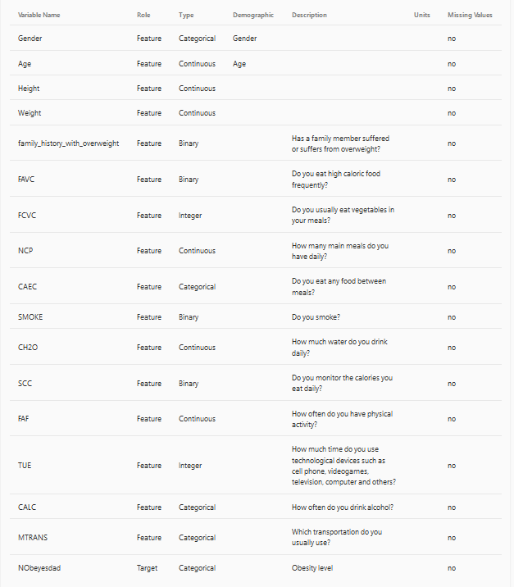

Sample Records:

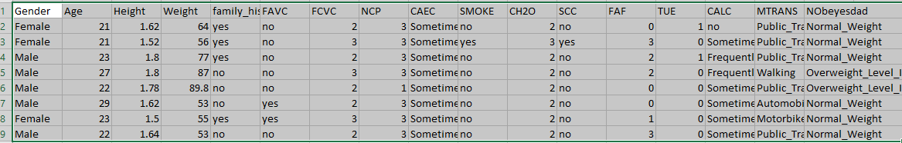

Objective:

Detetermine which features are the most useful in predicting obesity.
To do this, start with pairwise plotting to see if there are linear relationships between pairs consisting of the first 16 columns and the last column.

You will need to subset the data set into several data sets. For example, a dataset with all males or females.

You will need to look for clusters by the features after you have perfromed subsetting.

Select the features with linear relationships and extract those columns from the data set.
So, you might end up with a dataset with gender, age, height, weight, smoke, and Mtrans plus the last column.

These are later split into training sets and test sets for use with GLM an Predict.

You will try to predict obesity level for subsets of the data using the features you have determined to be most relevant.
To do: Follow the rubric presented in Clustering & Classification.
1. For this data set, plot the data using pairwise plotting to get a sense of the relationships between the attributes.

a. Try plotting the data using several plotting functions to see what it looks like. Use pairs (e.g., 2D plots) or 3 variables (3D plots) based on the packages.
b. Which pairs of attributes seem to be correlated? How are they correlated?

2. Prepare the Data

a. Investigate some of the statistics of the data set: summary(). Describe(). What do you glean from this data?

Note: You may have to subset the data in order to run some of the algorithms on your machine.

b. To subset, pick the most correlated attributes to use – they may all be relevant, so document your rationale for eliminating some attributes. Use at least 5 attributes, but possibly more.

c. You may need to translate alphanumeric (e.g., character) values into numeric values.
Create a mapping for each field of values to integers.
Make sure you put these mapping tables into your report.

d. Split the original data set into Training and Test Sets. Use 70-30%, 60-40%, 50-50%

3. Clustering on the Whole Data Set

a. Use the whole date set when clustering (the first part of the rubric).

b. Build a table with your results succinctly displayed.

Document your results in your report in separate sections. Show screen shots of plots of the clusters (see class notes). Suggest using factoextra:fviz_cluster() and other methods.

4. Prediction (using Training and Test Sets)

Following the rubric, try to predict the values of the dependent variable in the test sets.

a. Use the glm(…) method to get linear fits for the data.

Try clusters of 5,7,9,11
Remember to generate labels using kmeans.
Do a cross-tabulation of the results to see how good you did by comparing kmeans vs prediction results.

b. Compute the performance measurements for each table. Calculate the accuracy, false positive, etc. and display in a table.

Try different parameter values and combinations of attributes.
Use predict.glm(…) to predict the values for the test set after training with the training set.

5. Deliverables: You will deliver your results by putting a zipfile in your group’s Blackboard file, with the following naming convention: Group-N-Project-2.zip, where N is your group number. Your written report should follow the format of the rubric.

Show all of your work!!

MAKE SURE YOU LABEL ALL PLOTS AND TABLES WITH A TITLE.
ALL PLOTS SHOULD HAVE LEGENDS.

Approach:

You should determine what to do and divide the work up among the team members after creating the different training and test subsets.

Remember to save your workspace! In your Group area would be a good place so all members can get to it.

(use CTRL-ALT-PrintScreen) to grab the screen
You may use Irfanview 4.54, irfanview@gmx.net or later. Paste in the screen image, and copy the image as JPEG to drop into your Word document.

6. Project #2 Value: 25 points
a. Items #1 and #2 - 2 points each
b. Items #3 and #4 – 10 points each
c. Analysis of what this project helped you learn about data science, e.g., the exploration of data which is what you have been doing – 1 point. You must argue persuasively.

Ask questions if you have problems – either by email or at office hours.
We can schedule a separate Zoom session if you are having trouble

