**Internal Recruitment Management System**

Design Document

24th July, 2017

Version: 0.1 Draft 1.0

Document Identification

| Project Code |  |
| --- | --- |
| Project Name | Internal Recruitment Management System |
| Document Id |  |
| Project Start Date | 24th July, 2017 |
| Project End Date |  |
| Project Type | Java, Spring, HTML, CSS, Bootstrap |
| Project Manager | Mr. Surender Kajla |
| Project Manager Cell No | +91-9015369467 |

Client Detail

| Client Name |  |
| --- | --- |
| Contact Person |  |
| Contact Person Email Id |  |
| Contact Person Cell No |  |

Version History

| Version | Date | Author(s) | Comment | Reviewed By |
| --- | --- | --- | --- | --- |
| Draft 0.1 | 24th July, 2017 | Shaivya Aggarwal | Initially Created |  |
|  |  |  |  |  |
|  |  |  |  |  |
|  |  |  |  |  |
|  |  |  |  |  |

Contents

1 Introduction 4

1.1 Purpose 4

1.2 Scope 4

2 Overview 5

2.1 GetModelList 5

2.2 GetModelIssueList 8

2.3 Visit Info 10

2.4 Dealer Info 20

2.5 Dealer Visit Info 23

2.6 Upload Image API: 26

# Introduction

## Purpose

The purpose of this document is to provide ER diagram depicting the relationship between the entities in the database.

## Scope

This document covers the ER diagram , ………… which would be the baseline for the implementation phase.

# Overview

Below mentioned are the list of APIS used in ASM:

* GetModelList
* Get Model Issue List
* Visit Info
* Dealer Info
* Dealer Visit Info
* Upload Image

## GetModelList

Get Model List API is used to get all the models required for zone and stock.

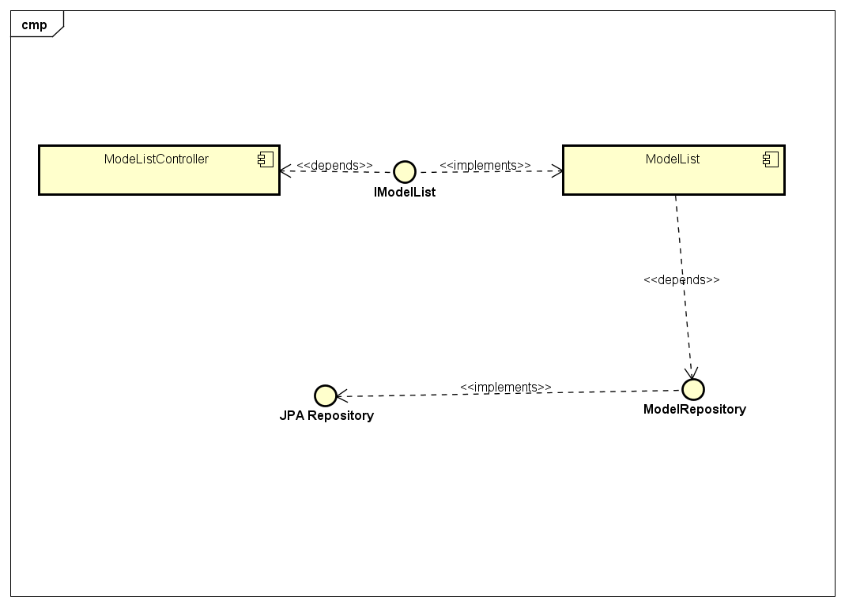

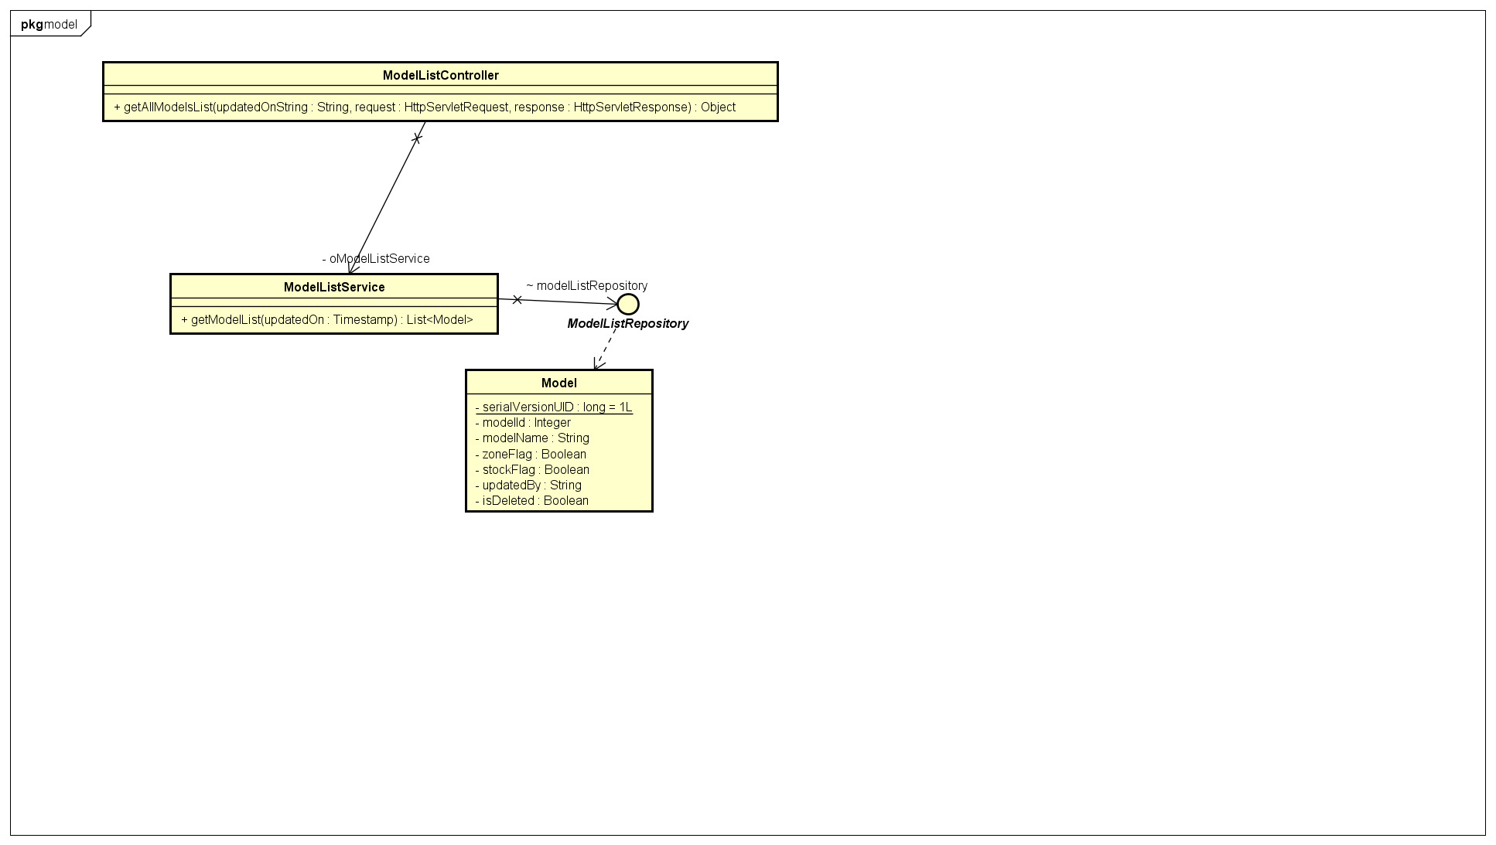

**API URL** : <http://10.167.18.182:8180/asm/modelList>

**Method** : Post

**User Type** : Mobile

**Input Parameters**

|  |  |  |  |  |
| --- | --- | --- | --- | --- |
| **Parameter Name** | **Value Type** | **Mandatory** | **Description** | **Validations** |
| updated_on | timestamp | Y | Time when last time mobile update | Should be timestamp value. First time provide value as 0 for get all records |

**Output Parameters**

|  |  |  |  |
| --- | --- | --- | --- |
| **Parameter Name** | **Value Type** | **Mandatory** | **Description** |
| responseCode | String | Y | Response code |
| responseMessage | String | Y | Response Message |
| responseType | Array | Y | Response Type |
| data | Array | N | Data will have output of API Call |

**data Array:**

|  |  |  |
| --- | --- | --- |
| **Parameter Name** | **Value Type** | **Description** |
| modelId | Integer | modelId |
| modelName | String | model Name |
| zoneFlag | boolean | Flag to check zone required or not. |
| stockFlag | boolean | Flag to check zone info required or not. |
| updatedOn | Timestamp | Last updatedOn time |
| updatedBy | String | Updated By |
| isDeleted | boolean | Flag to check model is deleted or not. |

|  |
| --- |
| **Success Response** |
| {  "responseCode": "200",  "responseMessage": "OK",  "responseType": "array",  "data": [  {  "modelId": 11  "modelName": "Saluto RX 110",  "zoneFlag": true ,  "stockFlag": true ,  "updatedOn": 1502562600000,  "updatedBy": "Neha"  "isDeleted": false  }  ]  } |

## GetModelIssueList

GetModelIssueList is used to get the list of issue types for each model type.

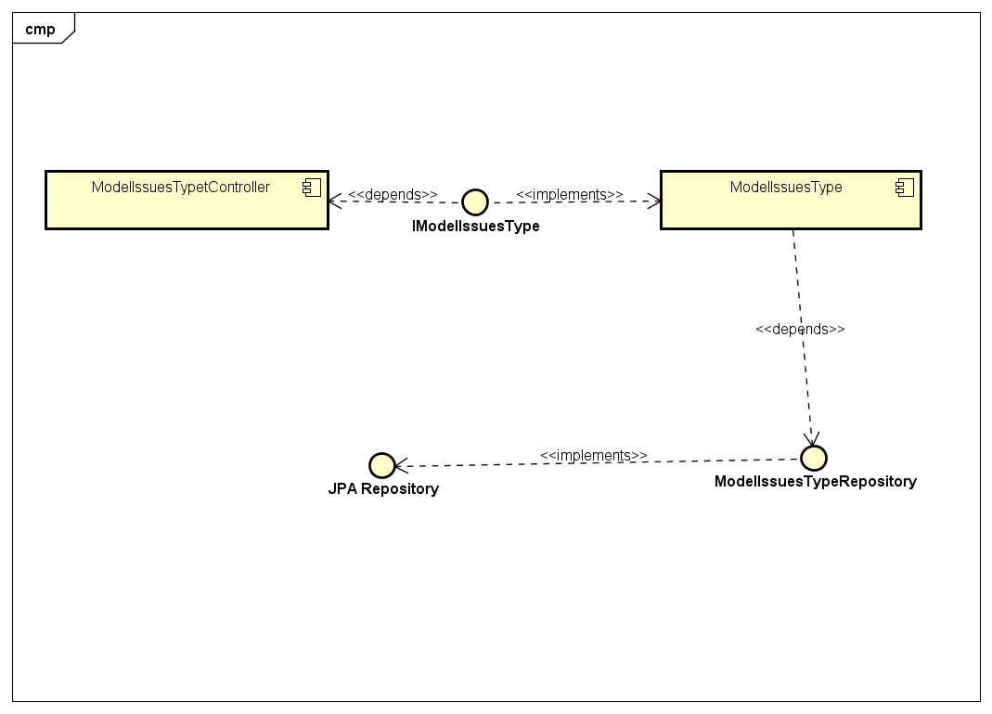

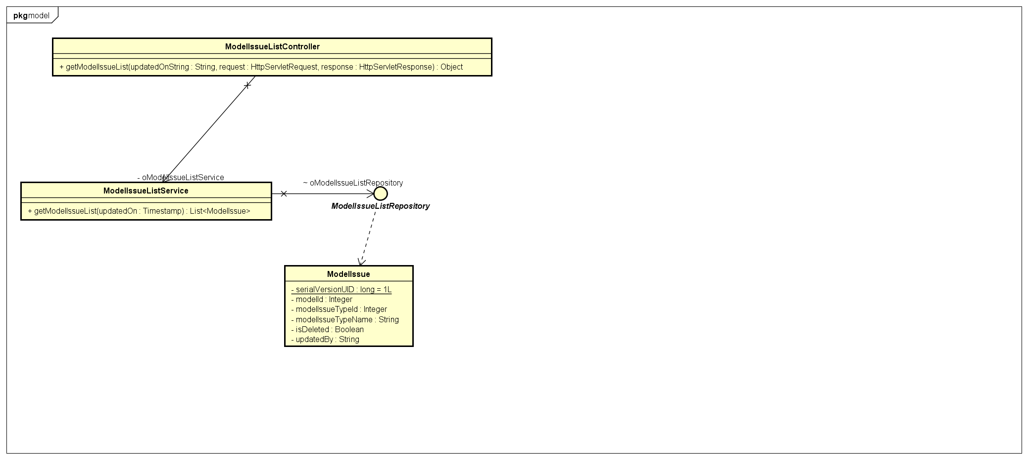

**API URL** : <http://10.167.18.182:8180/asm/modelsssueList>

**Method** : Post

**User Type** : Mobile

**Input Parameters**

|  |  |  |  |  |
| --- | --- | --- | --- | --- |
| **Parameter Name** | **Value Type** | **Mandatory** | **Description** | **Validations** |
| updated_on | timestamp | Y | Time when last time mobile update | Should be timestamp value. First time provide value as 0 for get all records |

**Output Parameters**

|  |  |  |  |
| --- | --- | --- | --- |
| **Parameter Name** | **Value Type** | **Mandatory** | **Description** |
| responseCode | String | Y | Response code |
| responseMessage | String | Y | Response Message |
| responseType | Array | Y | Response Type |
| data | Array | N | Data will have output of API Call |

**data Array:**

|  |  |  |
| --- | --- | --- |
| **Parameter Name** | **Value Type** | **Description** |
| modelId | Integer | Unique Id of Model. |
| modelIssueTypeId | Integer | Unique Id of model Issue type |
| modelIssueTypeName | String | Model Issue Type Name |
| isDeleted | Array | Flag to check issue type is delete or not |
| updatedOn | Timestamp | Last updatedOn time |
| updatedBy | String | Updated By |

|  |
| --- |
| **Success Response** |
| {  "responseCode": "200",  "responseMessage": "OK",  "responseType": "array",  "data": [  {  "modelId": 2  "modelIssueTypeId": 3,  "modelIssueTypeName": "type1”,  "isDeleted": true,  "updatedOn": 1498802264000,  "updatedBy": "kirti"    ]  } |

## Visit Info

Visit info API is used to add visit info into database or get visit info from database.

Visit Info API has two operation

* Add Visit Info
* GetVisitInfo

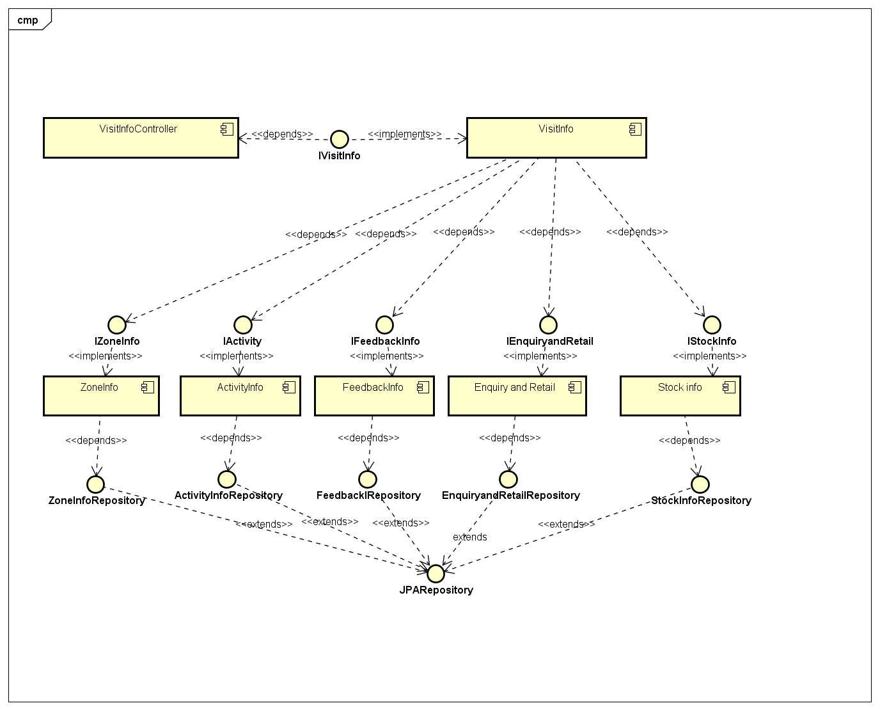

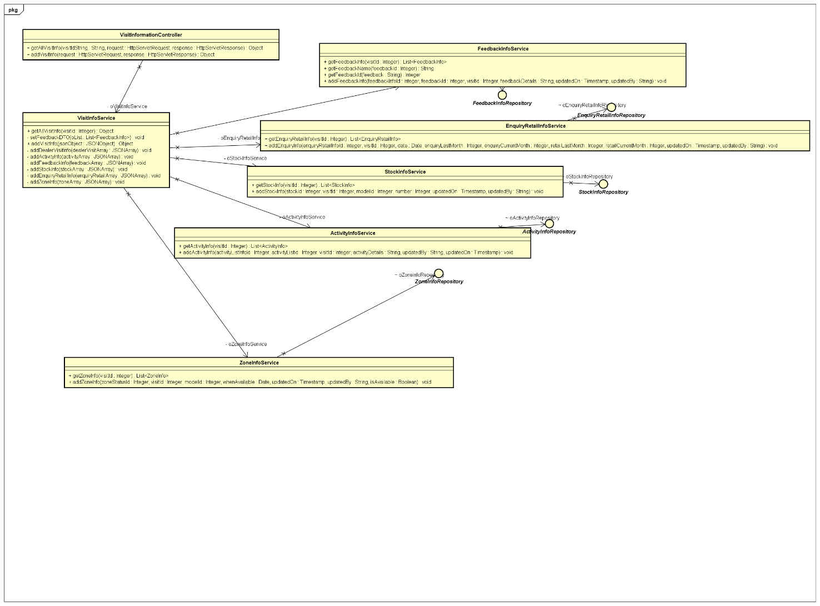

**GetVisitInfo**

**API URL** : <http://10.167.18.182:8180/asm/getVisitInfo>

**Method** : Post

**User Type** : Mobile

**Input Parameters**

|  |  |  |  |  |
| --- | --- | --- | --- | --- |
| **Parameter Name** | **Value Type** | **Mandatory** | **Description** | **Validations** |
| visitId | Integer | Y | Unique If for a visit | Should be Integer and cannot be null. |

**Output Parameters**

|  |  |  |  |
| --- | --- | --- | --- |
| **Parameter Name** | **Value Type** | **Mandatory** | **Description** |
| responseCode | String | Y | Response code |
| responseMessage | String | Y | Response Message |
| responseType | Array | Y | Response Type |
| data | Array | N | Data will have output of API Call |

**data Array:**

|  |  |  |
| --- | --- | --- |
| **Parameter Name** | **Value Type** | **Description** |
| zone_status_info | Array | Array having zone status information. |
| model_issues_feedback | Array | Array having model issues feedback information. |
| stock_info | Array | Array having stock information. |
| enquiry_retail_info | Array | Array having enquiry retail information. |
| activity_list_info | Array | Array having activity list information. |
| feedback_info | Array | Array having feedback information. |

**zone_status_info**

|  |  |  |
| --- | --- | --- |
| **Parameter Name** | **Value Type** | **Description** |
| zoneStatusId | Integer | Zone status Id |
| visitId | Integer | Unique Id for a particular Visit. |
| modelId | Integer | Model Id |
| isAvailable | Boolean | Zone is available or not. |
| whenAvailable | Timestamp | Date when zone will be available. |
| isRequired | Boolean | Flag to check zone is required or not. |
| updatedOn | Timestamp | Last updated Time |
| updatedBy | String | Updated By |
| image | String | Image Name |

**model_issues_feedback**

|  |  |  |
| --- | --- | --- |
| **Parameter Name** | **Value Type** | **Description** |
| modelIssuesId | Integer | Zone status Id |
| visitId | Integer | Unique Id for a particular Visit. |
| modelId | Integer | Model Id |
| feedbackDetails | Boolean | Zone is available or not. |
| modelIssueTypeId | Timestamp | Date when zone will be available. |
| updatedOn | Timestamp | Last updated Time |
| updatedBy | String | Updated By |

**stock_info**

|  |  |  |
| --- | --- | --- |
| **Parameter Name** | **Value Type** | **Description** |
| stockId | Integer | Stock Id |
| visitId | Integer | Unique Id for a particular Visit. |
| modelId | Integer | Model Id |
| stockNumber | Timestamp | Stock Number |
| updatedOn | Timestamp | Last updated Time |
| updatedBy | String | Updated By |

**enquiry_retail_info**

|  |  |  |
| --- | --- | --- |
| **Parameter Name** | **Value Type** | **Description** |
| enquiryRetailInfoId | Integer | Enquiry Retail Info Id |
| visitId | Integer | Unique Id for a particular Visit. |
| date | Timestamp | Date of Retail and Enquiry Info. |
| enquiryLastMonth | Integer | Last Month Enquiry Number |
| enquiryCurrentMonth | Integer | Current Month Enquiry Number |
| retailLastMonth | Integer | Last Month Retail Number |
| retailCurrentMonth | Integer | Current Month Retail Number |
| updatedOn | Timestamp | Last updated Time |
| updatedBy | String | Updated By |

**activity_list_info**

|  |  |  |
| --- | --- | --- |
| **Parameter Name** | **Value Type** | **Description** |
| activityListInfoId | Integer | Activity List Info Id. |
| visitId | Integer | Unique Id for a particular Visit. |
| activityListId | Integer | Activity List Id |
| activityDetail | String | Activity details |
| activityName | String | Activity Name |
| updatedOn | Timestamp | Last updated Time |
| updatedBy | String | Updated By |

**feedback_info**

|  |  |  |
| --- | --- | --- |
| **Parameter Name** | **Value Type** | **Description** |
| feedbackInfoId | Integer | Feedback Info Id. |
| visitId | Integer | Unique Id for a particular Visit. |
| feedbackId | Integer | Feedback Id |
| details | String | Feedback Details |
| feedbackType | String | Feedback Type |
| Image | String | Image Name |
| updatedOn | Timestamp | Last updated Time |
| updatedBy | String | Updated By |

|  |
| --- |
| **Success Response** |
| {  "responseCode": "200",  "responseMessage": "OK",  "responseType": "array",  "data": [  {  "zone_status_info": [  {  "zoneStatusId": 1  "visitId": 1,  "modelId": 1,  "isAvailable": true,  "whenAvailable": 1497810600000,  "isRequired": false,  "updatedOn": 1497865514000 ,  "updatedBy": "shaivya",  "image": "abc.jpg"  }  ],  "model_issues_feedback": [  {  "modelIssuesId": 1,  "visitId": 1,  "modelIssueTypeId": 1,  "feedbackDetails": "asd",  "updatedBy": "dvf",  "updatedOn": 1497871458076,  "modelId": 1  }  ],  "stock_info": [  {  "stockId": 1,  "visitId": 1,  "modelId": 1,  "stockNumber": 22 ,  "updatedOn": 1497871430515,  "updatedBy": "sdfdf"  }  ],  "enquiry_retail_info": [  {  "enquiryRetailInfoId": 1,  "visitId": 1 ,  "date": 1497810600000,  "enquiryLastMonth": 3,  "enquiryCurrentMonth": 3,  "retailLastMonth": 3 ,  "retailCurrentMonth": 5,  "updatedOn": 1497871405828,  "updatedBy": "Neha”  }  ],  "activity_list_info": [  {  "activityListInfoId": 1,  "activityListId": 1,  "visitId": 1,  "activityDetail": "dfsd",  "updatedOn": 1497871369659,  "updatedBy": "dvjksv",  "activityName": "Core/Kiosk Activity"  }  ],  "feedback_info": [  {  "feedbackInfoId": 2,  "feedbackId": 1,  "visitId": 1,  "details": "scds",  "updatedOn": 1497865771509,  "updatedBy": "sam",  "image": null,  "feedbackType": "RTO Related Issue"    }  ]  }  ]  } |

**API URL** : <http://10.167.18.182:8180/asm/addVisitInfo>

**Method** : Post

**User Type** : Mobile

**Input Parameters**

|  |  |  |  |  |
| --- | --- | --- | --- | --- |
| **Parameter Name** | **Value Type** | **Mandatory** | **Description** | **Validations** |
| data | Array | Y | One visit information | Cannot be null . |

**Data Array:**

|  |  |  |
| --- | --- | --- |
| **Parameter Name** | **Value Type** | **Description** |
| zone_status_info | Array | Array having zone status information. |
| model_issues_feedback | Array | Array having model issues feedback information. |
| stock_info | Array | Array having stock information. |
| enquiry_retail_info | Array | Array having enquiry retail information. |
| activity_list_info | Array | Array having activity list information. |
| feedback_info | Array | Array having feedback information. |

**zone_status_info**

|  |  |  |
| --- | --- | --- |
| **Parameter Name** | **Value Type** | **Description** |
| zoneStatusId | Integer | Zone status Id |
| visitId | Integer | Unique Id for a particular Visit. |
| modelId | Integer | Model Id |
| isAvailable | Boolean | Zone is available or not. |
| whenAvailable | Timestamp | Date when zone will be available. |
| isRequired | Boolean | Flag to check zone is required or not. |
| updatedOn | Timestamp | Last updated Time |
| updatedBy | String | Updated By |
| image | String | Image Name |
| modelName | String | modelname |

**model_issues_feedback**

|  |  |  |
| --- | --- | --- |
| **Parameter Name** | **Value Type** | **Description** |
| modelIssuesId | Integer | Zone status Id |
| visitId | Integer | Unique Id for a particular Visit. |
| modelId | Integer | Model Id |
| feedbackDetails | Boolean | Zone is available or not. |
| modelIssueTypeId | Timestamp | Date when zone will be available. |
| updatedOn | Timestamp | Last updated Time |
| updatedBy | String | Updated By |

**stock_info**

|  |  |  |
| --- | --- | --- |
| **Parameter Name** | **Value Type** | **Description** |
| stockId | Integer | Stock Id |
| visitId | Integer | Unique Id for a particular Visit. |
| modelId | Integer | Model Id |
| modelName | String | modelName |
| stockNumber | Timestamp | Stock Number |
| updatedOn | Timestamp | Last updated Time |
| updatedBy | String | Updated By |

**enquiry_retail_info**

|  |  |  |
| --- | --- | --- |
| **Parameter Name** | **Value Type** | **Description** |
| enquiryRetailInfoId | Integer | Enquiry Retail Info Id |
| visitId | Integer | Unique Id for a particular Visit. |
| date | Timestamp | Date of Retail and Enquiry Info. |
| enquiryLastMonth | Integer | Last Month Enquiry Number |
| enquiryCurrentMonth | Integer | Current Month Enquiry Number |
| retailLastMonth | Integer | Last Month Retail Number |
| retailCurrentMonth | Integer | Current Month Retail Number |
| updatedOn | Timestamp | Last updated Time |
| updatedBy | String | Updated By |

**dealer_visit_info**

|  |  |  |
| --- | --- | --- |
| **Parameter Name** | **Value Type** | **Description** |
| visited by | Integer | ASM Id |
| visitId | Integer | Unique Id for a particular Visit. |
| visit_longitude | double | Visit longitude |
| status | Integer | status |
| dealerId | Integer | Dealer Id |
| visit_latitude | double | Visit latitude |
| is_image_sent | Integer | Image Sent Flag |
| visitedOn | Timestamp | Visited On |
| is_sent | boolean | Sent Flag |
| updatedBy | String | Updated By |

**activity_list_info**

|  |  |  |
| --- | --- | --- |
| **Parameter Name** | **Value Type** | **Description** |
| visitId | Integer | Unique Id for a particular Visit. |
| activityListId | Integer | Activity List Id |
| activityDetail | String | Activity details |
| activityName | String | Activity Name |
| updatedOn | Timestamp | Last updated Time |
| updatedBy | String | Updated By |

**feedback_info**

|  |  |  |
| --- | --- | --- |
| **Parameter Name** | **Value Type** | **Description** |
| feedbackInfoId | Integer | Feedback Info Id. |
| visitId | Integer | Unique Id for a particular Visit. |
| details | String | Feedback Details |
| feedbackType | String | Feedback Type |
| Image | String | Image Name |
| updatedOn | Timestamp | Last updated Time |
| updatedBy | String | Updated By |
|  |  |  |

**Output Parameters**

|  |  |  |  |
| --- | --- | --- | --- |
| **Parameter Name** | **Value Type** | **Mandatory** | **Description** |
| responseCode | String | Y | Response code |
| responseMessage | String | Y | Response Message |
| responseType | Array | Y | Response Type |
| data | Array | N | Data will have output of API Call |

|  |  |  |  |
| --- | --- | --- | --- |
| **Parameter Name** | **Value Type** | **Mandatory** | **Description** |
| visitId | Integer | Y | Visit Id |

|  |
| --- |
| **Success Response** |
| {  "responseCode”: "200",  "responseMessage" : "OK",  "responseType" : "array",  "data" : [ {  "visitId”: 3  }  ]  } |

## Dealer Info

Dealer Info API will be used to get dealer Info related to specific area sales manager.

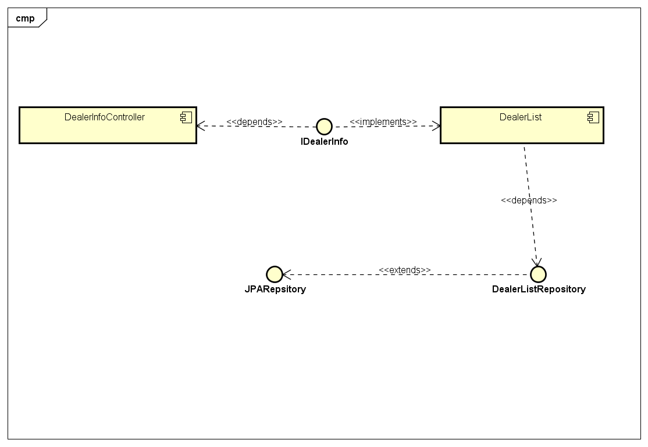

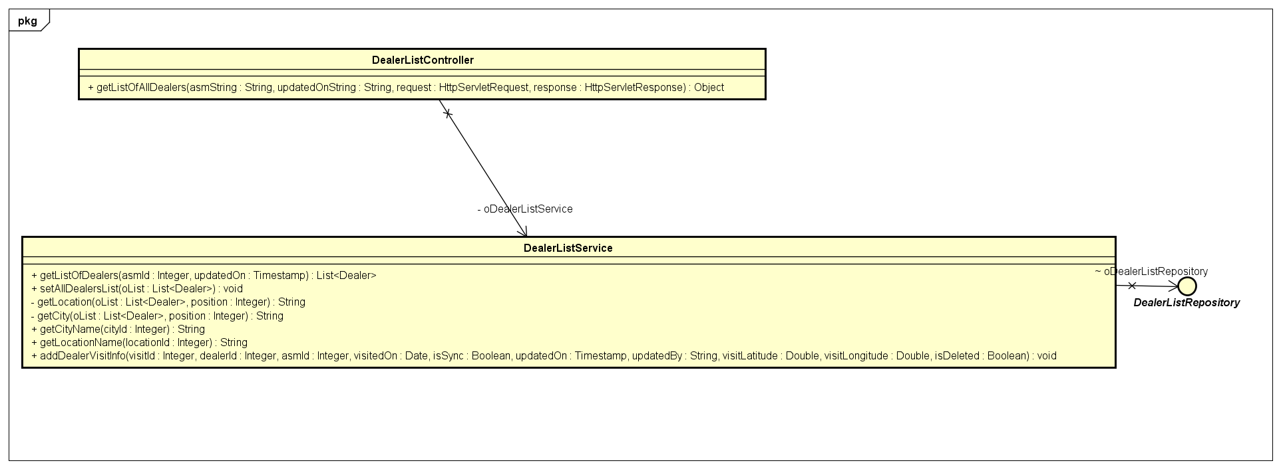

**API URL** : <http://10.167.18.182:8180/asm/dealerInfo>

**Method** : Post

**User Type** : Mobile

**Input Parameters**

|  |  |  |  |  |
| --- | --- | --- | --- | --- |
| **Parameter Name** | **Value Type** | **Mandatory** | **Description** | **Validations** |
| updated_on | timestamp | Y | Time when last time mobile update | Should be timestamp value. First time provide value as 0 for get all records |
| asmId | Integer | Y | Area sales manager Id | Asm Id cannot be null |

**Output Parameters**

|  |  |  |  |
| --- | --- | --- | --- |
| **Parameter Name** | **Value Type** | **Mandatory** | **Description** |
| responseCode | String | Y | Response code |
| responseMessage | String | Y | Response Message |
| responseType | Array | Y | Response Type |
| data | Array | N | Data will have output of API Call |

**data Array:**

|  |  |  |
| --- | --- | --- |
| **Parameter Name** | **Value Type** | **Description** |
| dealerId | Integer | Dealer Id |
| dealerName | String | Dealer Name |
| city | boolean | City Name |
| location | boolean | Location Name. |
| updatedOn | Timestamp | Last updatedOn time |
| updatedBy | String | Updated By |
| isDeleted | boolean | Flag to check model is deleted or not. |

|  |
| --- |
| **Success Response** |
| {  "responseCode": "200",  "responseMessage": "OK",  "responseType": "array",  "**data**": [  {  "dealerId": "101.07",  "dealerName": "KAITHAL YAMAHA MOTORS",  "city": "ITANAGAR",  "location": "HARYANA",  "isDeleted": false,  "updatedBy": "NKLARA",  "updatedOn": 1496207040000  }    ]  }  } |

## Dealer Visit Info

Dealer Visit info API will be used to get information of all visits related to all dealers corresponding to particular ASM.

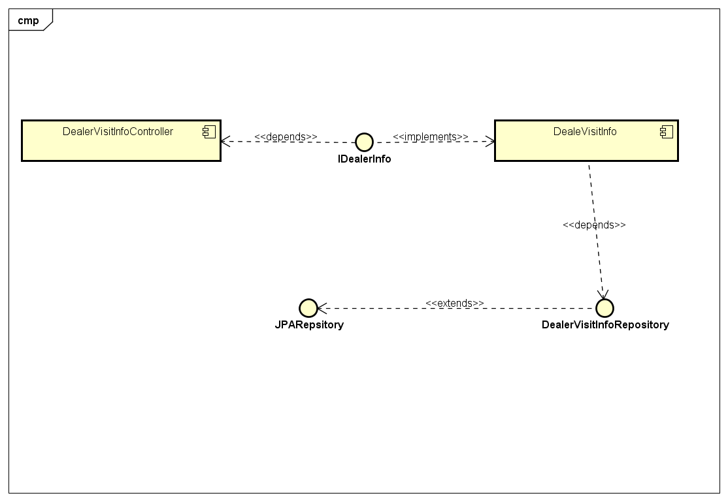

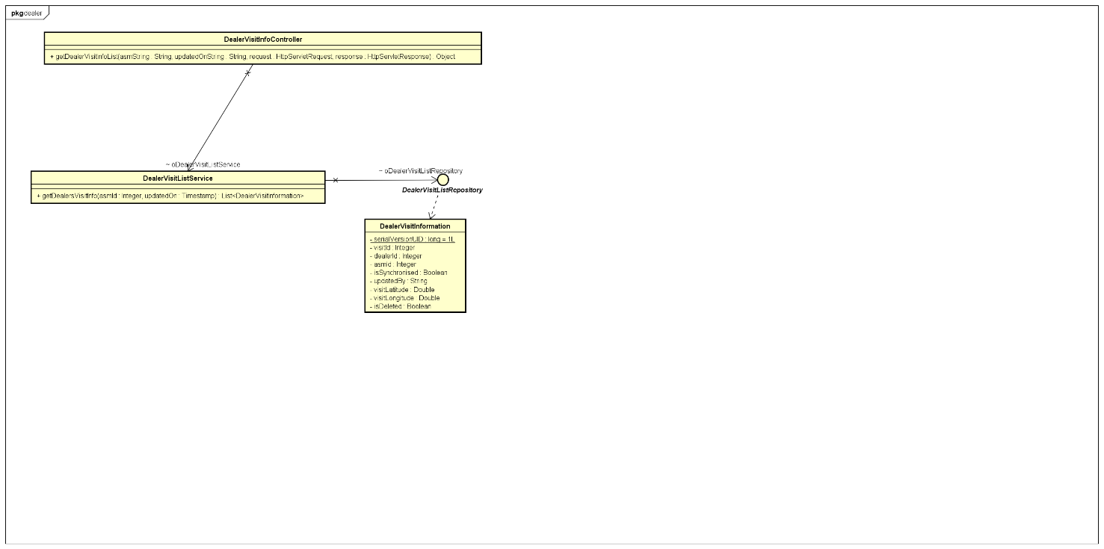

**API URL** : <http://10.167.18.182:8180/asm/dealerInfo>

**Method** : Post

**User Type** : Mobile

**Input Parameters**

|  |  |  |  |  |
| --- | --- | --- | --- | --- |
| **Parameter Name** | **Value Type** | **Mandatory** | **Description** | **Validations** |
| updated_on | timestamp | Y | Time when last time mobile update | Should be timestamp value. First time provide value as 0 for get all records |
| asmId | Integer | Y | Area sales manager Id | Asm Id cannot be null |

**Output Parameters**

|  |  |  |  |
| --- | --- | --- | --- |
| **Parameter Name** | **Value Type** | **Mandatory** | **Description** |
| responseCode | String | Y | Response code |
| responseMessage | String | Y | Response Message |
| responseType | Array | Y | Response Type |
| data | Array | N | Data will have output of API Call |

**data Array:**

|  |  |  |
| --- | --- | --- |
| **Parameter Name** | **Value Type** | **Description** |
| dealerId | Integer | Dealer Id |
| visitId | String | Dealer Name |
| asmId | boolean | City Name |
| visitedOn | boolean | Location Name. |
| updatedOn | Timestamp | Last updatedOn time |
| updatedBy | String | Updated By |
| isDeleted | boolean | Flag to check model is deleted or not. |
| visitLatitude | double | Visit Lattitude |
| visitLongitude | double | Visit Longitude |
| isDeleted | boolean | boolean |
| isSynchronised | boolean | boolean |

|  |
| --- |
| **Success Response** |
| {  "responseCode”: "200",  "responseMessage" : "OK",  "responseType" : "array",  "data" : [ {  "visitId”: 3,  "dealerId" : 2,  "asmId" : 1,  "visitedOn" : "1496207752303",  "isSynchronised" : true,  "updatedBy" : "Kirti”,  "visitLatitude”: 20.55,  "visitLongitude”: 41.89,  "updatedOn" : 1496207752303,  "isDeleted”: false  }  ]  } |

## Upload Image API:

Upload Image API will be used to upload feedback and zone info images of a particular visit.

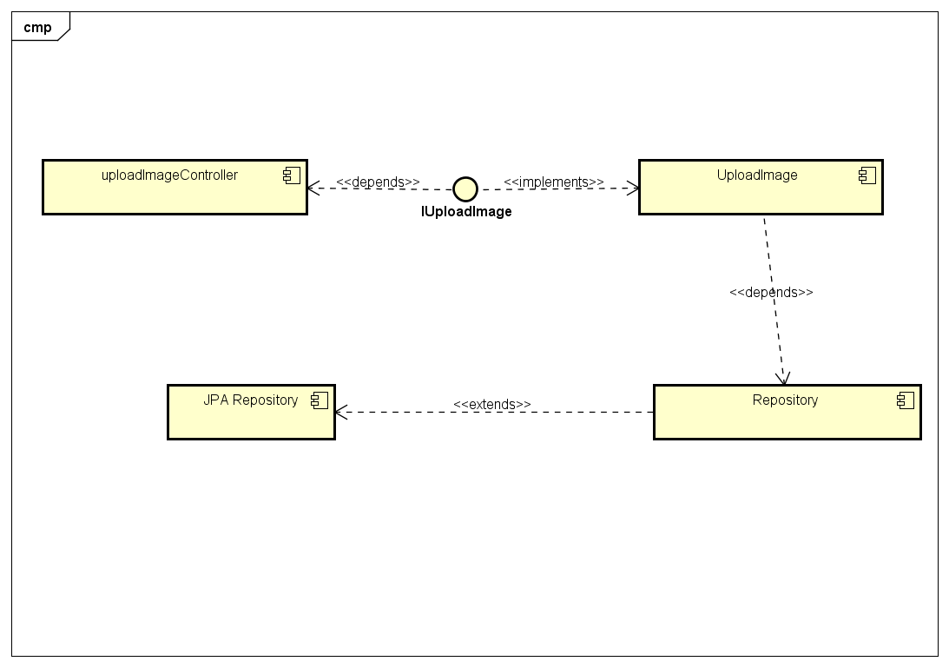

**API URL** : <http://10.167.18.182:8180/asm/uploadImage>

**Method** : Post

**User Type** : Mobile

**Input Parameters**

|  |  |  |  |  |
| --- | --- | --- | --- | --- |
| **Parameter Name** | **Value Type** | **Mandatory** | **Description** | **Validations** |
| id | Integer | Y | Image Id | Cannot be null. |
| type | String | Y | Type can be zone or feedback | Type cannot be null. |
| image | multipart | Y | Image need to be uploaded. | Image cannot be null |
| imageName | String | Y | Image name | Image name cannot be null or blank. |

**Output Parameters**

|  |  |  |  |
| --- | --- | --- | --- |
| **Parameter Name** | **Value Type** | **Mandatory** | **Description** |
| responseCode | String | Y | Response code |
| responseMessage | String | Y | Response Message |
| responseType | Array | Y | Response Type |
| data | Array | N | Data will have output of API Call |

**data Array:**

|  |  |  |
| --- | --- | --- |
| **Parameter Name** | **Value Type** | **Description** |
| visitId | Integer | Visit Id |

|  |
| --- |
| **Success Response** |
| {  "responseCode”: "200",  "responseMessage" : "OK",  "responseType" : "array",  "data" : [ {  "visitId”: 3  }  ]  } |