**ASM**

Use Case (Requirement) Document

24th July, 2017

Version: 0.1 Draft 1.0

Document Identification

| Project Code |  |
| --- | --- |
| Project Name | Internal Recruitment Management System |
| Document Id |  |
| Project Start Date | 24th July,2017 |
| Project End Date |  |
| Project Type | Java, Spring, HTML, CSS, Bootstrap |
| Project Manager | Mr. Surender Kajla |
| Project Manager Cell No | +91-9015369467 |

Client Detail

| Client Name |  |
| --- | --- |
| Contact Person |  |
| Contact Person Email Id |  |
| Contact Person Cell No |  |

Version History

| Version | Date | Author(s) | Comment | Reviewed By |
| --- | --- | --- | --- | --- |
| Draft 1.0 | 24th July,2017 | Shaivya Aggarwal | Initially Created |  |
|  |  |  |  |  |
|  |  |  |  |  |
|  |  |  |  |  |
|  |  |  |  |  |

Contents

1 Introduction 4

1.1 Purpose 4

1.2 Scope 4

1.3 Target Audience 4

1.4 Document Management 4

1.5 Reference Document 4

2 Overview 5

2.1 Assumption 5

2.2 Constraints 5

2.3 Risk 5

2.4 Technologies 5

* Application 5

2.5 Scope 5

2.6 Out of Scope 5

2.7 Exclusions 6

3 Top Level System Overview 7

Use Cases 7

3.0 High Level Use Cases Association 8

3.1 UC-001: MAIN SCREEN 9

3.2 UC-002: VIEW ALL JOBS 10

3.3 UC-003: VIEW JOB DESCRIPTION 11

3.4 UC-004: APPLY FOR A JOB 12

3.5 UC-005: POST A JOB 13

# Introduction

## Purpose

The purpose of this document is to provide a detailed overview related to the “Internal Recruitment Management System”. This document describes the project’s target audiences and its user interfaces, hardware and software requirements.

Also, it will be used as a baseline document for further design, development, testing and release of the project.

## Scope

This URS is aimed at specifying the requirements of the application to be developed including relevant benefits and applications.

## Target Audience

The target audience for this use case document includes project manager, project team members, job-seekers and job-applicants and the HR team which would post new jobs as and when applicable.

## Document Management

The requirements in this Use Case Document shall be traced to the appropriate deliverables in the development and testing phases to ensure that all requirements are properly implemented and tested

## Reference Document

# Overview

Internal Recruitment Management System (IRMS) will be used to display the jobs for which positions are available in the company, add new positions and allow the job-applicants to apply for a job.

## Assumption

* A web interface is required for the application.
* Single user application, i.e. the same user can post the jobs and view the jobs as well.

## Constraints

* Application will support Google Chrome and Mozilla Firefox browsers. Bootstrap components may not be supported in Internet Explorer.

## Risk

* In case the number of users applying for the same job is high, the website may not function properly.

## Technologies

## **Application**

**Languages & Tool**: Spring, Java, HTML, Bootstrap

**Operating Systems / Platforms:** Platform independent

**Databases:** Postgre SQL

## Scope

* Display list of jobs in which positions are available.
* Apply for a position.
* Add a new job.

## 2.6 Out of Scope

* Any failure in the server applications and server itself will be out of the scope of this application.

## Exclusions

* The execution of the project would be as stated in the above sections. Any other aspect or deviation introduced during the course of the project will be considered as Out of Scope or Change request; and would call for impact analysis in terms of added timeframe and additional charges.

# C:\Users\ve00AO358\Desktop\employee.pngaTexkaAT4.png (652×800)Top Level System Overview

**Job-applicant/**

**HR**

**Web Application - IRMS**

APPLICATION

**API**



1. **Database**

# Use Cases

## High Level Use Cases Association

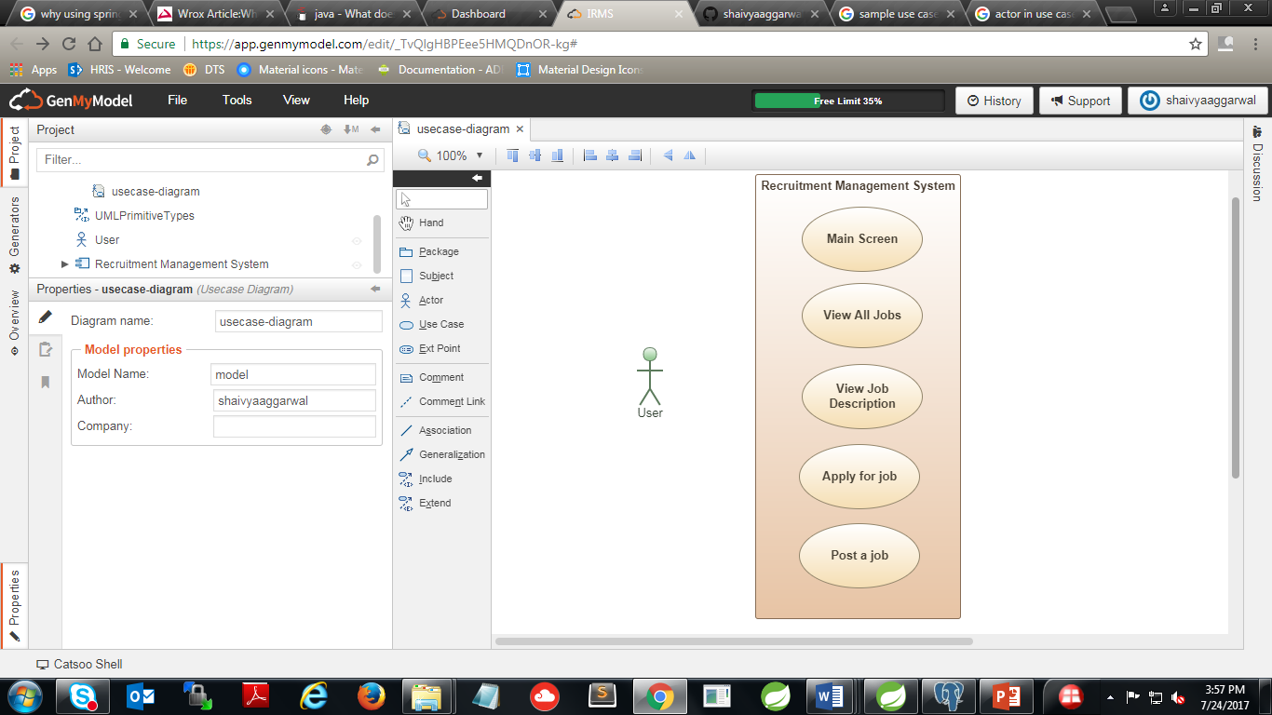

## UC-001: MAIN SCREEN

**Purpose**

* + - This use case describes how the main screen of the application will be displayed when the user hits the URL.

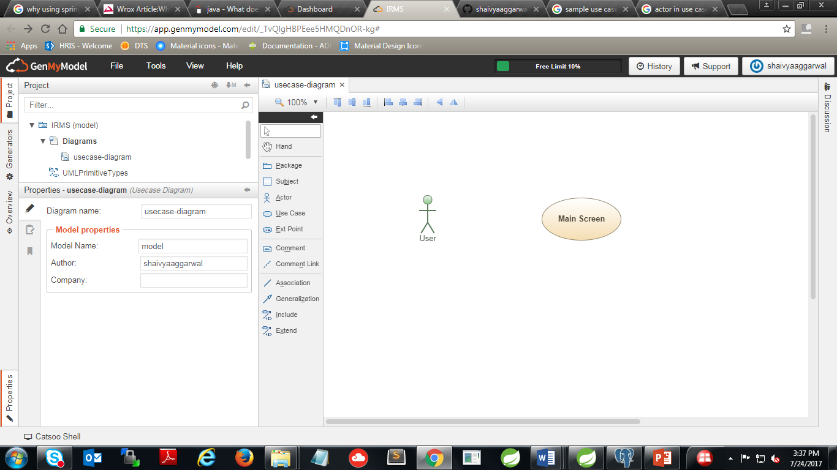

**Actors**

* + - The actor(s) that interact and participate in this use case is: **User**. Here, the job-seeker and the HR team member are considered as a single user as described in the assumption.

**Pre-Conditions**

* + - The user knows the URL of the web application.

**Post-Conditions**

* NA

**Basic Flow.**

* + - Display the description about the organization.
    - If user clicks on “View all jobs”, execute **UC: 002.**
    - If user clicks on “Add a new job”, execute **UC: 005.**

## UC-002: VIEW ALL JOBS

**Purpose**

* This use case describes how all the jobs, in which the vacancies are available, will be visible to the user.

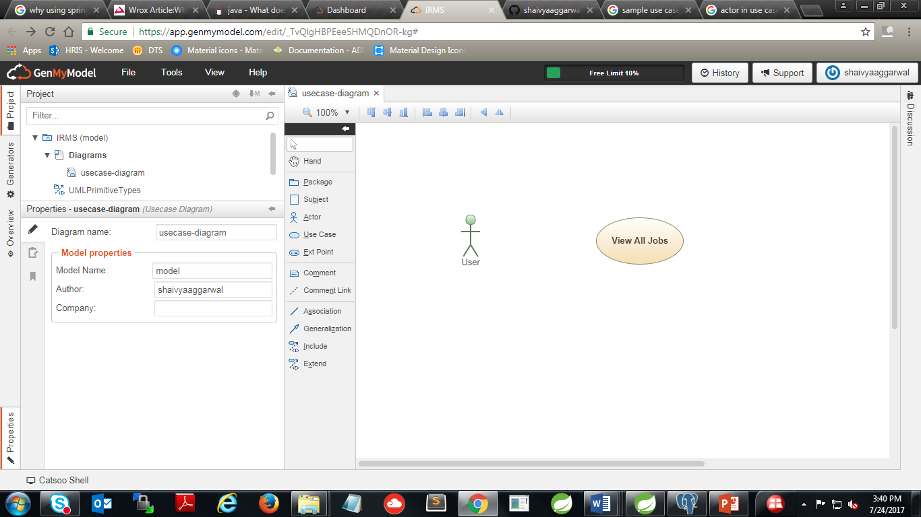

**Actors**

* + - The actor(s) that interact and participate in this use case is: **User**.

**Pre-Conditions**

* + - User clicked on the button “View all jobs”.

**Post-Conditions**

* + - NA

**Basic Flow**

* + - User can view all the jobs posted.
    - If User clicks on “View job”, execute **UC: 003.**
    - If User clicks on “Apply”, execute **UC: 004.**

## 3.3 UC-003: VIEW JOB DESCRIPTION

**Purpose**

* + - This use case describes how the job’s complete description will be visible to the user.

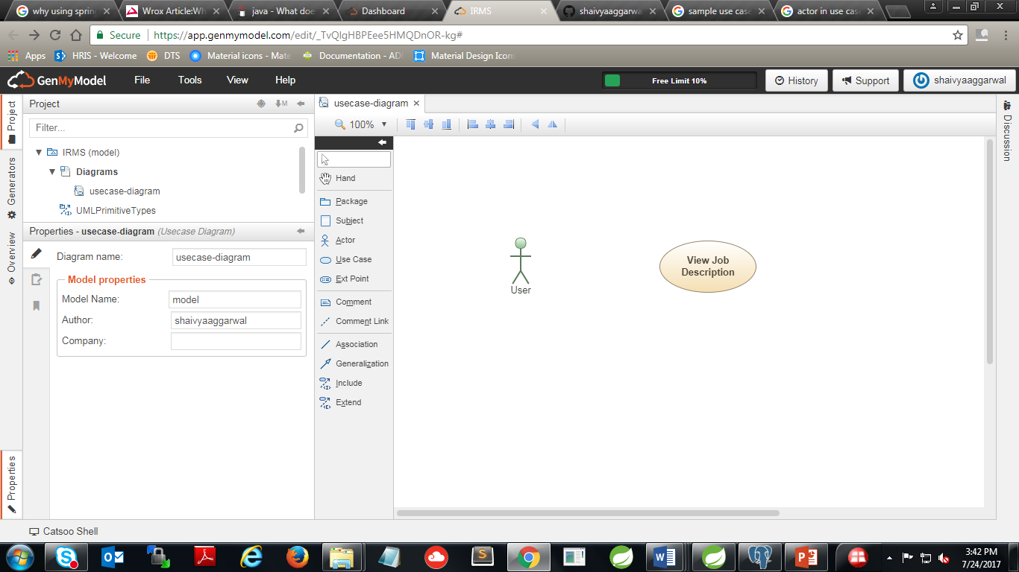

**Actors**

* + - The actor(s) that interact and participate in this use case is: User.

**Pre-Conditions**

* + - User clicked on the button “View job”.

**Post-Conditions**

* + - NA

**Basic Flow**

* + - User can view the complete description of the job.
    - If User clicks on “Apply”, execute **UC: 004.**

## 3.4 UC-004: APPLY FOR JOB

**Purpose**

* This use case describes how the user will apply for a job.

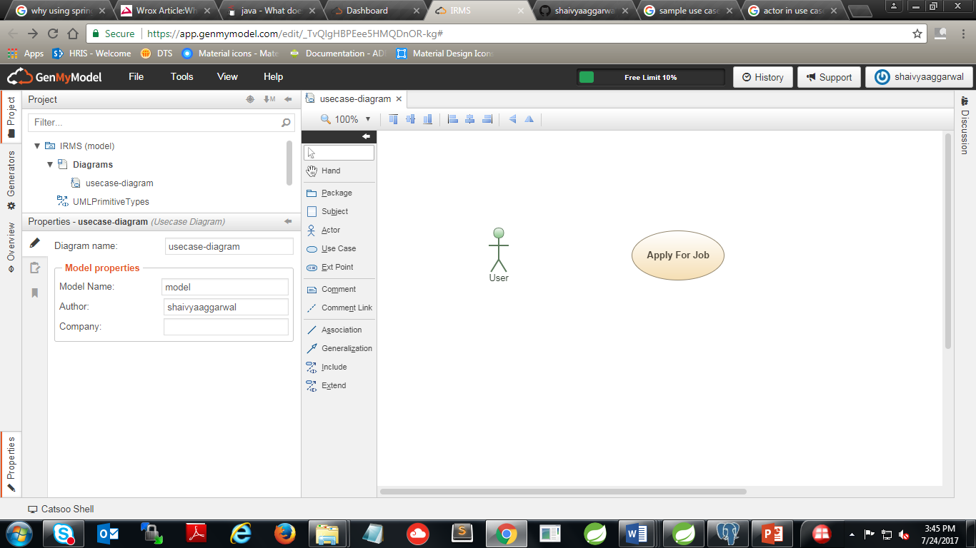

**Actors**

* + - The actor(s) that interact and participate in this use case is: User.

**Pre-Conditions**

* + - The user has filled all the credentials properly and uploaded the resume.

**Post-Conditions**

* + - Application is successfully saved in the database.

**Basic Flow**

* + - Enter all details and click on submit.
    - If user clicks on “Submit”: If all information is correct, save it in the database and execute **UC: 001.**
    - If user clicks on “Submit”: If any information is missing or incorrect, show the corresponding validation error message.
    - If user clicks on “Cancel”: execute **UC: 003.**

3.5 UC-005: POST A JOB

**Purpose**

* + - This use case describes how a new job can be posted on the website.

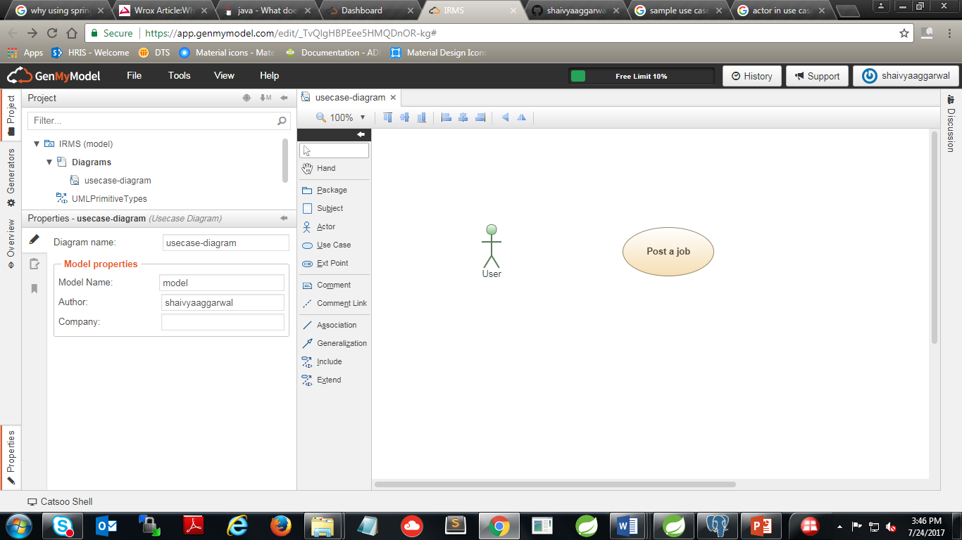

**Actors**

* + - The actor(s) that interact and participate in this use case is: User.

**Pre-Conditions**

* + - User clicked on “Add a new job”.

**Post-Conditions**

* + - New job is successfully saved in the database.

**Basic**

* Enter all the details and click on Submit.
  + - If user clicks on “Submit”: If all information is correct, save it in the database and execute **UC: 001.**
    - If user clicks on “Submit”: If any information is missing or incorrect, show the corresponding validation error message.
* If user clicks on “Cancel”: execute **UC: 005.**