





VISVESVARAYA TECHNOLOGICAL UNIVERSITY
JNANASANGAMA, BELAGAVI - 590018

DevOps Mini Project Report (23CSE1663) on
DYNAMIC RESUME ANALYZER

Submitted in partial fulfillment for the award of degree of

Bachelor of Engineering in
COMPUTER SCIENCE AND ENGINEERING

Submitted by
Sarvesh G (1BG23CS134)
Shashank Upadhya J (1BG23CS140)
Under the Guidance of
Dr. Revanasiddappa Bandi
Associate Professor, Dept. of CSE, BNMIT,
Bengaluru

An Autonomous Institution under VTU
Approved by AICTE, Accredited as grade A Institution by NAAC. All eligible branches – CSE, ECE, EEE, ISE & Mech. Engg. are Accredited by NBA for academic years 2025-26 to 2027-28 & valid upto 30.06.2028 URL: www.bnmit.org

Department of Computer Science and Engineering
2025 - 2026






An Autonomous Institution under VTU
Approved by AICTE, Accredited as grade A Institution by NAAC. All eligible branches – CSE, ECE, EEE, ISE & Mech. Engg. are Accredited by NBA for academic years 2018-19 to 2024-25 & valid upto 30.06.2025 URL: www.bnmit.org

DEPARTMENT OF COMPUTER SCIENCE AND ENGINEERING

CERTIFICATE
Certified that the Sixth Semester DevOps Mini Project entitled Dynamic Resume Analyzer carried out by Mr. Sarvesh G USN: 1BG23CS134, Mr. Shashank Upadhya J USN: 1BG23CS140. B.N.M Institute of Technology, an Autonomous Institution under Visvesvaraya Technological University, Belagavi submitted in partial fulfillment for the Bachelor of Engineering in COMPUTER SCIENCE AND ENGINEERING, during the year 2025-26. It is certified that all corrections/suggestions indicated for Internal Assessment have been incorporated in the report. The report has been approved as it satisfies the academic requirements.

Dr. Revanasiddappa Bandi Dr. Chayadevi M L Dr. S Y Kulkarni
Associate Professor, Professor and HOD, Additional Director Dept. of CSE, Dept. of CSE, and Principal, BNMIT, Bengaluru BNMIT, Bengaluru BNMIT, Bengaluru

Name Signature with Date

Examiner 1:

Examiner 2:

ACKNOWLEDGEMENT

We consider it a privilege to express through the pages of this report, a few words of gratitude to all those distinguished personalities who guided and inspired me in the completion of this DevOps Mini Project.

We would like to thank Shri. Narayan Rao R Maanay, Secretary, BNMEI, Bengaluru for providing an excellent academic environment in college.

We would like to thank Prof. T.J. Rama Murthy, Director, BNMIT, Bengaluru for having extended his support and encouragement during the course of work.

We would like to thank Dr. S.Y. Kulkarni, Principal and Additional Director, BNMIT, Bengaluru for his extended support and encouragement during the course of work.

We would like to express my gratitude to Prof. Eishwar N Maanay, Dean, BNMIT, Bengaluru for his relentless support, guidance, and encouragement.

We would like to thank Dr. Krishnamurthy G.N., Deputy Director, BNMIT, Bengaluru for his constant encouragement.

We would like to thank Dr. Chayadevi M L, Professor and Head of the Department of Computer Science and Engineering, BNMIT, Bengaluru, for her support and encouragement towards the completion of the DevOps Mini Project.

We would like to express our gratitude to our guide Dr. Revanasiddappa Bandi, Associate Professor, Department of Computer Science and Engineering, BNMIT, Bengaluru, who has given us all the support and guidance in completing the DevOps Mini Project successfully.

Sarvesh G 1BG23CS134
Shashank Upadhya J 1BG23CS140
TABLE OF CONTENTS

Chapter 1-Introduction 01
Chapter 2-Requirements Specification 03
Chapter 3-System Design and Architecture 04
Chapter 4-Implementation Details 08
Chapter 5-5-Results and Analysis 10
Chapter 6-6-Conclusion and Future Enhancements 12

CHAPTER-I
INTRODUCTION & PROJECT OVERVIEW

1.1 Problem Definition
In a competitive job market, candidates often struggle to understand why their resumes do not clear automated screening systems or recruiter evaluations. Traditional resume review processes are time-consuming, inconsistent, and offer little actionable guidance to applicants. Recruiters and hiring managers lack tools that can rapidly benchmark a candidate's skill set against the specific requirements of a target role and communicate the gaps in a structured, learner-friendly manner.
Furthermore, the rise of DevOps, cloud computing, and AI-augmented workflows has created rapidly evolving skill requirements that candidates find difficult to track. There is a clear need for an intelligent, automated system that can assess resume content against role-specific benchmarks, identify missing competencies, and guide candidates toward targeted skill acquisition.

1.2 Scope of the Project
The Dynamic Resume Analyzer addresses the above problem by providing the following capabilities:
• Automated keyword-based match scoring for seven career roles: DevOps Engineer, Cloud Engineer, Cybersecurity Analyst, Java Developer, Data Scientist, Frontend Developer, and RPA Developer.
• AI-powered skill-gap analysis using the Google Gemini API (gemini-2.0-flash-lite) with a comprehensive static built-in fallback engine.
• A RESTful API built with Spring Boot 3 that allows programmatic integration with external systems.
• A browser-based UI for direct candidate interaction, served at /api/resumes/ui.
• Persistent storage of all evaluations in MongoDB for historical analysis and reporting.
• Fully containerized deployment using Docker and Docker Compose for single-command startup.
The system accepts plain-text (.txt) resumes in the current version. PDF and DOCX ingestion are identified as future enhancements.

1.3 Objectives
• Design and develop a full-stack application to automatically evaluate resumes against predefined role skill matrices.
• Integrate the Google Gemini AI model for context-aware, nuanced skill-gap recommendations.
• Implement a robust static fallback engine to ensure offline and API-key-free operation.
• Containerize the complete application stack using Docker Compose for portability and repeatability.
• Provide structured, actionable feedback identifying missing skills, their importance, and concrete learning pathways.
• Expose a clean REST API enabling future integration with HR platforms, CI/CD pipelines, or ATS systems.

CHAPTER-II
REQUIREMENTS SPECIFICATION

2.1 Functional Requirements
• The system shall accept a candidate name, target job role, and a plain-text resume file as input.
• The system shall compute a match score (0–100%) by comparing resume content against role-specific keyword sets.
• The system shall perform skill-gap analysis for all evaluations where the match score is below 70%.
• The system shall attempt to use the Google Gemini AI API for skill-gap analysis when an API key is configured.
• The system shall fall back to the static skill engine if the Gemini API is unavailable or returns an error.
• The system shall retry Gemini API calls up to two times with a 3-second delay on HTTP 429 (rate-limit) responses.
• The system shall store every evaluation result in a MongoDB database.
• The system shall serve an interactive browser UI at /api/resumes/ui.
• The system shall expose a POST /api/resumes/evaluate endpoint returning a JSON response.
• The system shall return a structured skill-gap table with skill name, category, importance level, reason, and learning pathway for each missing skill.

2.2 Non-Functional Requirements

Attribute | Requirement
Performance | API response within 5 seconds for static engine; within 15 seconds for Gemini path
Availability | System must remain functional without internet connectivity (static fallback)
Scalability | Containerized deployment allows horizontal scaling of the application service
Security | API keys stored in .env / environment variables; never hardcoded in source code
Reliability | Automatic retry on transient API failures; graceful degradation on permanent failures
Maintainability | Layered architecture (Controller / Service / Repository) with SLF4J logging
Portability | Docker Compose ensures identical behavior across Linux, macOS, and Windows hosts

2.3 Hardware and Software Requirements
Hardware Requirements:

Component | Minimum Specification
Processor | Dual-core 64-bit CPU (Intel/AMD)
RAM | 4 GB (8 GB recommended for Docker)
Storage | 5 GB free disk space
Network | Optional – required only for Gemini AI path

Software Requirements:

Software | Version / Detail
Operating System | Windows 10/11, Ubuntu 22.04+, or macOS 12+
Java JDK | Java 17 (Eclipse Temurin recommended)
Apache Maven | 3.8+
Docker Desktop | 4.x (includes Docker Engine & Compose v2)
MongoDB | 7.0 (runs inside Docker container)
Browser | Chrome, Firefox, or Edge (latest)

CHAPTER-III
SYSTEM DESIGN AND ARCHITECTURE

3.1 Proposed System Methodology
The Dynamic Resume Analyzer follows a layered, microservice-ready architecture that separates concerns across four distinct layers: Controller, Service, Model, and Repository. The system is deployed as a Docker Compose application comprising two containers – the Spring Boot application container and the MongoDB container.
The proposed methodology proceeds as follows. A candidate accesses the browser UI hosted at /api/resumes/ui. The candidate submits their name, target role, and resume text. JavaScript sends an HTTP POST to /api/resumes/evaluate?role=<roleName>.
ResumeService performs keyword-based scoring against the predefined role skill matrix, calculates the match score, and persists the Resume document to MongoDB. If the score is below 70%, SkillGapService is invoked. It first attempts to call the Google Gemini API with a structured prompt. On success, the JSON response is parsed into a SkillGapAnalysis object. On failure or if no key is configured, the static skill database is used instead.
The complete result – including score, feedback, and skill-gap data – is returned as a JSON response and rendered by the front-end into a colour-coded results card and a detailed skill-gap table.

3.2 Architecture Diagram
The following diagram illustrates the end-to-end flow of the Dynamic Resume Analyzer:
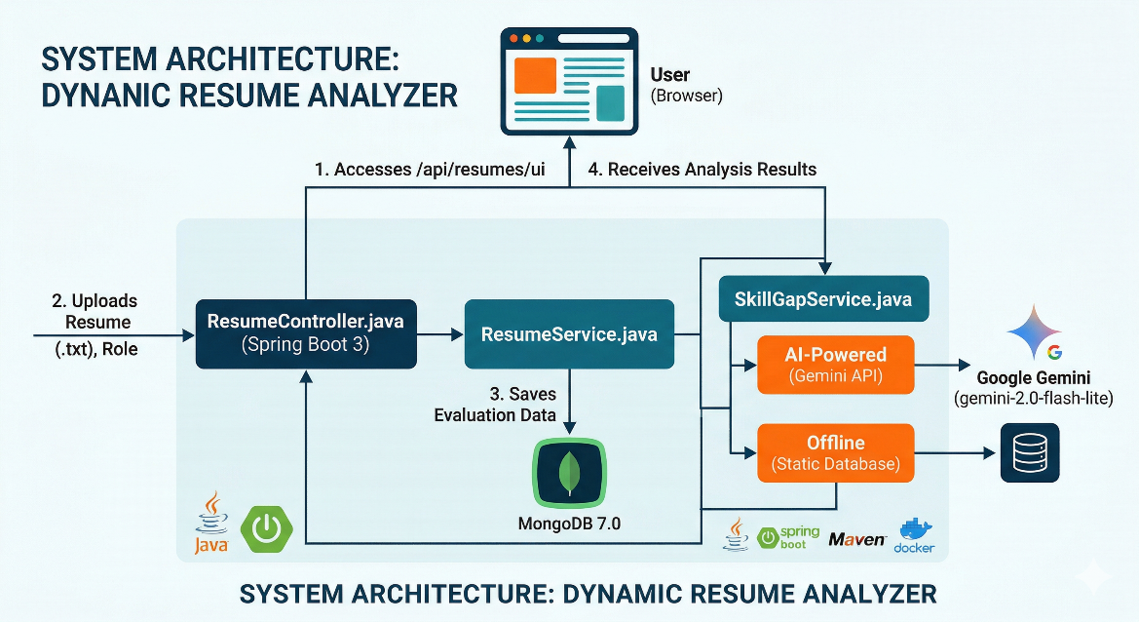
Fig 3.1 System Architecture Diagram

3.3 Project Layer Structure

Layer / Component | Class / File | Responsibility
Controller | ResumeController.java | Serves HTML UI; handles POST /evaluate
Service | ResumeService.java | Keyword scoring; MongoDB persistence
Service | SkillGapService.java | Orchestrates Gemini AI and static fallback
Model | Resume.java | MongoDB document entity
Model | SkillGapAnalysis | Holds missing skills + category summary
Repository | ResumeRepository | Spring Data MongoRepository interface
Infrastructure | Dockerfile | Multi-stage Maven build → slim JRE image
Infrastructure | docker-compose.yml | Orchestrates app + MongoDB containers
Config | .env + application.properties | API key injection and Spring settings

CHAPTER-IV
IMPLEMENTATION DETAILS

4.1 Technology Stack

Layer | Technology | Purpose
Language | Java 17 | Core application logic
Framework | Spring Boot 3 | REST API and embedded web server
Database | MongoDB 7.0 | Stores all resume evaluation documents
ORM/ODM | Spring Data MongoDB | Maps Java objects to MongoDB documents
AI/ML | Google Gemini (gemini-2.0-flash-lite) | AI-powered skill-gap analysis
HTTP Client | Spring RestTemplate | Calls the Gemini REST API
JSON | Jackson ObjectMapper | Parses Gemini JSON responses
Build Tool | Apache Maven | Dependency management and packaging
Containerization | Docker + Docker Compose | Isolated, portable deployment
Frontend | Vanilla HTML + JavaScript | In-browser resume upload and display
CSS Framework | Bootstrap 5 (CDN) | Responsive, polished UI components
Logging | SLF4J / Logback | Runtime log messages for debugging

4.2 End-to-End Application Flow
The request lifecycle proceeds through the following steps:
Step 1 – UI Access: The candidate opens http://localhost:8081/api/resumes/ui in a browser. ResumeController serves the embedded HTML/JS front-end.
Step 2 – Input Submission: The candidate enters their name, selects a target role from a dropdown, and pastes resume content. JavaScript sends a POST /api/resumes/evaluate?role=<role> request with a JSON body.
Step 3 – Scoring: ResumeService tokenizes the resume and counts keyword matches against the predefined role skill matrix. The match score is calculated as matchScore = (matchedKeywords / totalRoleKeywords) × 100. The result is saved to MongoDB.
Step 4 – Skill-Gap Analysis: If matchScore < 70, SkillGapService is called. It constructs a structured prompt, calls the Gemini API, and on HTTP 429 waits 3 seconds and retries (up to 2 attempts). On any failure, or if no API key is configured, it falls back to the static engine.
Step 5 – Static Engine: The built-in ROLE_SKILLS map is searched. Each skill definition contains keywords, category, importance level, rationale, and learning pathway. Any skill whose keywords are absent from the resume text is flagged as missing.
Step 6 – Response: ResumeController assembles the final JSON response and returns it to the browser. The UI renders the score with colour coding, the feedback message, and the full skill-gap table.

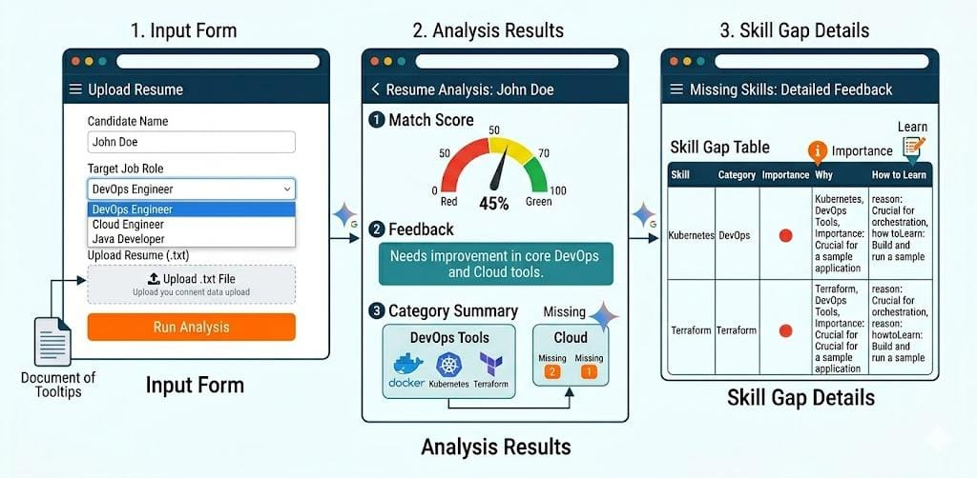
Fig 4.1 Workflow

4.3 Skill-Gap Engine – Static Skill Database
The static engine covers the following seven roles, each with 7–10 skill definitions:
Role | Sample Skills Covered
DevOps Engineer | Docker, Kubernetes, Jenkins, AWS, Terraform, Ansible, Linux, Git
Cloud Engineer | AWS, Azure, GCP, Terraform, IAM, VPC, CloudFormation, S3
Cybersecurity Analyst | SIEM, Penetration Testing, Firewalls, IDS/IPS, OWASP, Encryption
Java Developer | Spring Boot, JPA/Hibernate, REST APIs, JUnit, Maven, SQL
Data Scientist | Python, Pandas, NumPy, Scikit-learn, TensorFlow, SQL, Data Visualization
Frontend Developer | React, HTML5, CSS3, JavaScript ES6+, REST APIs, Webpack
RPA Developer | UiPath, Blue Prism, Automation Anywhere, VBA, Process Mining

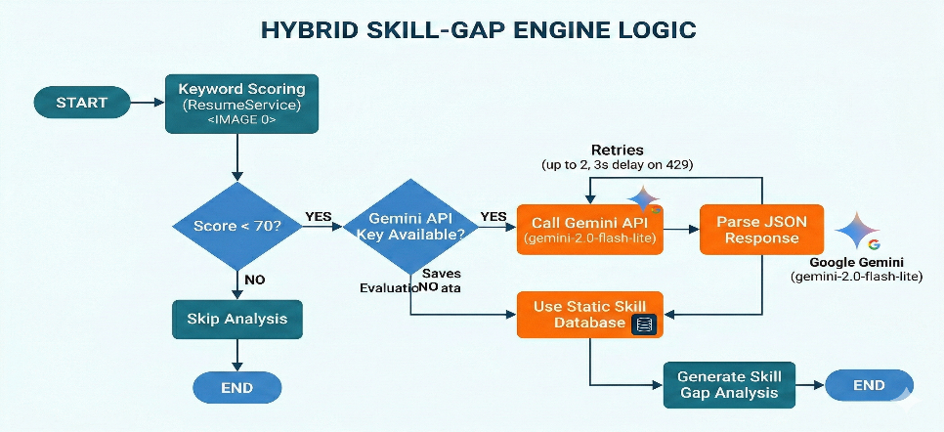
Fig 4.2 Skill Gap Engine Logic

4.4 Containerization
The project uses a multi-stage Dockerfile. The build stage uses a Maven image to compile the project and produce the JAR. The runtime stage copies only the JAR into a slim eclipse-temurin:17-jre-alpine image, minimizing the final image size.
The docker-compose.yml defines two services: mongodb (using mongo:7.0 image with a named volume for data persistence) and app (the Spring Boot service, linked to MongoDB, with environment variables injected from the .env file). A single command – docker compose up -d --build – builds and launches the complete stack.

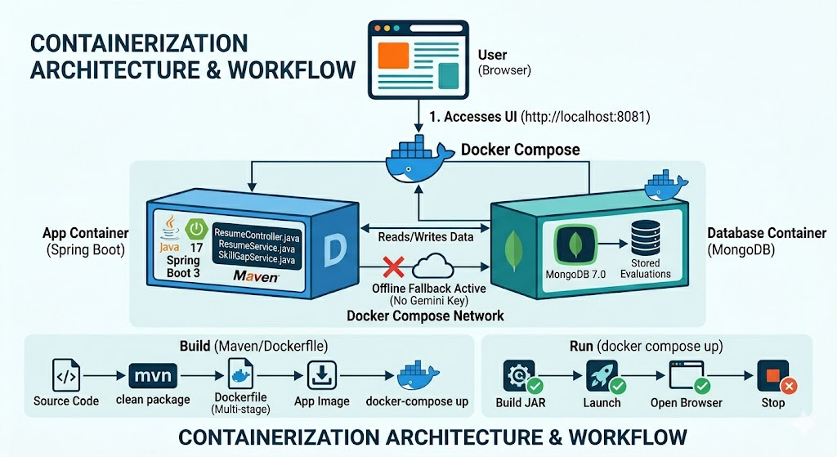
Fig 4.3 Containerization

4.5 Configuration and Security
The Gemini API key is loaded from an .env file at the project root. Spring Boot reads it via application.properties using ${GEMINI_API_KEY:} syntax, defaulting to an empty string if not set. This ensures the key is never committed to source control. The system remains fully functional without the key through the static fallback engine.

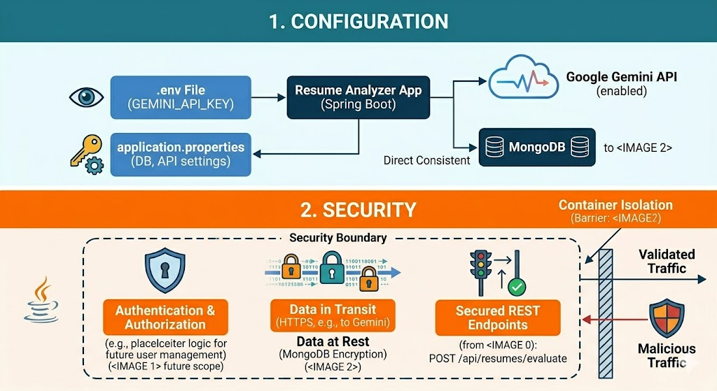
Fig 4.4 Configuration and Security

CHAPTER-V
RESULTS AND ANALYSIS

5.1 Sample Evaluation Scenario
The following scenario was used to validate the system's core functionality:

Parameter | Value
Candidate Name | Sarvesh
Target Role | DevOps Engineer
Resume Content | Java developer with Spring Boot and SQL experience
Match Score | 33%
Threshold | 70%
Engine Used | Static Skill Engine (Gemini fallback)

5.2 Skill-Gap Output
The system identified the following missing skills for the above scenario:

Skill | Category | Importance | Why Required | How to Learn
Docker | DevOps Tools | High | Containerisation is core to modern DevOps | Build and run apps with Docker Desktop
Kubernetes | DevOps Tools | High | Orchestrates containers at scale | Deploy a sample app on Minikube locally
Jenkins | CI/CD | High | Most widely used CI/CD automation server | Build a Jenkins pipeline for a GitHub repo
AWS | Cloud | High | Leading cloud platform required by most employers | Complete AWS Cloud Practitioner free course
Terraform | DevOps Tools | High | Infrastructure-as-Code is a key DevOps practice | Provision AWS resources with Terraform free tier
Ansible | Config Mgmt | Medium | Automates server configuration at scale | Write Ansible playbooks for LAMP stack setup
Linux | OS | High | All cloud and DevOps tooling runs on Linux | Complete Linux Essentials on Linux Foundation

5.3 Score Colour Coding

Score Range | Colour | Interpretation
70% – 100% | Green | Strong match – resume aligns well with the role
50% – 69% | Amber | Partial match – some gaps; skill-gap analysis provided
0% – 49% | Red | Weak match – significant skill gaps; detailed guidance provided

5.4 System Performance Observations

Obtained Output :
Test Case | Engine | Response Time
Score >= 70% (no skill-gap) | N/A | < 1 second
Score < 70%, static engine | Static Skill DB | 1 – 2 seconds
Score < 70%, Gemini available | Gemini AI | 5 – 12 seconds
Gemini API rate-limited (429) | Retry → Gemini / Static | 8 – 20 seconds
No API key configured | Static Skill DB | 1 – 2 seconds

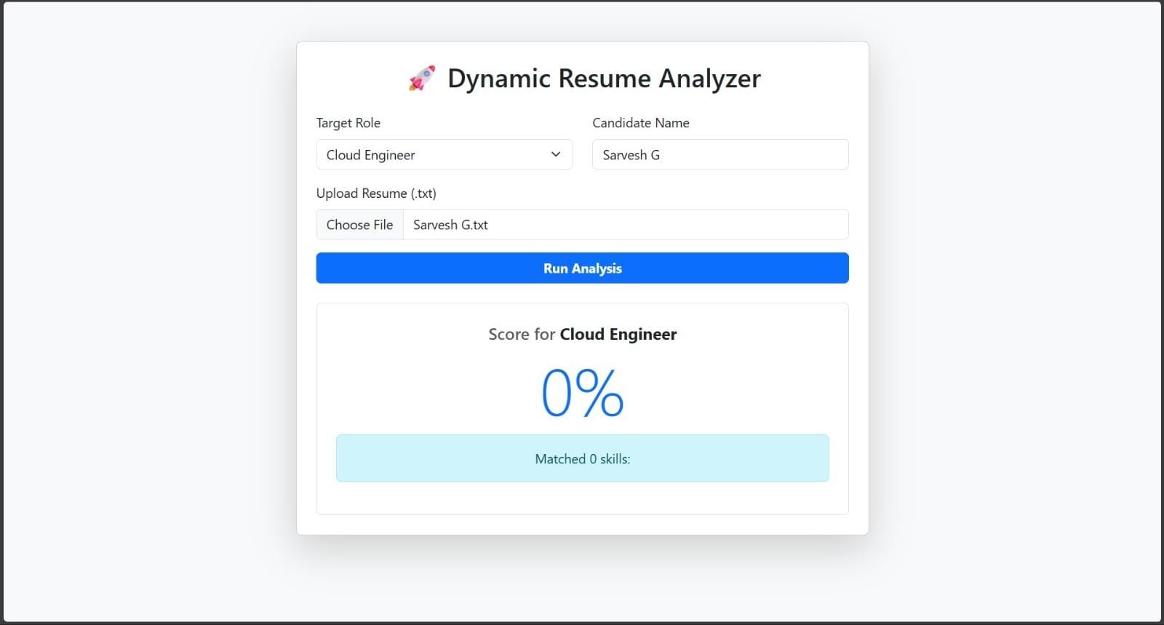

Fig 5.1 Resume Analyser analyzing the resume

CHAPTER-VI
CONCLUSION AND FUTURE ENHANCEMENTS

6.1 Conclusion
The Dynamic Resume Analyzer successfully demonstrates the practical integration of Spring Boot microservice architecture, MongoDB-based persistence, AI-augmented analysis via the Google Gemini API, and Docker-based containerization within a cohesive, production-ready application.
The system achieves its primary objectives: it accurately scores resumes against role-specific skill matrices, identifies actionable skill gaps, and presents candidates with a clear and structured learning roadmap. The dual-engine approach – AI-powered analysis with a robust static fallback – ensures the system is always available and functional, regardless of network or API key availability.
From a DevOps perspective, the project exemplifies key practices including containerization, environment-based configuration management, layered software architecture, and graceful error handling. The single-command Docker Compose deployment validates the portability and repeatability goals of modern DevOps workflows.

6.2 Future Enhancements

# | Enhancement | Description
1 | PDF / DOCX Resume Upload | Extend the intake layer to accept PDF and Word documents using Apache Tika or PDFBox, removing the limitation to plain-text files.
2 | Job Description Input | Allow users to paste a full job description instead of selecting a preset role, enabling more precise and dynamic skill-matching.
3 | Dashboard & History Page | Build a MongoDB-backed history page showing all past evaluations with filters by score, role, and date.
4 | User Authentication | Add Spring Security with JWT to support multi-user access, enabling each candidate to manage their own evaluation history.
5 | Email Report | Generate a PDF skill-gap report and send it to the candidate's email using JavaMailSender.
6 | Skill Trend Analytics | Aggregate missing-skill data across all evaluations to identify the most commonly absent competencies by role.

REFERENCES

[1] Spring Boot Documentation – https://docs.spring.io/spring-boot/docs/current/reference/html/
[2] MongoDB Documentation – https://www.mongodb.com/docs/manual/
[3] Google Gemini API Documentation – https://ai.google.dev/docs
[4] Docker Documentation – https://docs.docker.com/
[5] Docker Compose Reference – https://docs.docker.com/compose/
[6] Apache Maven Documentation – https://maven.apache.org/guides/
[7] Jackson ObjectMapper – https://fasterxml.github.io/jackson-databind/
[8] Spring Data MongoDB – https://docs.spring.io/spring-data/mongodb/docs/current/reference/html/
[9] Bootstrap 5 Documentation – https://getbootstrap.com/docs/5.0/
[10] Java 17 LTS Release Notes – https://openjdk.org/projects/jdk/17/
[11] SLF4J / Logback Documentation – https://logback.qos.ch/documentation.html
[12] Visvesvaraya Technological University – https://vtu.ac.in/

