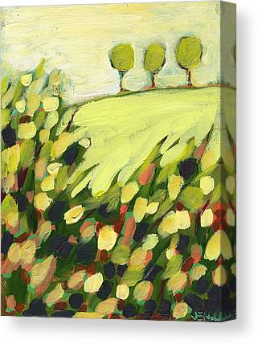

SAMSON HAJALIE  
079623869   
 shajalie@hotmail.com

# About Me

I am a very curious individual that likes learning everything

# Work Experince

**MoriningtonCars** 2008-2017  
 Working at the form end of the Business

# Skills

* practicing programmer