

Bahria University, Islamabad

Department of Software Engineering

Computer Communication & Networking Lab (Fall-2025)
Instructor: Engr. Muhammad Faisal Zia

Student:
Enrollment:

Lab Journal: 11
Date:

Task No: | Task Wise Marks |  | Documentation Marks |  |  | Total Marks  (20)
 | Assigned | Obtained | Assigned | Obtained
1
2
3
4
5
Comments:

Signature

LAB # 11

Configuring RIP (Routing Information Protocol) routing protocol between two routers
Objective
To enable communication between two hosts that are connected not to a single router but with the different routers
Introduction
The Routing Information Protocol (RIP) is a relatively old, but still commonly used, interior gateway protocol (IGP) created for use in small, homogeneous networks. It is a classical distance-vector routing protocol. RIP is documented in RFC 1058.
RIP uses broadcast User Datagram Protocol (UDP) data packets to exchange routing information.

The Cisco IOS software sends routing information updates every 30 seconds; this process is termed advertising. If a router does not receive an update from another router for 180 seconds or more, it marks the routes served by the non-updating router as being unusable. If there is still no update after 240 seconds, the router removes all routing table entries for the no updating router.

The metric that RIP uses to rate the value of different routes is hop count. The hop count is the number of routers that can be traversed in a route. A directly connected network has a metric of zero; an unreachable network has a metric of 16. This small range of metrics makes RIP an unsuitable routing protocol for large networks.
If the router has a default network path, RIP advertises a route that links the router to the pseudo network 0.0.0.0. The network 0.0.0.0 does not exist; RIP treats 0.0.0.0 as a network to implement the default routing feature. The Cisco IOS software will advertise the default network if a default was learned by RIP, or if the router has a gateway of last resort and RIP is configured with a default metric.
RIP sends updates to the interfaces in the specified networks. If an interface's network is not specified, it will not be advertised in any RIP update.

Equipment:
- Four routers
- Four switches
- Four PCs
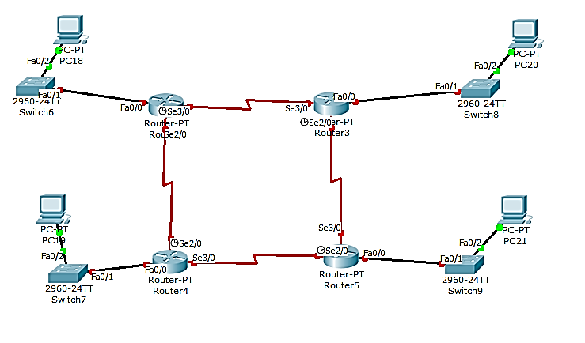

Procedure:
Step1: Assign IP address on all ports of R1, R2, R3 and R4
Assign IP addresses to all ports of Router shown in figure above.

Step2: Configure RIP protocol on all routers
ExampleName#config
ExampleName(config)#router rip
ExampleMame(config-router)#network aa.bb.cc.dd
ExampleName(config-router)# network ee.ff.gg.hh
ExampleName(config-router)#

Step3: Assign IP address to all computer
Assign IP address to computer with same network that assign to their respective port

Step4: confirm connection
Use ping command to confirm connection of each PC.

Step5: check routing protocol
ExampleName(config)# show ip router

Task:
- Implement the above-mentioned network using Packet Tracer
- Implement above network using 2 routers and four PCs, two on each side on Packet Tracer.

