Inter-Office Connectivity and VLAN-based Enterprise Network Implementation
M. Omer Jawaid 01-131232-063 Ahmad Iftikhar 01-131232-009 Shajar Hussain 01-131232-043

Abstract—This project presents the design, configuration, and testing of an enterprise-class network supporting communication between a Head Office (HO) and Branch Office (BO). The network is implemented using Cisco Packet Tracer and demonstrates practical application of VLAN segmentation, inter-VLAN routing, static routing, DHCP services, and shared resource accessibility. The proposed topology includes routers, switches, PCs, and printers interconnected using appropriate cabling standards. Verification through ping tests, routing tables, VLAN configurations, and DHCP allocations confirms successful end-to-end communication and network stability.

Exceutive Summary
This project focuses on the design and deployment of a complete enterprise network connecting a Head Office (HO) and a Branch Office (BO) using Cisco Packet Tracer. The network incorporates departmental VLAN segmentation, inter-VLAN routing via router-on-a-stick, static routing between offices, DHCP services for automated IP allocation, and shared resource accessibility such as network printers. The implementation demonstrates practical concepts taught in CCN, including structured cabling, hierarchical addressing, trunking, encapsulation, and WAN connectivity using serial links. The completed network fulfills all functional requirements, supports full end-to-end communication, and reflects an industry-standard approach to enterprise network architecture.
Use the enter key to start a new paragraph. The appropriate spacing and indent are automatically applied.

Introduction

Modern enterprises require robust, scalable, and secure networks that ensure seamless connectivity between geographically separated locations. This project focuses on developing a two-office enterprise network using Cisco Packet Tracer. The design incorporates industry-standard networking practices such as VLAN segmentation for departmental isolation, router-on-a-stick configurations for inter-VLAN routing, and static routing for inter-office connectivity. A DHCP server is deployed at the Head Office to automate IP address allocation for one department, reducing administrative overhead.
This report documents the complete implementation process, covering network design, device configuration, testing, and validation.
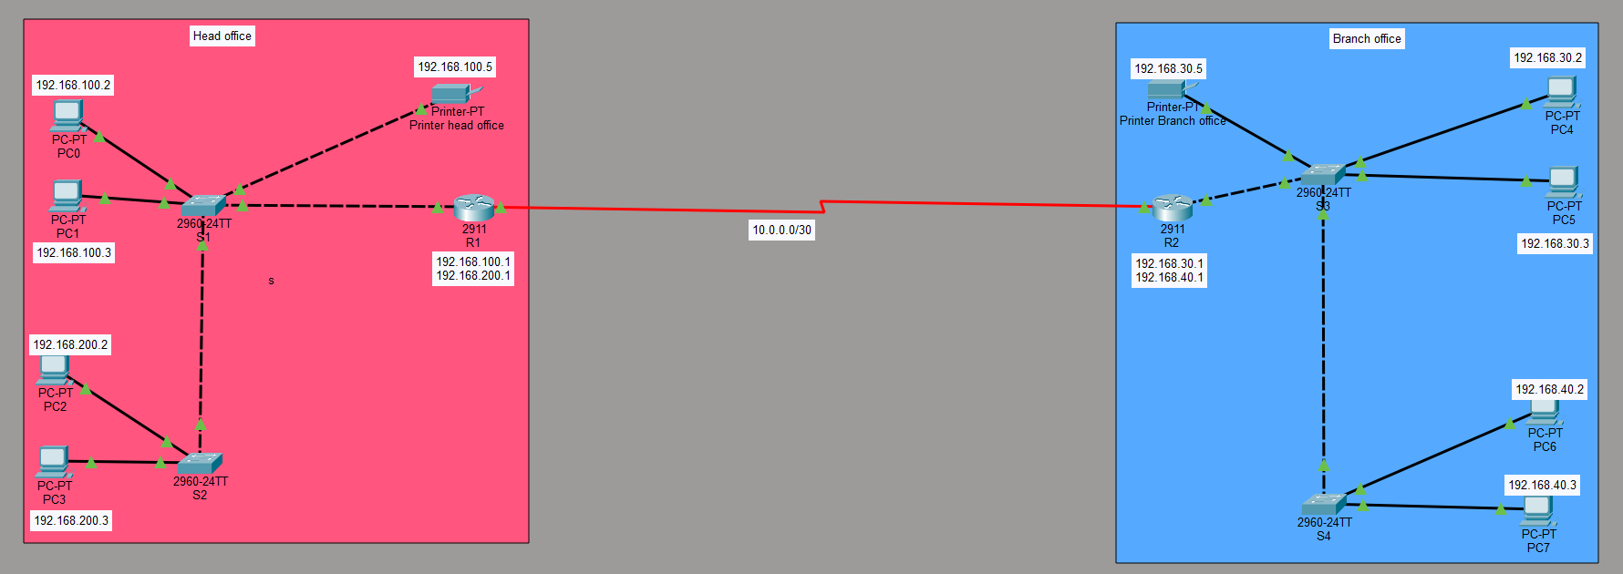
- Network

Project Orbjectives
The primary objectives of this project include
- Designing a functional network topology for HO and BO using routers, switches, PCs, and printers.
- Implementing VLANs for departmental segmentation in both offices.
- Enabling inter-VLAN communication through router-on-a-stick configuration.
- Establishing a WAN link between HO and BO using a serial connection.
- Configuring static routing for full-duplex inter-office connectivity.
- Deploying DHCP services at the HO to dynamically assign IP addresses to selected VLANs.
- Ensuring accessibility to printers located in both offices from any device.
- Verifying connectivity through simulation, ping results, and show commands.

Network Topology
The network consists of two physical locations: the Head Office (HO) and the Branch Office (BO). Each office contains:
- One 2911 Router
- Two 2960-24TT Switches
- Four PCs
- One Printer

Head Office Topology Description
R1 connects to S1 and S2 using FastEthernet trunk links.
VLAN 100 (Admin) is assigned to two PCs and one printer.
VLAN 200 (IT) is assigned to two PCs.
S1 and S2 are interconnected using trunk links to support VLAN propagation.
R1 connects to R2 via a Serial DCE/DTE WAN link.

Branch Office Topology Description
R2 connects to S3 and S4 using Fast Ethernet trunk links.
VLAN 30 (Admin) contains two PCs and one printer.
VLAN 40 (IT) contains two PCs.
S3 and S4 share a trunk link to maintain VLAN consistency.
R2 completes the WAN connection back to R1.

IP Addressing Scheme
SR. | Head Office Subnets
 | VLAN | Department | Network | Gateways
1 | 100 | Admin | 192.168.100.0/24 | 192.168.100.1
2 | 200 | IT | 192.168.200.0/24 | 192.168.200.1

SR. | Branch Office Subnets
 | VLAN | Department | Network | Gateways
1 | 30 | Admin | 192.168.30.0/24 | 192.168.30.1
2 | 40 | IT | 192.168.40.0/24 | 192.168.40.1
SR. | WAN Network
 | Link | Network | R1 Serial | Gateways
1 | HO- BO | 10.0.0.0/30 | 10.0.0.1 | 10.0.0.2

VLAN Configuration
VLANs were created on all switches to segment departmental traffic.

Switch1 (Head Office S1):
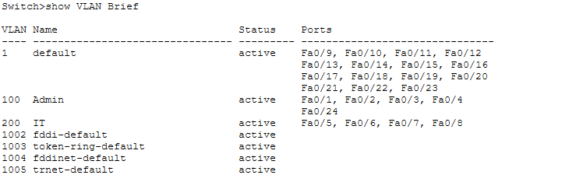
- Switch1 (Head Office S1)

Switch 2 (Head Office S2):
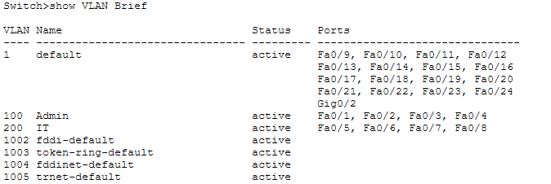
- Switch2 (Head Office S2)
Switch 3 (Branch Office S3):
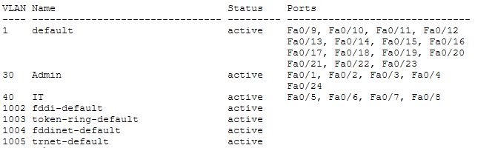

Switch 4 (Branch Office S4):
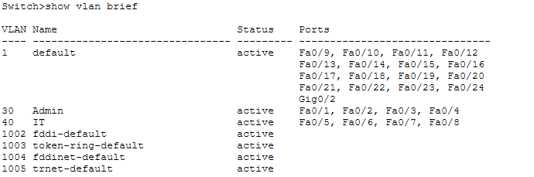
- Switch4 (Branch Office S4)

DHCP Server Configuration (Head Office)
A DHCP server was added to automate IP allocation whole network
PC 0 (VLAN Admin):
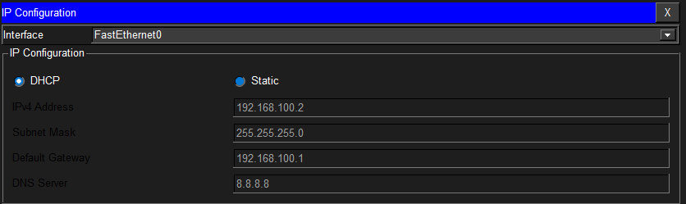
- PC 0 (VLAN Admin)
PC1 (VLAN Admin):
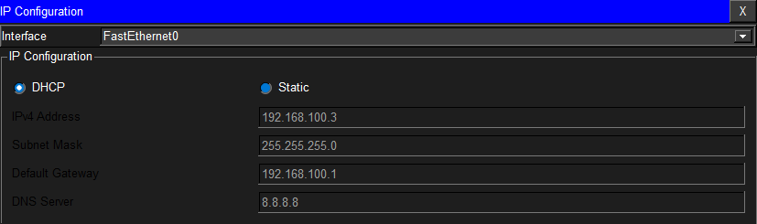
- PC 1 (VLAN Admin)
PC2 (VLAN IT):
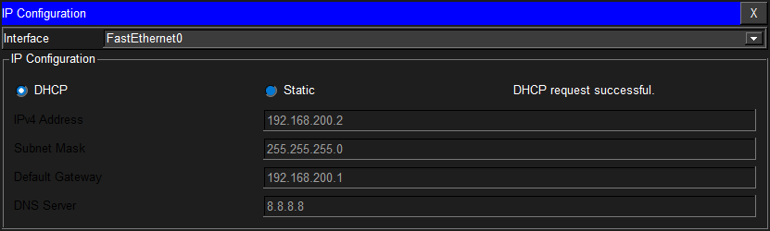
- PC 02 (VLAN IT)
PC3 (VLAN IT):
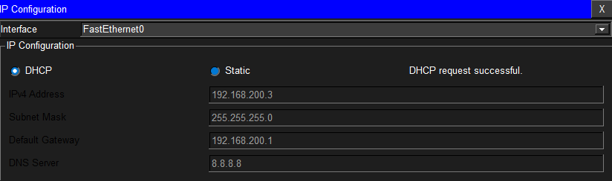
- PC 03 (VLAN IT)
DHCP Configuration Summary
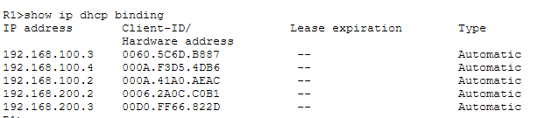
- DHCP Configuration Head Office

DHCP Server Configuration (Branch Office)
A DHCP server was added to automate IP allocation whole network

PC4 (VLAN Admin):
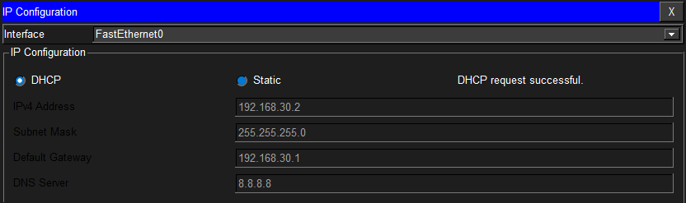
- PC 4 (VLAN Admin)
PC5 (VLAN Admin):
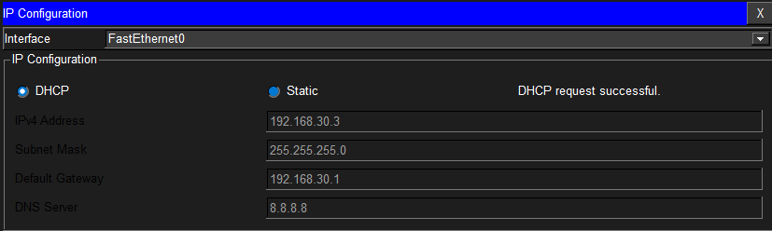
- PC 5 (VLAN Admin)
PC6 (VLAN IT):
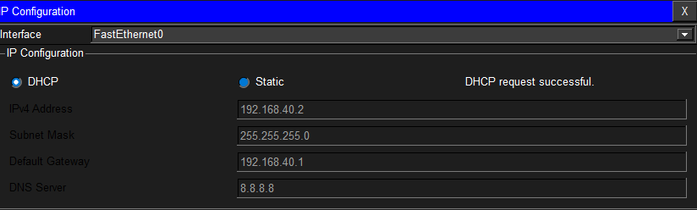
- PC 5 (VLAN IT)
PC 7 (VLAN IT):
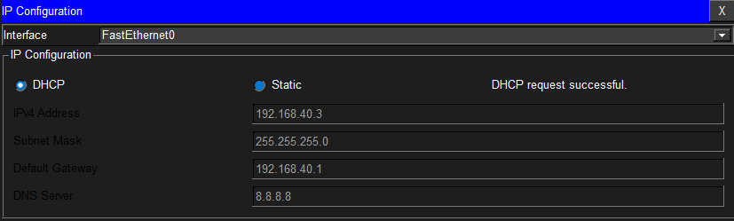
- PC 4 (VLAN IT)
DHCP Configuration Summary:
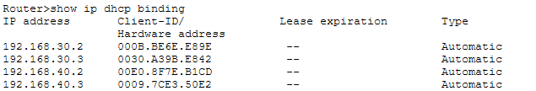
- PC 4 (VLAN Admin)

Static IP Routing

Router 1 Static IP Configuration:
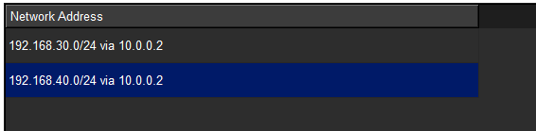
- Router 1 Static IP

Router 2 Static IP Configuration
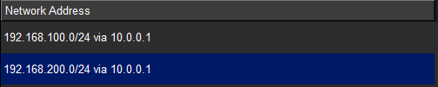
- Router 2 Static IP

Verification and Testing

Same VLANs:
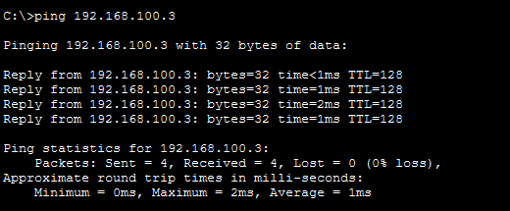
- PC 4 (VLAN Admin)

Across VLANs:
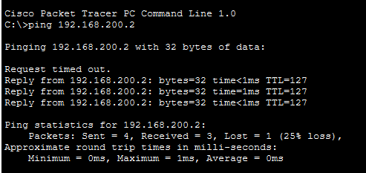
- Across VLANs:

Across Office:
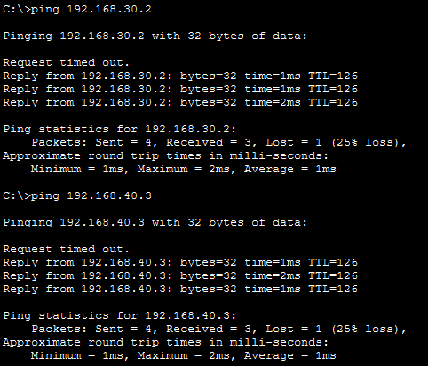
- Across Office

Conclusion
The implemented enterprise network successfully meets all project requirements, including VLAN segmentation, logical separation of departments, inter-VLAN routing, WAN connectivity, DHCP automation, and shared resource access. The network design is scalable, secure, and aligned with enterprise networking standards. All devices achieved end-to-end communication, validating the correctness of the configuration and routing setup.

