**Audio Animation**

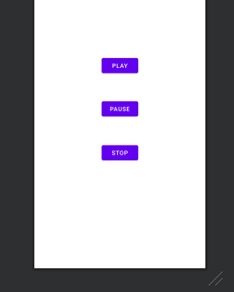

This is the main activity view of audio animation. Here play ,pause and stop button.

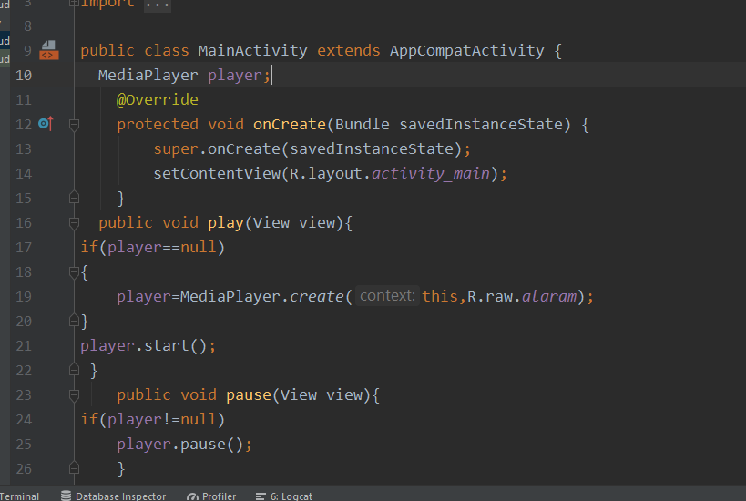

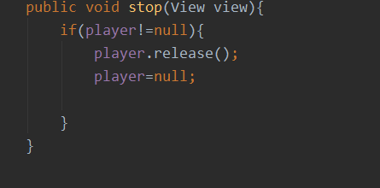

This is the code Behind these buttons.

We need to define media player object .

And then in play onclick function create media player object.

Then on click pause button pause that media player.

And in onClick stop button stop that pause button