**DATABASE Crud Operations**

Below is the interface in which we can add, delete and view all records .We have taken plain text for name and number for age and id to delete and three buttons. We have used **CONSTARINT Layout.**

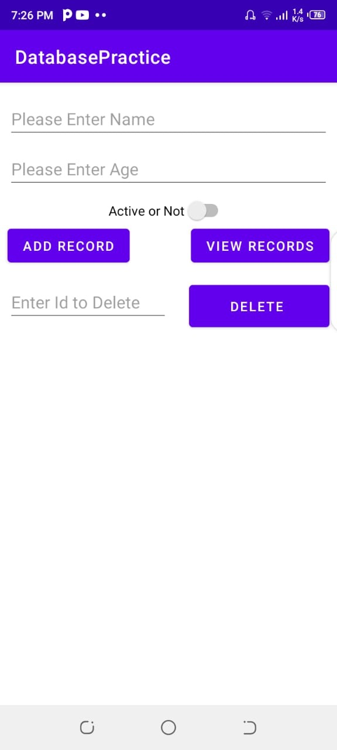

**Connecting Database:**

For connecting Database make a java class and implement it from SQLiteOpenHelper

Then implement its interface and make constructor .Below is the constructor In which we will make database and its name is MyDB.db.

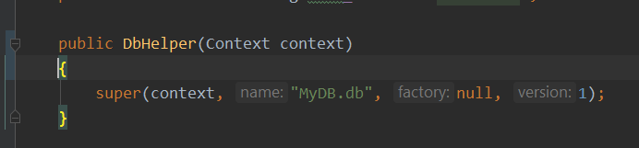

And the interface methods are below .These are onCreate and onUpgrade method .In onCreateMethod we will make tables and we can left the second method as blank.

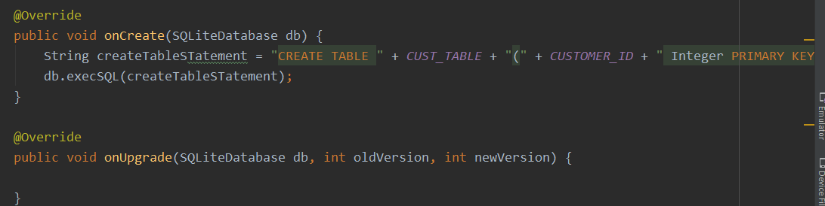

**Add a Record:**

For adding a record in database lets make a function. Below is the implementation of this function. 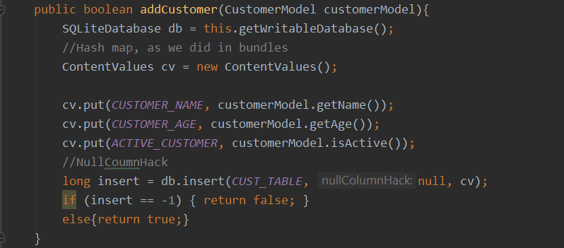

And in mainActivity call this method on button click AddRecord.

**View All Records:**For view all record lets make a function in java class .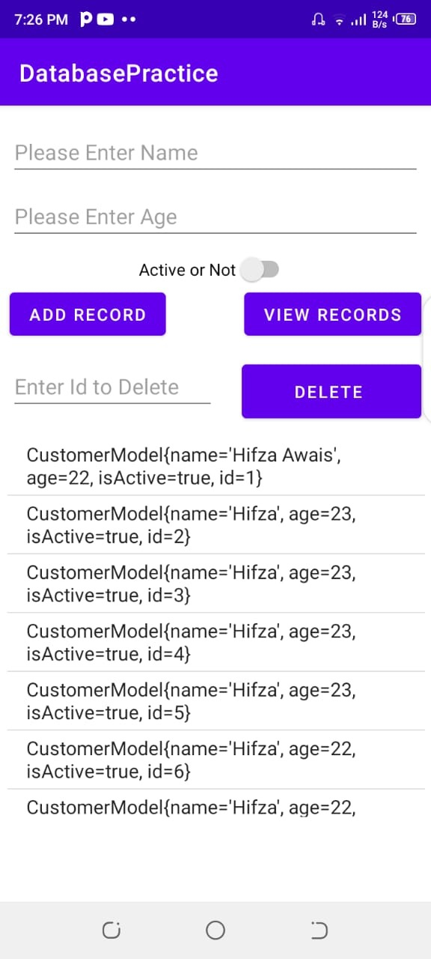

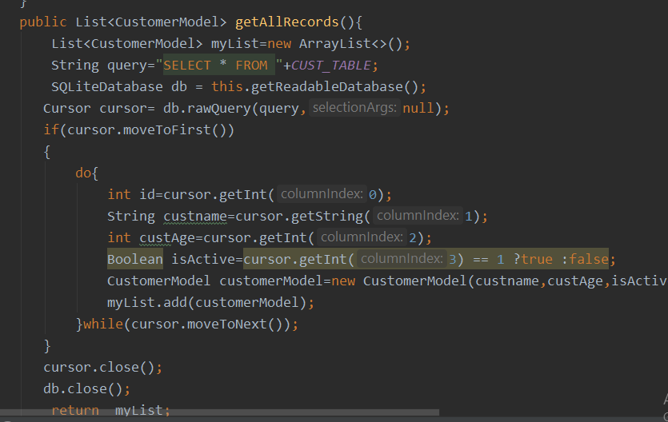

**Delete A Record:**

For deleting a record lets type id from user interface and pass it to java class function.

