**Display Screens Report**

**Display Screen 1.**

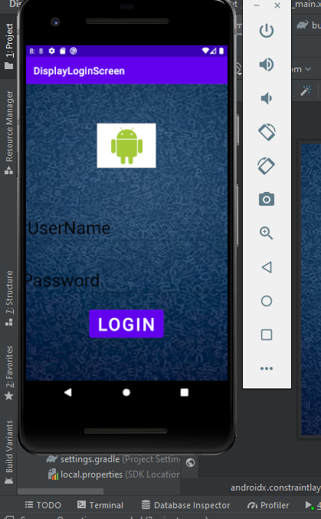

**Steps To Perform that Task:**

1. Open Android Studio . In Constraint Layout set Background as a image. Constraint layout is by default so you don’t need to add this.
2. From the Palette take image view and drop it on a screen .Then select which image you want to add.
3. Also, select two Plain Texts from Palette and set their text as username and password.
4. Add one button and set its text as Login.
5. Set height and width of Plain Texts, Button and Image.
6. Also adjust placement of all the elements on constraint layout by applying horizontal and vertical constraint.

**Display Screen 2.**

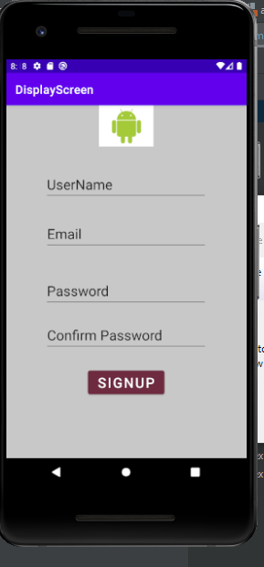

**Steps To Perform that Task:**

1. Open Android Studio . In Constraint Layout set Background as a image.
2. From the Palette take image view and drop it on a screen .Then select which image you want to add.
3. Also, select four Plain Texts from Palette and set their text as username, email, password and confirm password.
4. Add one button and set its text as Sign Up.
5. Set height and width of Plain Texts, Button and Image.
6. Also adjust placement of all the elements on constraint layout by applying horizontal and vertical constraint.

**Display Screen 3.**

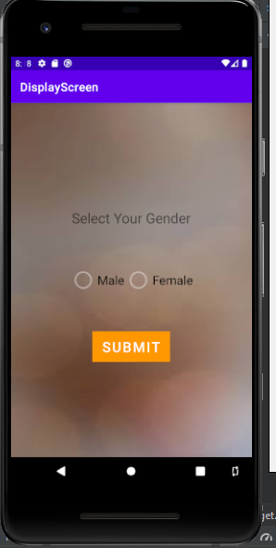

**Steps to Perform that Task:**

1. Open Android Studio. In Constraint Layout set Background as a image.
2. Take text view and set its text as Select Your Gender.
3. Take radio group from palette and drop it on screen .Radio Group is used to select only one radio button at a time.
4. Then take two radio buttons and drop them inside radio group .Then set text of radio buttons as Male and Female.
5. Add one button.