Notifications:

A notification is a message that Android displays outside your app's UI to provide the user with reminders, communication from other people, or other timely information from your app. Users can tap the notification to open your app or take an action directly from the notification.

In main activity .xaml

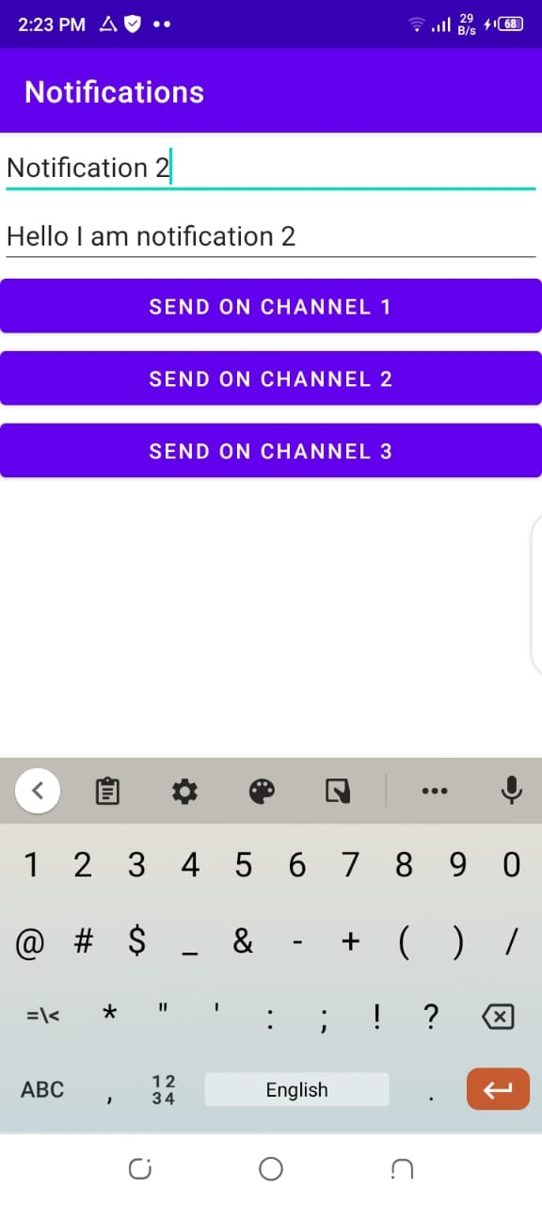

Implement this in main activity.xaml.

Then make a java class the implements three notificatins channel.

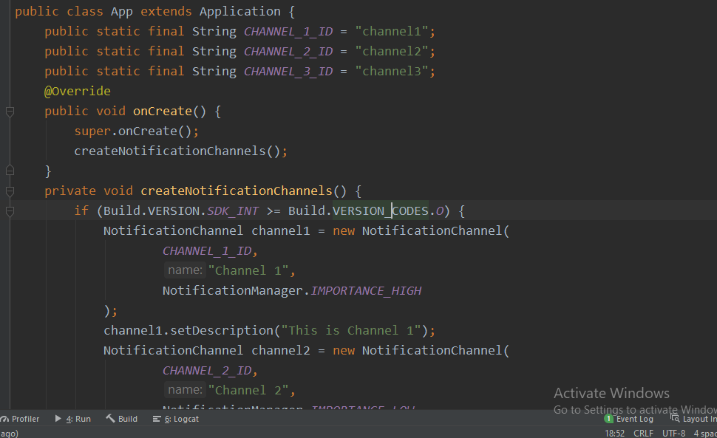

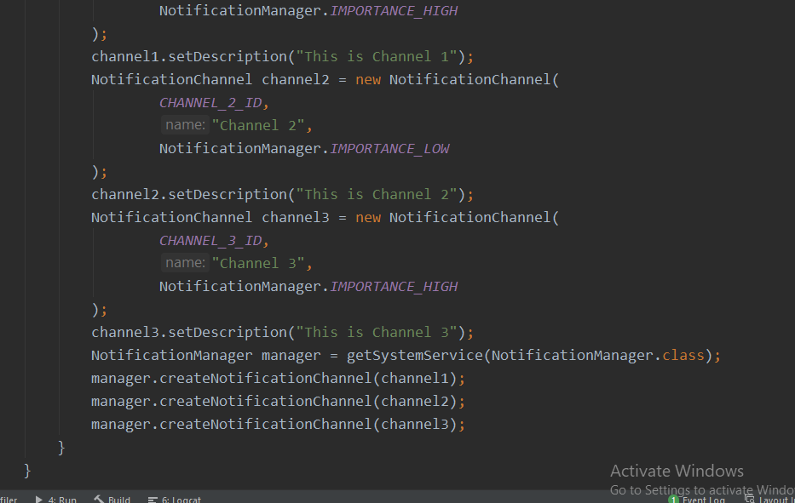

Then in main Activity java class implements the following.

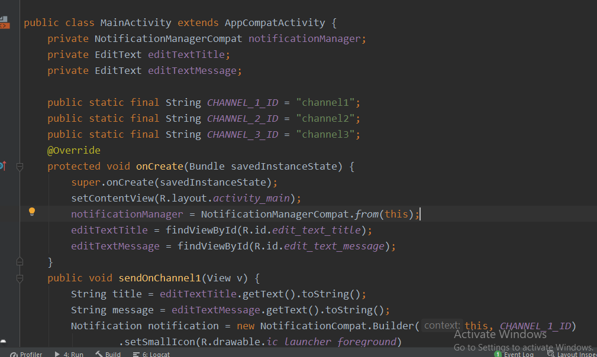

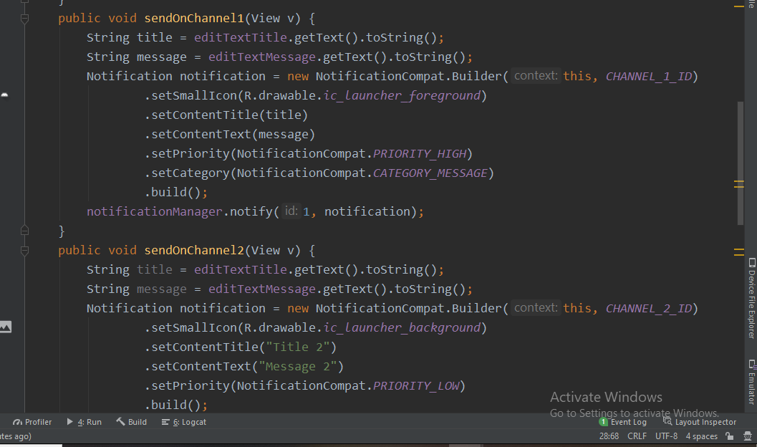

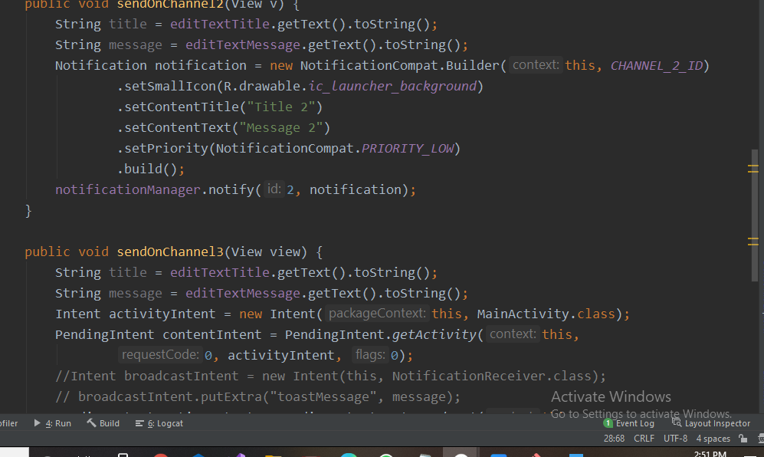

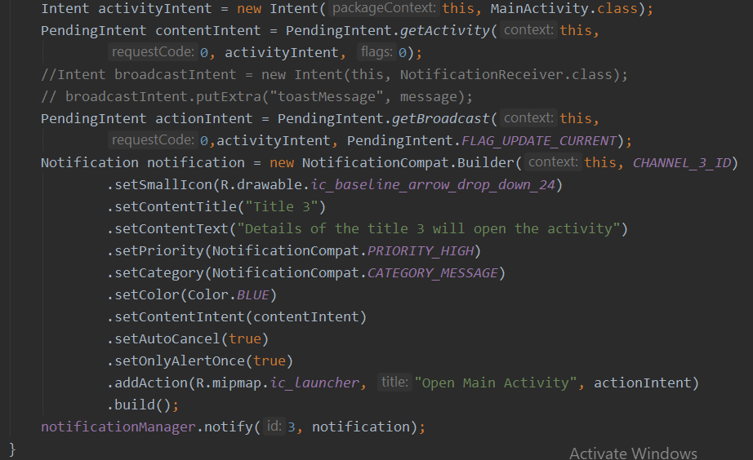

The implements these three functions which sends notifications on channel on button click.

Channel 1&& Chanel 3::

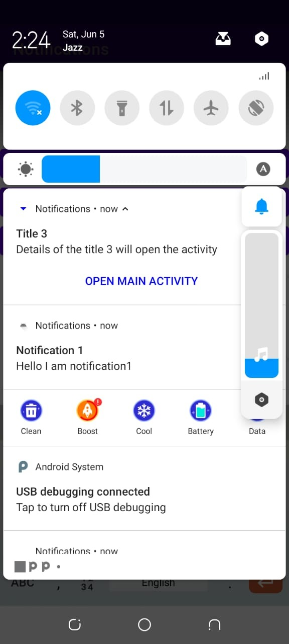

Channnel 2::

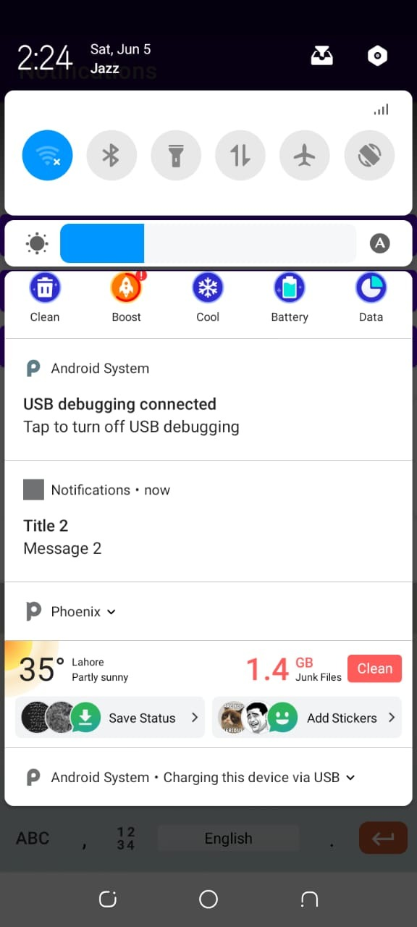

This is channels no 2 Notification .