**Version Control System**

**Git Commands**

**Clone a repository:**

Git clone command is used to clone a repository.

**Command**: git clone URL.

**For Example:** git clone <https://github.comhIFZA264/MC-Progress>.

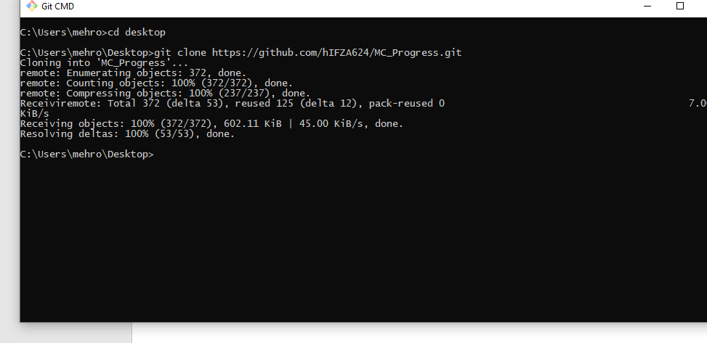

**Adding a File /Folder to Local Repository:**

For adding a file to local repository write command

**Command:** git add filename.

**For Example**: git add atm/



**Commit to the changes:**

Before adding a file from local repository to central repository commit need to be done which we are ready to push it.

**Command:** git commit -m "Message".

Message is user choice what message he want to give..

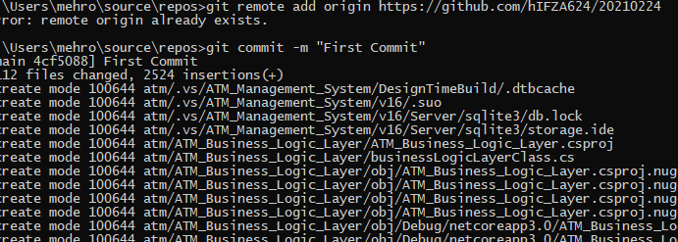

**Push a file to central Repository**:

To Push a file from local repository to central repository we type push command.

**Command**: git push

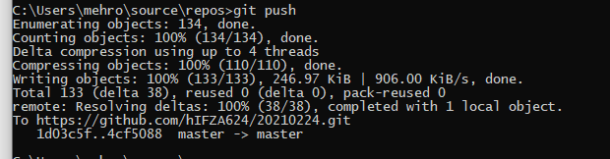

**Pull a File/Folder to local repository:**

To take changes from central repository to local repository we use pull statement .

**Command:** git pull

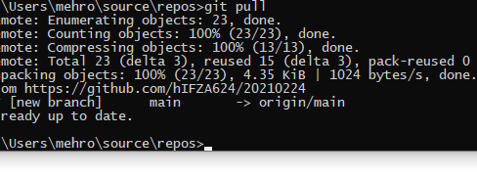

**Git Status:**

Git status is used to get status of git repository.

**Command:** git status

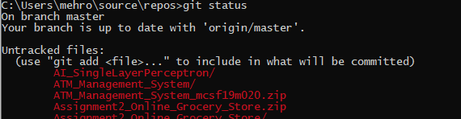

**Changing a file after push:**

We push a file and then after that we changed that file then again we have to add that file in local repository , commit it and then push it .The file will be updated after that procedure.