Fragments:

Fragments bookmark_border. A Fragment represents a reusable portion of your app's UI. A fragment defines and manages its own layout, has its own lifecycle, and can handle its own input events. Fragments cannot live on their own--they must be hosted by an activity or another fragment.

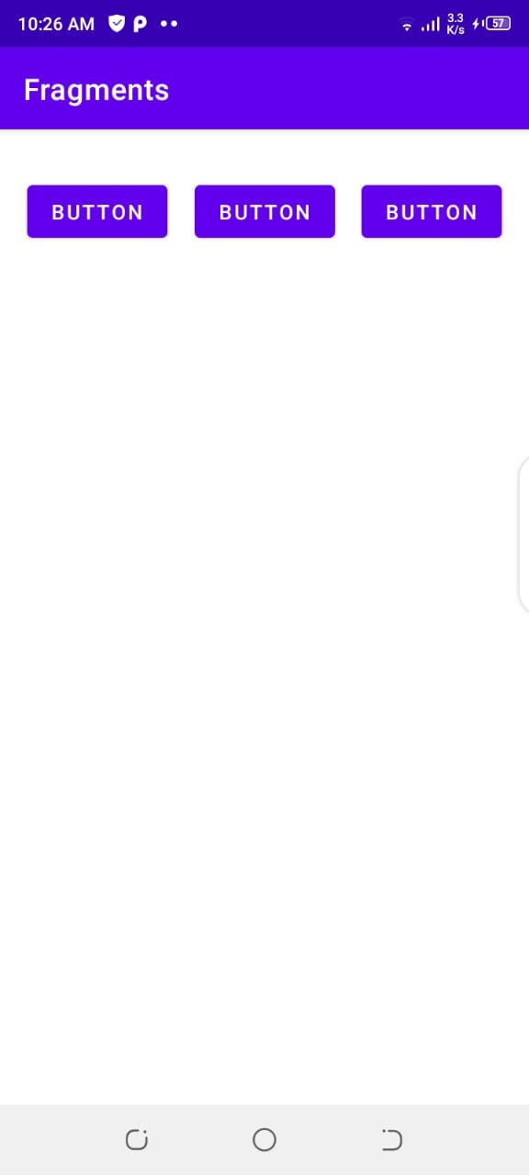

This is the view of Main Activity. Now we want that rest of the area between these buttons will change.

So we add a linear layout below these buttons.

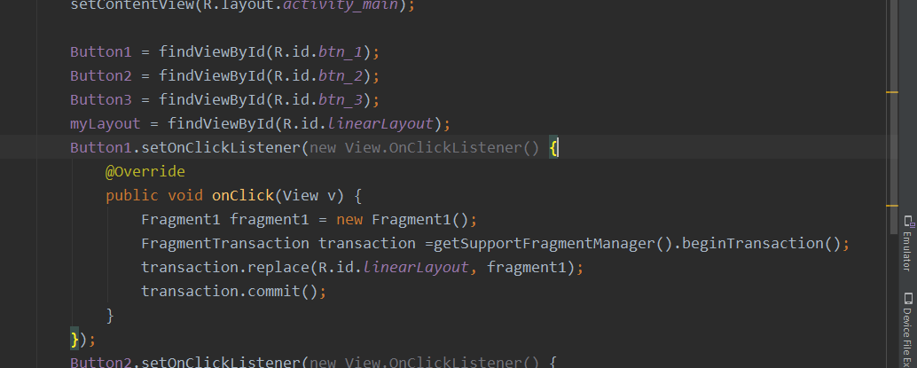

This is the main activity code in which get get elements from xaml and then on button click we will call fragment 1 that will take the remaining space.

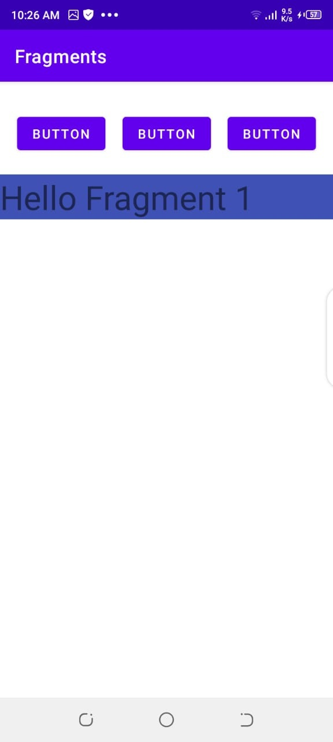

When we click on first button this code appeas.

We havenot added anything but that text view hello fragment 1 .

Now when we click on second button.

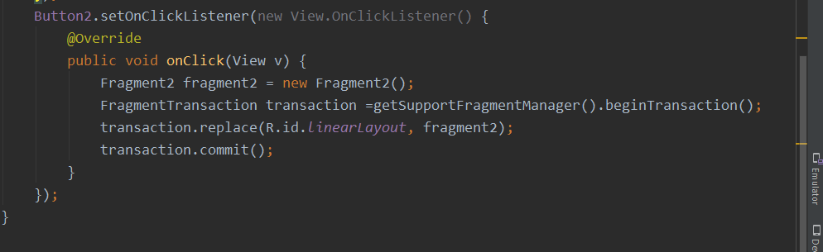

This is the event of button 2.

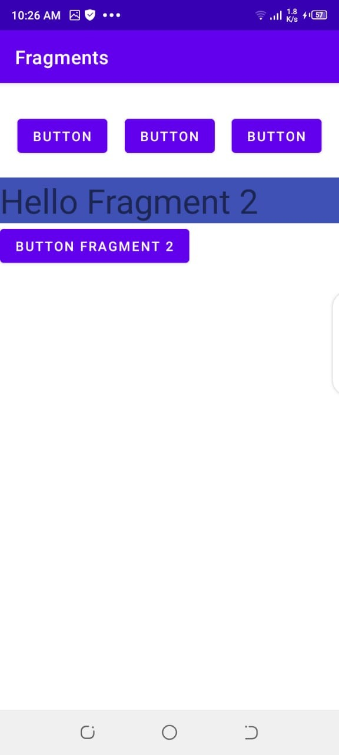

This is the view of fragment 2.

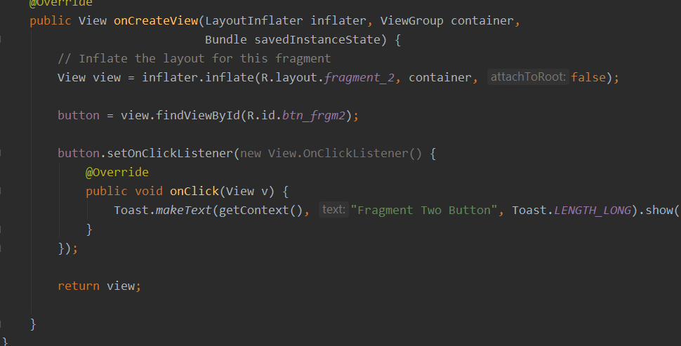

This is the on click method of button in framgemt2.Here toast is different from simple toast. Here in first parameter we are using getContext() we havenot used that before.

