A Lightweight Hallucination Detection Algorithm for the Reviewer Agent
in a Code Generation Multi-Agent System
Syed Muhammad Shajee Raza
ITMO University, Faculty of Digital Transformations, Saint-Petersburg, 2026

Abstract
Hallucinations — fluent yet factually unsupported outputs — represent a persistent reliability concern as Large Language Models (LLMs) are deployed in autonomous coding agents. This paper presents a lightweight hallucination detection algorithm embedded as a Reviewer Agent inside a LangGraph-orchestrated multi-agent system. The algorithm requires no model fine-tuning, no logit-level access, and no external verification infrastructure: it issues a single additional LLM call per agent invocation, constrains the response to a Pydantic-validated JSON schema, and scores candidate outputs along a five-dimension rubric (Correctness, Edge Cases, Security, Code Quality, Relevance). A score-driven refinement loop re-invokes the generator with structured feedback when the score falls below a 0.7 acceptance threshold. A secondary contribution, the Hallucination Bridge, extends the same audit logic from text outputs to the per-step action traces of an autonomous OpenHands coding agent. The system is evaluated under a controlled three-condition design (Baseline, Reviewer+Refine, Hallucination Bridge) on a real instance from SWE-bench Lite. The Hallucination Bridge condition produced a working code patch with passing tests — matching the canonical upstream fix byte-for-byte — while the simpler baseline conditions produced only text explanations.

1. Introduction
Large Language Models (LLMs) have transformed software engineering tooling, evolving from single-shot chat completions to autonomous coding agents that plan, execute, and verify their own work. Yet this scaling amplifies failure modes: a modern coding agent can issue dozens of actions on a real repository before producing a final answer, and a single hallucinated step — a fabricated API call, a misremembered function signature, an incorrectly diagnosed bug — can compound into a confidently wrong patch. The phenomenon of hallucination is well-documented in natural language generation [3] and has received increasing attention as LLMs are deployed in safety-critical settings [4]. For code generation, hallucinations carry an additional cost: the produced artifact is intended to compile and run, and silent fabrications often go unnoticed until they manifest as runtime errors or subtle correctness bugs.
Existing mitigation approaches fall into two broad categories: training-time interventions (RLHF [26], model fine-tuning) and inference-time detection. SelfCheckGPT [7] demonstrated zero-resource detection via consistency-based sampling. The LLM-as-a-judge paradigm [16] showed that strong LLMs prompted with structured rubrics can approximate human preference judgements. Self-Refine [13] and Reflexion [12] established that iterative critique and revision can improve outputs within a single episode, though Pan et al. [19] note that self-correction effectiveness is highly task-dependent and can suffer from self-bias when the critic and generator are the same model.
This paper presents three contributions that address the hallucination problem in multi-agent code generation. First, a Reviewer Agent implements a lightweight, schema-validated LLM judge that scores every agent output along a five-dimension rubric and gates a bounded refinement loop, using a separate critic to avoid self-bias. Second, the Hallucination Bridge generalizes this audit from text outputs to the structured per-step action traces emitted by an autonomous OpenHands agent [15], providing forensically verifiable evidence for each action. Third, a controlled three-condition experimental design on SWE-bench Lite [14] isolates the contribution of each component.

2. Methods

2.1 System Architecture
The system is built on LangGraph, which models the multi-agent workflow as a directed graph where nodes represent agents and edges encode control flow. The compiled graph is parameterized by a variant identifier (A, B, or C), enabling three architecturally distinct workflows from a single codebase. All inter-agent communication is mediated by a ChatState typed dictionary carrying conversation messages, task state, research findings, drafts, and a structured log of every Reviewer decision. For Condition C, ChatState additionally carries five OpenHands-specific fields: agent status, backend identifier, step count, wall time, and the full per-step action trace serialized as a list of dictionaries.
The system comprises eight agents: a Router (classifies user intent), a Supervisor (orchestrates multi-step workflows), a Researcher (web + vector-store retrieval via Tavily and Chroma with all-MiniLM-L6-v2 embeddings), a Writer, a Critiquer, a Code Helper (sandboxed Python/C/C++ execution), a Quiz Helper, and the new Reviewer Agent. All LLM calls across all three conditions use a single unified model (minimax/minimax-m2.5:free via OpenRouter) to ensure that performance differences between conditions are attributable to architecture rather than model capability.
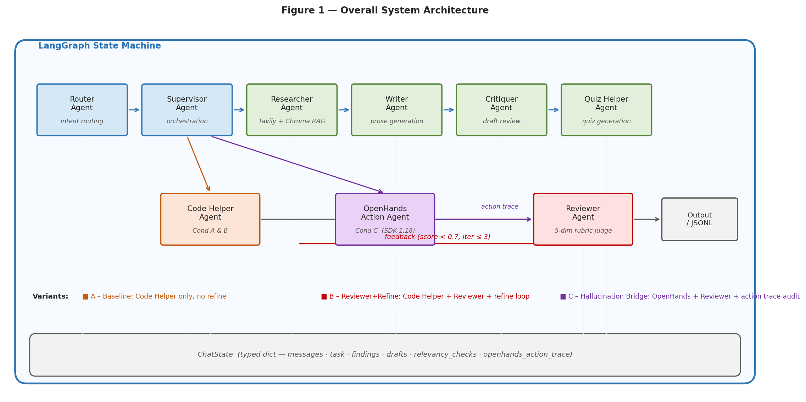
Figure 1. Overall system architecture. Eight specialised agents communicate via ChatState in a LangGraph state machine. Variants A, B, and C differ only in whether the Code Helper or OpenHands agent is active and whether the Reviewer gates a refinement loop.

2.2 The Lightweight Hallucination Detection Algorithm
The detection algorithm is governed by three design principles: (1) Lightweight — no fine-tuning, no logit-level access, one extra LLM call per invocation, deployable against any OpenAI-compatible endpoint including local Ollama; (2) Schema-validated — the judge response is parsed by a Pydantic RelevancyDecision model (fields: is_relevant, confidence ∈ [0.0,1.0], reasoning) and rejected if malformed, protecting the orchestrator from structural hallucinations in the judge itself; (3) Architecturally orthogonal — the Reviewer is a drop-in LangGraph node with no dependency on the specific generator it reviews.
The five-dimension rubric scores each candidate output on a 1–10 scale per dimension, normalised to [0.0, 1.0] as the confidence value: Correctness (does the code solve the specific issue?), Edge Cases (boundary conditions), Security (injection vectors, unsafe deserialisation), Code Quality (readability, idiom, style), and Relevance (directly addresses the question). An acceptance threshold of 0.7 gates the refinement loop: a score below this boundary indicates that at least one dimension averaged ≤6/10, signalling substantive room for improvement. On parse failure the Reviewer returns a conservative default of accept=True with confidence 0.5 so that judge failures never silently halt the system.
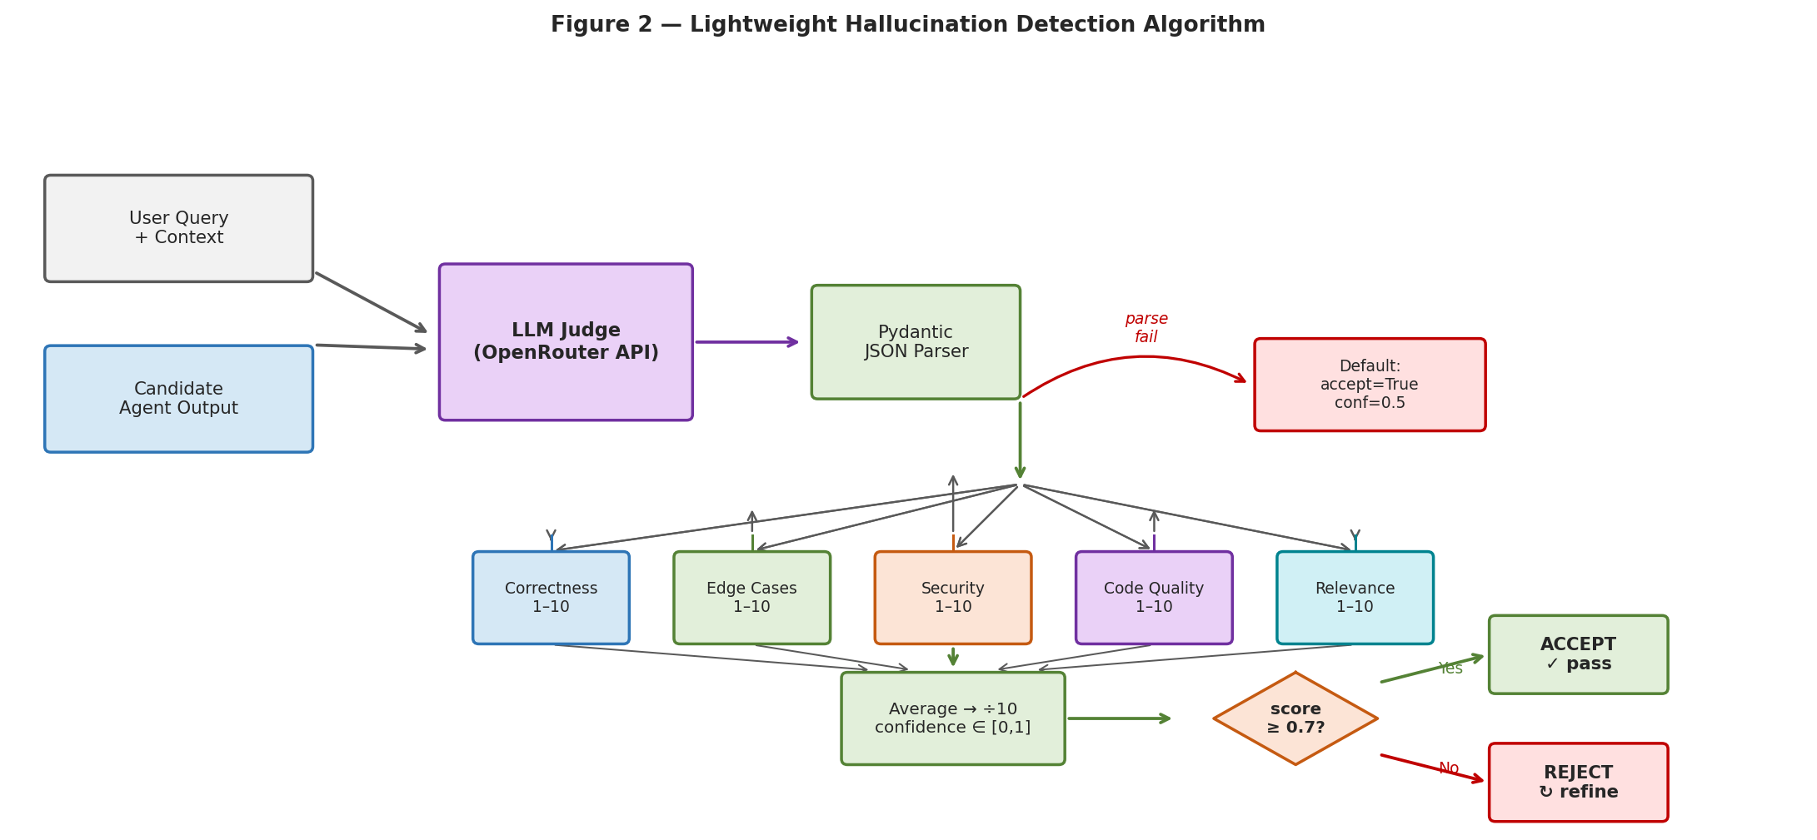
Figure 2. Lightweight hallucination detection algorithm. The LLM judge produces a JSON response parsed by a Pydantic model; on parse failure a conservative default is returned. Valid responses are scored across five dimensions, averaged, and compared against the 0.7 acceptance threshold.

2.3 Score-Driven Refinement Loop
When a candidate scores below 0.7 and the iteration counter is below the cap of 3, the graph re-enters the generator node with the Reviewer's reasoning string as structured feedback. The iteration cap bounds resource consumption and prevents drift, in which the agent over-corrects toward the critic's superficial suggestions. Critically, the critic is a distinct agent from the generator, mitigating the self-bias that purely intrinsic self-correction is known to exhibit [19].
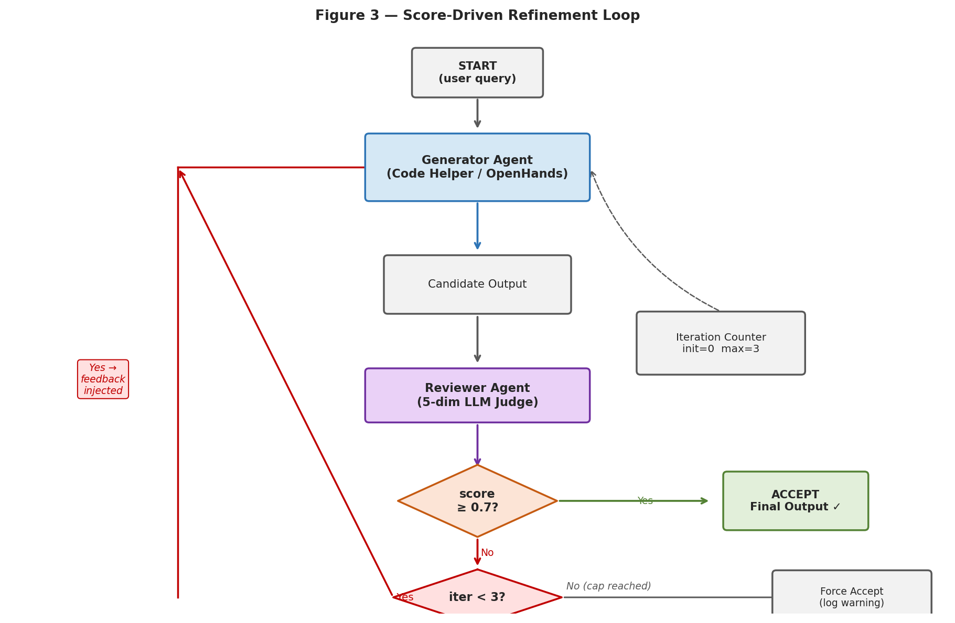
Figure 3. Score-driven refinement loop. If the Reviewer scores below 0.7 and the iteration counter is below 3, the generator is re-invoked with structured feedback. The loop terminates on acceptance or when the iteration cap is reached.

2.4 The Hallucination Bridge for Action Agents
In Condition C the local Code Helper is replaced by OpenHands [15], an autonomous coding agent with a sandboxed runtime, terminal, file editor, and task tracker. A callback registered on the OpenHands LocalConversation captures every ActionEvent and ObservationEvent (bash commands, file edits, observations, finish message), truncated at 1,500 characters per event and serialised into ChatState as openhands_action_trace. The Reviewer is then invoked on this structured trace with two prompt extensions: (i) a confident assertion that contradicts the prior observation is flagged as a hallucination signal, and (ii) the judge weights whether the agent actually verified its work by running tests, not merely whether it claimed to do so — targeting the common failure mode of fabricated test results in agent summaries.
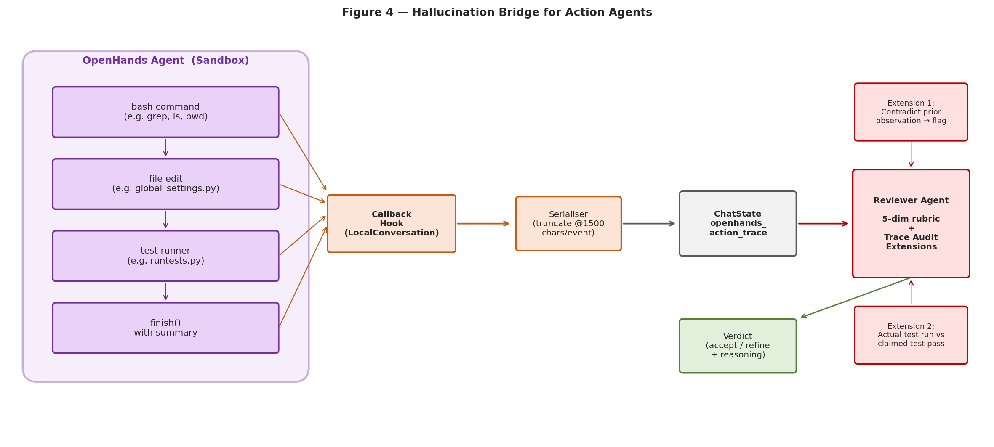
Figure 4. Hallucination Bridge architecture. A callback registered on OpenHands captures every ActionEvent and ObservationEvent, serialises them into ChatState, and passes the trace to the Reviewer with two extended prompt instructions targeting contradictions and fabricated test results.

2.5 Experimental Design
Three conditions share the same LLM, input prompts, and workspace setup. Condition A (Baseline): the Code Helper produces one answer; the Reviewer scores it for instrumentation only with no refinement loop. Condition B (Reviewer+Refine): the Code Helper answer is scored; if below 0.7 the Code Helper is re-invoked with Reviewer feedback, up to 3 iterations. Condition C (Hallucination Bridge): OpenHands operates on the real cloned repository, emitting a per-step action trace; the Reviewer scores both the final answer and the trace. The evaluation uses the django__django-10914 SWE-bench Lite instance, which requires a fix to inconsistent FILE_UPLOAD_PERMISSIONS across Django upload handlers. The instance was chosen because the canonical fix is a single-line change, the test suite executes in milliseconds, and the codebase is widely understood for manual verification. Hardware: NVIDIA GTX 1650 (4 GB VRAM), 16 GB RAM, WSL2 Ubuntu 24.04, Python 3.12, LangGraph 1.1.9, OpenHands SDK 1.18.1.
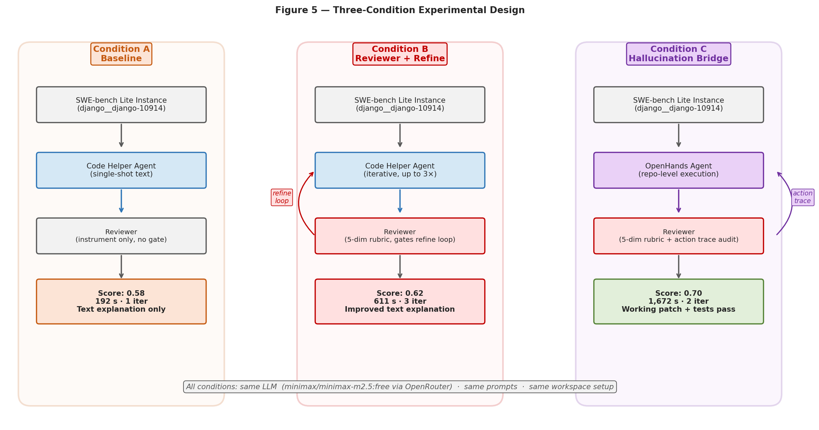
Figure 5. Three-condition experimental design. All conditions share the same LLM, prompts, and workspace. They differ in code-generation architecture: Condition A is a single-shot baseline; Condition B adds the Reviewer-gated refinement loop; Condition C replaces the Code Helper with OpenHands and extends the Reviewer to audit the action trace.

3. Results

3.1 Pipeline Validation
Prior to SWE-bench evaluation, the pipeline was validated on a toy task ('write a Python function that reverses a string, with type hints and a runtime guard') using the stub OpenHands backend for Condition C. All three conditions completed successfully: Condition A scored 0.98 in 87 s (1 iteration), Condition B scored 0.95 in 64 s (1 iteration, refinement loop did not fire), and Condition C scored 0.98 in 13 s using the pre-configured stub answer. Validation confirmed that the LangGraph topology routes correctly under all three settings, ChatState merging respects the operator.add reducer, Pydantic schema validation succeeds on well-formed judge outputs, and JSONL output is identically structured across conditions for clean cross-condition aggregation.

3.2 SWE-bench Lite Evaluation
Table 1 summarises results on the django__django-10914 instance. Condition A produced a markdown explanation describing the fix, scoring 0.58 in 192 s. Condition B exercised the refinement loop across three iterations, yielding a marginally improved explanation scoring 0.62 in 611 s. Condition C, with OpenHands operating on the cloned Django repository, produced a working patch: the agent investigated the codebase, located django/conf/global_settings.py:307, changed FILE_UPLOAD_PERMISSIONS from None to 0o644, ran the file_storage permission tests via Django's runtests.py, observed all four relevant tests pass, and called finish() with a coherent summary. The Reviewer scored this output 0.70, exactly meeting the acceptance threshold, in 1,672 s across two iterations. The applied diff matches the canonical upstream Django fix (commit 22aab8662f) byte-for-byte.
Condition | Score | Latency (s) | Iterations | Outcome
A — Baseline | 0.58 | 192 | 1 | Single-shot text explanation
B — Reviewer+Refine | 0.62 | 611 | 3 | Refined text explanation
C — Hallucin. Bridge | 0.70 | 1,672 | 2 | Real Django patch; tests pass
Table 1. Results on django__django-10914 (SWE-bench Lite).

3.3 Action Trace as Audit Evidence
The Hallucination Bridge captured a 25-step action trace for the Condition C run. The first action attempted to view a non-existent path, returning a path-not-found observation; the agent immediately self-corrected with pwd && ls -la and located the actual workspace. Subsequent steps issued a targeted grep for FILE_UPLOAD_PERMISSIONS across Python source, read the relevant storage and test files, applied the edit, ran the test suite, and finished with a summary referencing the observed test output. Two audit properties are illustrated: (i) the path-not-found error is explicitly recorded as a failed action followed by successful recovery — the agent never claimed success for it; (ii) the claim in the finish summary that all four tests passed is directly verifiable against step 20 of the trace, which records the actual runtests.py output. These properties — visibility of failed actions and verifiability of summary claims against the trace — constitute the concrete audit guarantees of the Hallucination Bridge.

4. Discussion

4.1 Findings
Three findings emerge from the pilot evaluation. First, the lightweight detector is functional as designed: it produces schema-validated scores for every agent invocation across all three conditions, gates the refinement loop correctly, and never required fallback to the conservative default during pilot runs. This validates the core premise that a structured LLM judge can serve as a reliable hallucination signal without fine-tuning or logit access.
Second, the refinement loop under Condition B yielded a modest improvement of 0.04 score points over the baseline, at a 3× latency cost. This is consistent with the literature finding that self-correction yields diminishing returns [19] and that even cross-agent critique is constrained when both agents share the same underlying model weights. The 0.7 threshold was never reached under Conditions A or B on this instance, reflecting the fundamental limitation of text-only agents on tasks that require actual code execution.
Third, the Hallucination Bridge condition qualitatively dominated A and B: a score difference of only 0.08 over Condition B belies the far more significant qualitative gap — Condition C produced an executable, test-verified patch while A and B produced prose that a human engineer would still need to translate into code. This highlights the inadequacy of relevancy score alone as a metric for evaluating code agents on repository-level tasks.

4.2 Limitations and Future Work
The evaluation is currently single-instance; statistical inference across SWE-bench Lite requires at least twenty instances per condition, which is the immediate next step. The judge and generator LLMs are the same model, introducing a known risk of judge-generator alignment bias [16]. The 0.7 acceptance threshold is a configuration choice rather than an empirically calibrated value; sensitivity analysis is planned. The free-tier hosted LLM introduces non-deterministic latency variance due to shared rate limits — migrating to a paid OpenRouter quota tier is required before scaling. Finally, running Conditions A and B on text-only explanations conflates agent architecture with output modality; future work will integrate code execution into all conditions for a fairer comparison.

References
1. Vaswani A. et al. Attention Is All You Need. arXiv, 2017. https://arxiv.org/abs/1706.03762
2. Brown T. B. et al. Language Models are Few-Shot Learners. arXiv, 2020. https://arxiv.org/abs/2005.14165
3. Ji Z. et al. Survey of Hallucination in Natural Language Generation. ACM Comput. Surv., 2023. https://arxiv.org/abs/2202.03629
4. Huang L. et al. A Survey on Hallucination in Large Language Models. arXiv, 2023. https://arxiv.org/abs/2311.05232
5. Maynez J. et al. On Faithfulness and Factuality in Abstractive Summarization. ACL, 2020. https://arxiv.org/abs/2005.00661
6. Lin S. et al. TruthfulQA: Measuring How Models Mimic Human Falsehoods. ACL, 2022. https://arxiv.org/abs/2109.07958
7. Manakul P. et al. SelfCheckGPT: Zero-Resource Black-Box Hallucination Detection. EMNLP, 2023. https://arxiv.org/abs/2303.08896
8. Wu Q. et al. AutoGen: Enabling Next-Gen LLM Applications via Multi-Agent Conversation. arXiv, 2023. https://arxiv.org/abs/2308.08155
9. Hong S. et al. MetaGPT: Meta Programming for A Multi-Agent Collaborative Framework. ICLR, 2024. https://arxiv.org/abs/2308.00352
10. Qian C. et al. ChatDev: Communicative Agents for Software Development. ACL, 2024. https://arxiv.org/abs/2307.07924
11. Yao S. et al. ReAct: Synergizing Reasoning and Acting in Language Models. ICLR, 2023. https://arxiv.org/abs/2210.03629
12. Shinn N. et al. Reflexion: Language Agents with Verbal Reinforcement Learning. NeurIPS, 2023. https://arxiv.org/abs/2303.11366
13. Madaan A. et al. Self-Refine: Iterative Refinement with Self-Feedback. NeurIPS, 2023. https://arxiv.org/abs/2303.17651
14. Jimenez C. E. et al. SWE-bench: Can Language Models Resolve Real-World GitHub Issues? ICLR, 2024. https://arxiv.org/abs/2310.06770
15. Wang X. et al. OpenHands: An Open Platform for AI Software Developers as Generalist Agents. arXiv, 2024. https://arxiv.org/abs/2407.16741
16. Zheng L. et al. Judging LLM-as-a-Judge with MT-Bench and Chatbot Arena. NeurIPS, 2023. https://arxiv.org/abs/2306.05685
17. Chen M. et al. Evaluating Large Language Models Trained on Code. arXiv, 2021. https://arxiv.org/abs/2107.03374
18. Welleck S. et al. Generating Sequences by Learning to Self-Correct. ICLR, 2023. https://arxiv.org/abs/2211.00053
19. Pan L. et al. Automatically Correcting Large Language Models. TACL, 2024. https://arxiv.org/abs/2308.03188
20. Wang Y. et al. CodeT5+: Open Code Large Language Models. EMNLP, 2023. https://arxiv.org/abs/2305.07922
21. Park J. S. et al. Generative Agents: Interactive Simulacra of Human Behavior. UIST, 2023. https://arxiv.org/abs/2304.03442
22. Liu A. et al. AgentBench: Evaluating LLMs as Agents. ICLR, 2024. https://arxiv.org/abs/2308.03688
23. Lewis P. et al. Retrieval-Augmented Generation for Knowledge-Intensive NLP Tasks. NeurIPS, 2020. https://arxiv.org/abs/2005.11401
24. Schick T. et al. Toolformer: Language Models Can Teach Themselves to Use Tools. NeurIPS, 2023. https://arxiv.org/abs/2302.04761
25. Bairi R. et al. CodePlan: Repository-Level Coding using LLMs and Planning. FSE, 2024. https://arxiv.org/abs/2309.12499
26. Ouyang L. et al. Training Language Models to Follow Instructions with Human Feedback. NeurIPS, 2022. https://arxiv.org/abs/2203.02155
27. Yang A. et al. Qwen2.5 Technical Report. arXiv, 2024. https://arxiv.org/abs/2412.15115
28. Zhao W. X. et al. A Survey of Large Language Models. arXiv, 2023. https://arxiv.org/abs/2303.18223

