**Fundamentals of Software Engineering**

**Assignment 1**

**Group Members:**

* **Zoya Arif Kazmi (21i-1515)**
* **Shajia Naqvi (21i-0130)**
* **Osama Waheed (21i-1516)**

**Problem Statement:**

| **The problem of** | Managing industry projects efficiently. |
| --- | --- |
| **Affects** | Employees, project managers, senior management, and evaluation teams. |
| **The impact of which is** | Poor communication, inefficient task allocation, manual documentation, increased administrative workload, errors during documentation. This leads to potential project inefficiencies. |
| **A successful solution would be** | A web-based project management system that facilitates seamless communication, automates task allocation and tracking, and reduces paperwork. |

**USER STORIES**

| Story ID | Story Title | User Story | Acceptance Criteria | Importance | Estimate | Type |
| --- | --- | --- | --- | --- | --- | --- |
| 1 | User Account Management | As a project administrator, I want to manage user accounts (create, edit, deactivate), so that I can ensure proper access control and data integrity. | The system should allow creation, editing, and deactivation of user accounts, with role-based access control. | High | 5 | Manage Data |
| 2 | Search Users | As a project administrator, I want to search and filter users (employees, managers), so that I can effectively manage system access, monitor team participation, and track project progress. | The system should support searching and filtering by role, name, and project. | Medium | 3 | Search |
| 3 | Create Employee Accounts | As a project administrator, I want to create new employee accounts with accurate details, so that I can ensure smooth onboarding and system access. | Employees should have unique usernames, emails, and be assigned to teams upon creation. | High | 4 | Manage Data |
| 4 | View Employee List | As a project administrator, I want to view all employees and their assigned projects, so that I can monitor productivity and resource allocation. | System should display employee name, role, project assignment, and status. | High | 3 | Report/View |
| 5 | Edit Employee Profiles | As a project administrator, I want to edit employee profiles, so that I can maintain up-to-date information. | Editable fields should include department, project, and contact details, but not username. | Medium | 3 | Manage Data |
| 6 | List Project Managers | As a project administrator, I want to view a directory of all project managers, so that I can identify available leaders for new projects. | System should display manager names, workload, and assigned projects. | High | 3 | Report/View |
| 7 | Workload Distribution | As a project administrator, I want to track and manage project manager workload, so that I can ensure fair distribution of tasks. | The system should prevent assigning more than six projects to a manager. | High | 4 | Manage Data |
| 8 | Assign Employees to Projects | As a project administrator, I want to assign employees to projects, so that I can optimize resource utilization. | System should allow selecting employees based on skills and availability. | High | 5 | Workflow |
| 9 | Create Evaluation Panels | As a project administrator, I want to create evaluation panels, so that I can ensure projects are reviewed by appropriate stakeholders. | System should allow adding panel members and defining evaluation criteria. | Medium | 4 | Manage Data |
| 10 | Assign Projects to Panels | As a project administrator, I want to assign projects to evaluation panels, so that I can ensure structured project reviews. | Each project should be linked to at least one evaluation panel. | Medium | 4 | Workflow |
| 11 | Enable Task Assignment | As a project administrator, I want to assign specific tasks to employees within a project, so that work is distributed efficiently. | The system should allow managers to assign, track, and update task status. | High | 5 | Workflow |
| 12 | Track Time Spent on Tasks | As an employee, I want to log time spent on each task, so that I can track my productivity. | System should include a time-tracking feature with manual entry or timer functionality. | Medium | 3 | Manage Data |
| 13 | Request Additional Resources | As a project manager, I want to request additional resources for a project, so that I can avoid delays. | System should allow managers to submit requests and receive approvals from administrators. | High | 4 | Workflow |
| 14 | Approve or Reject Change Requests | As a project administrator, I want to approve or reject project change requests, so that I can maintain control over project scope. | System should allow tracking and justification of change requests. | High | 5 | Workflow |
| 15 | Track Project Milestones | As a project manager, I want to track project milestones, so that I can monitor progress. | System should provide milestone tracking with estimated and actual completion dates. | High | 4 | Report/View |
| 16 | Assign Priority Levels to Tasks | As a project manager, I want to assign priority levels to tasks, so that urgent tasks are completed first. | System should support High, Medium, and Low priority assignments. | Medium | 3 | Manage Data |
| 17 | Generate Custom Reports | As a project administrator, I want to generate custom reports based on selected criteria, so that I can analyze specific trends. | System should support customizable report filters and export options. | High | 5 | Report/View |
| 18 | Audit Log for Changes | As a system administrator, I want an audit log of all changes made within the system, so that I can ensure accountability. | The system should store timestamps, user actions, and changes made. | High | 5 | Manage Data |
| 19 | Archive Completed Projects | As a project administrator, I want to archive completed projects, so that they remain accessible without cluttering active projects. | System should provide an archive section with search functionality. | Medium | 3 | Manage Data |
| 20 | Set Up Project Budget | As a finance manager, I want to set up budgets for projects, so that expenses are controlled. | System should include budget allocation, tracking, and alerts for overages. | High | 5 | Payment |
| 21 | Request Expense Approval | As a project manager, I want to submit expense requests for approval, so that I can manage financial resources. | System should route requests to finance and track approval status. | Medium | 4 | Payment |
| 22 | Enable File Sharing | As a project team member, I want to share files within the system, so that I can collaborate with my team. | System should support secure file uploads and access permissions. | High | 5 | Manage Data |
| 23 | Assign Substitute Managers | As a project administrator, I want to assign a substitute manager when the primary manager is unavailable, so that projects continue smoothly. | System should allow reassignment and notify relevant team members. | High | 4 | Workflow |
| 24 | Performance Review Tracking | As an HR representative, I want to track employee performance reviews, so that I can assess productivity and improvement areas. | System should store past performance reviews and allow scheduled assessments. | Medium | 4 | Report/View |
| 25 | Set Up Email Notifications | As a system administrator, I want to configure email notifications for important events, so that users stay informed. | System should support customizable email alerts for deadlines, approvals, and updates. | High | 5 | Manage Data |

**ROLES:**

| **PRODUCT OWNER** | Zoya Arif Kazmi is the product owner. Her responsibility includes:   * Maintaining and prioritizing the project backlog. * Aligning requirements with business objectives and stakeholder needs. * Collaborating with the team to ensure clear project deliverables. |
| --- | --- |
| **SCRUM MASTER** | Shajia Naqvi is the scrum master. Her responsibility includes:   * Leading Scrum ceremonies such as Sprint Planning, Stand-ups, Reviews, and Retrospectives. * Coaching the team on Agile best practices. * Identifying and resolving obstacles hindering the team's progress. * Ensuring smooth implementation of Agile methodologies. |

| **Development Team** | Osama Waheed is a part of the development team. His roles include:   * Collaborating with the Product Owner to define and refine project requirements. * Estimating and committing to tasks within each sprint. * Organizing work autonomously to meet sprint goals. * Delivering functional product increments in each sprint cycle. * Ensuring that the product meets the required quality standards. |
| --- | --- |

**Trello Screenshots**

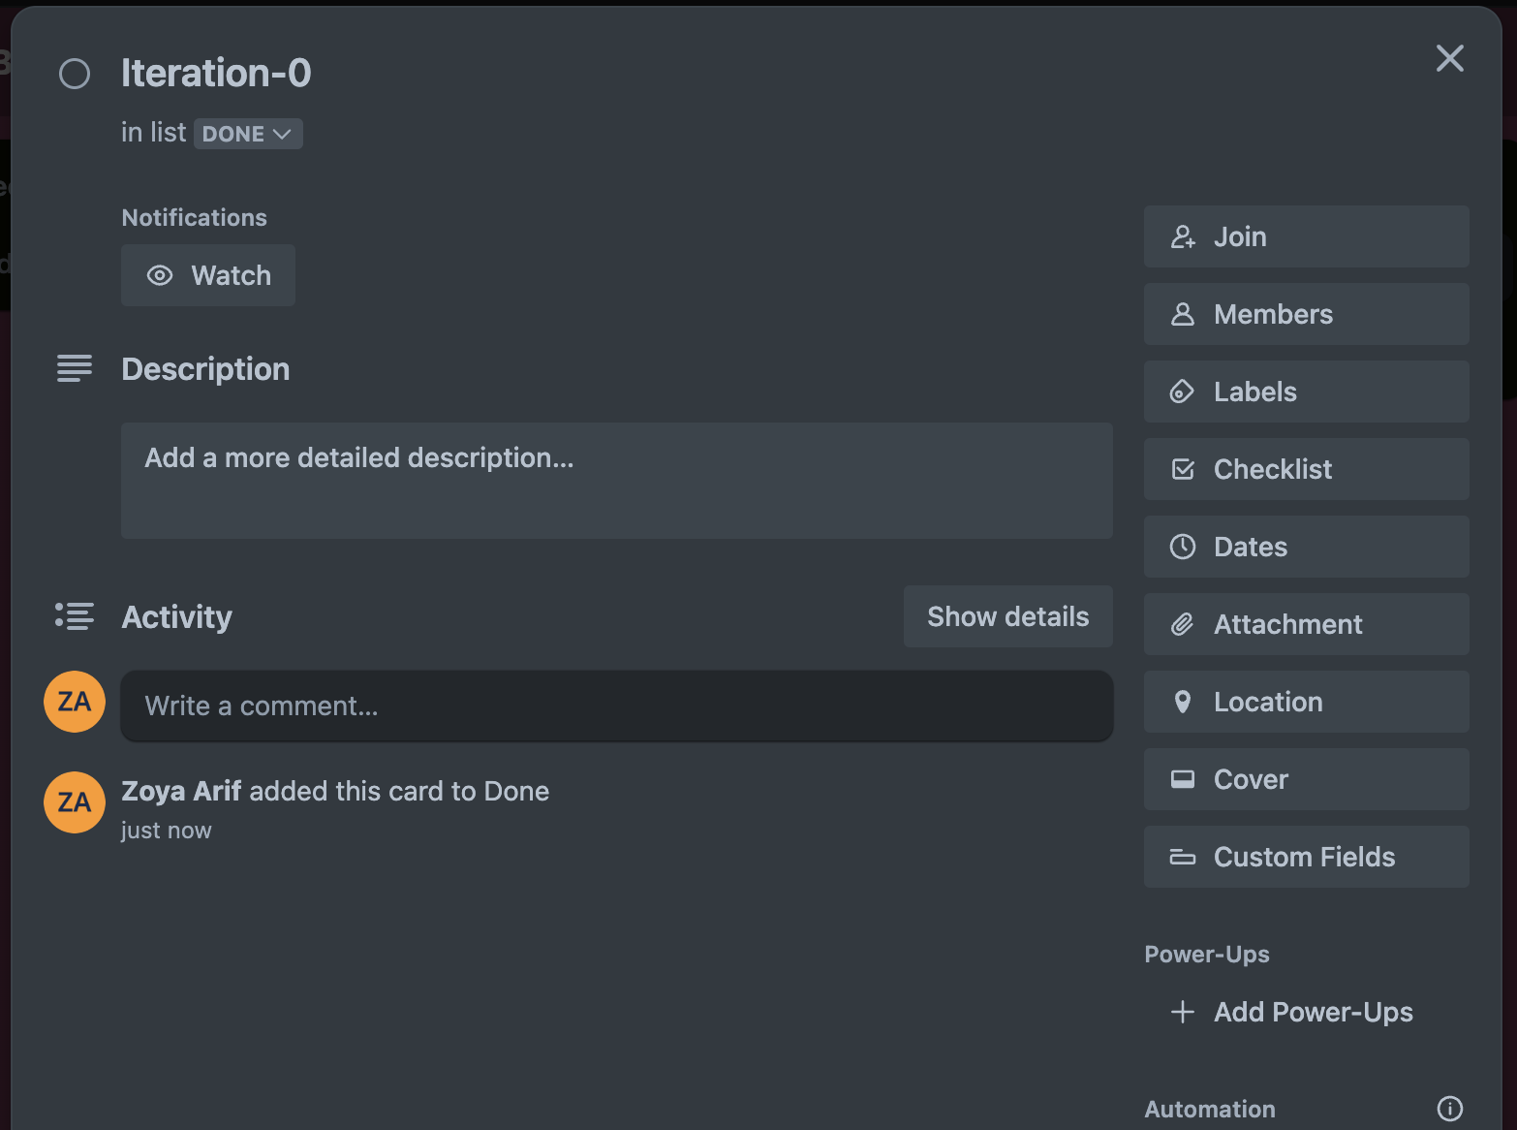

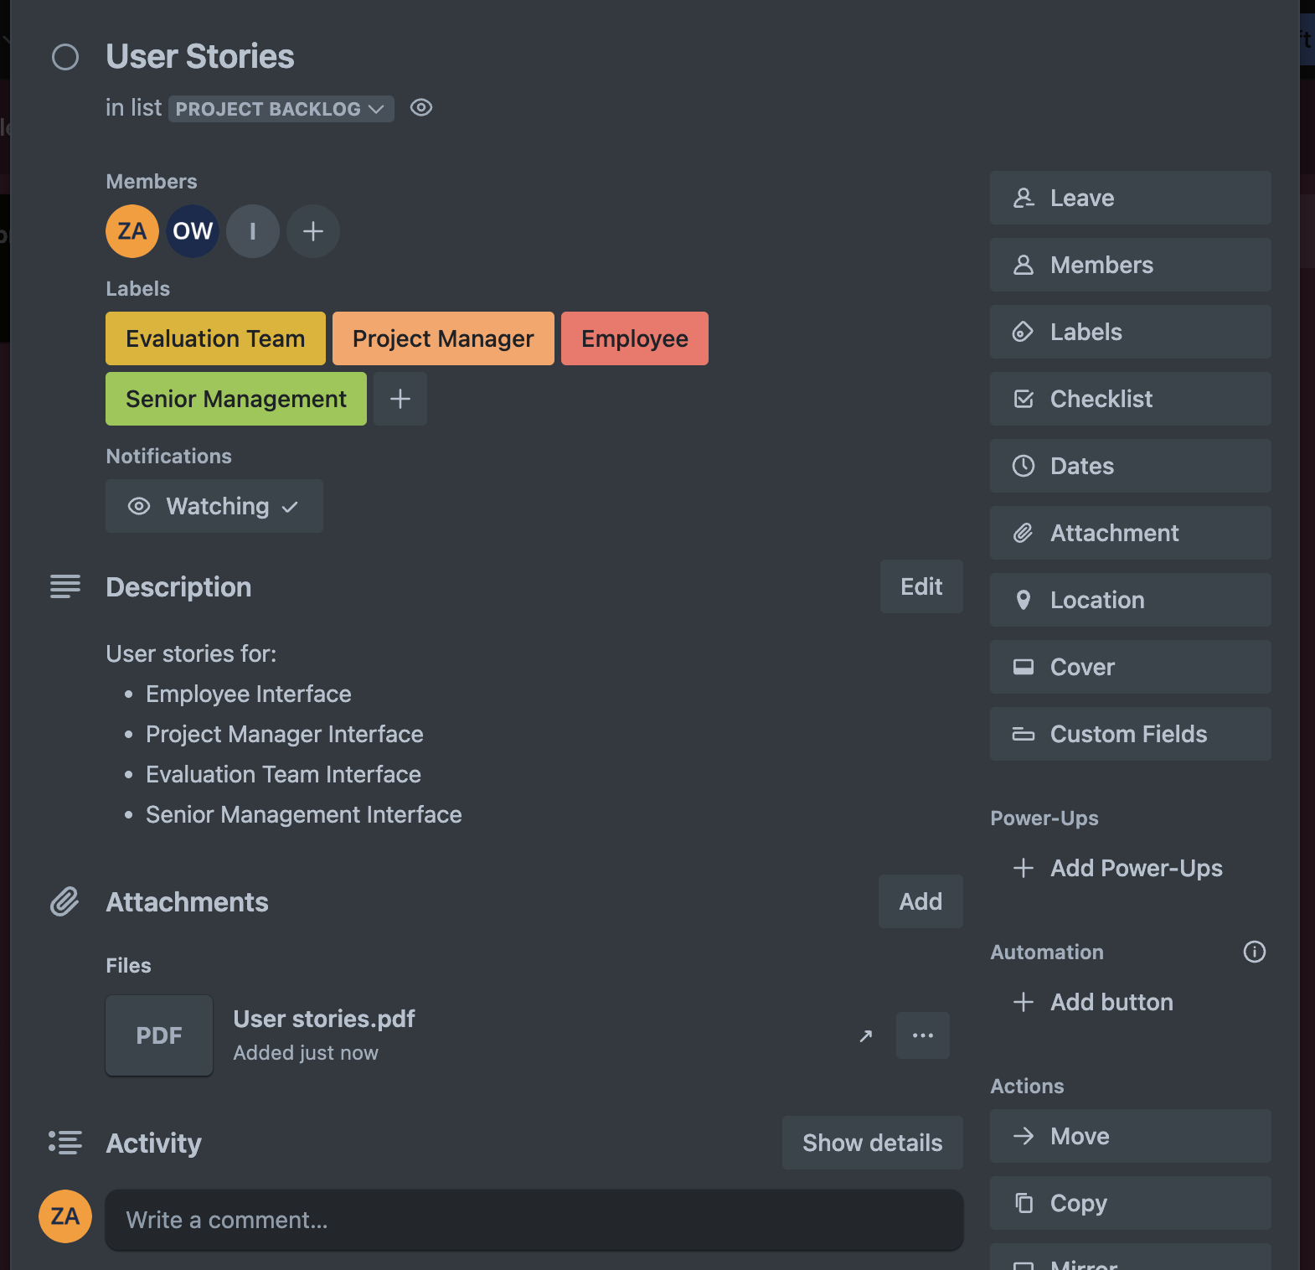

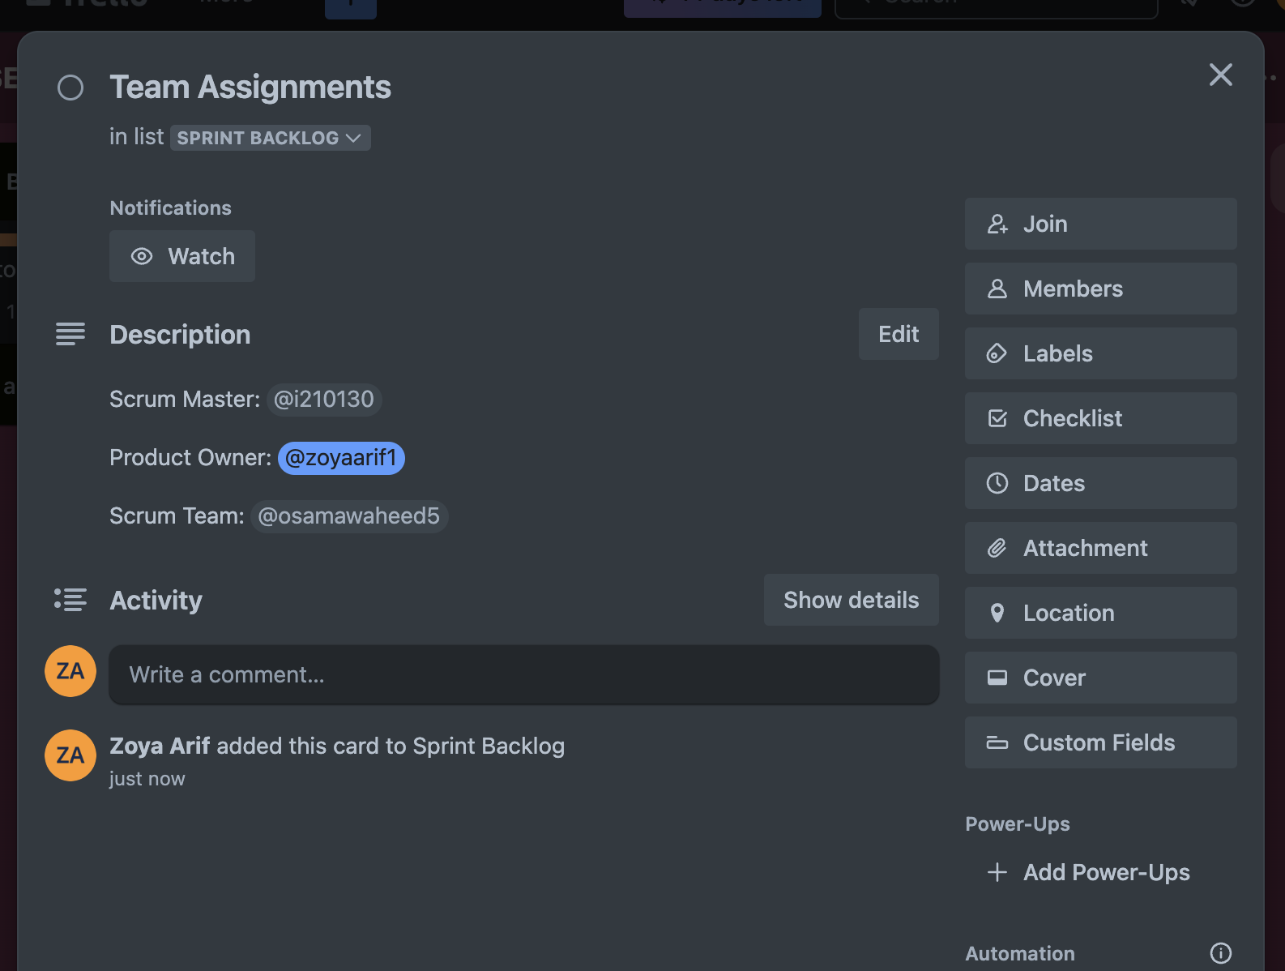

**Github Link**

[**shajianaqvi/SoftwareEngineeringProject**](https://github.com/shajianaqvi/SoftwareEngineeringProject)