Tableau Dashboard Project
Analysis of Tableau-Focused Job Postings
This project focuses on analyzing job postings that require Tableau skills using Tableau. The goal of the dashboard is to provide insights into job demand, salary expectations, experience requirements, and trends over time for Tableau-related roles.
The dataset used contains job postings with details such as job titles, required skills, salary, number of applicants, and posting dates. Using Tableau, multiple visualizations were created to help understand the job market for data-related roles.
Data Preparation
The dataset was imported into Tableau and preprocessed before visualization.
• The “Job Skills” column was split into multiple columns (Split 1, Split 2, Split 3, etc.) to analyze individual skills.
• A calculated field called “Tableau Top 3” was created to identify jobs where Tableau appears within the first three required skills.
• Another calculated field was created to identify all Tableau-related jobs using the CONTAINS function.
• Filters were applied to focus only on relevant job titles such as Data Analyst, Data Engineer, Data Scientist, and Data Science Manager.
Calculated Field
The following calculated fields were created:
1. Tableau Top 3:
This field checks whether Tableau is listed within the first three required skills.
IF LOWER([Job Skills - Split 1]) = "tableau"
OR LOWER([Job Skills - Split 2]) = "tableau"
OR LOWER([Job Skills - Split 3]) = "tableau"
THEN "True"
ELSE "False"
END
2. Tableau Skill:
This field identifies whether Tableau is mentioned anywhere in the job skills.
CONTAINS(LOWER([Job Skills]), "tableau")
DASHBOARD
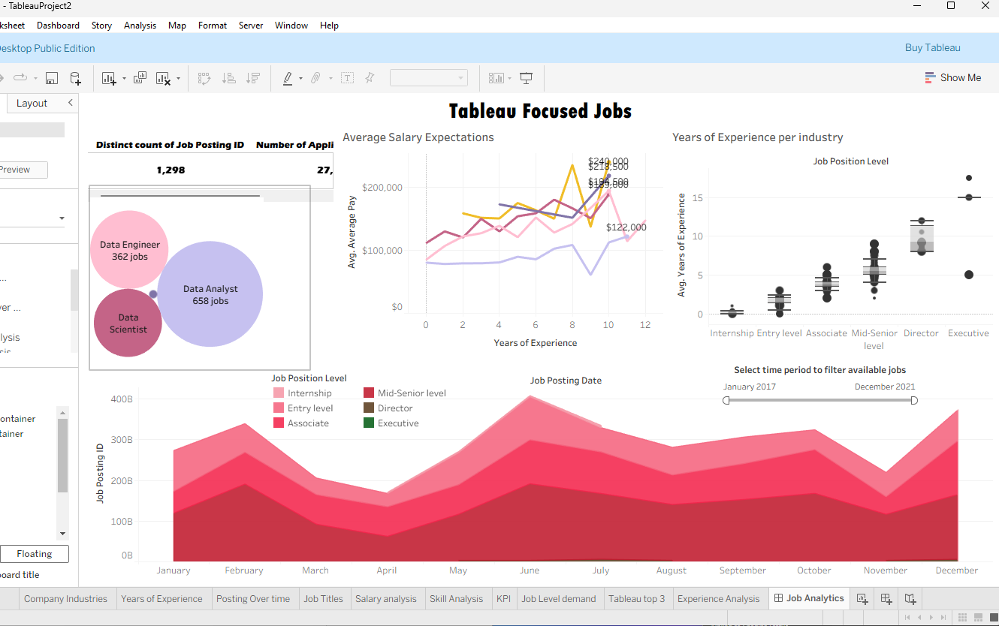

The KPI section provides an overview of the total number of Tableau-related job postings and the total number of applicants.
• Total Job Postings: 1,298
• Total Applicants: 27,335
These values were calculated using COUNTD(Job Posting ID) and SUM(Number of Applicants).
This dashboard provides valuable insights into the demand for Tableau-related jobs. It highlights the most in-demand roles, salary trends, and experience requirements.
Overall, the analysis shows that Data Analyst roles dominate the market, while salaries increase significantly with experience. The dashboard can be used by job seekers and professionals to understand industry trends and make informed career decisions.
SCREENSHOTS
