To integrate Postman execution via Jenkins

- Invoke Jenkins ( applicable for local setup ) ( enabled UTF-8 encoding )
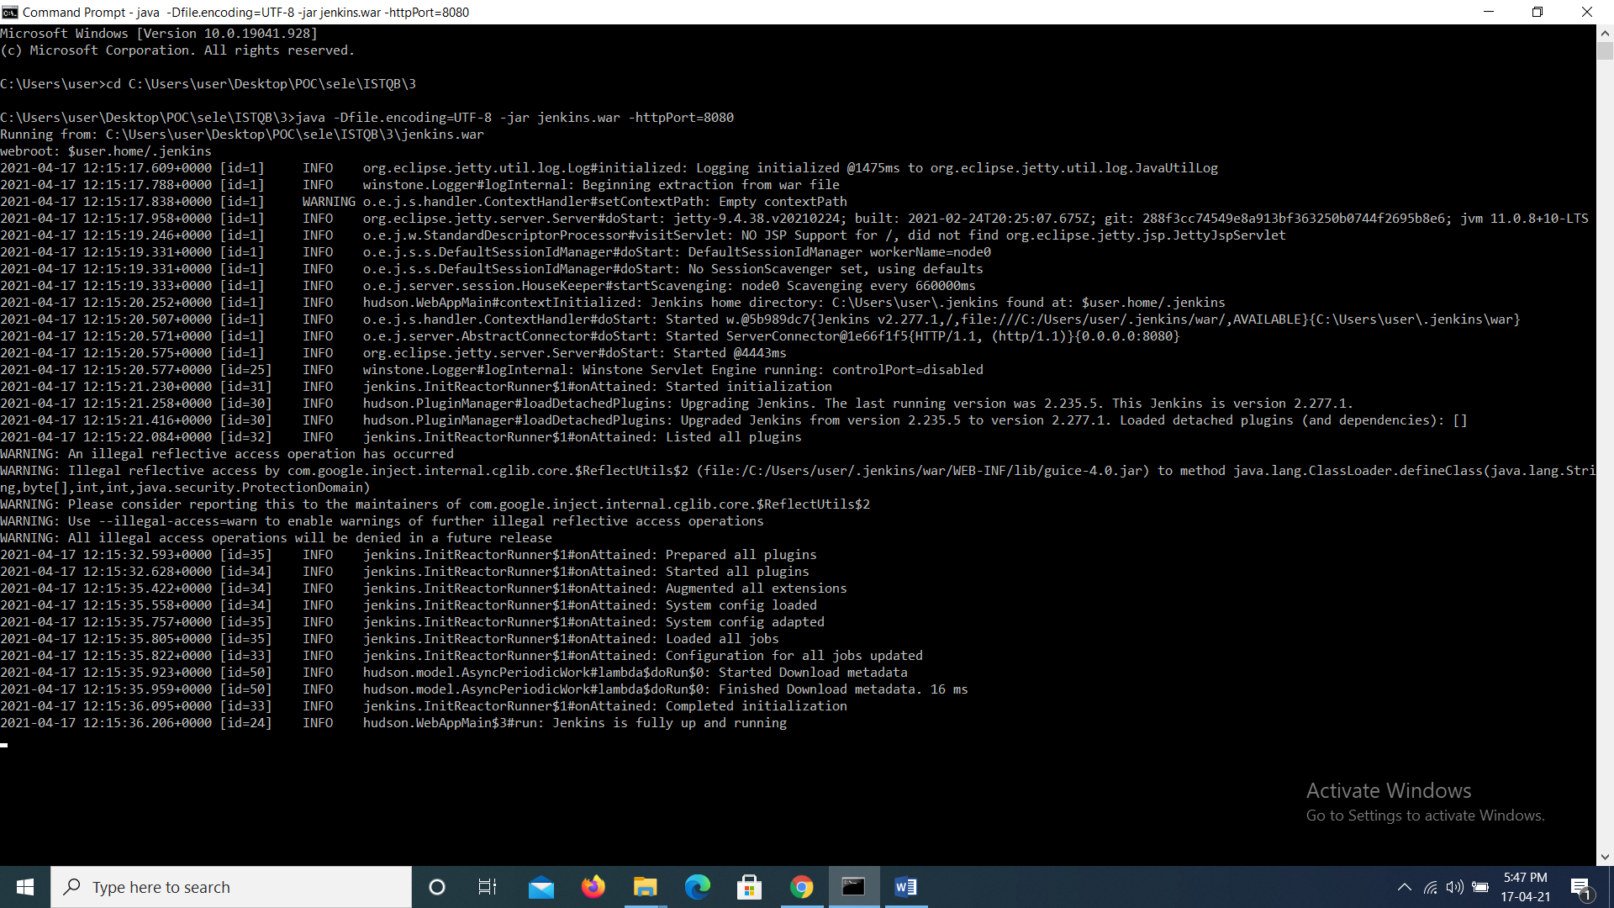

- Login into Jenkins and create a Freestyle Project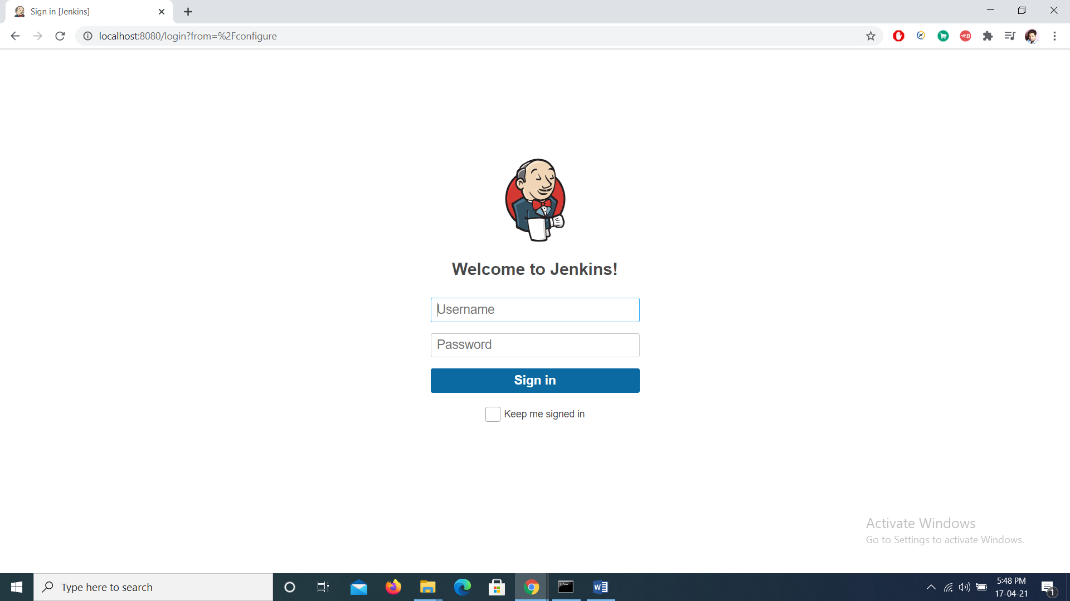
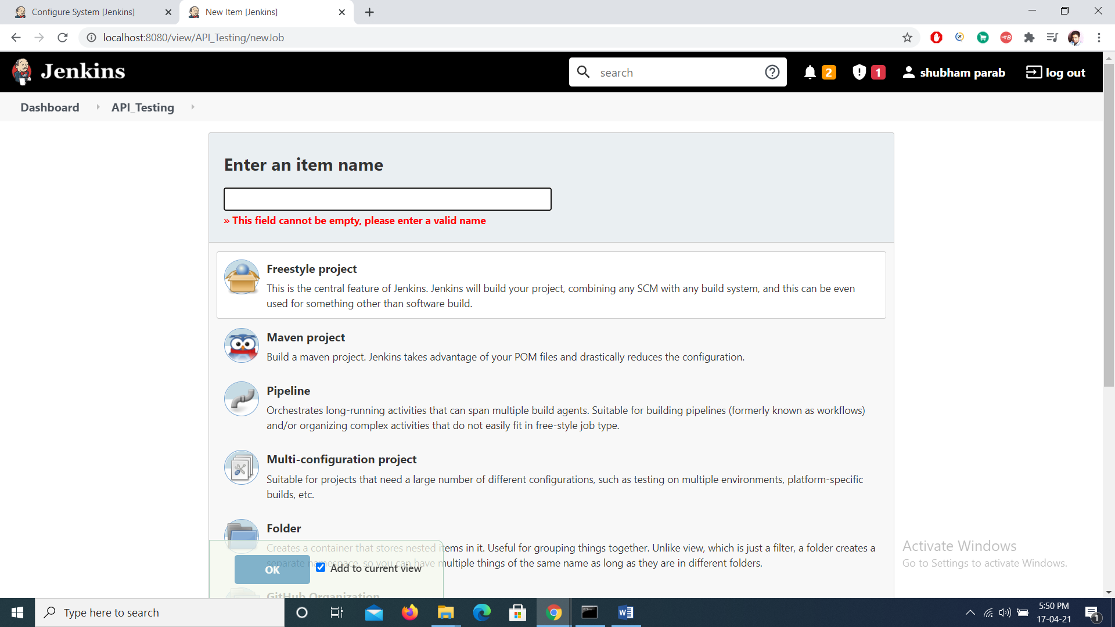
- Once Project is created do following configuration changes
- From dashboard
Manage Jenkins -> Configuration Settings ( set env path as per given in your local system )
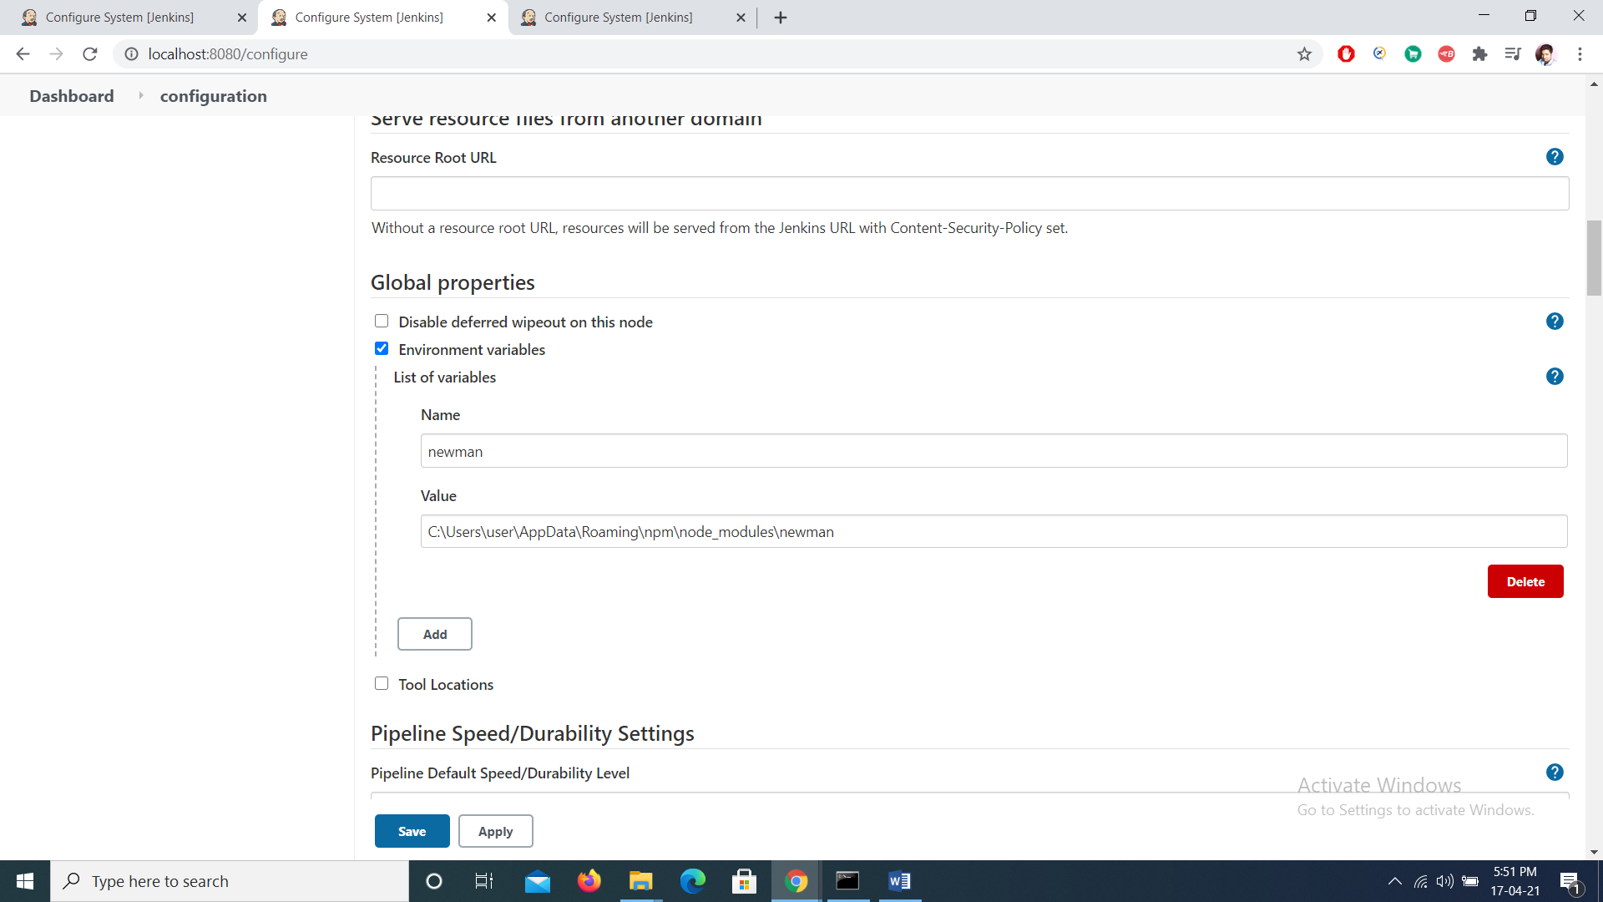
- Global Configuration
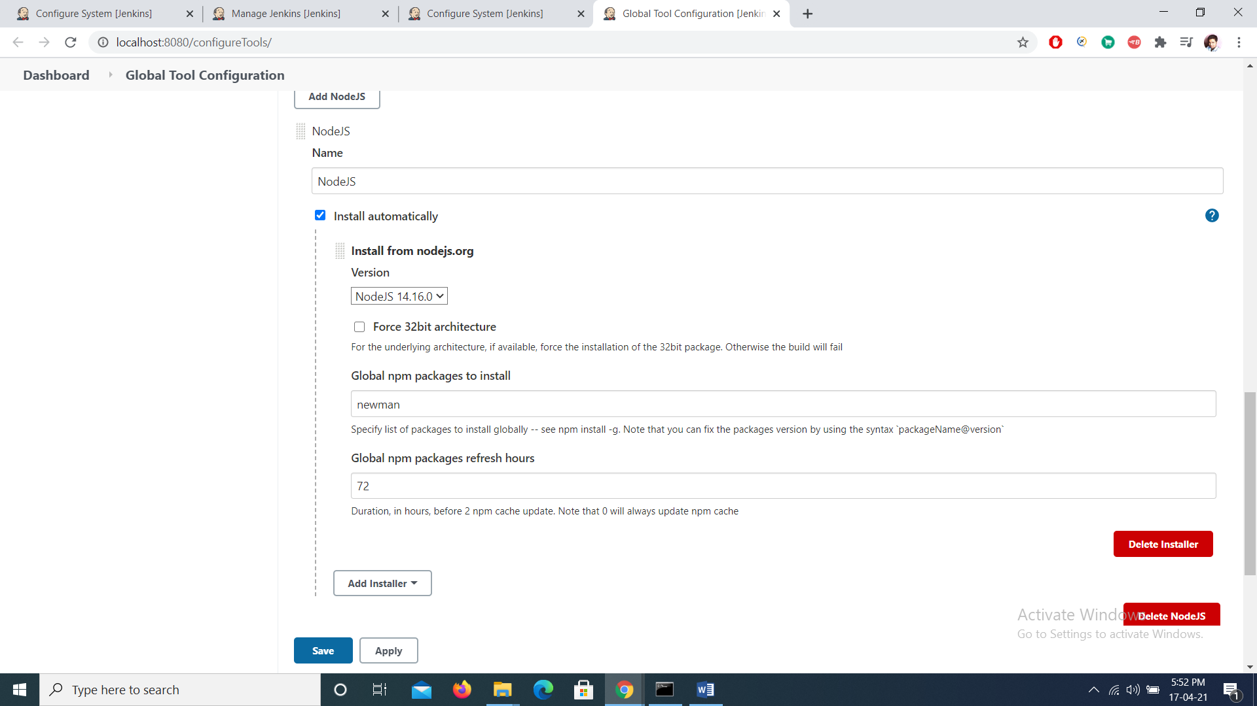

- Configure Project for Execution
Select Windows execute shell ( for windows ) or execute shell ( unix )
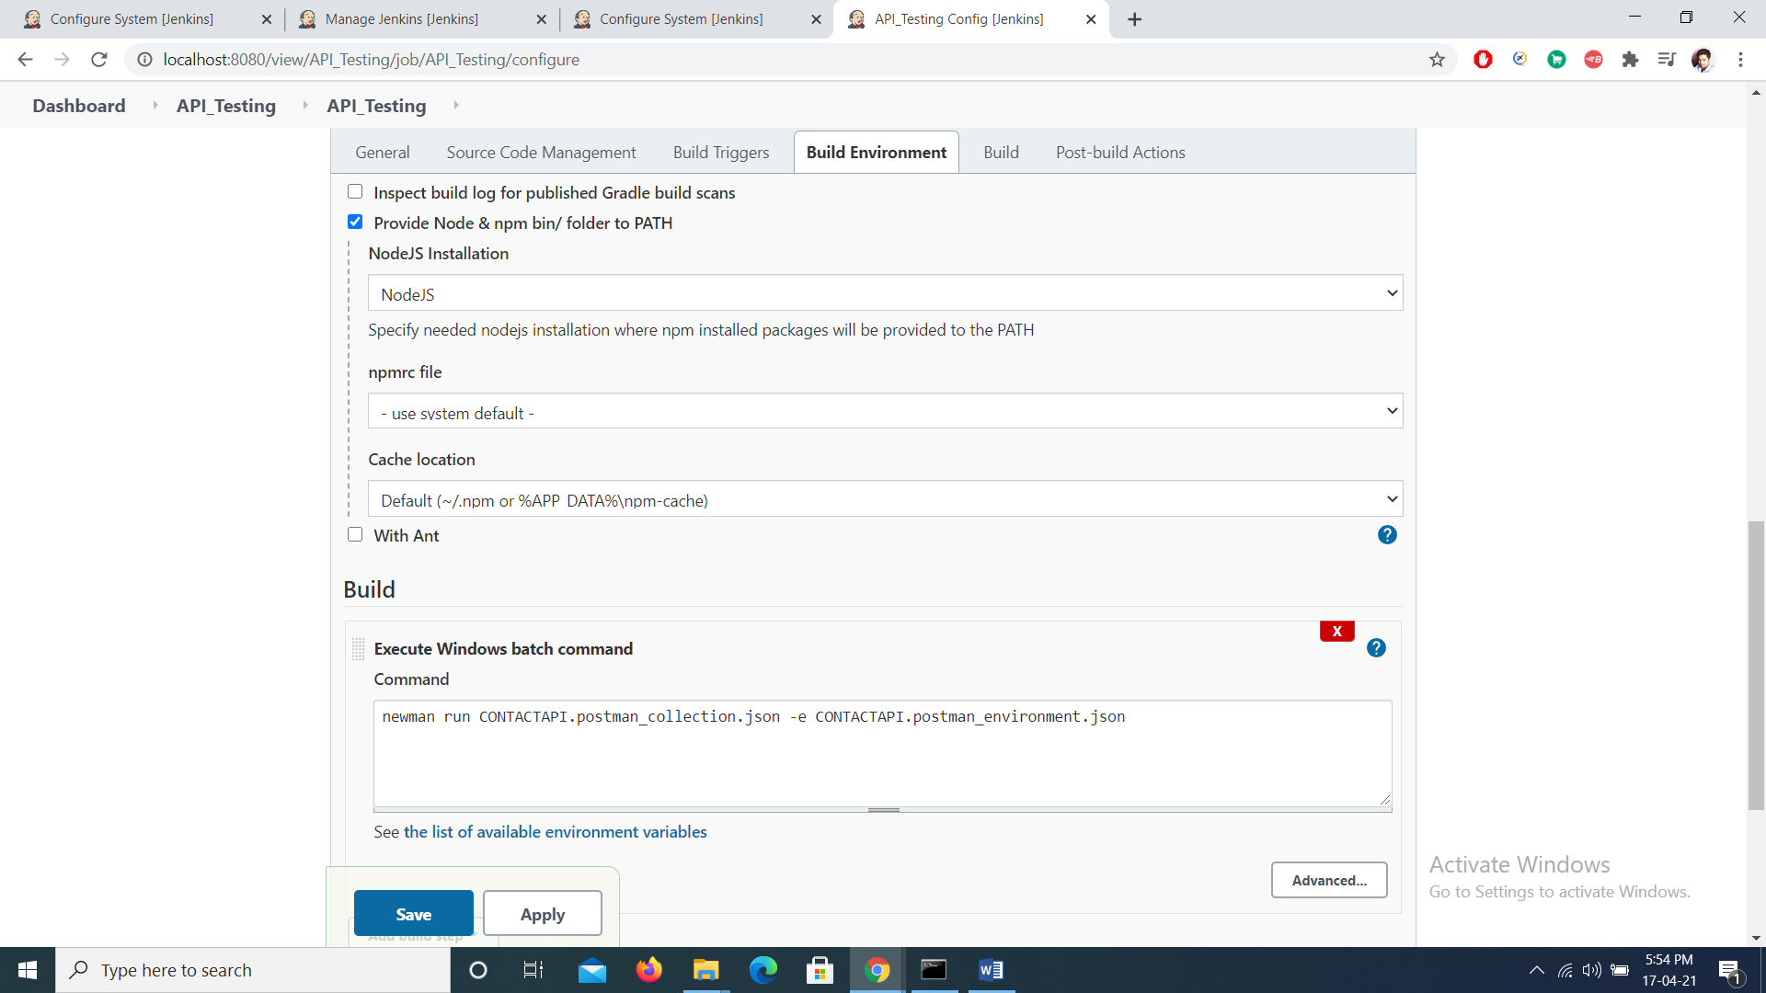

Apply and save .
Click on Build now
Console Will be viewable in project ( go to build -> Console Output )
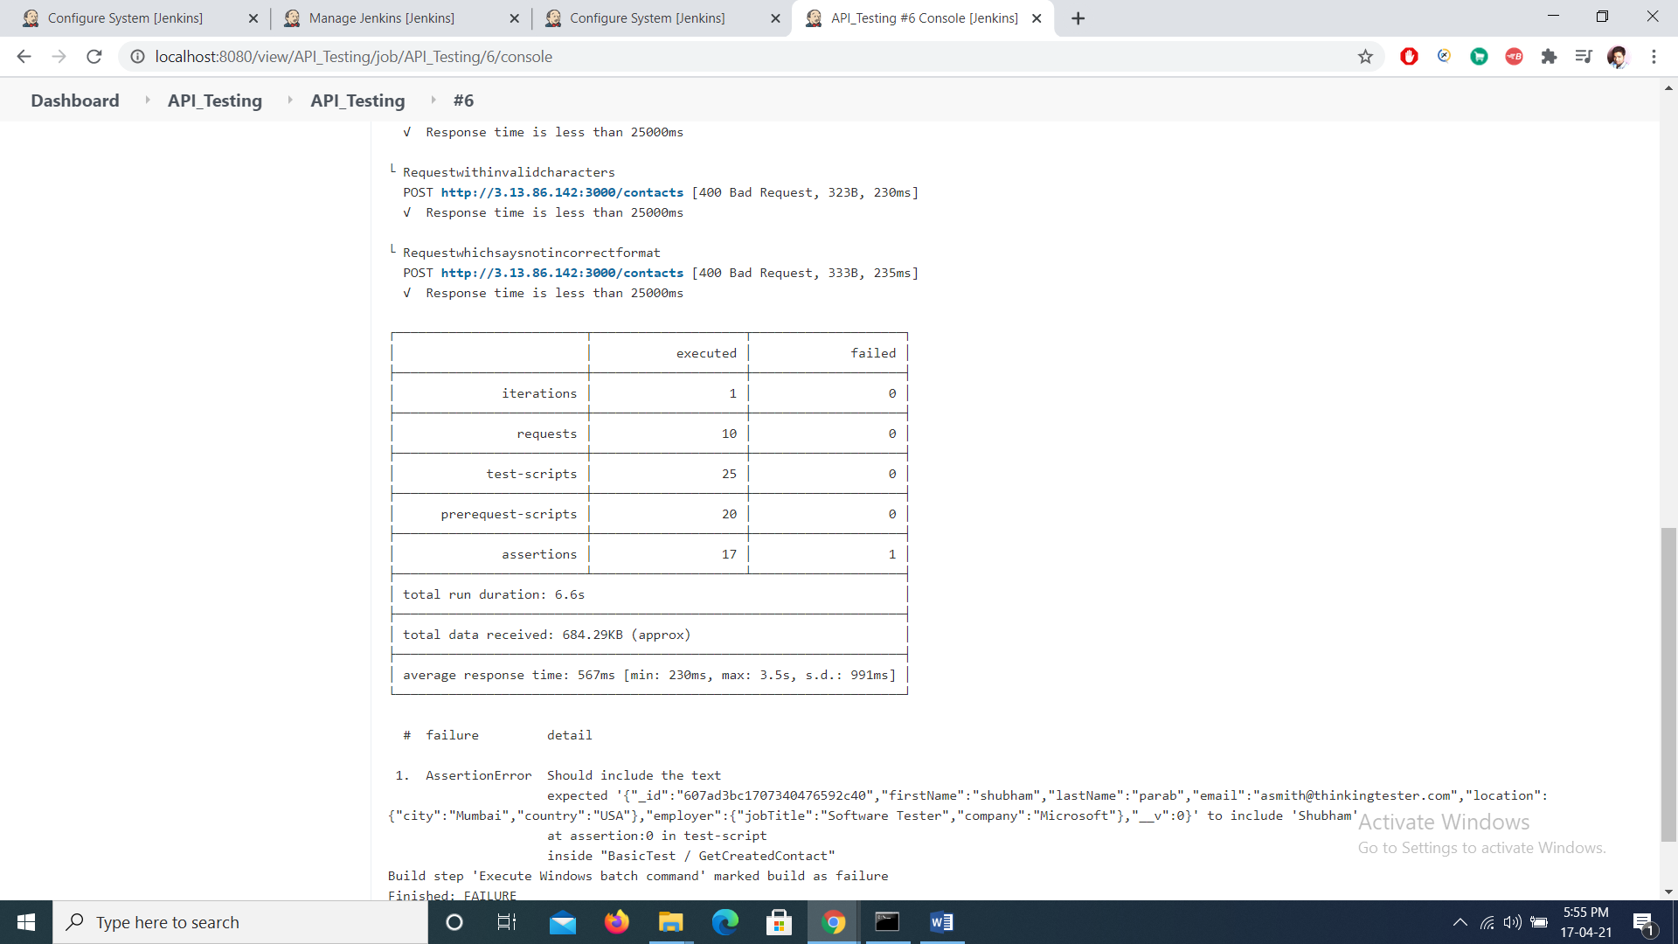

Note : This Document just gives a basic demo of integration with Jenkins
We can further configure nodes js installed in Jenkins by installing several packages like
Newman reporter for generating html reports
To install these packages just add following commands
npm install –g newman-reporter-html
npm install –g newman-reporter-htmlextra

