History
Author | Rev | Date / Remark
S. Kabir | 01 | 03/08/25 <Initial release>d

- Purpose

This document serves as a technical reference for the home server setup running Proxmox 7.x+ The server functions as a private cloud, file server, and virtualization host without internet dependency.
- SCOPE
Tool # | Description
T201 | Private data server.

- Requirements
  - Hardware Requirements
Req # | Description | Test? | Test #
 | Server Hardware (CPU , RAM, Storage)  - Processor (CPU): At minimum of 6 cores and a clock speed of 2GHz that support CPU virtualization  - Memory (RAM):  - At least 16GB DDR4/DDR5  - Storage: At minimum 256GB with RAID for fault tolerance.  - NIC: At least one gigabit Ethernet port  - Graphics: Standard VGA or HDMI output for basic setup (Proxmox supports headless operation but may require a monitor during setup).  - Peripheral I/O: At least two USB ports | Y | None
 | Optionally, a managed network switch with at least 5 port | N
 | Optionally, UPS for power backup | N
 | Optionally, backup storage (External Drive)

  - Software Requirements
Requirement # | Description | Test? | Test #
 | The server must run on a virtualization environment such as Proxmox Virtual Environment must boot up without errors that may inhibit performance. | <Y/N> | <Test#>
The server must provide a private
- File sharing scheme such as SAMBA to offer network drives for mass storage.
- Local cloud content collaboration platform such as Nextcloud.
- Network print server to share printer within the LAN.
- Network scanner server to share scanners within the LAN.
- Docker host to run container applications.
 | The server must provide a test environment which mimics similar test virtualization environment.
 | Optionally, the server may provide a IT configuration automation tool such as Ansible.
 | The server must use a predetermined set of static IP addresses to for its services. The router / switch DHCP settings must be configured suitably such that no IP conflict will occur.

- Equipment / Tools
  - Equipment
    - A flash drive of 16GB+(to create a boot able disk)
    - A broadband internet connection
  - Tools
    - Software
      - Latest Proxmox LTE (.ISO) file
      - A bootable media creation tool such as Rufus
    - <List all software(s)>
- Bill of materials
  - A computer with suitable processing capabilities
  - See BOM (Doc#)
  - <Insert Bill of Materials>
- Procedure
  - <Document detailed implementation steps, prerequisites, test, troubleshooting and routine maintenance procedure.>
  - Preparing Server Hardware
    - Connect a monitor to the server.
    - Power up and enter into motherboard boot screen. In this case “Del” or “F2” button for Asrock brand motherboard.
    - Setup below parameters.
Parameter Path | Parameter | Value / Action
Main | RTC
Advanced \ SVM Mode | CPU Virtualization
Advanced \ PCI Configuration | IO Virtualization
Advanced \ Onboard Devices Configuration | Turn On Onboard LED in S5 | Enabled
 | Restore Onboard LED Default | Disabled
 | RGB LED On / OFF | Off
 | Gnb Hd Audio | Enabled
 | Front Panel | HD
 | Restore On AC Power Loss | Power O
 | Wi-Fi and WAN Radio | Disabled
 | BT On / Off | Disabled
 | PS2 Y-Cable | Auto
Advanced \ Storage Configuration | AHCI | None
Advanced \ ACPI Configuration | Suspend to RAM | Auto
 | Deep Sleep | Disabled
 | PS/2 Wakeup | Disabled
 | RTC Alarm Power On | By OS
 | USB PD in S5 | Disabled
Advanced \ AMD CBS\ NBIO Common Options | IOMMU | Enabled
 | DMA Protection | Auto
 | DMAr Support | Auto
 | PCIe ARI Support | Auto
 | HD Audio Enable | Auto
Boot | Priority during OS installation | Need basis
OC Tweaker | Save User Profile in BIOS or Flash | Recommended, Production V1.0 PATH: TBD
Exit | Save Changes and Exit | Yes

    - Bootable disk
      - Create bootable disk on a separate machine from the server OS ISO file.
    - Install the OS
      - Insert the bootable flash drive on a server USB port and then reboot the server.
      - Boot from the flash device
      - Rest TBD.
  - First Time Boot/ Setup:
  - Setting up Ansible Control Node
    - Ansible control node can be any computer that is connected to the same local network. Below setup is for Windows 10 machine WSL2. Windows 11 inherently supports WSL. If using a Linux machine, skip this.
      - Run “wsl2-install-win10.ps1” from “bash-scripts”. Launch Windows PowerShell in admin mode. May need to run below command to bypass security. Restart the computer for the changes take effect.
Set-ExecutionPolicy -Scope Process -ExecutionPolicy Bypass
      - Check installation by running below command which should yield following.
wsl --list --verbose
NAME STATE VERSION
* Ubuntu Stopped 2
Debian Stopped
      - Here two version installed. To launch either, use below command.
wsl -d <DistroName>
      - Follow on screen instructions to setup account. It should by default have networking configured. Therefore it should have visibility to your local ` network and internet.

Note: WSL2 runs as a lightweight virtual machine using a Hyper-V-based virtual Ethernet adapter. WSL connects to a virtual gateway inside Windows, and Windows acts as a NAT router for it.
      - (Optional)Map a shared folder
sudo mkdir -p /mnt/<name of the drive>
sudo mount -t drvfs <drive_letter>: /mnt/<drive_letter>
      - Next, run setup-control-node.sh from the control node. But first, copy it to the control node and then make the script executable. Best practice is to copy it to the control node.

Note: The shared drives is not mounted automatically. Which can be done if necessary.
# Optional: create a target directory in WSL
mkdir -p ~/ansible/wsl
# Optional: Copy from the C:\ drive
cp /mnt/c/<actual_path>/setup-control-node.sh ~/ansible/wsl/
# Make it executable
chmod +x ~/ansible/wsl/setup-control-node.sh
# Run it
~/ansible/wsl/setup-control-node.sh
      - Ping main production server from WSL and then generate SSH key pair. Accept default path. Optionally, use pass phrase for added security.

Note: Last part is comment.
ssh-keygen -t rsa -b 4096 -f ~/.ssh/ansible_id_rsa_ansible-user -C "ansible-user@control_node"
      - Remove old keys for server from control node if needeed. It will throw error if the server has changed.

Note: Set temporarily “PasswordAuthentication yes” using nano /etc/ssh/sshd_config.
ssh-keygen -f "/home/rumie/.ssh/known_hosts" -R "192.168.0.111"
      - Next, copy the SSH public key to main prod server from control node. Now, Ansible utilize passwordless secure login.
//ssh-copy-id username@<main_prod_server_ip_addr>
      - To view the public key use below command
//cat ~/.ssh/id_ed25519.pub
      - Next, create users on the main production server using following command.
ansible-playbook playbooks/bootstrap.yml \

-l pve_main \
-u rumie \
--ask-become-pass --check
ansible-playbook playbooks/validate-bootstrap.yml -l pve_main
      - SSH in to the main production server to allow passwordless sudo escalation for admins. Its safe since we are using SSH keys to login.
echo "prodadmin ALL=(ALL) NOPASSWD: ALL" | sudo tee /etc/sudoers.d/prodadmin
      - Next, run hardening
ANSIBLE_CONFIG=inventories/prod/ansible.cfg ansible-playbook playbooks/harden.yml -l prod_main
      - (Optional) Upgrade to version from version 7.x if needed. There is a known bug that causes PVE 8.x installation to freeze. Therefore, install 7.x first and then upgrade to 8.x via below command.
ANSIBLE_CONFIG=inventories/prod/ansible.cfg ansible-playbook playbooks/upgrade-to-pve8.yml -l prod_main --ask-vault-pass
      - Run a basic check, “changed” means passed.
ANSIBLE_CONFIG=inventories/prod/ansible.cfg ansible-playbook playbooks/check-basics.yml -l prod_main

  - To create new ansible-role folder structure
ansible-galaxy init ansible/roles/role-name/
  - Print Server CUPS
    - VM Setup
      - To set up CUPS. Run the “print-server” play.
ansible-playbook playbooks/create-print-server.yml --ask-vault-pass
      - If the printer is not added properly, connect the printer via USB port and add the printer from hardware properties.
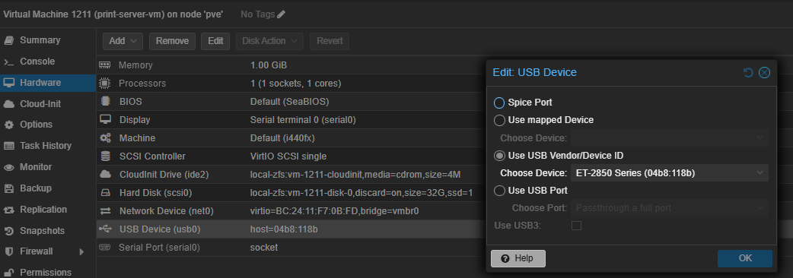
        - The set up is optimized for an EPSON ET-2850 series printer. Therfore, changes may be made to accommodate for a different series printer.
        - TODO: Add roles for automatically adding the printer via USB.
    - Fine Tuning
      - Printer Side
        - Goto the printer UI and reset all settings.
        - Turn the WIFI off, we don’t need it anymore!
        - To help suppress some warnings related to page size, disable auto page size switching and then set paper size to A4.
        - Finally, save all changes.
      - Server Side
        - Navigate to server ip:631/admin. We can use server root credentials to authorize any changes.
        - Next, click “Add Printer” and pick one from local.
        - Check to share the printer if not already set bu Ansible.
        - For driver, it was found that “IPP Everywhere” works better than “Epson factory driver” or “Driverless” configuration. Also, it appears that factory driver seems to execute print job super slow!
        - Add Printer and authorize by entering the root credentials.
        - Also, make changes “Set Default Options” to change the paper size to A4 if not set already.
      - User Side
        - On a windows machine, add the printer.
        - Then go to settings to set the paper size to A4.
        - Click apply to apply all changes. This should suppress the warnings related to paper size mismatch warnings.
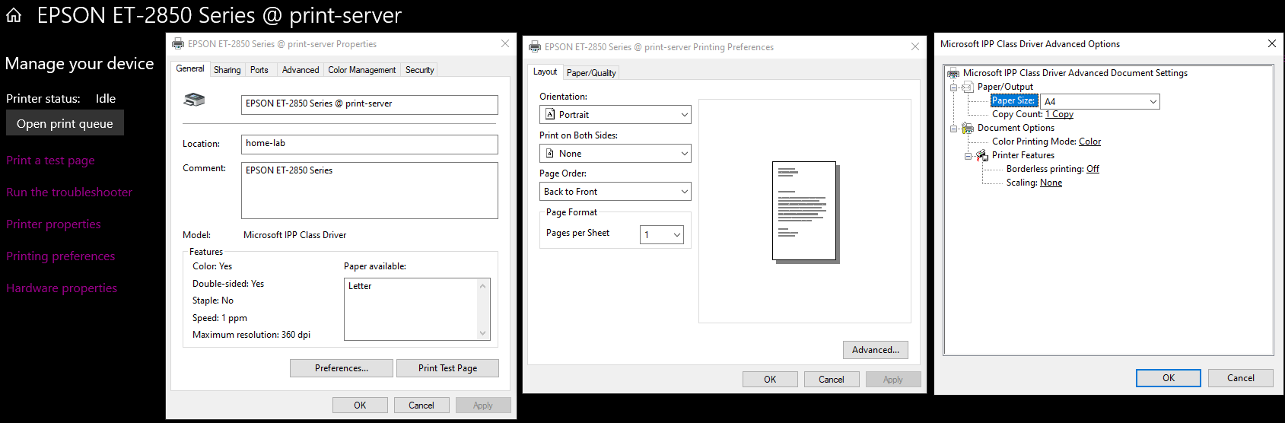
  - Samba File Server
    - HDDs structure for reference.
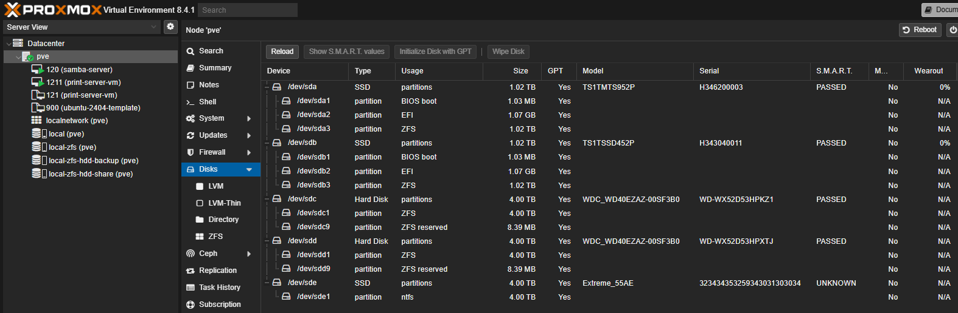
    - Create the ZFS mirror from bulk HDDs.
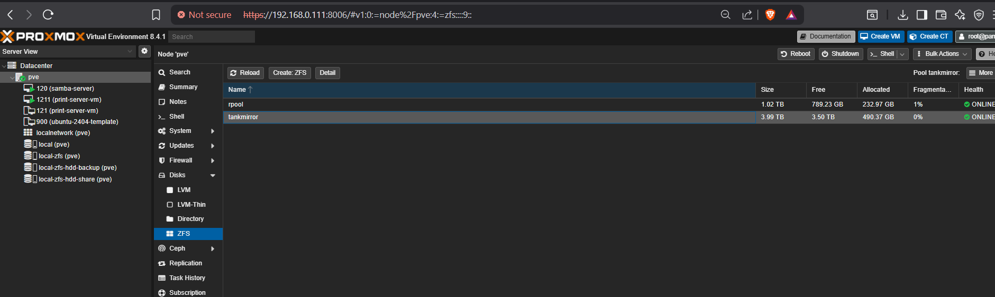
ansible-playbook playbooks/create-file-server.yml --ask-vault-pass

- Routine maintenance
  - <List routine maintenance procedure and intervals>
- Appendix A References
  - <List continues>

- Appendix B Definitions / acronyms
TERM | MEANING | TERM | MEANING
LTS | Long Term Support

- Appendix Diagrams
- Appendix Bill of materials
  - <List Bill of materials>

- Appendix D Testing Validation
  - Equipment / Materials
    - Equipment
      - <Equipment>
    - Materials
      - <Material>
  - Prerequisites
    - <List prerequisites if any>
  - Test configuration(s) information
Item | Configuration
  - Test Instruction
Requirment# | Description | Test? | Pass?
 | <First one> | Y/N | Y/N

- Appendix C Usage instruction
  - <Document special usage instruction if any>

- Appendix Diagrams

