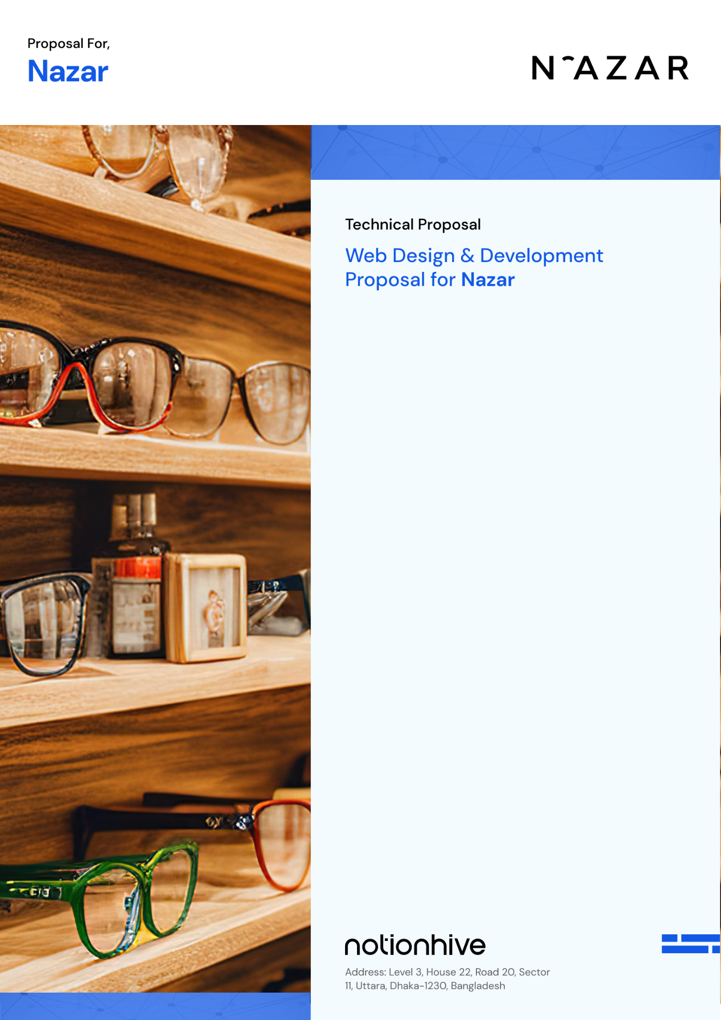

**Table of Contents**

|  |
| --- |
| **Technical Proposal 3**  **1. Introduction: 3**  1.1 Project Understanding: 4  **2. Specifications: 6**  2.1 Custom Website Architecture 6  **3. Website Reference: 11**  **4. UX Strategy: 11**  **5. Proposed Technology Stack: 12**  **6. System Features: 13**  **7. Scope Summary: 14**  **8. Project Management Approach: 17**  **9.** **Cost Breakdown 18**  **10****. Terms & Conditions:** |

**19**

# **Technical Proposal**

# **Introduction:**

We are excited to present our proposal for the development of a custom-built website for **Nazar**, a pioneering eyewear brand launched by United Group. As the first of its kind in Bangladesh, Nazar introduces a new era of **branded, authentic spectacles and eyewear**, offering customers premium quality and style under one trusted name.

This digital platform will serve as the central destination for Nazar’s target audience, providing seamless access to their curated collection of eyeglasses, sunglasses, and optical accessories. Our vision is to build a **visually striking, easy-to-navigate, and highly functional website** that captures the essence of Nazar’s brand ethos: **clarity, confidence, and contemporary design**.

With a focus on delivering a smooth and engaging shopping experience across all devices, this platform will empower customers to explore, choose, and purchase with ease—while reinforcing Nazar’s identity as a symbol of authenticity and innovation in Bangladesh’s eyewear market.

**Objective**

The objective of this project is to develop a **custom-built, fully responsive website** for **Nazar**, the first branded eyewear line in Bangladesh by United Group. The platform will serve as a **stylish and informative digital presence**, allowing users to explore Nazar’s range of authentic spectacles and sunglasses.

Key objectives include:

* **Showcasing the Product Range:** Present Nazar’s premium eyewear collection with high-quality visuals and clear product information.
* **Reflecting Brand Identity:** Design a modern, elegant interface that embodies Nazar’s values of authenticity, innovation, and style.
* **Enhancing User Experience:** Ensure intuitive navigation and an engaging layout for smooth browsing across all devices.
* **Mobile-First Accessibility:** Build a responsive design optimized for mobile, tablet, and desktop users.
* **Supporting Brand Awareness:** Position Nazar as a pioneer in the local eyewear market through impactful storytelling and visual design.
* **Scalability and Flexibility:** Create a platform that can grow with the brand, allowing for future content updates and feature enhancements.

This website will help Nazar build brand recognition, connect with its target audience, and establish a strong digital footprint in Bangladesh’s eyewear industry.

## **1.1 Project Understanding**:

We understand that the goal of this project is to create a **visually engaging, user-friendly website** for **Nazar**, a new eyewear brand by United Group and the first of its kind in Bangladesh. The website will act as a **digital showroom**, showcasing Nazar’s collection of premium, authentic spectacles and sunglasses to a broad audience.

Our approach is to design a custom-built platform that **reflects Nazar’s brand values**—style, authenticity, and innovation—while ensuring a smooth, intuitive experience across all devices. The site will be structured to highlight the product range with high-quality visuals, brand storytelling, and essential product details, enabling visitors to explore and connect with the brand effortlessly.

Key elements of our strategy include:

* Creating a **clean and modern visual layout** that resonates with fashion-conscious users
* Ensuring **mobile-first, responsive design** for optimal user experience
* Highlighting **product features and brand story** through engaging content
* Designing with **scalability** in mind for future updates and expansions

This website will serve as a strong digital foundation for Nazar’s brand journey, positioning it as a trendsetter in Bangladesh’s eyewear industry and building trust with its target audience.

User-Friendly CMS: We propose the implementation of a user-friendly content management system (CMS) that empowers the webmaster to effortlessly manage and update content, ensuring agility and responsiveness in addressing evolving needs.

Enhanced UX/UI: Our design philosophy revolves around creating a seamless and intuitive user experience (UX/UI) that enables visitors to navigate the website with ease, find relevant information efficiently, and engage with the offerings effortlessly.

In essence, our proposal encapsulates our dedication to delivering a platform that not only meets but also exceeds user expectations, setting the stage for continued growth, engagement, and success in the digital landscape.

# **Specifications:**

# **2.1 Custom Website Architecture**:

The website for **Nazar** will serve as a **visually compelling and user-centric platform**, designed to showcase the brand’s premium eyewear collection. Our goal is to create a clear and intuitive structure that allows visitors to **easily explore products, learn about the brand**, and navigate with ease.

The architecture will prioritize **simplicity, responsiveness, and scalability**, ensuring a seamless experience across all devices while supporting future content growth.

|  |  |  |
| --- | --- | --- |
| **Information Architecture** | | |
| **Serial** | **Page/Screen Name** | **Description/Notes** |
| 1 | Home | - Section containing banner carousel along with CTA (Call to actions) button  - Banner section showcasing various frames in an attractive layout, where clicking on a highlighted frame will redirect the user to its detailed page  - Section featuring featured collection along with explore button  - Section showing new arrivals in a unique way to showcase the products  - Section showcasing the USPs [Change the way you see the world]  - A grid carousel section to view the spectacles using brands  - Section featuring stores along with the location and CTA [Visit us]  - Floating banner containing Contact Us and About Us CTA to redirect the user to the specific page  - Newsletter signup section |
| 2 | Collections | - The user will find the category lists once they hover over the collections  - Under the collection, the user will get all opticals, sunglass, eyeglass, special eyewear, special eyewear, new arrivals, best sellers, etc.  - Once the user clicks on this category, the user will be redirected to the specific product category landing page |
| 2.1 | All Optical | - Banner  - Section showcasing the categories and under the categories the user will get the product along with the title, short description and view more button  - Clicking on the view more button will redirect the user to the specific product details page  - Floating banner containing Contact Us and Store Location CTA to redirect the user to the specific page |
| 2.2 | Sunglass | - Banner  - Section showcasing the categories and under the categories the user will get the product along with the title, short description and view more button  - Clicking on the view more button will redirect the user to the specific product details page  - Floating banner containing Contact Us and Store Location CTA to redirect the user to the specific page |
| 2.3 | Eyeglass | - Banner  - Section showcasing the categories and under the categories the user will get the product along with the title, short description and view more button  - Clicking on the view more button will redirect the user to the specific product details page  - Floating banner containing Contact Us and Store Location CTA to redirect the user to the specific page |
| 2.4 | Special Eyewear | - Banner  - Section showcasing the categories and under the categories the user will get the product along with the title, short description and view more button  - Clicking on the view more button will redirect the user to the specific product details page  - Floating banner containing Contact Us and Store Location CTA to redirect the user to the specific page |
| 2.4 | New Arrivals | - Banner  - Section showcasing the new arrival products along with a video and product image  - Clicking on the view more button will redirect the user to the specific product details page  - Section featuring USPs  - Floating banner containing Contact Us and Store Location CTA to redirect the user to the specific page |
| 2.5 | Best Sellers | - Banner  - Section showcasing best-selling products  - Clicking on the view more button will redirect the user to the specific product details page  - Section featuring USPs  - Floating banner containing Contact Us and Store location CTA to redirect the user to the specific page |
| 3 | Product Details | - Banner containing the product image with a short description in the corner  - Section containing the product name  - Multiple product image viewing options  - Options for configuring the product, product types, etc  - Section containing product price with offer  - Option for viewing the store location  - Accordions for product description & FAQs  - Section representing the geometrical presentation of the product [By clicking on the marks, the user can view the specific specifications for each component  - Section containing more related products |
| 4 | About us | - Banner  - Section containing the short story/history of Nazar  - Section containing why our products are best  - Section containing statistics (total types of products, total selling products, happy customers, etc)  - Section containing upcoming new products  - Section containing USPs |
| 5 | Generic Inner | - Generic Inner is the layout of a standard inner page.  Standard inner pages are flexible layouts that can  support almost any type of content, including,  but not limited to text, images, videos,  tables, accordions, etc. |
| 6 | Lifestyle | - Categorized news and blogs listed in a grid arrangement  - The filter option allows users to customize the content based on their specific needs |
| 7 | Lifestyle Details | - Banner section  - Author and news source  - Brief introduction summarizing the main points or purpose of the post  - Main body of the insights divided into logical sections with headings and subheadings as necessary  - Relevant multimedia content to enhance the readability and engagement of the insights  - Links to other related insights on similar topics  - Options to easily share insights on various social media platforms |
| 8 | Visit us [Outlets] | - Banner  - Section featuring the outlets list; clicking on the list, the user can view the outlet address along with Google map location  - Clicking on the Google map will engage the user to Google map  - Section showcasing an interactive map where user can view the map and engage |
| 9 | Contact us | - Banner  - Section containing form with dropdown options to identify contacting purpose  - An email will be sent to the admin with the details; nothing will be stored in the web server for security  - Section showing address |
| 10 | Search | - Dynamic search  - Optimized search results  - Filter options by category |
| 11 | Privacy Policy | - Details on what user data is collected (name, email, etc.)  - Information on how data is used and stored (including GDPR compliance) |
| 12 | Terms & Conditions | - Explain the terms of using the website and services  - Detail the payment/refund policies, service agreements, and limitations |

|  |
| --- |
| **Header** |
| - Logo  - Navigation  - Search  - Breadcrumb navigation (e.g., Home > Collections) |

|  |
| --- |
| **Footer** |
| - Copyright Notice  - Social Profile Links  - Address  - Newsletter  - Copyright Notice  - Terms & Conditions  - Privacy Policy  - Trust badges  - Customer service information (contact email, phone number) |

# **Website Reference:**

* [Hello Visionist](https://hellovisionist.com/)
* [Orgreen Optics](https://www.orgreenoptics.com/)
* [Garrettleight](https://www.garrettleight.com/)
* [Owl Optics](https://www.owloptics.com/en/shop)
* [Max & Tiber](https://www.maxandtiber.com/ch_fr/)
* [Rolf Spectacles](https://www.rolf-spectacles.com/)
* [Cubitts](https://cubitts.com/)
* [Oxydo Eyewear](https://oxydoeyewear.tumblr.com/)

# **UX Strategy:**

* **Design Aspiration**
  + - Design and develop a unique, secure, and dynamic world-class Website
    - Welcoming
    - Warm & Lively
    - Modern & Elegant
* **Functional Aspiration**
  + - Organized
    - User friendly
    - Easy navigation
    - Minimum clicks/ taps
* **Core Design Principles**
  + - Design for the target audience
    - Take the organization’s goals into account
    - Make the site easy to learn and use
    - Conversion-driven
    - The human experience is given the highest priority
    - Make it satisfying and pleasant
* **Strategies**
  + - Optimized UI & UX
    - Improved IA
    - Mobile-first, responsive designs
    - Increased user engagement & conversions
    - Continuous improvement
* **Optimized UI & UX**
  + - Simplified and short user journeys
    - Seamless experience across all devices
    - Cleaner, simpler, more user-friendly UI
    - Clear call to action wherever possible to drive conversions
    - Reduce visual complexity
    - Use standard design patterns
    - Consistent UI components
    - Legible, clear, and high-contrast typography with a logical hierarchy of information (Skimmable content)
* **Mobile-first responsive design**
  + - Mobile-first design
    - Mobile users account for around 80% of all your visitors
    - Prioritizing the mobile experience will increase conversions.
    - Google favors mobile-optimized sites

# **Proposed Technology Stack:**

Below, we have proposed a technology stack specifically tailored for the development of your website. These have been chosen to align with your project requirements and ensure optimal performance, scalability, and user experience. Once your team reviews and confirms, we will proceed with the development process accordingly.

| **Category** | **Frontend** | **Backend** | **CMS** | **Database** |
| --- | --- | --- | --- | --- |
| Website Design & Development | ReactJS | Headless Wordpress | WordPress | MySQL |
| ReactJS | Laravel | Custom Laravel | MySQL |

# **System Features:**

**Google Analytics Integration:**

* 1. Track user activity, page views, bounce rates, and other important metrics to optimize the user experience.

**Google Tag Manager Integration:**

* 1. Easily manage and deploy marketing and tracking tags across the platform without modifying the codebase.

**SMTP Integration for Email Notifications:**

* 1. Use SMTP services like SendGrid or Mailgun for sending transactional and marketing emails, such as registration confirmations, password resets, and event reminders.

**Role-Based Access Control (RBAC):**

* 1. Implementing role-based access for users (Admin, Investor, Job Seeker, Learner, etc.), ensuring that users only access the features they are authorized for.

**User Authentication with OAuth2:**

* 1. Integrating with third-party providers (Google, Facebook) for social sign-in and OAuth2 for secure authentication.

# **Scope Summary:**

* **Custom Responsive Designs:**
* The Company (Notionhive Bangladesh Ltd.) will provide custom responsive designs for desktop and mobile, ensuring the website adapts based on the device layout.
* **Resource Submission:**
* All relevant resources (visual imagery in appropriate resolutions, vector files, and textual content) must be submitted within 2 working days of project commencement.
* Any **third-party costs** (domain, hosting, plugin/app purchases, stock photo purchases, etc.) will be borne **by the Client**.
* **Website Development:**
* The Company will design and develop a **custom website using Headless WordPress** or **Custom Laravel**, ensuring a seamless development process.
* The Company will upload Client-provided content for the pages specified in the Information Architecture:
  + Each page can include up to 1,000 words and 10 images; additional content will be treated as a new page and charged at the standard man-hour rates.
  + Content may be uploaded a maximum of 2 times; uploads beyond that or for additional pages will incur extra charges.
  + Content creation or adaptation is also subject to additional charges based on the Company’s standard man-hour rates.
* **Design Revisions:**
* A maximum of 2-page design options will be provided before proceeding with the remaining designs.
* The Client is allowed up to 2 rounds of revisions per design; additional revisions will be billed at the standard man-hour rates.
* **Intellectual Property & Copyright:**
* The Client confirms that all provided content (logos, trademarks, photos, illustrations, audio, video, and written content) is either owned by the Client or used with explicit permission, ensuring no violations of copyright laws.
* The Client agrees to indemnify and hold The Company harmless from any claims arising from copyright or trademark infringement, privacy or publicity rights violations, or defamation related to the provided content.
* **Showcasing Work:**
* Unless otherwise agreed in writing, the Company and its employees may display or showcase any work created during the project (in whole, in part, or in modified form) along with the Client’s name and/or logo in their portfolio and promotional materials.
* **Usage Rights:**
* The Client is entitled to use the final product solely for its intended purpose and on the designated distribution channels.
* The Client shall not use, reproduce, or resell any of the individual resources used within the final product separately.
* **Liability Disclaimer:**
* The Company is not liable for any damages arising from the project’s operation, including indirect, special, incidental, or consequential damages (e.g., loss of business or profits).
* **Termination by the Client:**
* The Client may cancel the project at any time by providing written notice. Upon cancellation, the Client is responsible for payment for all work completed up to the receipt of the cancellation notice, billed at the Company’s standard man-hour rates. If the work completed exceeds the initial payment, the Client will pay the difference.

**Termination by The Company:**

* The Company reserves the right to refuse service and cancel the project if deemed necessary, in which case the balance of the initial payment will be returned to the Client after deducting fees for work completed. The Company may cancel or halt the project for any reason, including delays in responses from the Client, and does not guarantee resource dedication beyond the timeline provided in the Initial Scope (adjusted for any approved change requests).

# **Project Management Approach:**

Once the project is approved, we initiate a project kickoff meeting. This initial meeting is crucial for understanding the project scope and clearly defining elements that are not included in the scope. Following the kickoff, we will outline the project plan and assign roles, which will be shared with our client through Clickup. In Clickup, clients can conveniently track project progress, view tasks, and communicate effectively throughout the project's duration.

Our team employs Clickup for project management, which allows us to efficiently track and document the progress of the project. ClickUp offers a comprehensive suite of tools that help us maintain clear communication, set deadlines, assign tasks, and monitor milestones. It facilitates real-time updates and provides a transparent view of the project's status at any given moment. This ensures that all team members are aligned and informed, and it allows for prompt adjustments as needed. Overall, Clickup's robust functionality supports our commitment to delivering projects on time and within scope while keeping our clients consistently updated on their project's progress.

**Financial Proposal for**

**Nazar Website Design & Development**

# **Cost Breakdown**

|  |  |  |
| --- | --- | --- |
| **Feature** | **Headless WordPress** | **Custom Laravel** |
| **Technology Stack** | ReactJS with Headless WordPress Backend | ReactJS using Custom Laravel Backend |
| **Estimated Timeline** | **56 Working Days** | **75 Working Days** |
| **Cost for Website Design & Development** | **৳1,00,000**  [* 5% VAT will be added] | **৳1,00,000**  [* 5% VAT will be added] |
| **Content Management** | WordPress CMS | Custom CMS |
| **Flexibility** | High | High |
| **Scalability** | High | High |
| **SEO Friendliness** | High | High |
| **Cost-Effectiveness** | Cost-effective | Costly |
| **Time to Market** | High | Low |

# 

# **Payment Cycle**

|  |
| --- |
| The Company's general payment policy is that 50% of the quoted amount is to be paid in advance along with the work order to commence the project. 30% of the remaining amount is to be paid once the site is deployed in the Staging Server. The remaining 20%, along with any additional charges, are to be paid after the handover and training of the site from the Client to the Company. The Company will generate invoices based on the approved quotation, and the amount/bill against the submitted invoice needs to be cleared within 7 days of invoice submission. |

# 