**Name: Nurul Arefin Nabil**

**ID: 223081027**

**Batch: 58 A**

**Task – 1**

Router>ENABLE

Router#CONFIGURE TERMINAL

Enter configuration commands, one per line. End with CNTL/Z.

Router(config)#HOSTNAME NABIL

NABIL(config)#line con 0

NABIL(config-line)#password NABIL123

NABIL(config-line)#LOGIN

NABIL(config-line)#EXIT

NABIL(config)#LINE VTY 0 4

NABIL(config-line)#PASSWORD AREFIN123

NABIL(config-line)#LOGIN

NABIL(config-line)#EXIT

NABIL(config)#ENABLE PASSWORD 123NABIL

NABIL(config)#ENABLE SECRET 123AREFIN

NABIL(config)#banner motd #Authorized Access Required#

NABIL(config)#exit

NABIL#show running-config

Building configuration...

Current configuration : 849 bytes

version 15.1

no service timestamps log datetime msec

no service timestamps debug datetime msec

no service password-encryption

hostname NABIL

enable secret 5 $1$mERr$7O2qrrE4F6zesvVwSKaz5/

enable password 123NABIL

ip cef

NABIL#

NABIL(config)#exit

NABIL#

%SYS-5-CONFIG_I: Configured from console by console

**Task – 2**

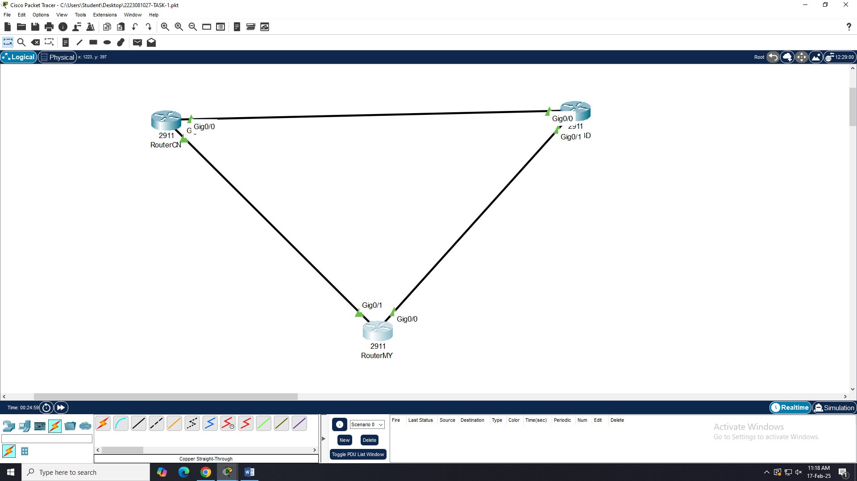

For RouterBD

Router>enable

Router#configure terminal

Enter configuration commands, one per line. End with CNTL/Z.

Router(config)#interface gigabitEthernet 0/0

Router(config-if)#ip address 172.30.1.1 255.255.255.0

Router(config-if)#no shutdown

Router(config-if)#

%LINK-5-CHANGED: Interface GigabitEthernet0/0, changed state to up

exit

Router(config)#interface gigabitEthernet 0/1

Router(config-if)#ip address 172.30.3.1 255.255.255.0

Router(config-if)#no shutdown

Router(config-if)#

%LINK-5-CHANGED: Interface GigabitEthernet0/1, changed state to up

exit

Router(config)#

For RouterCN

Router>enable

Router#configure terminal

Enter configuration commands, one per line. End with CNTL/Z.

Router(config)#interface gigabitEthernet 0/0

Router(config-if)#ip address 172.30.1.2 255.255.255.0

Router(config-if)#no shutdown

Router(config-if)#

%LINK-5-CHANGED: Interface GigabitEthernet0/0, changed state to up

%LINEPROTO-5-UPDOWN: Line protocol on Interface GigabitEthernet0/0, changed state to up

exit

Router(config)#interface gigabitEthernet 0/1

Router(config-if)#ip address 172.30.2.2 255.255.255.0

Router(config-if)#no shutdown

Router(config-if)#

%LINK-5-CHANGED: Interface GigabitEthernet0/1, changed state to up

%LINEPROTO-5-UPDOWN: Line protocol on Interface GigabitEthernet0/1, changed state to up

exit

Router(config)#

For RouterMY

Router>enable

Router#configure terminal

Enter configuration commands, one per line. End with CNTL/Z.

Router(config)#interface gigabitEthernet 0/0

Router(config-if)#ip address 172.30.2.1 255.255.255.0

Router(config-if)#no shutdown

Router(config-if)#

%LINK-5-CHANGED: Interface GigabitEthernet0/0, changed state to up

%LINEPROTO-5-UPDOWN: Line protocol on Interface GigabitEthernet0/0, changed state to up

exit

Router(config)#interface gigabitEthernet 0/1

Router(config-if)#ip address 172.30.3.1 255.255.255.0

Router(config-if)#no shutdown

Router(config-if)#

%LINK-5-CHANGED: Interface GigabitEthernet0/1, changed state to up

exit

Router(config)#