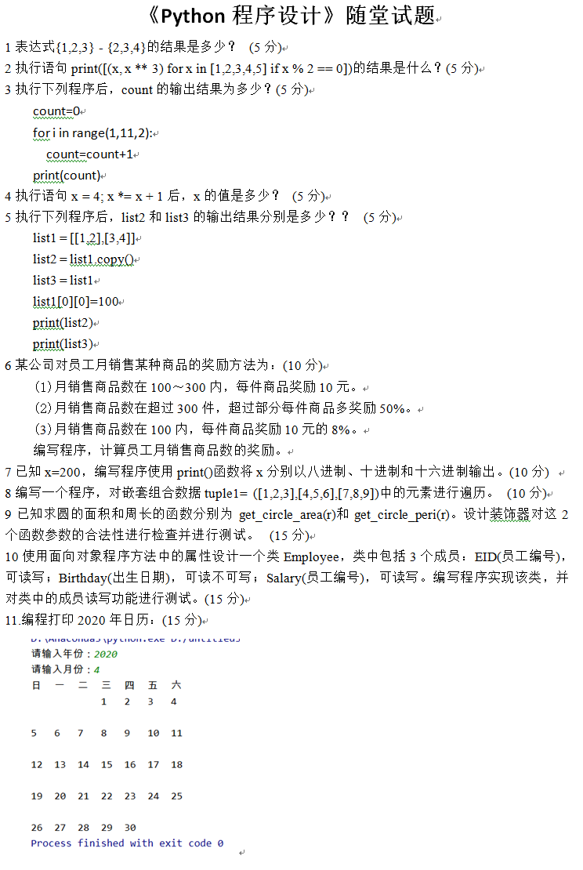
一、express1 = {1,2,3}
express2 = {2,3,4}
print(express1-express2)

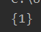
二、
print([(x, x ** 3) for x in [1, 2, 3, 4, 5] if x % 2 == 0])
# 求x,代入

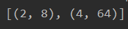
- count = 0
for i in range(1, 11, 2):
# 间隔为2
count = count + 1
print(count)
四、
x = 4
x *= x +1
# 等价于 x = x*(x + 1)
print(x)

五、list1 = [[1, 2], [3, 4]]
list2 = list1.copy()
list3 = list1
list1[0][0] = 100
print(list2) # [[100, 2], [3, 4]] 地址，都是指向了内存地址
print(list3) # [[100, 2], [3, 4]]
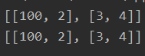
六、
def bonusGive(amount):
if 100 < amount <= 300:
bonus = 10 * amount
elif amount > 300:
bonus = (amount - 300) * 10 * (1 + 0.5) + 10 * 300
else:
bonus = amount * 10 * 0.08
return bonus
if __name__ == '__main__':
n = int(input("请输入员工的销售商品的数量："))
print("该员工奖励金额数为：", bonusGive(n))

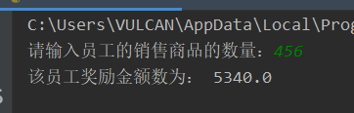
- 进制转换
x = 200
print("十进制数为：", x)
print("二进制数为：", bin(x))
print("八进制数为：", oct(x))
print("十六进制数为：", hex(x))
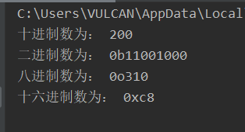
八、
tuple1 = ([1, 2, 3], [4, 5, 6], [7, 8, 9])
for tup in tuple1:
for i in tup:
print(i, "===", end=' ')
print()

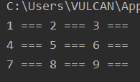
九、
import math
def get_circle_area(r):
return math.pi * pow(r, 2)
def get_circle_peri(r):
return 2 * math.pi * r
if __name__ == '__main__':
try:
r = int(input("请输入一个数字"))
print("面积是", get_circle_area(r))
print("周长是", get_circle_peri(r))
except:
print("错误输入")

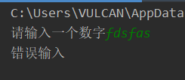
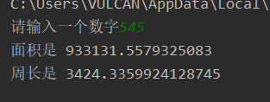
十、
# https://blog.csdn.net/weixin_35653315/article/details/78077253
from typing import Any
class Employee:
def __init__(self):
self._eid = "2015"
self._birthday = "2017-2-21"
self._salary = 123
def seteid(self, value):
self._eid = value
def geteid(self):
return self._eid
@property
def onlyReadbirth(self):
return self._birthday
def setsalary(self, value):
self._salary = value
def getsalary(self):
return self._salary
if __name__ == '__main__':
print("创建一个实例对象")
a = Employee()
print("获取eid")
print(a.geteid())
print("设置eid")
a.seteid("4555")
print(a.geteid())
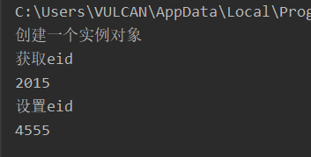
十一、
# 引入日历模块
import calendar
# 输入指定年月
yy = int(input("输入年份: "))
mm = int(input("输入月份: "))
# 显示日历
print(calendar.month(yy, mm))
