外文翻译：

Design of Smart Campus System Based

on WeChat Mini Program

原文来源：[1]段萌萌. Design of Smart Campus System Based on WeChat Mini Program[D].华中师范大学,2019.

译文正文：

章节一

介绍性内容

* 1. 研究背景

1.1.1 物联网的发展

物联网是世界信息产业的第三次革命。它的前身是互联网。然而，互联网获取的信息大多来自人类，人类的能量有限。所以1999年，麻省理工学院的凯文·阿什顿研究RFID时，他提议让计算机从我们的物理世界获取信息，以便我们能够跟踪物品，查看物品的消费，以便及时维修和更换，但当时对物联网没有准确的定义，物联网仅限于RFID技术。2005年11月17日，在突尼斯的世界信息社会峰会上，国际电联发布了《国际电联2005年互联网报告：物联网》，介绍了“物联网”的概念，物联网不仅指RFID技术。2009年，IBM首席执行官首次提出“智能星球”的概念。2009年8月，物联网在中国引起广泛关注。  
 如今，物联网是互联网和传统电信网等信息载体，使所有能够驱动独立功能的普通对象实现互联互通。这是中国制造的概念。互联网的发展使世界上普通的物体都能与网络连接起来，对物体的控制和跟踪也更加方便。这也使得人们越来越离不开手机。物联网的整体结构如图所示（省略）

1.1.2校园背景

随着物联网的发展，“智能地球”、“智能城市”、“智能家居”、“智能农业”、“智能校园”应运而生。学校作为教育的重要场所，建设智慧校园是教育信息化的重要手段。作为中大的一名研究生，很多日常应用让我觉得自己生活在一个智能的环境中example:We often 穿梭于相距遥远的两个校园之间，此时，我们常常骑着共享的自行车，只需扫码即可乘坐，方便快捷；平时我们应该去洗衣机前面看看是否可以免费使用，但在我们学校，洗衣机是智能的，不用站在洗衣机前面，就可以在专门的app上实时关注机器的动态。这些应用为学生的生活提供了极大的便利。同时，随着学生需求的增加，应用的数量也随之增加，更多的软件占用了大量的手机内存，这也为用户消耗了更多的手机流量数据。对于开发者来说，有必要区分Android和苹果系统，版本不兼容也给开发和维护带来一定的困难和挑战。

1.1.3微信小程序开发

微信是腾讯2011年推出的免费应用，为智能终端提供即时通讯服务。在微信1.0版本开始时，只有用户可以发送文字和图片。微信的功能越来越好。2013年，腾讯推出微信公众号，公众号允许开发者、企业、商家和个人注册。放纵QQ。公众号分为服务号、订阅号、企业号三类，商家可以通过服务号向用户推送一些店铺信息，并可以与用户进行互动，但微信服务号每月只能推送4次，订阅号每天可以推送消息，但一天只能发送一条消息。2017年，微信苹果正式上线。小节目和之前的公众号是并行的。它不需要下载，不用下载就可以运行的优点吸引了大量用户。该小程序易于开发和维护，这一特点也吸引了大量开发人员致力于小applet的开发。

本文试图开发一个基于微信小程序的系统，让学生不用下载大量软件就可以使用我们的日常应用程序，使用完毕后不用卸载。下次使用时，用户可以在微信下拉菜单}S}中找到，当用户使用过多的小程序时，下拉菜单中显示的小程序太多，用户需要很长时间才能找到具体的应用程序。

2018年，微信applet宣布增加了一个公众号组件，当用户使用这个小程序扫描代码时，可以快速关注自己的公众号。本文尝试采用小程序和公众号相结合的方式开发一个系统，不仅消除了用户的下载，而且可以让用户快速找到系统。

1.2国内外研究现状

随着物联网的发展，“智慧地球”、“智慧城市”、“智慧校园”正慢慢出现在人们的视野中。校园作为一个非常重要的教学活动场所，通过互联网与校园的高度融合，将学习、工作、生活、科研、管理融为一体。智慧校园的建设为师生提供了更加便捷、人性化的服务。在这种情况下，智慧校园的建设越来越受到国内外的重视。智慧校园的建设标志着校园信息化进入了一个新阶段。

21世纪，智慧校园在西方国家蓬勃发展。无论是硬件还是软件，许多西方校园基本实现了校园信息化建设，他们利用SNS、Facebook等相关媒体丰富学生的社会化；利用云计算技术构建有效的云平台，这些平台为学生提供了便捷的学习空间，例如：

1. 日本广岛大学利用云计算和无线射频技术来压缩智能考勤系统。通过相应的系统，教师可以实时监控学生的出勤情况。
2. 西方一些学校依靠大数据对学生的作业和平时表现进行分析，并根据结果制定相应的对策，及时掌握学生的情况，方便及时与学生沟通；
3. 国外一些学校开始按照智能家居的理念，建设节能、低成本、安全、智能化的校园等。当然，中国对智慧校园的研究并不逊色。许多面向师生的智能应用正在推向市场，给师生的工作和日常生活带来了极大的便利。
4. 智慧校园应用，针对教师用户，该应用为学生实时推送业务信息、通讯录即时聊天、休假管理、教师评估、薪资查询等，提供学生作业、学生休假、师生互动等功能，适合中小学生使用，教师管理学生非常方便。
5. 迅飞御记是科大讯飞公司发布的一款专门用于语音输入的综合性云状笔记，可以将语音转换成word文档存储，非常适合新教师备课，卿演讲或准备演讲。

随着微信苹果的推出，微信苹果的一些特性吸引了更多的学生投入到智慧校园的建设中，如：无需下载、触手可及、随时可用、无需卸载等；广袤的附属智慧校园；西华师范大学智慧图书馆；智能校园点菜等。这些小程序的开发，使学生的校园生活更加丰富多彩，更加方便。

1.3研究目的和意义

2017年，随着微信小程序的推出，支付宝、百度、蚂蚁金融也推出了无下载、无安装的小程序。一时间，小程序成为智能手机应用开发的新阶段。本文尝试采用小程序和公众号相结合的方式开发一个系统，不仅消除了用户的下载，而且可以让用户快速找到系统。本系统的实现使用户每次使用最新的软件，获取最新的信息，无需每次更新app前}'o}，本系统的开发更贴近学生的日常学习和生活，可以给学生的学习和生活带来很大的便利。具有很好的使用价值和研究意义。市场上有很多专门为智慧校园设计的应用，如智慧校园点菜系统、智慧校园考勤系统等。与这些系统相比，该系统具有以下优点：

1. 功能更齐全
2. 无需下载安装，无需升级
3. 不区分Android和苹果操作系统
4. 不会占用手机内存
5. 个人信息安全
6. 消息可以及时通知用户。
7. 它具有中大的地方特色。

1.4研究内容

1.4.1系统主要研究内容

本文主要尝试利用微信applet和公众号开发一个面向学生的智能校园系统。本文的主要研究内容如下：

1. 通过对学校现有部分软件的研究，走访部分学生，总结学生的意见和建议，确定系统的主要功能。
2. 通过分析这些学生反馈的现有app中存在的问题，结合微信applet的优势，决定将微信applet与公众号相结合，开发一个智能校园系统。并决定采用微信开发者工具来开发，微信开发者工具有自己的一套框架MINA框架，采用JavaScript、WXML、WXSS、Json、mysql来开发系统，具体技术之间的关系将在第二章中讨论。
3. 使用流程图显示。确定每个功能的接口。
4. 系统开发，包括前端、后端、接口和数据库。
5. 测试。编写详细的测试用例来测试系统的各种功能。

1.4.2创新

当然，软件市场上有很多samrt校园系统，图1.2是一个信息系统，但是它只有计算机版本，所以如果用户想从手机上浏览sonme信息，就很不方便了。

图1.3是另一个samrt系统，它只为学生、教师或家长开发，如果想使用这个应用程序，必须下载另一个应用程序，这将占用大量的手机内存和流量。所以我们真正需要的是一个免费下载，易于访问，节省内存，方便的软件，这正是本文所要做的。

该系统的开发主要有以下创新点：

1. 使用微信小程序，用户可免费下载。
2. 使用公共号码，如果用户使用多个小程序，他们可以迅速找到目标。
3. 以前可以在计算机上查看的内容可以在移动电话上查看现在。
4. 通过对在校学生的调查，了解他们的需求，使本系统更贴近学生的生活。
5. 论文结构

第一章绪论。

阐述了研究开发本系统的缘由，论述了本系统的研究背景和国内外研究现状，主要阐述了论文的研究内容和创新点，并在本章结尾对论文的总体结构进行了组织。

第二章：系统框架及关键技术研究。

首先分析了系统结构，然后阐述了框架所采用的关键技术，包括前端技术、后端技术和数据库技术。

第三章：系统需求分析。将系统划分为多个功能，并为每个模块绘制流程图。

第四章：详细设计。基于第3章中确定的特性，详细设计包括前端、后端、数据库和交互功能。

第五章：测试。手动编写测试用例来测试每个函数，并给出函数的一些屏幕截图。

第六章：总结与展望。对全文进行了总结，分析了开发过程中遇到的问题，并对未来的发展进行了展望。

章节二

相关技术概述

2.1微信小程序

2.1.1系统结构分析

微信是一种连接用户和服务的新方式而ni程序附在微信上，用户可以直接在微信下拉列表中使用，也可以在需要时通过微信公众号找到小程序，无需下载安装，开发者无需区分Android、Apple等不同操作系统，applet通过调用不同的接口将数据发送到前端，因此，无论用户是学生、教师还是开发者，微信applet都为他们提供了极大的便利。

每个小项目都有一个AppID，如果你没有id，可以在微信公共平台注册或者使用test id，我们第一步新建applet后，微信开发者工具会自动为你创建一些新的文件users:JS，JSON，WXSS，WXML。这些文件是每个页面必须包含的文件结构，您可以根据自己的需要创建新内容。

以下三个文件必须存在于项目的根目录中。这三个文件是applet的主要组件。以下以表格形式显示：

每个小程序的首页由以下四个文件组成。有些文件是必需的，但有些文件是可选的。以下以表格形式列出：.js负责网络处理和页面逻辑。.wxml和wxss共同呈现页面，它们的功能与HTML、CSS相同。

2.1.2 MINA框架结构

MINA不是一个app，它是微信小程序开发团队定义的一个框架，名为MINA framework。MINA框架的核心是一个响应式数据绑定系统，它封装了微信客户端提供的文件系统、网络通信、任务管理和数据安全，为上层提供了全套JavaScript api，这使得开发人员能够更快地构建应用程序，为开发人员的开发和维护带来极大的方便。MINA框架图如图2.1所示

从图2.1可以看出：applet的框架主要由两部分组成：视图层和逻辑层。为了在前端提供一个漂亮的界面，MINA框架提供了wxml和wxss文件以及一组基本组件，wxml和wxss类似于html标记和css样式。APPService是MINA的服务中心，通过微信客户端实现异步线程的加载和分离，表面渲染所需的数据和页面交互处理逻辑在APPService中实现。逻辑层使用JavaScript编写交互逻辑、网络请求和数据处理，但是由于CIS结构与B/S结构不同，web中JavaScript的许多特性无法使用。例如：文档、窗口等。MINA框架还为页面提供与事件相关的属性，如bindtap和bindtuchstart，这使得数据和视图非常容易保持同步。在进行数据修改时，只需更改逻辑层中的数据，视图层就会响应更新。开发人员只需将页面路由、方法和生命周期函数注册到框架中，所有其他复杂操作都将由框架处理。

2.1.3微信开发者工具

如第一节所述，每页的主体一般由三个文件组成，确切地说，是四个基本文件documents:JS，JSON，WXSS，WVIL.JSON文件可以为空。如果希望前端界面美观，则需要一个WXSS文件来呈现页面。

本系统采用微信开发者工具进行开发，微信公共平台提供了详细的开发流程tutorials:from the 注册一个AppD到发布的小程序完成后，用户只需申请一个小程序id（AppID）即可开始自己的开发，每个applet都有一个唯一的m。在开发过程中，他们可以在模拟器中查看页面效果，也可以在控制台中查看界面的返回结果，这样我们就可以随时修改代码。微信开发者工具可以用来开发而ni pragrame，一个小游戏或者一个公共账号页面}l'}，微信开发者工具的主界面如图2.2所示

2.2系统前端技术

前端是一个以用户为中心的界面。微信为开发小程序提供了一套自己的前端框架。前端和后端分开，使前端开发和后端开发并行。前端oaly需要注意页面显示。关注业务逻辑和提高工作效率。前端的开发主要包括三个方面aspects:framework，页面显示和API接口。系统使用开发者工具构建前端页面，主要通过编写以下三个文件：

1.JavaScript:JavaScript是前端开发最重要的语言。applet的JS文件与web前端开发使用的JS函数几乎相同。它可以实现界面的基本功能，如：根据用户的操作与服务器交互、修改信息等。但是applet的JS文件增加了一些微信}19}的API接口，比如开发者可以很方便的调用微信的sweep或者微信支付函数，去掉一些不必要的函数，比如DOM}2o}。

2.WXML:WXML是MINA框架提供的一组组件，实现了页面的整体结构，

三。WXSS是MINA框架提供的一套样式语言，用于改变前端页面的样式，使applet页面显示更加美观。WXSS和CSS在语言上没有区别，它们可以互相使用。

2.3系统后端技术

对于来自前端的用户的操作，后台服务器需要调用不同的接口与数据库进行交互，并从数据库中检索信息，服务器正在部署后端服务，服务器与数据库的交互是通过接口完成的。因此，系统采用Spring技术开发后端服务器，服务器端程序采用SSM框架，即Spring+SpringMVC+Mybatis作为业务流程处理程序，选择SSM框架是因为它是BIS模式下优秀的开源框架之一，稳定、高效、易用。由于applet的所有视图文件都不是由第三方服务器存储的，因此SpringMVC返回的内容将不是完整的视频，而是JSON格式的数据。微信作为客户端发送数据取数请求，服务器响应相应数据，返回数据类型json格式

交互是依靠接口完成的。通常，当量规没有二次请求时，需要使用接口。如果页面的单个功能需要第二个请求，则需要使用接口。如果页面包含多个函数，其中一个函数需要第二个请求，那么您需要定义多个接口。因此，在确定系统功能的同时，还需要确定接口的数量，MAC模式如图2.3所示

2.4 MySQL

本系统使用MySQL存储数据。MySQL是一个关系系统，属于Qracle产品。MySQL之所以成为本次系统开发的m数据库，是因为MySQL在系统开发过程中具有以下优势：

1.它是开源的，可以免费使用。

2为各种编程语言提供API}26}。

3.支持多线程。

4可以在客户机-服务器网络环境中作为独立应用程序应用，也可以嵌入到其他软件中。

5提供各种数据库连接方法，如TCPIIP和}DBCC2'}。

6提供可以管理、检查和优化数据库的管理工具

2.5小结

本章主要介绍了智能校园系统开发过程中的关键技术。前端采用微信开发者工具开发，后端采用Spring技术。由于需要使用http接口，采用SpringMVC+Mybatis开发了相应的接口。肌炎是内部包裹的。JDBC，所以开发人员只需要关注sql语句本身，而不需要花费大量精力去做繁琐的工作，比如：加载驱动程序、创建连接。数据库采用MySQL设计，并简要介绍了MySQL框架。下图2.5是关键技术之间的关系图：

原文正文：

Chapter 1

Introduction

1.1 Research background

1.1.1 The development of the Internet of Things

The Internet of Things is the third revolution in the world's information industry. Its predecessor was the Internet. However, most of the information obtained by the Internet comes from human beings, and human energy is limited. So in 1999, when MIT's Kevin Ash-ton studied RFID, he proposed to let computers get information from our physical world so that we can track items and view item consumption for timely repair and replacement.But at the time there was no accurate definition of the Internet of Things, and the Internet of Things was limited to RFID technology. On November 17, 2005, at the WSIS in Tunis, the ITU released the "ITU Internet Report 2005:Internet of Things", introducing the concept of "Internet of Things", and the Internet of Things does not only refer to RFID technology. In 2009, the CEO of IBM first proposed the concept of "smart planet". In August 2009, the Internet of Things caused widespread concern in China.

Nowadays, the Internet of Things is an information carrier such as the Internet and traditional telecommunication networks, enabling all ordinary objects that can drive inde- pendent functions to realize interconnected networks. This is a Chinese-made concept. The development of the Internet allows the world's ordinary objects to connect with the network, and it is more convenient to control and track objects. It also makes people more and more inseparable from mobile phones. The overall structure of the Internet of Things is as Figure

1.1.2 Campus background

With the development of the Internet of Things,"smart earth", "smart city", "smart home","smart agriculture", "smart campus" came into being. School as an important place for education, establishing a smart campus is an important means of educational informationization. As a graduate student of CCNU, many daily applications make me feel that I live in a smart environment, For example:We often shuttle back and forth between two campuses that are far apart, at this time, we often ride a shared bicycle, just need to scan the code to ride, convenient and fast; Usually we should go to the front of the washing machine to see if it is free for use, but in our school, washing machine is smart,You can pay attention to the dynamics of the machine in real time on a special app without standing in front of the washing machine. these applications provide great convenience for students' life. At the same time,with the demand for students increases, so does the number of applications,more software occupies a lot of mobile phone memory, which also consumes more mobile traffic data for users. For developers, it is necessary to distinguish between Android and Apple systems, version incompatibility also brings certain difficulties and challenges to development and maintenance.

1.1.3 The development of WeChat mini program

WeChat is a free application launched by Tencent in 2011 to provide instant messaging services for smart terminals. At the beginning of WeChat 1.0 version, only users are allowed to send text and pictures. The function of WeChat is getting better and better. In 2013,Tencent launched the WeChat public number, and the public number allowed developers, enterprises, businesses and individuals to register. Intemperate with QQ. The public number is divided into three categories: service number, subscription number, and enterprise number.The merchant can push some store information to the user through the service number, and can interact with the user, but the WeChat service number can only be pushed four times a month, The subscription number can push messages every day, but only one message can be sent in a single day. In 2017, the WeChat apples was officially launched. The small program and the previous public number were in parallel. It didn't need to be downloaded.The advantage of running without downloading attracted a large number of users. The small program is easy to develop and maintain,this feature also attracts a large number of developers have devoted themselves to the development of small applet.

This article attempts to develop a system based on WeChat mini program, so that students can use our daily applications without downloading a large amount of software, after use finished, they can go without uninstalling. When they use it next time, the can find it in WeChat drop-down menu}S}.When the user has used too many small programs, there are so many small programs displayed in the drop-down menu, so that the user will take a long time to find a specific application.

In 2018, the WeChat applet announced the addition of a public number component, when users use the small program to scan code, they can quickly pay attention to their public number. This article attempts to develop a system using a combination of small program and public number, which not only eliminates user downloads, but also allows users to quickly find the system.

1.2 Research status at home and abroad

With the development of the rnternet of Things, the "Smart Earth", "Smart City" and "Smart Campus" are slowly appearing in people's field of vision. As a very important place for teaching activities, the campus integrates learning, work, life, research and management through the high integration of the Internet and the campus. The construction of a smart campus provides students and teachers with more convenient and humanized services. Under this circumstance, more and more attention is paid to the construction of smart campuses at home and abroad. The construction of a smart campus marks a new stage in the campus-Informatization.

In the 21 st century, smart campuses are flourishing in Western countries. Whether it is hardware or software, many Western campuses have basically realized campus information construction}6}‘They use SNS, Facebook and other related media to enrich students' socialization; use cloud computing technology to build an effective cloud platform, these platform provide students with a convenient learning spacer's.For example:

1. Hiroshima University in Japan uses cloud computing and wireless radio frequency technology to constrict an intelligent time and attendance system. Through the corresponding system, teachers can monitor students' attendance in real time.

2. Some western schools rely on big data to analyze student's homework and usual performance, and make corresponding countermeasures according to the results, timely grasp the students' situation, and facilitate communication with students in a timely manner;

3. Some foreign schools begin to build a energy-efficient, low-cost, safe and intelligent campus according to the idea of smart home. etc.

Of course, the study of smart campuses in China is not inferior. Many smart apps are being introduced to the market for teachers and students, which brings great convenience to teachers and students' work and daily life. For example:

1 .smart campus app, for teachers users, this application has real-time push of business messages, instant chat of address book, leave management, teacher evaluation, salary inquiry, etc. for students, provide student homework, student leave, teacher and student interaction, etc. this app is suitable for primary and middle school students, it is very convenient for teachers to manage students.

2. XunFeiYuJi is a comprehensive cloud-like note dedicated to voice input released by IFLYTEK CO. It can convert voice into word document storage, which is very suitable for new teachers to prepare lessons,卿to speak, or prepare speeehes.

With the launch of the WeChat apples, some of its features attracting more students to invest in the construction of smart campus such as: no need to download, within reach, ready to use, no need to uninstall,and so on.Fanra.ous smart campus have: the smart campus system of Xi' an Jiaosong University; the vast affiliated wisdom campus; the Xihua Normal University Wisdom Library; the smart campus ordering etc}9}.The development of these small programs makes the campus life of the students more colorful and convenient.

1.3 Purpose and significance of the research

In 2017, with the launch of the WeChat applet, Alipay, Baidu, Ant Financial also launched the without download,without installation small programs. For a time, small programs became a new stage in the development of smartphone applications. This article attempts to develop a system using a combination of small program and public number, which not only eliminates user downloads, but also allows users to quickly find the system. The implementation of this system allows the user to use the latest software every time, get the latest information, no need to update the app every time before}'o} .The development of this system is close to the daily study and life of students, which can bring a lot of convenience to students' study and life. It has good use value and research significance. There are many apps on the market that are specially designed for smart campuses, such as smart campus ordering system and smart campus attendance system. This system has the following advantages compared to these systems:

1 .More complete functions

2. No need to download and install, no need to upgrade

3. Does not distinguish between Android and Apple operating systems

4. Does not occupy the phone memory

5. Personal information security

6. The message can be notified to the user in time.

7. It has the local characteristics of CCNU.

1.4 Research content

1.4.1 Main research content of the system

This paper mainly attempts to develop a smart campus system serving students by using the WeChat applet and the public number. The main research contents of the thesis are as follows:

1 .Through the study of some existing software in the school, visited some students,sumrnarize the opinions and suggestions of these students, determine the main functions of the system.

2. Through analysis the problems in the existing app that these students feedback, combiped with the advantages of the WeChat applet, decided to develop a smart campus system by using the WeChat applet combined with the public number. And decided to use WeChat developer tools to develop, WeChat developer tools have their own set of framework -MINA framework, using JavaScript, WXML, WXSS, Json, mysql to develop the system, the relationship between the specific technology will talk about in the second chapter.

3. Use flowchart to display. determine the interface for each function.

4. System development, including front-end, rear-end, interface and database.

5. Testing. Write detailed test cases to test the various functions of the system.

1.4.2 Innovation

Of course,there are so many samrt campus system in the software market, Figure 1.2 is a information system, but it only have computer version so if the users want to brower sonme information from the mobile phone, it is so inconvenient.

Figure 1.3 is another samrt system which developed only for students, teachers or parents who wants to use this application have to download another application, this will occupy much phone memory and traffic. so what we really need is a download-free, easy-to-access,memory-saving, and convenient software, this is exactly what this article does.

The development of this system mainly has the following innovations:

1 .Using the WeChat mini program, download free for users.

2. Using the public number, if the user uses more than one small program, they can

quickly find the target.

3. Content that was previously viewable on a computer can be viewed on a mobile phone

now.

4. Through the investigation from students in the school, to understand their needs, so this system is more closer to students' life.

5 Thesis structure

Chapter 1 Introduction.

Explain the reasons why researching and developing this system,dissertate the research background and the research status at home and abroad, mainly describe the research content of the paper and the innovation of the paper.the overall structure of the paper is organized at the end of this chapter.

Chapter 2: Research on system framework and key technologies.

First, analyze the systemstructure, and then explain the key technologies used in the framework include front-end,rear-end, and database technology.

Chapter 3:Analysis the needs of the system. Divide the system into multiple functions and draw flowchart for each module.

Chapter 4: Detailed design. Based on the features identified in Chapter3, detailed design includes front-end, rear-end, database, and interaction capabilities.

Chapter 5: Testing. Manually writing test cases to test each function and give some screenshot of the function.

Chapter 6: Summary and Outlook. Summarize the whole paper, analyze the problems encountered in the development process, and look forward to the future development.

Chapter 2

Related Technical Overview

2.1 Wechat mini programe

2.1.1 System structure analysis

WeChat mini program is a new way to connect users and services.The而ni program is attached to WeChat,so users can use it directly in the WeChat drop-down list, or use the WeChat public number to find the small program when they needed without downloading and installing.Developers do not need to Differentiating between different operating systems such as Android and Apple, The applet sends data to the front end by calling different interfaces.so,whether the user is a student, a teacher or a developer, the WeChat applet provides them with great convenience.

Every mini project has an AppID,if you don't have an id, you can register one on the WeChat public platform or use test id. After we create a new applet in first step, the WeChat developer tools will automatically create some new files for users:JS,JSON,WXSS,WXML. These files are the file structures that must be included in each page, you can create a new content according to your own needs}l2j.

The following three files must exist in the root directory of the project. These three files are the main components of the applet. The following is shown in the form of a table:

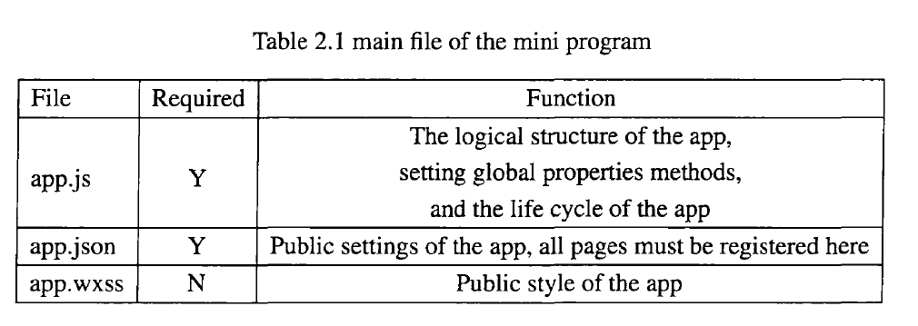

The front page of each applet consists of the following four files. Some files are required,but some files are optional. The following is listed in the form of a table:

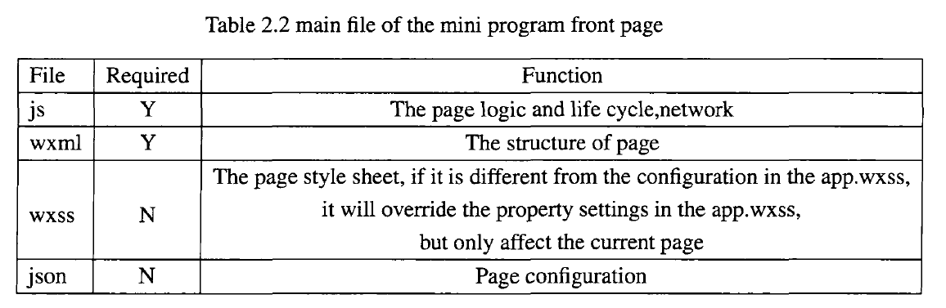

.js responsible for network processing and page logic.

.wxml and wxss co-render the page, their function are the same as HTML, CSS.

2.1.2 MINA frame structure

MINA is not a app, which is a framework defined by the WeChat team for small program development, named MINA framework. At the heart of the MINA framework is a responsive data binding system that encapsulates the file system, network communication, task management, and data security provided by the WeChat client, providing a full set of JavaScript APIs to the upper layers, which making developers faster building an application，andbrings great convenience to developers' development and maintenance. The MINA frame diagram is as Figure 2.1

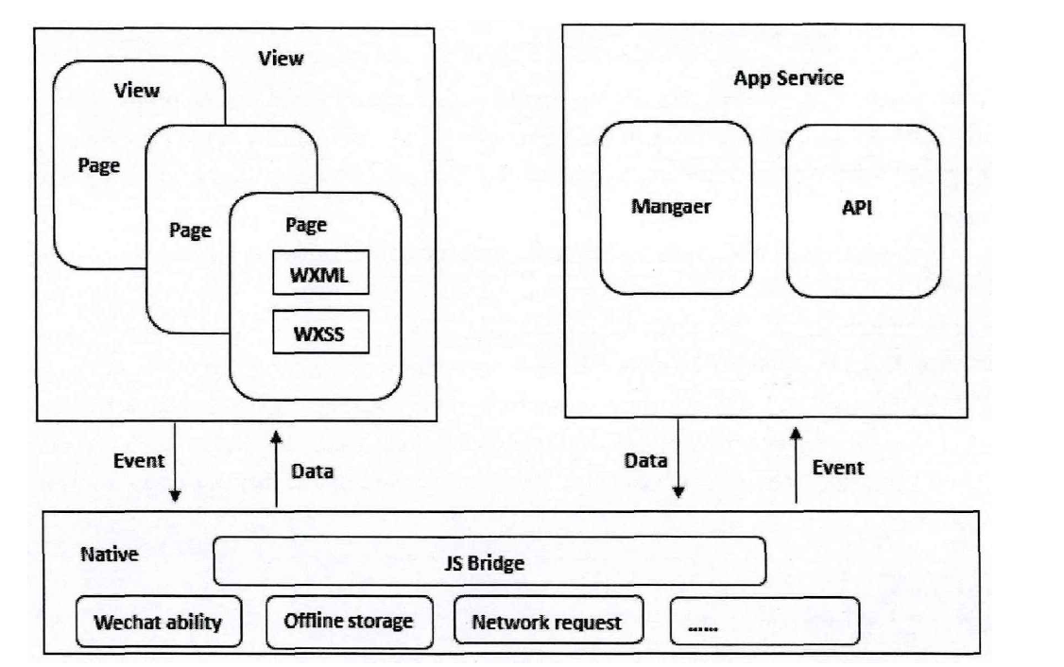

As can be seen from the Figure2.1:the framework of the applet mainly consists of two parts: the view layer and the logic layer. To present a nice interface on the front end, the MINA framework provides wxml and wxss files and a set of basic components, wxml and wxss similar to html tags and css styles. APPService is the service center of MINA .It is enabled by the WeChat client to enable the asynchronous thread to load and、separately.The data required for the~surface rendering and the page interaction processing logic are implemented in the APPService. The logic layer uses JavaScript to write interaction logic, network requests, and data processing, but since the CIS structure is different from the B/S structure, many of the features of JavaScript in the web cannot be used. For example: document, window, etc. The MINA framework also provides event-related properties such as bindtap and bindtouchstart for the page, which makes the data and view very simple to keep in sync. When doing data modification, you only need to change the data in the logical layer,and the view layer will respond to the update. Developers only need to register page routing,methods, and lifecycle functions into the framework, and all other complex operations will be handled by the framework.

2.1.3 WeChat developer Tools

As mentioned in the first section, the main body of each page is generally composed of three files,to be exact, four essential documents:JS,JSON,WXSS,W}}VIL.JSON file can be empty.If you want the front-end interface to be beautiful, you need to have a wxss file to render the page.

This system uses WeChat developer tools to develop, WeChat public platform provides detailed tutorials:from the registration of a AppD to the release of the small program after completion, users can begin their development only by applying for a mini programe id(AppID), each applet has an unique m. during the development, they can view the page effect in the simulator, and view the return results of the interface in the Console, so that we can change the code at any time. WeChat Developer tool can use to develop a而ni pragrame, a small game or a public account page}l'}.The main interface of WeChat Developer Tools is as Figure 2.2

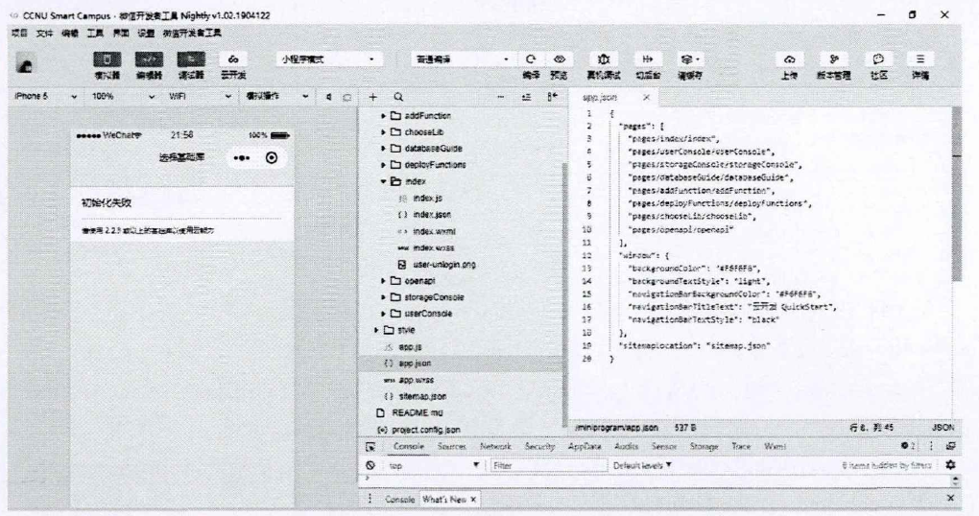

2.2 System front-end technology

The front-end is an interface that is focused on the user. WeChat provides a set of its own front-end framework for developing small programs. The front-end and back-end are separated, so that the front-end development and the back-end development are parallel. The front-end oaly needs to pay attention to the page display. Focus on business logic and

improve work efficiency.The development of the front-end mainly includes three aspects:framework, page display and API interface. The system uses the developer tools to build the front-end page, mainly by writing the following three files:

1 .JavaScript: JavaScript is the most important language for front-end development. The JS file of the applet is almost the same as the JS function used by the web front-end development. It can realize the basic functions of the interface, such as: interacting with the server according to the user's operation, and modifying the information. Etc.but the JS file of the applet adds some API interfaces of WeChat}19}.For example,developers can easily call WeChat's sweep or WeChat payment function, and remove some unnecessary functions, such as DOM}2o}.

2. WXML: WXML is a set of components provided by the MINA framework that implements the overall structure of the page, similar to HTML. Although WXML and HTML functions are similar, there are still big differences between the two. Use a table to compare WXML. and HTML:

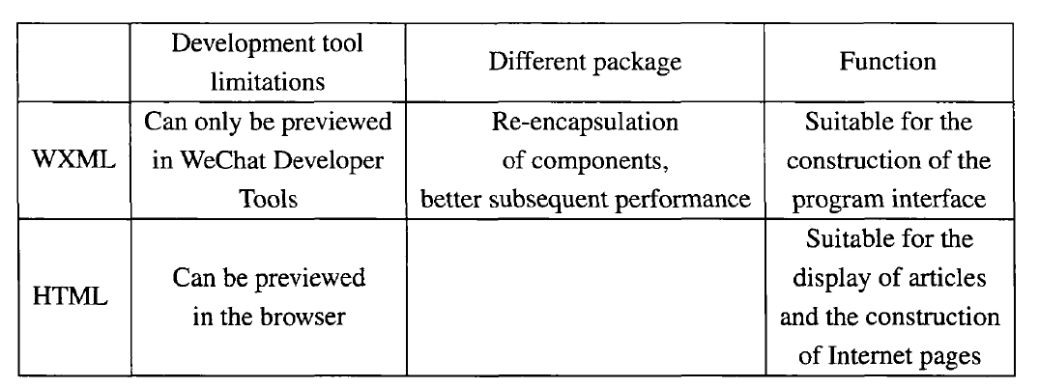

3. WXSS is a set of style language provided by the MINA framework to change the style of the front-end page, making the applet page display more beautiful. There is no difference in language between WXSS and CSS, and they can be used with each other.

2.3 System rear-end technology

For the operation of the user coming from the front end, the background server needs to call different interfaces to interact with the database and retrieve information from the database.The server is deploying the backend service, and the interaction between the server and the database is done by the interface. Therefore, the system uses Spring technology to develop the back-end server, and the server-side program uses the SSM framework, namely Spring+SpringMVC+Mybatis as the business process handler.The SSM framework was chosen because it is one of the excellent open source frameworks in the BIS mode, which is stable, efficient, and easy to use. Since all the view files of the applet are not stored by the third-party server, the SpringMVC return content will not be the full video, but the JSON format data. As a client, WeChat sends a data retrieval request, and the server responds with corresponding data and returns the data type json format，

interaction is done by relying on the interface. Generally, when a gage does not have a secondary request, an interface needs to be used. If the single function of the page requires a second request, an interface needs to be used. If the page contains multiple functions, There is one that requires a second request, then you need to define multiple interfaces. Therefore, while the system function is determined, it is also necessary to determine the number of interfaces .the MAC pattern is as follow: Figure 2.3

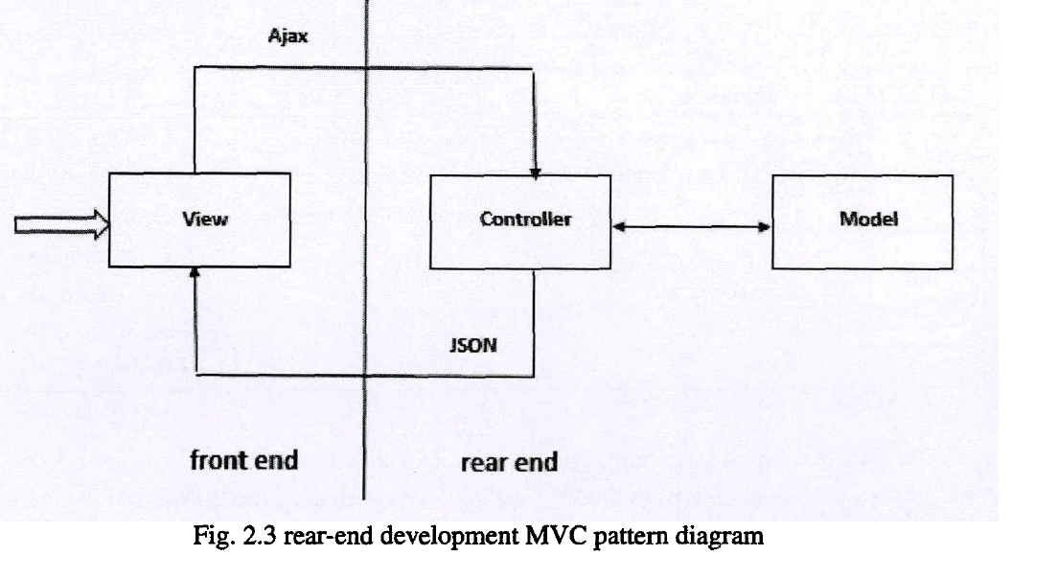

2.4 MySQL

This system uses MySQL to store data. MySQL is a relational system, belonging to Qracle products. The reason why MySQL is database m for this system development is because MySQL has the following advantages in the system development process:

1 .It is open source and can be used without paying.

2. provides API for a variety of programming languages}26}.

3. Support for mufti-threading.

4. Can be applied as a standalone application in a client server network environment or embedded in other software.

5. Provide various database connection methods such as TCPIIP and }DBCC2'}.

6. Provide management tools that can manage, inspect, and optimize databases.MySQL system architecture diagram is as Figure 2.4

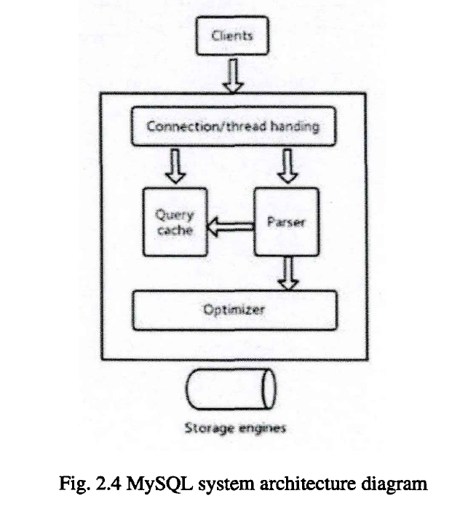

2.5 Summary

This chapter mainly introduces the key technologies in the development process of smart campus system. The front-end page is developed by WeChat developer tool, and the back end adopts Spring technology. Because of the need to use http interface, SpringMVC+Mybatis is used to develop the corresponding interface. Mybatis is encapsulated internally. JDBC, so developers only need to pay attention to the sql statement itself, without the need to spend a lot of effort to do tedious work, such as: load drivers, create connections. The database was designed using MySQL and briefly explained the MySQL framework. The following Figure 2.5 is a diagram of the relationship between key technologies:

