**Project - The Pet Shop Application**

**Introduction**

We need to handle simple online catalogue of a pet shop. Customers should be able to browse at the catalogue, look at individual animals and leave comments.

The application breaks down to:

* Home page – welcome, two selected animals (most highly commented upon)
* Catalogue Page – lists the animals by category (Mammal, Reptile, Aquatic)
* Animal Page – shows an individual animal (name, age, picture, short description) as well as a list of comments. This page will also allow to add comments for the animal.
* Admin page – allows to add / edit / remove an animal.

## **Database Schema**

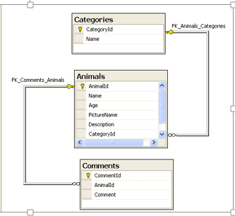The following screenshot shows the tables and relationships in the PetShop database.

## **PetShopSite**

The Web Site comprises of the following pages:

1. Home

Contains a table that shows the 2 animals in the shop with the most amount of reviews. It contains a site map which shows the structure of the application.  
The structure is very simple. From the Home page you can either go to Catalogue or to the Administrator page.

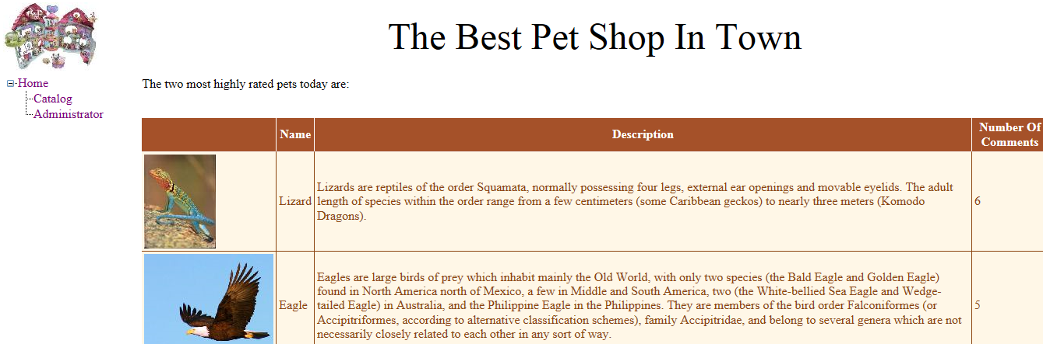

1. Catalogue

Displays all animals in the shop. Customers may select a pet category from a drop down list, and all the animals in that category will be displayed in a table. The information is not very detailed. A button on each row allows the customer to request more information about the animal on that row, and to add comments about the animal. These are handled by the Animal page.

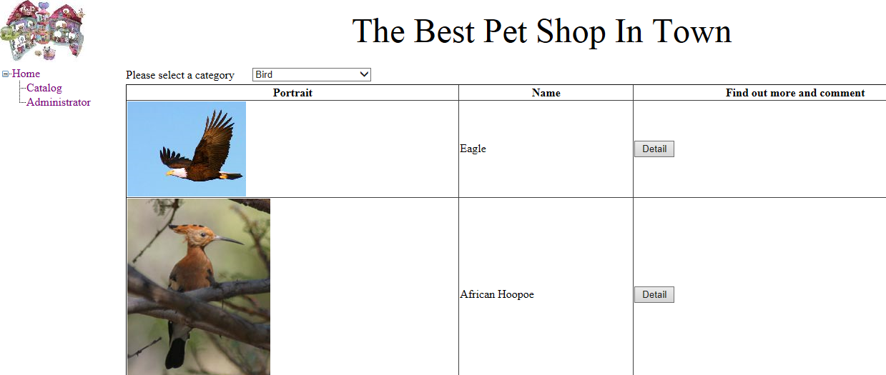

1. Animal

This page shows information from the database about the selected animal. In particular one part of the page shows a JOIN between the Animals table and the Categories table and another part of the page displays all the comments entered for the animal. The customer can also add comments to the database for the animal.

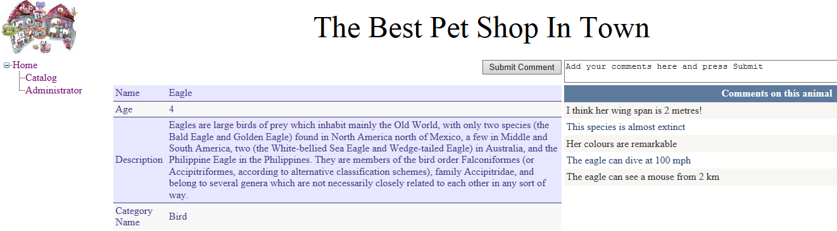

1. Administrator

On this page a drop down list and a table present the Categories and the animals in those categories of all animals in the shop. This page also allows the Administrator to edit, insert, delete animals in the shop.

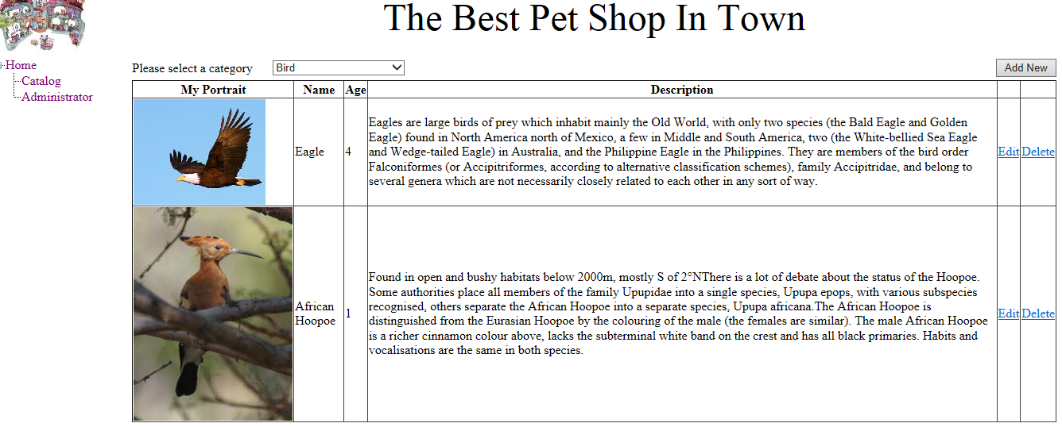

1. NewAnimal

This page implements the insertion of a new animal, as follows:

* 1. The Add New button on Administrator page causes a server transfer to the NewAnimal page.
  2. When the Insert button is pressed, the new animal is inserted into the database and control is returned to the Adminstrator page.

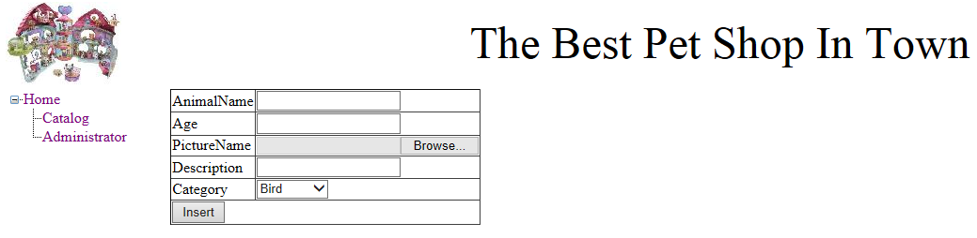

## **Additional Requirements:**

- Bootstrap for styling

- Form validation

- SQL or SQLite database

- Configuration for database connection