## Part 3:

## Parameters:

Hidden dimension: 200

LSTM hidden dimension: 100

Embedding dimension: 100

Batch size: 16

Optimizer: AdamW

Learning rate: 0.003

## NER Curves:

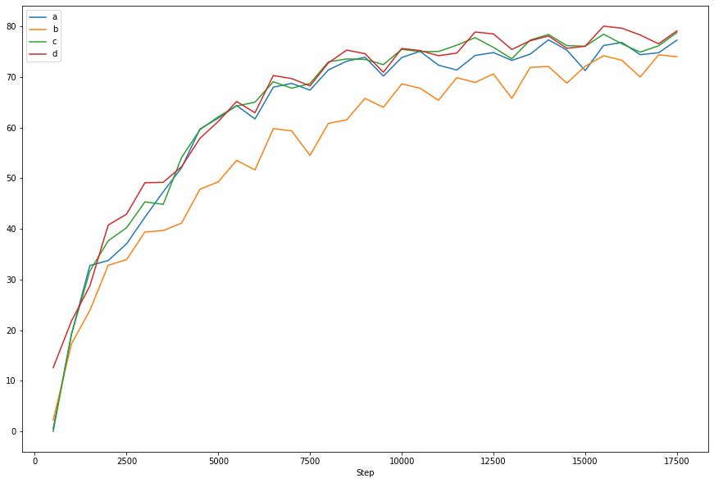

## POS Curves:

