# Contents

1. **Ex1Ori.pdf** **2**
2. **ex1code.py** **9**

### 1

1 libxz - zecnel zekxrnl `ean

305612038 :f.z

2017 uxna 23

1 dl`y 1

` sirq 1.1

:*MA* (*A*) ≥ |*log* (|*H*|)∫ = |*log* (*N* )∫ miiwzny jk *E* daiaq zniiwy d`xp

.daiaqa dnibc lka d`iby lawzzy jk |*log* (*N* )∫ lceba daiaq xevip xicbp dlgzda .iaiqxewx ote`a {*b*1*, ..., bn*} miipni mirhw zxcq oke {*a*1*, ..., an*} miil`ny mirhw zxcq xicbp

.*h*ˆ dfizetida opeazp oke *xi* = *ai* +*bi* xicbp divxhi` lka zrk .*a*1 = 0*, b*1 = *N*

2

.*bi*+1 = *bi , ai*+1 = *xi* okcrpe *yi* = 1 xicbp if` *h*(*xi*) = 1 xy`k *y*ˆ*i* = 1 m`

.*ai*+1 = *ai* oke *bi*+1 = *xi* xnelk ,jetd okcrpe *yi* = 1 xicbp *y*ˆ*i* = −1 m`

.*MA*(*E*) ≥ |*log* (*N* )∫ = |*log* (|*H*|)∫ ok lre *instance* lkl d`iby zniiw ef dxcbd t"ry al miyp

:oky yenin zxa ef daiaqy al miyp ,sqepa

{*hθ*| *θ* ∈ [*ai, bi*]}

⇓

{*h* ∈ *Vt* | *h*(*xi*) = 1} = ∅ ∧ {*h* ∈ *Vt* | *h*(*xi*) = −1} = ∅

.yxcpk

a sirq 1.2

*n* miaeaiq xtqn lkle *A* dcinl mzixebl` lkl ik d`xpe ,Θ ∈ [0*,* 1] ∪ .− 1 *,* 3 Σ xnelk [0*,* 1] hqd mr *X* hqd z` silgp

:*MA*(*H*) = *n* miiwzn

2

2

:*MA*(*H*) = *n* miiwzn

*n i*=1

{*x*}

dxcq lawl lkep *n* lkl ik al miyp .mcew sirq enk weica dyrpe *b*1 = 1 ,*a*1 = 0 z` lgz`p ,` sirql dneca

.*n* lceba dxcq xviil lkep izexixy *n* lkl okle ,1 ≤ *j* ≤ *n* lkl *xj* = *aj* +*bj* miiw cinz miiynnd zetitvn oky

2

.yxcpk *M* (*A*) = ∞ lawzn *A* cnel mzixebl` lk xeary o`kn

## zix`pil dxabl` - 2 dl`y 2

` sirq 2.1

ik d`xp .*σi* = Σ*ii* oke ,dn`zda *V, U* ly *i*-d zecenrd zeidl *vi, ui* onqp . *A* = *U* Σ*V T SV D* mr *A* R*m×d* idz

∈

.*AT ui* = *σivi* oke *Avi* = *σiui*

:dxevdn `id Σ ik xekfp

*σ*1 0 · · · 0 

0 *σ*2 0

Σ = .

 

 .

0 0 · · · . . .

. . .

.

. 

miiwzn *i* = *j* xeare (*ui*|*uj*) = (*vi*|*vj*) = 0 miiwzn*i*

*j* xear ixw ,zeilnxepezxe` md *V, U* zevixhnd ik oke

.(*ui*|*uj*) = (*vi*|*vj*) = 1

1

*v*11 · · · · · · *v*1*d* *v* 

1*i*

*i*

*i*

. 2*i*

0

.





 . 

*i*

0

 . 

.

0

:f`e

 0 

.

 . 

*i*

 0 

 . . 

*i*

*i*

.

. . . .

 0 

*i*

0

*i*

0

*m×d*

 0 

*m×m*

*Av* = *U* Σ*V T v*

= *U* Σ·

. *v*22

.

*v*

· = *U* Σ·(*v* |*v* )

 

.



  . 





= *U* Σ

* 1 = *U*
* *σ*  =

*vd*1 · · · · · · *vdd*

*vdi*

 . 

0

 . 

0

 . 

0

*m×*1

0

*d×*1

0

*d×*1

0

*m×*1

= *U*1*i* · *σi* + *U*2*i* · *σi* + *...* + *Umi* · *σi* = *σi* · *ui* □

:dnec ote`a f`e , (*AB*)*T* = *BT AT* miiwzn mdylk *A, B* zevixhn xear ik xekfp

 *u*11 · · · · · · *u*1*m* 

.

 *u*1*i* 

*AT ui*

= .*U* Σ*V T* Σ*T u*

*i*

= ..*V T* Σ*T* (*U* Σ)*T* Σ *u*

*i*

= *V* .Σ*T U T* Σ *ui*

= *V* Σ*T* 

.

. *u*22

. *u*2*i*

 · . =

 

 .

. . . .

 

. 

0





.

.

  . Σ

*T*

= *V* Σ (*ui*|*ui*) = *V*

Σ*T*

0

0

0

.

 

0

.

 

*um*1 · · · · · · *umm*

 0 

0

.

 

.

 

*umi*

. 



.

0

0

.

0

.

 

   

 

*m×d*

1 = *V* Σ*d×m* 1

 . 

0

0

.

0

.

 

 

 . 

0

*m×*1

0

.

 

 

= *V σi*

=

 . 

0

*d×*1

= *V*1*iσi* + *V*2*iσi* + *...* + *Vdiσi* = *σi* · *vi* □

a sirq 2.2

miiwzn *i* = *j* xeare (*ui*|*uj*) = (*vi*|*vj*) = 0 *i* ƒ= *j* xear miiwzn f` zeilnxepezxe` md *U, V* zevixhnde xg`n :xaqd

.(*ui*|*uj*) = (*vi*|*vj*) = 1

lkl 1 = (*vi*|*vj*) = −1 · −1 (*vi*|*vj*) = (−*vi*| − *vj*) zeliwyd zniiwzn mipzyna zeix`piln dyrnl ik al miyp la`

.*i* = *j*

.iehia eze` lawle ilily-i`l ely dtlgdd z` rval ozip zxg` oky *σi* ≥ 0 ik gipdl ozip ,okl

b sirq 2.3

. *A* ∈ R*m×d* idz

a sirq 2.3.1

*EV D* dpid *AT A* = *V* Σ*T* Σ*V T* oke ,*AAT* ly *EV D* dpid *AAT* = *U* ΣΣ*T U T* if` *A* ly *SV D A* = *U* Σ*V T* m` ik d`xp

.*AT A* ly

:f`e*V V T* = *I* okle zilnxepezxe` *V* ik xekfp

*AAT* = .*U* Σ*V T* Σ .*U* Σ*V T* Σ*T* = .*U* Σ*V T* Σ ..Σ*V T* Σ*T U T* Σ = .*U* Σ*V T* Σ .*V* Σ*T U T* Σ = *U* Σ*I*Σ*T U T* = *U* ΣΣ*T U T*

okl ,*d m* xcqn wx oeqkl`a mikxr mze` mr zipeqkl` mb `id Σ*T* okl , *m d* xcqn zipeqkl` dvixhn `id Σ

× ×

.*λii* = *σi σi* md oeqkl`d ikxr xy`k zixhniqe zipeqkl` *m m* xcqn dvixhn `id ΣΣ*T*

( | ) ×

.*AAT* ly *EV D* `ed l"pd wexitd k"dqa okle zilnxepezxe` *U* ,sqepa

:f`e *U U T* = *I* okle zilnxepezxe` *U* dnec ote`a

*AT A* = .*V* Σ*T U T* Σ .*U* Σ*V T* Σ = *V* Σ*T I*Σ*V T* = *V* Σ*T* Σ*V T*

xcqn wx oeqkl`a mikxr mze` mr zipeqkl` mb `id Σ*T* okl , *m d* xcqn zipeqkl` dvixhn `id Σ ,mcewn enk

×

.*λii* = *σi σi* md oeqkl`d ikxr xy`k zixhniqe zipeqkl` *d d* xcqn dvixhn `id Σ*T* Σ okl ,*d m*

( | ) × ×

.*AT A* ly *EV D* `ed l"pd wexitd k"dqa okle zilnxepezxe` *V* ,sqepa

□ .yxcpk

b sirq 2.3.2

.*V* -a *i*-d dcenrd zeidl *v*¯*i* onqpe , *k* = *rank*(*A*) ≤ *min*(*m, d*) onqp

*w*¯*i* = *Av*¯*i* mixehwe xicbp f`e .(*vi*|*vj*) = *δi,j* ixw ilepebezxe` *V* lkl ,okl *AT A* ly *EV D* `id *AT A* = *V DV T* ik oezp

:{*w*¯*i*}*d* mixehwed zxcqa opeazpe . 1 ≤ *i* ≤ *d* lkl

*i*=1

*d*l l"za mixehwe *m* − *d* gwipy jk ici lr qiqal maigxdl lkep f`e ,miilpebeze` mixehwe *d* mpyi if` *k* = *d* m` qiqa eplaiwe l"pd mixehwedn cg` lk lnxpl wx xzep okl ,l"za mixehwe *m* mpyi zrk .miilpebezxe`d mixehwed

ilnxepezxe`

.dnec `id dgkedd *k* = *m* m` .{*w*¯*i*}*d* ly zlnxepnd dagxdd mdy {*w*˜1*, ..., w*˜*m*}

*i*=1

## 3 dl`y 3

Σ

*i*

lr dlhdd zvixhn *P* =

*k i*=1

*vivT* xicbp .*V* -l ilnxepezxe` qiqa *v*1*, ..., vk* ∈ R*d*

eidie ,R*d*

ly *k* cninn agxn-zz*V* idz

.*V*

*P* =Σ

*k*

*v vT* =Σ

*k*

.*vT*

Σ*T vT* =

.Σ*k*

.*v vT*

ΣΣ*T*

` sirq 3.1

:zixhniq *P* ik d`xp

:okl ilnxepezxe` qiqa *v*1*, ..., vk*

= *P T*

*i i*

*i*=1

*i i*

*i*=1

*i i*

*i*=1

a sirq 3.2

:f`e edylk ilnxepezxe` qiqa xehwe *vj* xgap ,1 invrd jxrd mr mleke *P* ly miinvr mixehwe *v*1*, ..., vk* ik d`xp

*P vj* =

.Σ*k*

*vivT* Σ

*vj* =Σ

*vivT vj* = *vjvT vj* = *vj*

.*vT vj* Σ

= *vj* · (1) = *vj*

*i*

*i*=1

*i j j*

*i*=1

*k*

□ .yxcpk 1 `ed *P vi* = *λvi* miiwny cigid *λ* invrd jxrd *P* xear ilnxepezxe` qiqa xehwe *vi* lkl ik epi`xde

b sirq 3.3

:*P* xear *EV D* `vnp

.zixhniq *P* oke ,1 wx md *P* ly miinvrd mikxrd ik epi`x ziy`x

c sirq 3.4

:*P* 2 = *P T P* = *P P T* = *P* miiwzn ik d`xp f`e *P* 2 = *P T P* = *P P T* okle *P T* = *P* ik epi`x sqepae ,*P* xear *EV D* wexit dpid *P* = *U DU T* ik mcew sirq epi`x

:lawpe gztp

*P* 2 = *U DU T* .*U DU T* Σ*T* = *U DU T* .*U* (*U D*)*T* Σ = *U DU T U DT U T* = *U DDT U T*

:lawpe jiynpy o`kn *D* = *D*2 okle1 e` 0 md dilr mikxrd sqepa ,*D* = *DT* okle zipeqkl` dvixhn `id *D* ik xekfp

*U DDT U T* = *U D*2*U T* = *U DU T* = *P*

□ .yxcpk

d sirq 3.5

:okl *P* 2 = *P* ik xekfp .(1 − *P* ) *P v* = 0 *v* ∈ *V* lkl ixw ,qt`d zwzrd `id (1 − *P* ) *P* ik d`xp

(1 − *P* ) *P v* = (*I* − *P* ) *P v* = *P v* − *P P v* = *P v* − *P* 2*v* = *P v* − *P v* = 0

□ .yxcpk

e sirq 3.6

:1 invr jxr lra invr xehwe `ed agxna xehwe lk zexg` milina e` ,*P x* = *x* miiwzn *x* ∈ *V* xehwe lkl ik d`xp miniiw xnelk ,{*v*1*, ..., vk*} eply ilnxepezxe`d qiqad ly cigi ix`pil sexivk *x* z` bviil lkep ,xehwe *x* ∈ *V* idi

-y jk *α*1*, ..., αk* dcya mixlwq

*k*

Σ

*x* = *αivi*

*i*=1

:lawpe0 zxg`e *i* = *j* xear .*vT* |*vj*Σ = 1 ik xekfp f`e

*i*

*k*

*k*

*k*

*k*

*P x* =

.Σ*k*

*vivT* Σ *x* =

.Σ*k*

*vivT*

*i*

Σ Σ*k*

*αjvj* =ΣΣ *vivT αjvj* =ΣΣ *αjvi* .*vT vj*Σ =

*i*=1

*i*

*i*

*i*

*i*=1

*j*=1

*j*=1 *i*=1

*j*=1 *i*=1

*k k k*

=ΣΣ *αjvi* (*δij*) =Σ *αivi*

*j*=1 *i*=1

*i*=1

□ .yxcpk

## 5 dl`y 4

.*Zi*

∼ *Ber*(*p*) okl ,*Zi*

= 1 *H*

0 *T*

.

ixw ,*i*-d dlhddd ly oiivnd `edy *Zi*

` sirq 4.1

ixwn dpzyn xicbp

:lawp zelhd *m* xear okl .dn`zda *p* (1 − *p*) -e *p* md ilepxa bltznd n"n ly zepeyde zlgezd ik xekfp

*m m m*

*V ar*[ 1 · Σ *Z* ] = 1 ·*V ar*[Σ *Z* ]+ 2 Σ *Cov*(*z , z* ) = 1 ·*V ar*[Σ *Z* ]+0 = 1 ·*m*·*p*(1−*p*) = 1 ·*p*·(1−*p*)

*i*=1

*i*=1

*i*

*i*=1

*i*=1

*i*=1

*i*

*i*=1

*m*

*i*

*m*2

*i*

*i*

*i<j*

*j*

*z*

*is indt m*2

*i*

*m*2

*m*

.. *m*

1

. Σ *V ar*

Σ 1

:lawzn avia'v oeieeiy-i`n ,zrk

*m*

Σ

Σ

*Zi*

*P* . *m*

Σ*i*=1

*Zi* − *p*. *> s* ≤

*m*

*i*=1 =

*s*2

*p* · (1 − *p*) *m* · *s*2

4

:miiwn epaiwy iehiad okle 1 i"r lirln dneqg ilepxa bltznd n"n ly zepeyd ik xekfp zrk

4

*p*(1 − *p*) 1

≤ =

1

4

*m* · *s*2 *m* · *s*2 4 · *m* · *s*2

:lawpe mitb` xiarp okl , 1

4*·m·s*

2 *< δ* -y jk *m >* 0 lawl dvxp

1

4 · *δ* · *s*2 *< m*

.l"pd i`pzd z` miiwny irah *m* xegal icy o`kn z` lirtdl lkep if` z"a md dl` n"n sqepae ,1 ≤ *i* ≤ *m* lkl *Zi* ∈ [0*,* 1] miiwzn ,*Zi* zxcbd t"ry oeeikn ,zrk

:lawle bpicted oeieeiy-i`

*P* .. 1 Σ

*m*

*Zi* − *p*. *> s*Σ

≤ 2*e−*2*ms*

2

. *m i*=1

.

:ixw ,*δ*-n ohw eplaiwy iehiady jk *m* dvxp dnec ote`a f`e

2*e−*2*ms < δ*

2

:lawle *m* z` cceale mitb`d ipy lr *log* lirtdl lkep miiaeig mitb`d izyy oeeikne

1 2

2*s*2 *log*( *δ* ) *< m*

.l"pd i`pzd z` miiwny irah *m* xegal icy o`kn

□.yxcpk

a sirq 4.2

a sirq 4.2.1 oia yxtdd (1-5 zexey) zepeyd zelhdd zexcqa jk (zelhd xzei erveay lkk) lcb *m*-y lkky (`vi mb jke) dtvn ip`

.*y* = 0*.*25 mdly zlgezd sxb lr zecklzdl s`yi mdly bviind sxbd xnelk ,xzei miphw eidi mxear milawznd mikxrd

.*m* ly divwpetk xzei miwegx mikxr lawl miieyr mitxbd jk ohw *m*-y lkk dnec ote`a

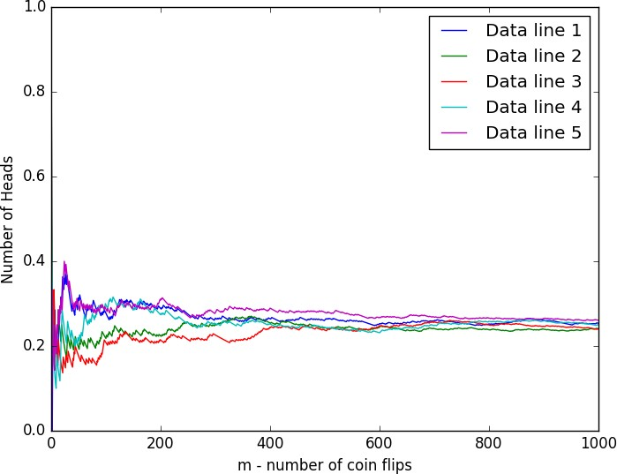

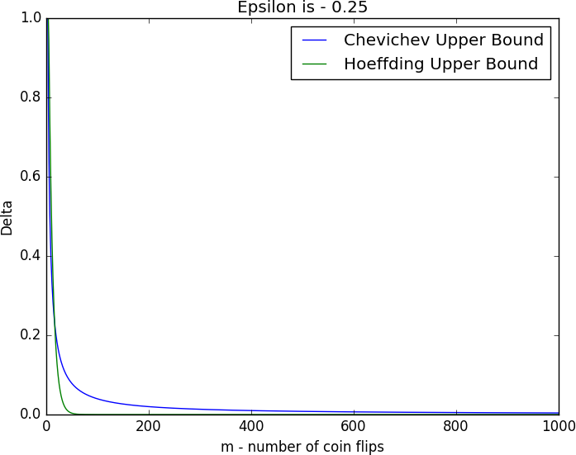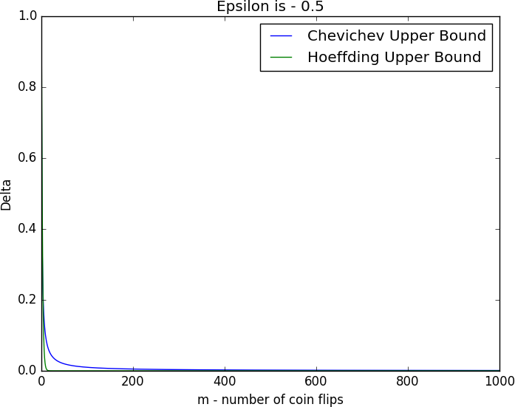b sirq 4.2.2

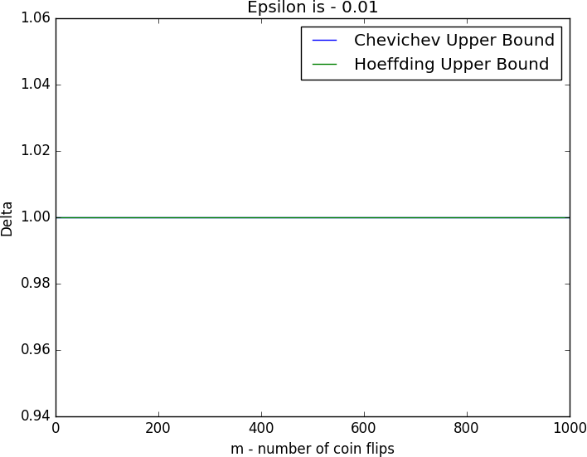.

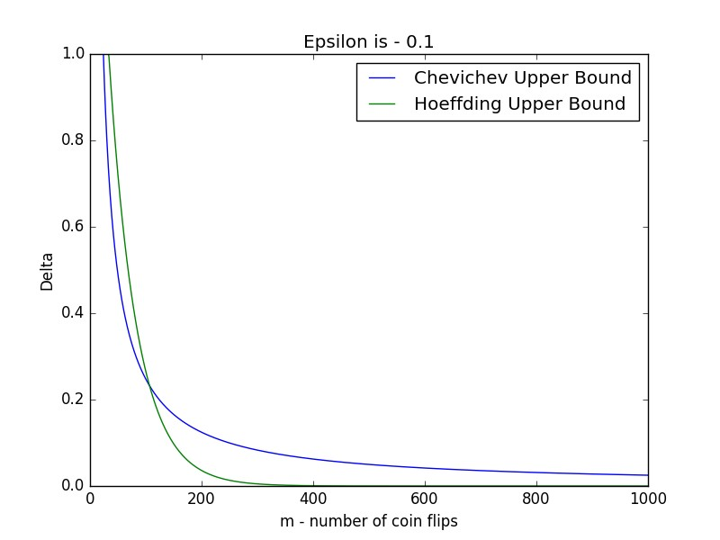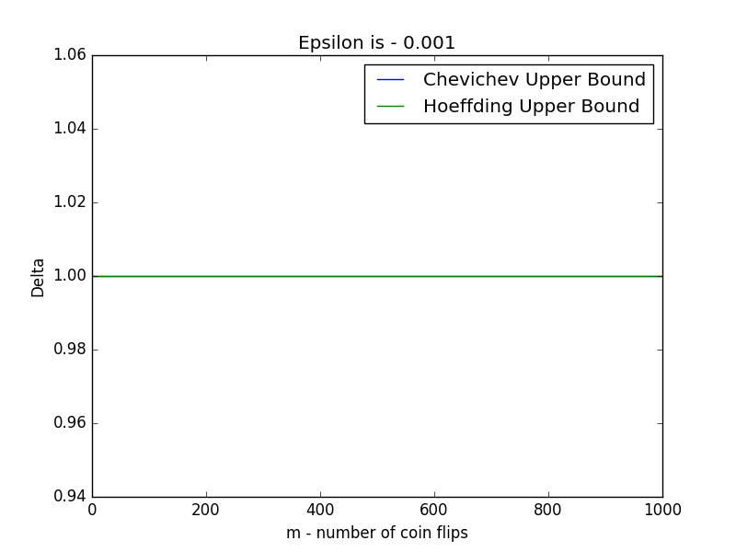

.

.

c sirq 4.2.3

xzei yi miphw mi'*m* xear ok lre *p* `idy ely zlgezl axwzi *Xm* jk zelhd xzei rvapy lkk oeliqt` lkly dtvn ip`

.ohw oeliqt`n bexgl iekiqd jk lcb *m*-y lkke (oeliqt`n bexgl) d`iby lawl iekiq zegt bexgpy ick zelhd zxcq lk xear yexcy zelhdd xtqn lr rityi oeliqt`d jxry `ed mipeliqt`d oia lcadd

.d`ibyd z` oihwdl ick (*m* z` licbdl) zelhd xzei jxhvp jk ohw oeliqt`y lkk xnelk ,oeliqt`n

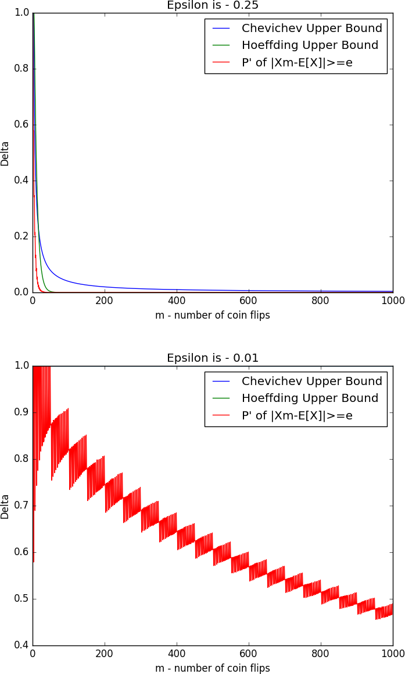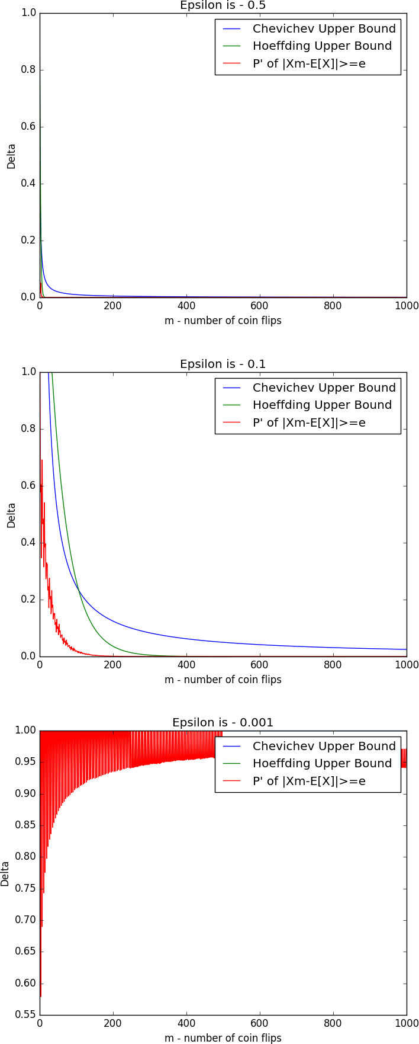.

.

# 2 ex1code.py

1 importnumpy

2 importmatplotlib.pyplotasplt

3 importmath

4

5

6 defgenerator():

7 data=numpy.random.binomial(1,0.25, (100000,1000))

8 epsilon_arr=[0.5,0.25,0.1,0.01,0.001]

9 plot_five(data)

10 chev_data, hoef_data=calc_chevichev_hoeffding(epsilon_arr)

11 percenteges=calc_deviators(data, epsilon_arr)

12 forepsiloninrange(5):

13 plt.title("Epsilon is -"+str(epsilon_arr[epsilon]))

14 plt.ylabel("Delta")

15 plt.xlabel("m - number of coin flips")

16 plt.plot(chev_data[epsilon], label=’Chevichev Upper Bound’)

17 plt.plot(hoef_data[epsilon], label=’Hoeffding Upper Bound’)

18 plt.plot(percenteges[epsilon], label="P’of |Xm-E[X]|>=e")

19 plt.legend()

20 plt.show()

21

22

23 defplot_five(data):

24 rows_sum=[[0]*1000, [0]*1000, [0]*1000, [0]*1000, [0]*1000]

25 plt.ylabel("Number of Heads")

26 plt.xlabel("m - number of coin flips")

27

28 forminrange(1,1001):

29 foriinrange(m):

30 rows_sum[0][m-1]+=data[0][i]

31 rows_sum[1][m-1]+=data[1][i]

32 rows_sum[2][m-1]+=data[2][i]

33 rows_sum[3][m-1]+=data[3][i]

34 rows_sum[4][m-1]+=data[4][i]

35 rows_sum[0][m-1]/=float(m)

36 rows_sum[1][m-1]/=float(m)

37 rows_sum[2][m-1]/=float(m)

38 rows_sum[3][m-1]/=float(m)

39 rows_sum[4][m-1]/=float(m)

40 plt.plot(rows_sum[0], label=’Data line 1’)

41 plt.plot(rows_sum[1], label=’Data line 2’)

42 plt.plot(rows_sum[2], label=’Data line 3’)

43 plt.plot(rows_sum[3], label=’Data line 4’)

44 plt.plot(rows_sum[4], label=’Data line 5’)

45 plt.legend()

46 plt.show()

47

48

49 defcalc_chevichev_hoeffding(epsilon_arr):

50 upper_bounds_chev=[[0]*1000, [0]*1000, [0]*1000, [0]*1000, [0]*1000]

51 upper_bounds_hoef=[[0]*1000, [0]*1000, [0]*1000, [0]*1000, [0]*1000]

52 forminrange(1,1001):

53 foriinrange(5):

54 chev_res=float(1/float(4*m*epsilon_arr[i]*epsilon_arr[i]))

55 hoef_res=2*float(math.exp(-2*m*epsilon_arr[i]*epsilon_arr[i]))

56 ifchev_res>1:

57 chev_res=1

58 ifhoef_res>1:

59 hoef_res=1

60 upper_bounds_chev[i][m-1]=chev_res

61 upper_bounds_hoef[i][m-1]=hoef_res

62 returnupper_bounds_chev, upper_bounds_hoef

63

64

65 defcalc_deviators(data, epsilon_arr):

66 p=0.25

67 cum_data=numpy.cumsum(data, axis=1)

68 total_data=[[0]*1000, [0]*1000, [0]*1000, [0]*1000, [0]*1000]

69 forcurr_epsiloninrange(len(epsilon_arr)):

70 forminrange(1,1001):

71 bad_lines_counter=0

72 foriinrange(len(data)):

73 ifmath.fabs((cum_data[i][m-1]/float(m))-p)>=epsilon_arr[curr_epsilon]:

74 bad_lines_counter+=1

75 total_data[curr_epsilon][m-1]=float(bad_lines_counter/float(len(data)))

76 print("Finished epsilon number"+str(curr_epsilon))

77 returntotal_data

78

79 if name ==’ main ’:

80 generator()