1. The parse tree:

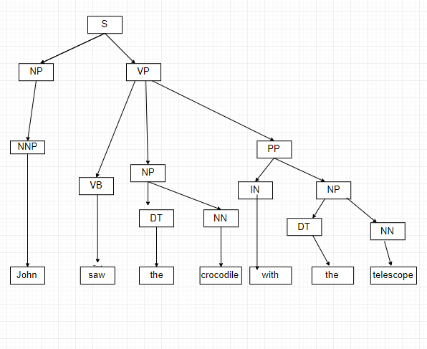

* 1. There is only a **single** parse tree which is the one we demonstrated in a
  2. This is the result tree:

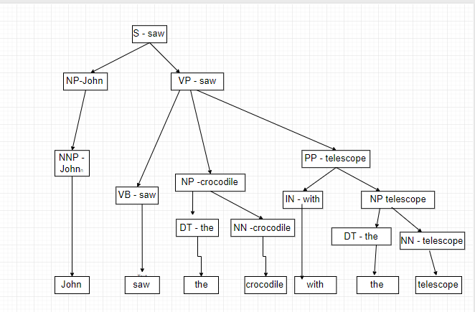

* 1. corresponding unlabeled dependency tree for the sentence:

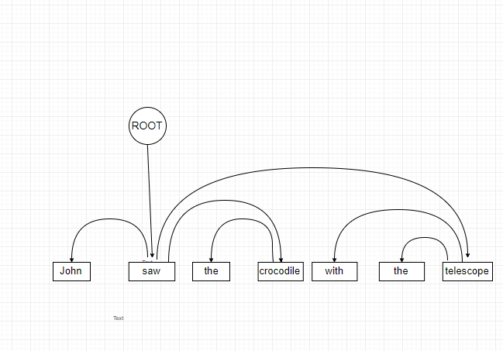

1. d
   1. d
   2. d
2. **Evaluation**:
   1. Result Summary:

|  |  |  |  |
| --- | --- | --- | --- |
| Wiki Page | Donald Trump | Ruth Bader Ginsburg | J. K. Rowling |
| POS tag based | 317 | 98 | 145 |
| Dependency Tree Based | 130 | 35 | 61 |

* 1. 15 random triplets from the POS Tag Based extractor:

**Result: 11/15 🡪: 73.33%**

* + 1. {Subject: [FBI, Director, James, Comey], Relation: [told], Object: [Congress]} 🡪: GOOD
    2. {Subject: [China], Relation: [countered, with, on, of], Object: [U.S.]} 🡪: GOOD
    3. {Subject: [Trump], Relation: [have, pleaded, have, been, convicted, in], Object: [Mueller]} 🡪: BAD
    4. , {Subject: [Trump], Relation: [had, told], Object: [Comey]} 🡪: GOOD
    5. {Subject: [Trump], Relation: [said, that, voted, for], Object: [George, W., Bush]} 🡪: GOOD
    6. [{Subject: [Supreme, Court, Sandra, Day, O'Connor], Relation: [would, follow], Object: [Ginsburg]} 🡪: GOOD
    7. {Subject: [Ginsburg], Relation: [filed, sat, with, at, for], Object: [Craig]} 🡪: BAD
    8. {Subject: [Ginsburg], Relation: [responded, to, about], Object: [Colin, Kaepernick]} 🡪: BAD
    9. {Subject: [Ginsburg], Relation: [was, hospitalized, in], Object: [Washington, DC]} 🡪: GOOD
    10. {Subject: [Ginsburg], Relation: [took, on, of, as, for, of], Object: [Fourth, Amendment]} 🡪: BAD
    11. {Subject: [Prince], Relation: [was, released, on], Object: [July]} 🡪: GOOD
    12. {Subject: [Jude, Callegari], Relation: [said, that, was], Object: [Rowling]} 🡪: GOOD
    13. {Subject: [Rowling], Relation: [owns, in], Object: [Kensington]} 🡪: GOOD
    14. {Subject: [Waterstones], Relation: [asked], Object: [Rowling]} 🡪: GOOD
    15. {Subject: [Forbes], Relation: [removed], Object: [Rowling]} 🡪: GOOD
  1. 15 random triplets from the Dependency Tree Based extractor:

**Result: 15/15 🡪: 100%**

1. (Ruth, [attended], School) 🡪: GOOD
2. (Ginsburg, [transferred, to], School) 🡪: GOOD
3. (Bader, [attended], University) 🡪: GOOD
4. (Ginsburg, [underwent, at], Center) 🡪: GOOD
5. (Clinton, [nominated, on], June) 🡪: GOOD
6. (Rowling, [announced, In], September) 🡪: GOOD
7. (Rowling, [discussed, in], February) 🡪: GOOD
8. (Rowling, [stated, On], October) 🡪: GOOD
9. (Rowling, [moved, In], December) 🡪: GOOD
10. (Rowling, [attended], School) 🡪: GOOD
11. [(Trump, [purchased], Generals) 🡪: GOOD
12. (Trump, [told], NBC) 🡪: GOOD
13. (Trump, [denied, as], October) 🡪: GOOD
14. (Comey, [testified, on], June) 🡪: GOOD
15. (Trump, [referred, to], Art) 🡪: GOOD
16. Bonus:
    1. For the Dependency Tree Based extractor we wouldn’t need to do any change in the second phase BUT would need to change the way it extracts the arcs for a given sentence. The change would be in the relation of the root and the nsubj and the dobj arcs. Instead it would have to go until the end of the sentence in order to find the arcs for the root.
    2. For the POS based the problem is to determine when the Subject’s propn’s finishing and when the Object’s propn’s starts. This because we determine it now by the verb which is in between the two and in a verb-final language we can’t count on it and would have to find another sign to separate between the two.