## Part 1:

### Parameters:

1. Embedding dimension: 128
2. RNN type: LSTM
3. hidden dimension: 256 ( * 2 because it is Bi-directional)
4. Directions: 2
5. Number Of Layers: 3
6. Batch size: 4
7. Optimizer: AdamW
8. Learning rate: 0.002
9. Dropout P: 0.4

Score on the test: 64.11

Best score on Dev: 61.2

### Evaluation BLEU:

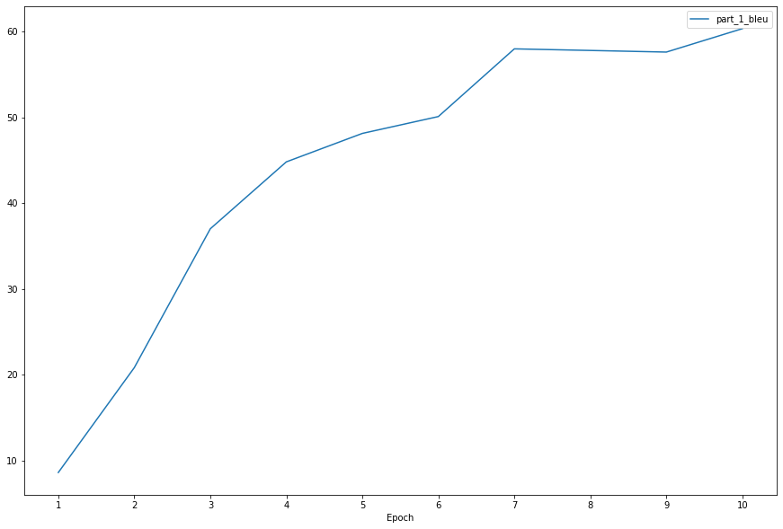

### Evaluation Loss:

