**YAML**

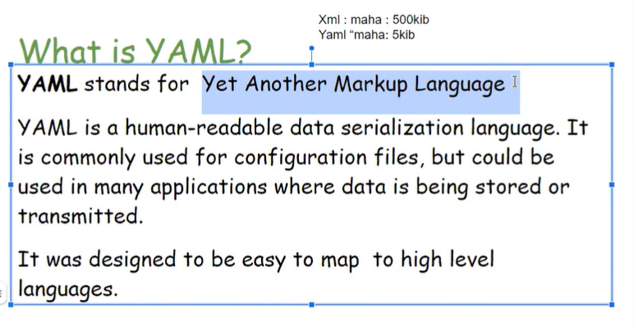

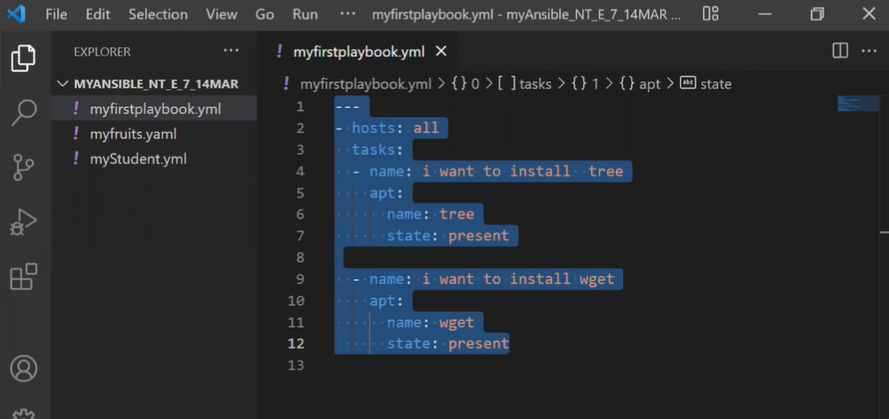

State absent(sudo user )

Red hot and ubuntu webserver install

