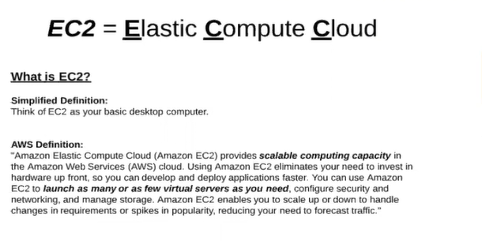

**Pem file : just like a user name and password**

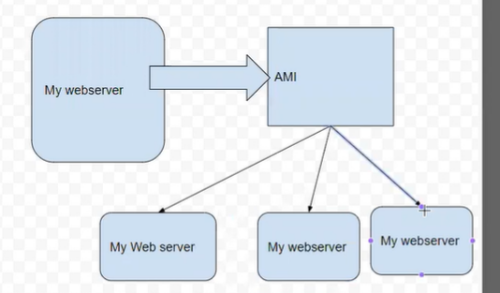

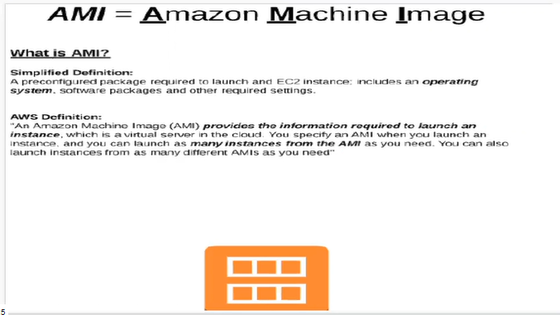

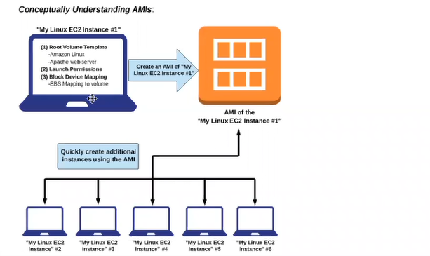

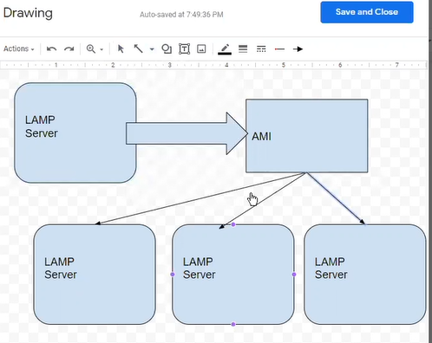

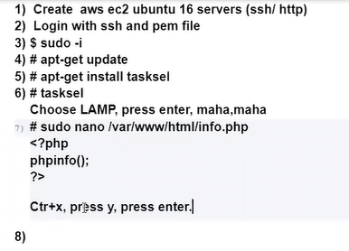

Roundrobin machanisum :

**Simple notification server :**

**AUTOSCALEING**

**R53 :**

**Creating steps :**

