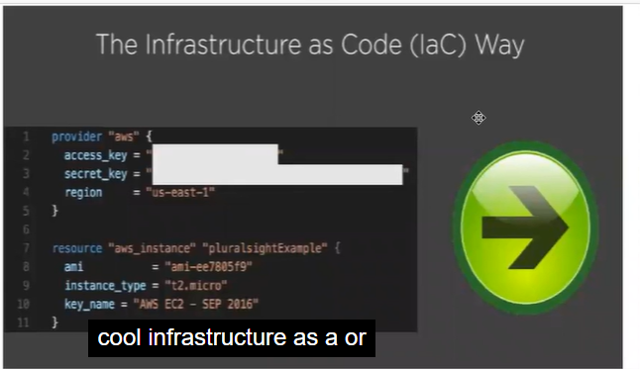

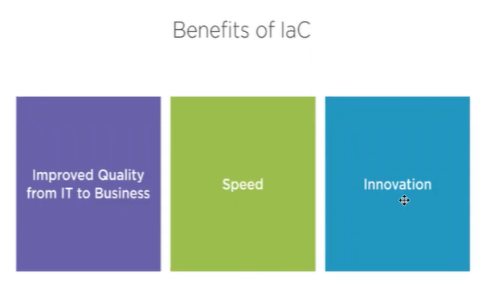

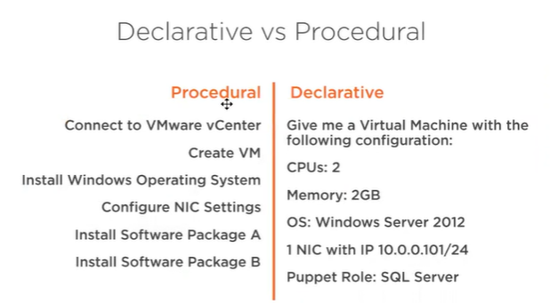

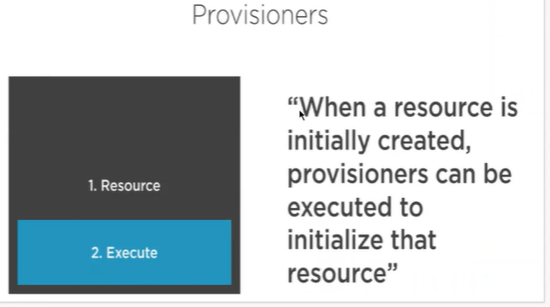

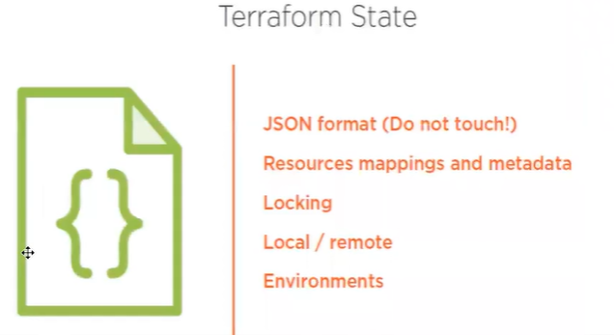

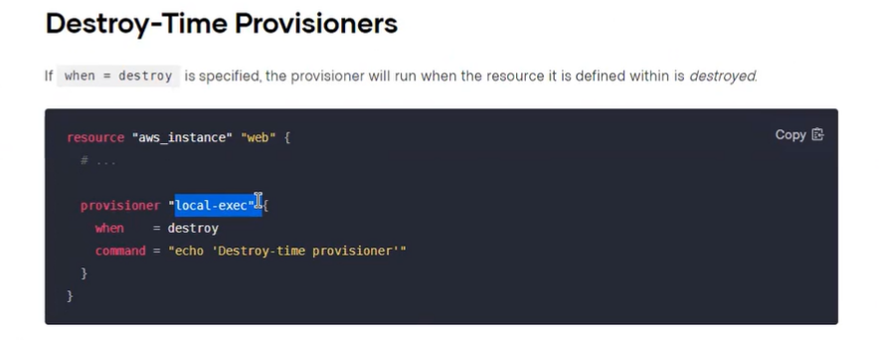

C0de

