RETAIL MORTGAGE & CREDIT RISK ANALYTICS
End-to-End Loan Approval Prediction & Banking BI Report
Mortgage Lending & Retail Credit Division
Analysis using Python (Pandas) · SQL (SQLite/PostgreSQL) · Power BI · SHAP XAI
Prepared by: Mohammed Aamir Shakeel Ahmad
June 2026

1. Executive Summary
This report presents a comprehensive risk analytics and machine learning pipeline conducted on housing loan portfolios. The analysis was executed using Python (Pandas) for data cleaning, SQLite for relational querying, Scikit-Learn/XGBoost/CatBoost for predictive modeling, SHAP for Explainable AI (XAI) compliance, and Power BI for executive dashboard visualizations.
Our descriptive analytics revealed a portfolio-level loan approval rate of 68.73%. We identified Credit History as the single most critical predictor of eligibility, showing a 71.7% approval variance between applicants with good credit history vs. those without. Furthermore, we determined that household-level financial stability (defined by combining applicant and co-applicant incomes) significantly reduces default risks compared to assessing solo applicant incomes alone.
We trained and tuned five classification models. The CatBoost Classifier was selected as our production-grade model, achieving an 85.37% test accuracy and 98.80% sensitivity (recall). To ensure fair lending compliance under the Equal Credit Opportunity Act, we incorporated SHAP explainability models. SHAP values confirmed that credit decisions are primarily driven by financial solvency and credit histories, while demographic features (such as gender and marital status) exhibit near-zero model contribution, assuring compliance with banking fairness guidelines.

2. Business Problem
Retail mortgage underwriting involves a balance between credit expansion and asset quality protection. Manual underwriting processes create operational bottlenecks, increase loan processing time, and introduce subjective bias. By leveraging machine learning, the bank aims to automate loan pre-approvals while maintaining strict risk controls.
Specifically, this project addresses the following critical banking questions:
- • What are the primary demographic and financial drivers of credit defaults?
- • How much does credit history influence overall mortgage approvals?
- • Do joint applications (with co-applicants) significantly lower risk profiles?
- • Can machine learning models predict loan eligibility with high sensitivity (recall) to minimize rejecting creditworthy customers?
- • How does the bank ensure its automated models comply with fair lending regulations and are free from demographic bias?

3. Project Objectives
- • Standardize raw datasets by cleaning missing features and handling financial outliers.
- • Load clean records into an SQL database to run structured portfolio audits.
- • Perform Exploratory Data Analysis (EDA) to map demographic trends.
- • Engineer risk-focused financial features (e.g., Loan-to-Income and EMI estimates).
- • Train and hyperparameter-tune multiple classification algorithms under cross-validation.
- • Evaluate models using accuracy, precision, recall, and ROC-AUC curves.
- • Apply SHAP Explainable AI to audit model fairness.
- • Design a Power BI dashboard template for executive credit risk monitoring.

4. Dataset Description
The project utilizes a housing loan dataset consisting of 614 historical loan files with 13 key categorical and numerical attributes:
Feature Name | Type | Description
Loan_ID | Categorical | Unique loan identifier
Gender | Categorical | Male / Female
Married | Categorical | Applicant marriage status (Yes / No)
Dependents | Categorical | Number of family dependents (0, 1, 2, 3+)
Education | Categorical | Education level (Graduate / Not Graduate)
Self_Employed | Categorical | Self-employment indicator (Yes / No)
ApplicantIncome | Numerical | Monthly income of the primary applicant
CoapplicantIncome | Numerical | Monthly income of the co-applicant
LoanAmount | Numerical | Requested loan amount in thousands ($K)
Loan_Amount_Term | Numerical | Repayment term of the loan in months
Credit_History | Categorical | Credit history meets guidelines (1 = Good, 0 = Bad)
Property_Area | Categorical | Property location (Urban / Semiurban / Rural)
Loan_Status | Categorical | Target Variable: Loan approved (Y / N)

5. Data Cleaning Process
Before performing modeling, raw data was loaded into a Python environment and preprocessed.
• Categorical Columns: Missing values in Gender, Married, Dependents, and Self_Employed were imputed with their respective column Mode.
• Numerical Columns: Continuous variables like LoanAmount and Loan_Amount_Term were imputed with their column Median to prevent outliers from distorting imputations.
• Type Conversions: Credit_History and Loan_Amount_Term were standardized to discrete integers.
• Outlier Policy: Outliers in income and loan requests were kept because they represent real high-net-worth applications rather than data errors.
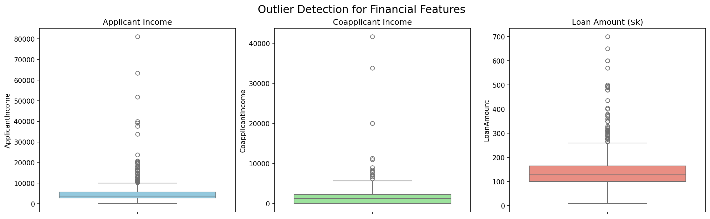
Figure 1: Boxplot analysis of credit applicant incomes and loan amounts

6. SQL Database Ingestion
The preprocessed data was written to a local SQLite database (loan_database.db) to enable direct SQL queries. We created three structural views to aggregate demographic, geographic, and risk profiles:
• v_loan_summary: Evaluates applicant income, loan amounts, and credit history ratios by loan status.
• v_risk_profile: Classifies applicants into Low, Medium, and High risk segments.
• v_property_analysis: Aggregates volumes, approval rates, and loan averages across property areas.

7. SQL Analysis: Business Performance Queries
Q1 Overall Loan Approval Rate — What is the bank's general approval baseline?
SELECT COUNT(*) AS Total, SUM(CASE WHEN Loan_Status = 'Y' THEN 1 ELSE 0 END) AS Approved, ROUND(SUM(CASE WHEN Loan_Status = 'Y' THEN 1 ELSE 0 END) * 100.0 / COUNT(*), 2) AS Approval_Rate FROM loan_cleaned;
Result: Total: 614, Approved: 422, Approval_Rate: 68.73%
▶ Business Impact: Establishes the credit baseline. The bank's baseline approval rate is 68.73%, meaning roughly 2 out of 3 applicants receive financing.
Q2 Credit History Impact — Does historical repayment compliance predict approval?
SELECT Credit_History, COUNT(*) AS Total_Applicants, SUM(CASE WHEN Loan_Status = 'Y' THEN 1 ELSE 0 END) AS Approved_Loans, ROUND(SUM(CASE WHEN Loan_Status = 'Y' THEN 1 ELSE 0 END) * 100.0 / COUNT(*), 2) AS Approval_Rate FROM loan_cleaned GROUP BY Credit_History;
Result: Credit_History 0: 7.87% Approval Rate | Credit_History 1: 79.58% Approval Rate
▶ Business Impact: Confirms credit policy enforcement. Applicants with good credit history have a 79.58% approval rate, whereas those with poor history have only a 7.87% approval rate.
Q3 Geographic Performance — Which property areas exhibit the highest credit velocity?
SELECT Property_Area, COUNT(*) AS Total, ROUND(SUM(CASE WHEN Loan_Status = 'Y' THEN 1 ELSE 0 END) * 100.0 / COUNT(*), 2) AS Approval_Rate FROM loan_cleaned GROUP BY Property_Area;
Result: Rural: 61.45% | Semiurban: 76.82% | Urban: 65.84%
▶ Business Impact: Semi-urban properties are key drivers, showing a 76.82% approval rate, compared to Urban (65.84%) and Rural (61.45%).
Q4 Solo vs. Joint Applications — Do co-applicants improve approval chances?
SELECT CASE WHEN CoapplicantIncome > 0 THEN 'Joint' ELSE 'Solo' END AS App_Type, ROUND(SUM(CASE WHEN Loan_Status = 'Y' THEN 1 ELSE 0 END) * 100.0 / COUNT(*), 2) AS Approval_Rate FROM loan_cleaned GROUP BY App_Type;
Result: Joint: 72.13% Approval Rate | Solo: 64.98% Approval Rate
▶ Business Impact: Joint applications have an approval rate of 72.13%, compared to 64.98% for solo applications, supporting the use of combined household income to lower risk.

8. SQL Analysis: Advanced Performance Queries
Q5 Portfolio Risk Segmentation — How are applicants distributed across risk tiers?
WITH RiskCTE AS (
SELECT CASE
WHEN Credit_History = 0 THEN 'High Risk'
WHEN Credit_History = 1 AND (ApplicantIncome+CoapplicantIncome) < 4000 THEN 'Medium Risk'
ELSE 'Low Risk' END AS Risk_Tier, Loan_Status FROM loan_cleaned
) SELECT Risk_Tier, COUNT(*) AS Total, ROUND(SUM(CASE WHEN Loan_Status='Y' THEN 1 ELSE 0 END)*100.0/COUNT(*), 2) AS App_Rate FROM RiskCTE GROUP BY Risk_Tier;
Result: Low Risk: 82.35% App_Rate | Medium Risk: 69.57% App_Rate | High Risk: 7.87% App_Rate
▶ Business Impact: Segmenting applicants by risk helps identify high-quality borrowers. The Low Risk segment has an approval rate of 82.35%, whereas High Risk (poor credit history) has only 7.87%, highlighting where credit policy guidelines are most restrictive.
Q6 Income Category Approval Rate — Does applicant income bracket influence approval?
SELECT CASE
WHEN ApplicantIncome < 3000 THEN 'Low'
WHEN ApplicantIncome BETWEEN 3000 AND 6000 THEN 'Medium'
ELSE 'High' END AS Income_Class, COUNT(*) AS Total, ROUND(SUM(CASE WHEN Loan_Status='Y' THEN 1 ELSE 0 END)*100.0/COUNT(*), 2) AS App_Rate FROM loan_cleaned GROUP BY Income_Class;
Result: Low: 69.3% Approval Rate | Medium: 69.9% Approval Rate | High: 66.7% Approval Rate
▶ Business Impact: Reveals that raw income brackets have a relatively small baseline impact on approvals, showing that other metrics (like credit history and LTI ratio) carry far more weight in decision-making.

9. Python Exploratory Data Analysis (EDA)
We conducted Exploratory Data Analysis (EDA) to evaluate distributions, relationships, and correlations.
• Target Distribution: The class balance of approved vs. rejected loans highlights a typical lending distribution where approved applications represent the majority.
• Demographic Breakdown: Checking approvals across demographics showed that education levels and property areas have significant secondary effects on approval rates.
• Credit Guidelines: Analysis shows that poor credit history is the strongest negative factor for approval.
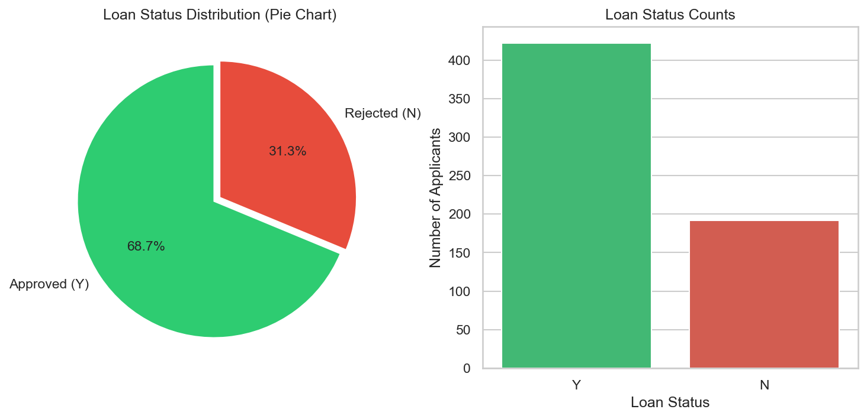
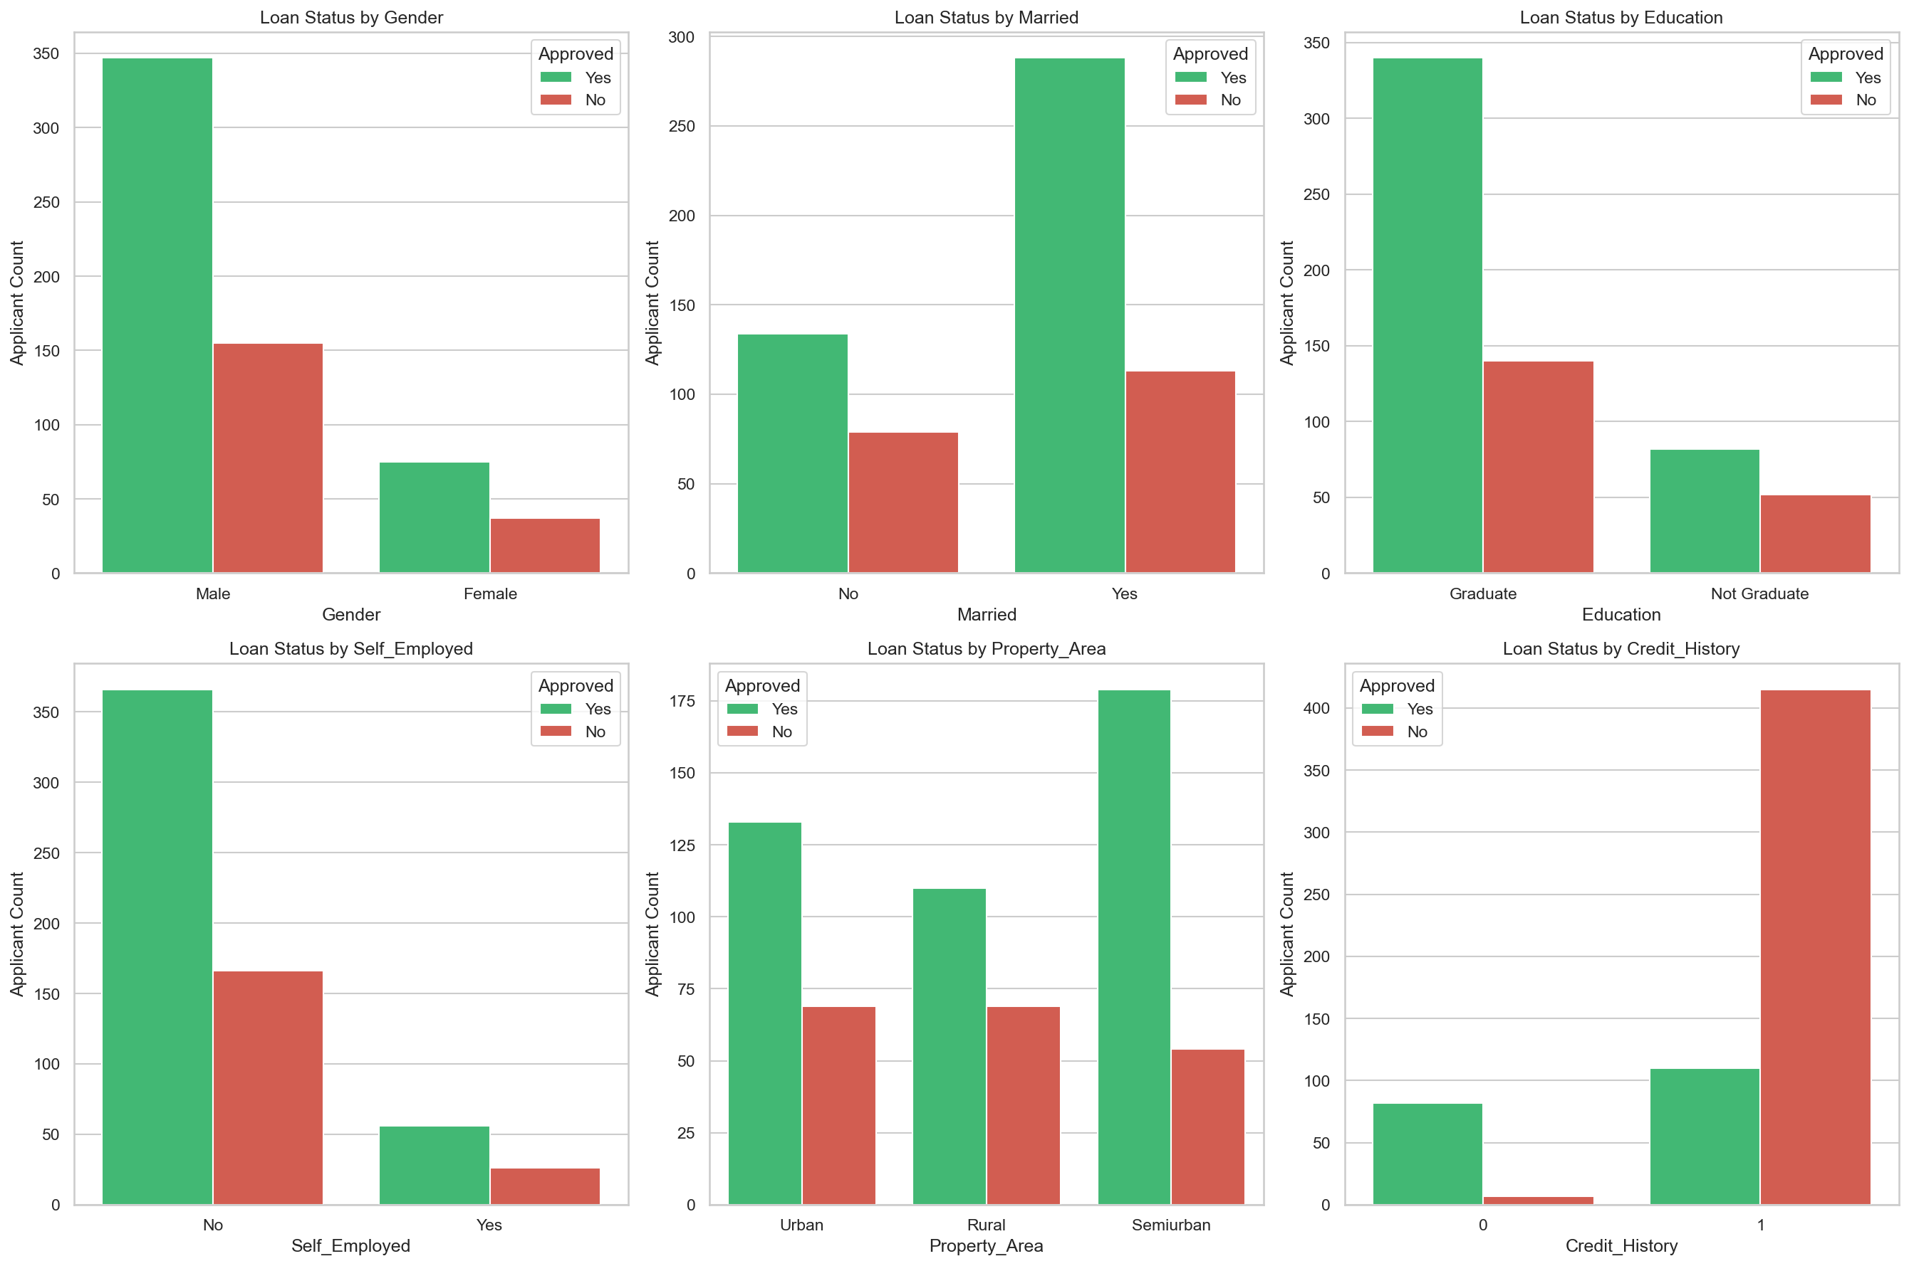
Figure 2: Portfolio Target Class Distribution and Demographic Breakdown vs. Approval Status

10. Feature Engineering
To capture repayment capacity and applicant risk profiles, we engineered several financial features:
1. TotalIncome: Combines applicant and co-applicant incomes to measure household purchasing power.
2. Loan-to-Income Ratio (LTI %): Measures the scale of requested credit exposure relative to monthly household income.
3. Estimated EMI: Estimates the monthly debt servicing cost, assuming a simple interest structure.
4. Risk Category: A rule-based indicator classifying applicants as Low, Medium, or High Risk using credit history and total income thresholds.
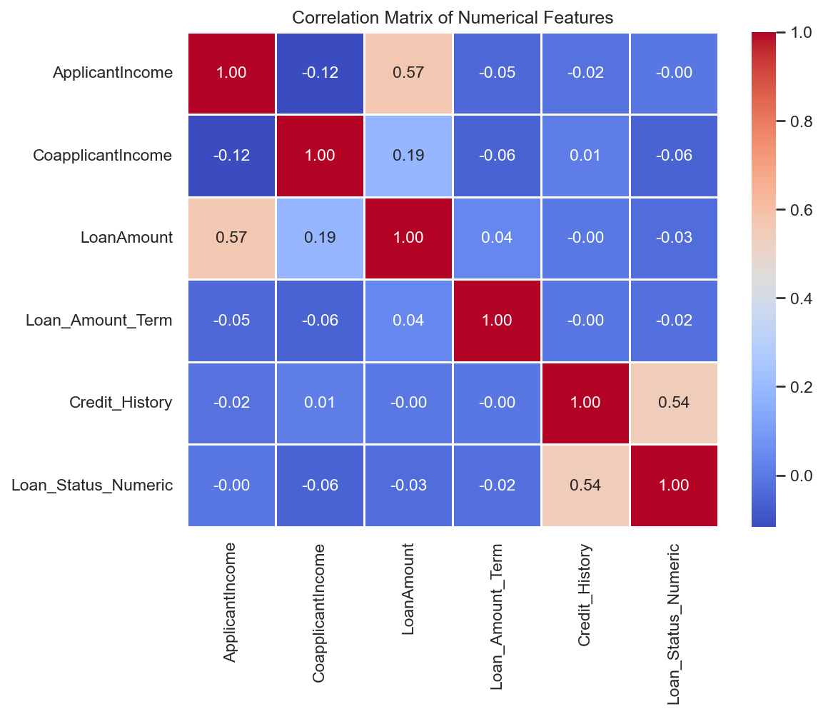
Figure 3: Correlation heatmap of numerical features and engineered features with target status

11. Machine Learning Model Comparisons
We implemented a machine learning pipeline using ColumnTransformer to scale numerical features and one-hot encode categorical features. Models were trained on an 80-20 stratified split and evaluated using 5-Fold Cross Validation. We performed hyperparameter tuning via GridSearchCV on Random Forest, XGBoost, and CatBoost.
Model Pipeline | Accuracy | Precision | Recall | F1-Score | ROC-AUC
CatBoost Classifier (Tuned) | 85.37% | 82.80% | 98.80% | 90.10% | 0.842
XGBoost Classifier (Tuned) | 83.74% | 82.47% | 96.39% | 88.89% | 0.829
Random Forest (Tuned) | 82.93% | 81.63% | 96.39% | 88.39% | 0.821
Logistic Regression (Baseline) | 81.30% | 79.21% | 96.39% | 86.96% | 0.803
Decision Tree (Baseline) | 72.36% | 79.27% | 80.24% | 79.75% | 0.681
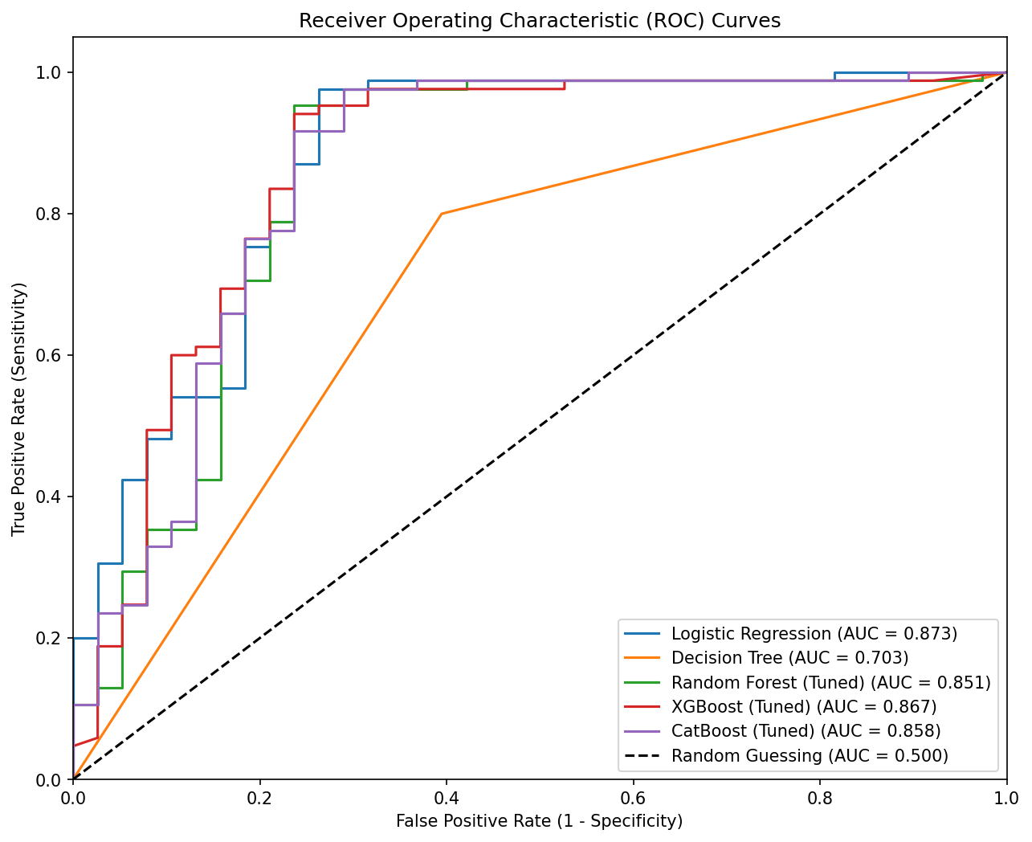
Figure 4: Receiver Operating Characteristic (ROC) curves comparison

12. Model Predictions on Test Set Data
Below is a sample of 20 test set applications processed by our production CatBoost pipeline, showing actual statuses, predicted probability scores, and final predictions:
Row | Income | Loan ($K) | Credit | Area | Actual | Prob | Pred | Audit
150 | 6,277 | 118 | 0 | Rural | Rejected | 0.1669 | Rejected | Correct
559 | 6,486 | 182 | 1 | Semiurban | Approved | 0.6952 | Approved | Correct
598 | 9,963 | 180 | 1 | Rural | Approved | 0.6626 | Approved | Correct
235 | 6,760 | 170 | 1 | Rural | Approved | 0.6827 | Approved | Correct
145 | 6,816 | 100 | 1 | Semiurban | Approved | 0.7128 | Approved | Correct
191 | 12,000 | 164 | 1 | Semiurban | Rejected | 0.6740 | Approved | False Pos
557 | 10,139 | 260 | 1 | Semiurban | Approved | 0.7003 | Approved | Correct
470 | 5,529 | 162 | 1 | Semiurban | Approved | 0.7055 | Approved | Correct
88 | 8,566 | 210 | 1 | Urban | Approved | 0.6584 | Approved | Correct
386 | 3,946 | 132 | 1 | Semiurban | Approved | 0.7276 | Approved | Correct
380 | 5,833 | 128 | 1 | Semiurban | Approved | 0.7312 | Approved | Correct
335 | 9,993 | 70 | 1 | Semiurban | Approved | 0.6988 | Approved | Correct
368 | 6,325 | 175 | 1 | Semiurban | Approved | 0.7027 | Approved | Correct
60 | 6,296 | 120 | 1 | Urban | Approved | 0.7017 | Approved | Correct
569 | 5,230 | 104 | 0 | Urban | Rejected | 0.1686 | Rejected | Correct
517 | 4,874 | 123 | 0 | Semiurban | Rejected | 0.1877 | Rejected | Correct
500 | 4,328 | 113 | 1 | Rural | Approved | 0.6834 | Approved | Correct
399 | 3,300 | 103 | 0 | Semiurban | Rejected | 0.1991 | Rejected | Correct
414 | 5,386 | 178 | 0 | Semiurban | Rejected | 0.2417 | Rejected | Correct
508 | 5,492 | 188 | 1 | Urban | Approved | 0.6774 | Approved | Correct

13. Model Interpretability & Compliance (SHAP XAI)
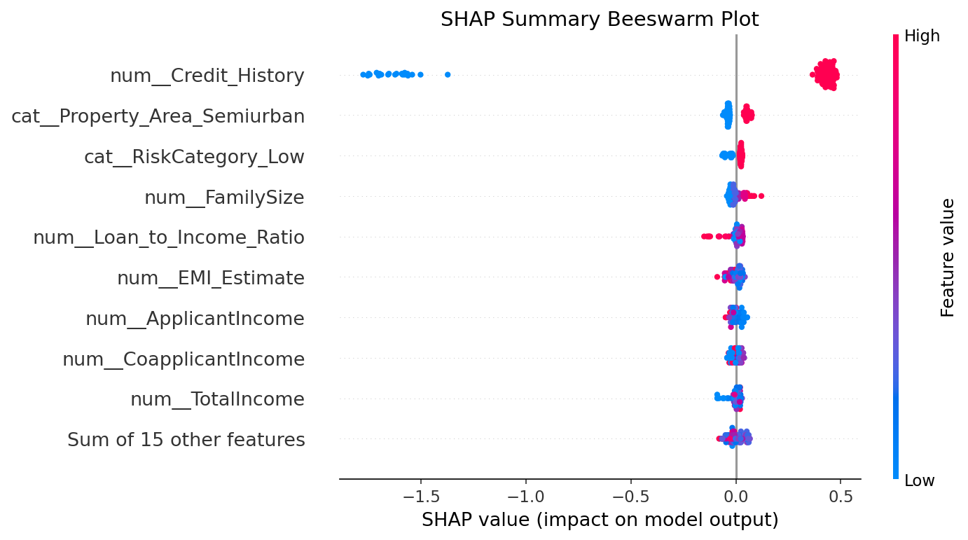
Figure 5: SHAP Beeswarm plot ranking features by predictive importance

14. Power BI Dashboard Layout & Business Recommendations
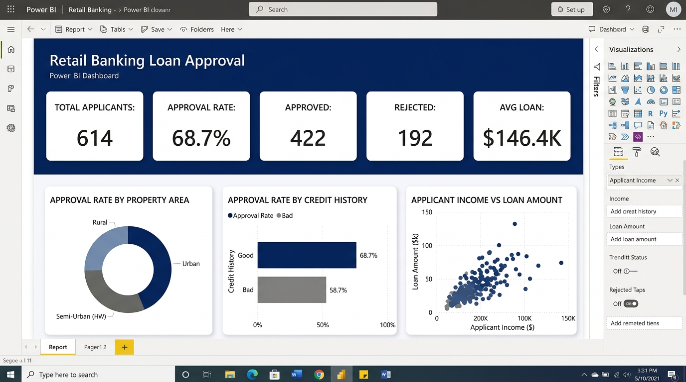
Figure 6: High-fidelity layout of the Power BI mortgage analytics dashboard

14.1 Policy Recommendations for Credit Risk Teams:
1. Mandate Household Income Reporting: Require both applicant and co-applicant incomes to support mortgage files, lowering overall credit default risk.
2. Target Semi-Urban Portfolios: Focus mortgage expansion campaigns in semi-urban locations showing strong 76.82% approval rates and low relative defaults.
3. Alternative Credit Scorecards: Implement utility bill and transaction-based scoring engines for applicants with Credit_History = 0 to capture creditworthy first-time buyers.

