Enterprise Knowledge Assistant
System Design Document
AI Engineer Assignment
Prepared by: Shakeel Irfan

1. Problem Statement
Enterprise organizations store large amounts of information in PDF documents such as policies, manuals, technical guides, and reports. Manually searching these documents is time-consuming and inefficient. This project uses Retrieval-Augmented Generation (RAG) to provide fast and accurate answers based only on document content.

2. Objective
Build an AI-powered knowledge assistant that ingests PDF documents, creates a searchable vector index, retrieves relevant information through semantic search, and generates context-aware answers using Google Gemini.

3. High-Level Architecture
The workflow consists of document ingestion, indexing, semantic retrieval, and LLM-based answer generation.
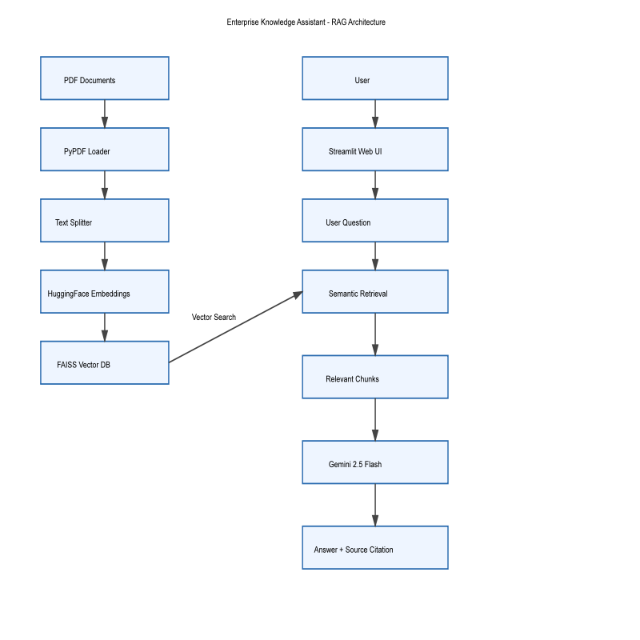

4. Data Flow
- User uploads PDF documents.
- PyPDFLoader extracts document text.
- RecursiveCharacterTextSplitter divides text into overlapping chunks.
- HuggingFace Embeddings converts chunks into vectors.
- FAISS stores vectors for semantic retrieval.
- User asks a question through Streamlit.
- FAISS retrieves the top relevant chunks.
- Gemini 2.5 Flash generates an answer using retrieved context only.
- The application displays the answer with document source and page reference.

5. Component Description
Component | Purpose
Streamlit | User Interface
PyPDFLoader | Extracts text from PDF documents
RecursiveCharacterTextSplitter | Splits documents into overlapping chunks
HuggingFace Embeddings | Generates semantic vector embeddings
FAISS | Stores and searches vectors efficiently
Gemini 2.5 Flash | Generates context-aware answers

6. Technology Stack
Python, Streamlit, LangChain, FAISS, HuggingFace Embeddings (all-MiniLM-L6-v2), Google Gemini 2.5 Flash, PyPDFLoader.

7. Design Decisions
• FAISS was selected for fast local semantic search.
• HuggingFace embeddings provide high-quality semantic representations without embedding API costs.
• Gemini 2.5 Flash was selected for fast, accurate response generation.
• Overlapping chunking preserves context and improves retrieval quality.

8. Scalability Considerations
The solution can be extended by replacing FAISS with cloud vector databases such as Pinecone or Weaviate, adding authentication, conversation memory, Docker deployment, monitoring, and support for multiple concurrent users.

9. Limitations
Currently supports PDF documents only, uses a local FAISS index, and does not include OCR, hybrid search, or multi-user authentication.

10. Future Enhancements
- Conversation memory
- Hybrid keyword + semantic search
- Query rewriting
- Re-ranking
- OCR support
- Cloud deployment
- Role-based authentication
- Multi-document reasoning

11. Conclusion
The Enterprise Knowledge Assistant demonstrates a practical implementation of Retrieval-Augmented Generation (RAG). By combining semantic retrieval with Google Gemini, the application delivers accurate, context-aware responses while citing the original document source, making it suitable for enterprise knowledge management.

