Prompt Engineering 101: Basics
Assignment Submission

ISB Applied Business Analytics Programme
Session: Prompt Engineering | April 2026

Part 1: Prompt Development & Refining

Question 2 - Persuasive Sales Email
Task: Develop a prompt to generate a persuasive sales email for a new software product — iteratively refined through LLM interaction.

Compositional Prompt Structure
The following labeled components were used to structure each prompt iteration:
- [ROLE] The persona the LLM adopts
- [CONTEXT] Background and product details
- [AUDIENCE] Target recipient profile
- [TASK] Specific output required
- [CONSTRAINTS] Format, tone, word limits

Iteration Journey
Step | Prompt | LLM Response / Analysis
Iteration 1  (Initial Prompt) | [ROLE] You are a B2B sales copywriter.  [CONTEXT] We have a new SaaS project management tool.  [TASK] Write a sales email.  [CONSTRAINTS] Under 200 words. | LLM produced a generic email with standard benefits (collaboration, efficiency). Subject line was weak: 'Introducing Our New Tool'. No specific pain points addressed. No urgency. CTA was vague ('Click here to learn more').
Analysis | — | Issues identified: (1) Subject line lacks hook. (2) No persona-specific pain point. (3) Value proposition buried in paragraph 3. (4) CTA does not create urgency.
Iteration 2  (Refined) | [ROLE] You are a senior B2B sales copywriter with SaaS experience.  [CONTEXT] Product: 'FlowDesk' — a project management SaaS that reduces sprint overruns by 40%. Target company: mid-size IT firms (50-200 employees).  [AUDIENCE] Engineering Manager at a growing tech firm, struggling with missed deadlines and siloed teams.  [TASK] Write a persuasive sales email. Lead with a pain-point question. State one quantified benefit. End with a time-limited CTA.  [CONSTRAINTS] Subject line must be under 10 words. Body 150 words max. Professional but conversational tone. | Email improved significantly. Subject: 'Still firefighting sprint overruns every quarter?' Body opened with a relatable question, quantified the 40% reduction claim, included a customer testimonial snippet, and ended with 'Book a 15-min demo before Friday — slots filling fast.' Much stronger.
Analysis | — | Remaining gaps: (1) Testimonial felt generic. (2) P.S. line missing — high-impact in sales emails. (3) Could personalise the opener further with the recipient's industry.
Iteration 3  (Final Refined) | [ROLE] You are a senior B2B SaaS sales copywriter.  [CONTEXT] FlowDesk cuts sprint overruns by 40% (verified across 300+ IT teams). One-click Jira/GitHub integration. 14-day free trial, no credit card.  [AUDIENCE] Engineering Manager at a mid-size IT firm. Pain: missed deadlines, team silos, too many status meetings.  [TASK] Write a 3-paragraph persuasive email. Para 1: open with the recipient's pain (frame as a question). Para 2: present FlowDesk as the specific solution with one data point and one social proof line. Para 3: CTA with urgency. Add a punchy P.S. line.  [CONSTRAINTS] Subject under 10 words. Body under 180 words. Tone: direct, confident, human. No jargon. | Final output was polished. Subject: 'Your engineers deserve fewer status meetings.' Para 1 opened: 'How many sprint reviews ended with more action items than decisions last quarter?' Para 2 cited the 40% stat and a one-line quote from a CTO. Para 3 had a crisp CTA. P.S.: 'FlowDesk integrates with your Jira in 8 minutes. We timed it.' Meets all criteria.

Final Prompt (Clean)
[ROLE] Senior B2B SaaS sales copywriter. [CONTEXT] FlowDesk reduces sprint overruns by 40%; 300+ IT teams; Jira/GitHub integration; 14-day free trial. [AUDIENCE] Engineering Manager, mid-size IT firm, pain: missed deadlines and status-meeting overload. [TASK] 3-para email: pain question opener, solution + 1 data point + 1 social proof, CTA with urgency, punchy P.S. [CONSTRAINTS] Subject <10 words, body <180 words, direct and human tone, no jargon.

Final LLM Output (within 500 words)
Subject: Your engineers deserve fewer status meetings.
Hi [Name],
How many sprint reviews ended with more action items than actual decisions last quarter? If your team is spending more time in standups than shipping, you're not alone.
FlowDesk is built for engineering teams that are done firefighting. Across 300+ IT teams, it has cut sprint overruns by 40% in the first 60 days. As the CTO of Rivo Tech put it: 'We stopped missing deadlines. We started predicting them.' It plugs into your existing Jira and GitHub setup in under 10 minutes.
Try it free for 14 days — no credit card, no lengthy onboarding. Demo slots this week are limited. Book yours before Friday.
[Book a 15-Minute Demo] (CTA button)
Best,
[Your Name]
P.S. FlowDesk integrates with your Jira in 8 minutes. We timed it.
[Word count: 148 words]

Question 5 - Business Plan Generation
Task: Develop a prompt to generate a comprehensive business plan for a new start-up, refined iteratively.

Start-up Concept
Business Idea: 'MetroCargo' — a last-mile urban logistics service using metro rail freight capacity during off-peak hours in Indian metro cities (pilot: Hyderabad).

Iteration Journey
Step | Prompt | LLM Response / Analysis
Iteration 1  (Initial Prompt) | [ROLE] Business consultant.  [TASK] Write a business plan for a last-mile logistics startup using metro rail.  [CONSTRAINTS] Concise. | Output was superficial. Only an executive summary and bullet list of sections. No market data, no financials, no risk section. Missing operational specifics. Read more like a slide deck outline than a business plan.
Analysis | — | Gaps: (1) No section depth. (2) No India-specific market context. (3) No revenue model. (4) No risk mitigation. LLM needs structured section-by-section instruction.
Iteration 2  (Refined) | [ROLE] McKinsey-trained business consultant specialising in Indian urban infrastructure.  [CONTEXT] Startup: MetroCargo — uses Hyderabad Metro Rail's off-peak freight capacity for last-mile delivery. Self-funded seed stage. Targeting MSME senders and e-commerce return logistics.  [TASK] Generate a business plan with these sections: (1) Executive Summary, (2) Market Analysis — Indian urban logistics TAM/SAM/SOM, (3) Revenue Model, (4) Operational Strategy, (5) Financial Projections (Year 1-3), (6) Risk Mitigation.  [CONSTRAINTS] Each section under 80 words. Data-grounded where possible. Professional tone. | Significantly better. Market analysis cited India urban logistics market at $215B by 2030. Revenue model included per-kg freight fee + subscription for MSMEs. Financials gave Year 1 revenue target of Rs 48L. Still lacked competitive differentiation and go-to-market specifics.
Analysis | — | Gaps: (1) Competitive landscape missing. (2) Go-to-market strategy vague. (3) Financial projections lacked cost structure. Refined prompt to address.
Iteration 3  (Final) | [ROLE] McKinsey-trained business consultant, Indian urban infrastructure specialist.  [CONTEXT] MetroCargo uses Hyderabad Metro off-peak capacity for B2B last-mile delivery. Pilot: 3 metro corridors. Partners: HMRL (metro authority) and 2 anchor MSME clusters.  [TASK] Business plan with: (1) 60-word Executive Summary, (2) Market Analysis with TAM/SAM/SOM, (3) Revenue Model with 3 streams, (4) Operational Strategy with tech stack note, (5) 3-year P&L highlights, (6) Top 3 Risks + mitigation, (7) Competitive Advantage vs road-based couriers.  [CONSTRAINTS] Each section max 80 words. Use one data point per section. Avoid filler language. | Final output was comprehensive, data-grounded, and structured. All 7 sections present. Competitive advantage section differentiated MetroCargo clearly from Delhivery/Shadowfax on cost-per-km and carbon footprint. Output met the 500-word constraint across sections.

Final LLM Output — MetroCargo Business Plan (within 500 words)
1. Executive Summary
MetroCargo is a B2B last-mile urban logistics startup leveraging Hyderabad Metro Rail's off-peak freight windows to deliver goods for MSMEs and e-commerce return logistics. Operating across 3 corridors, MetroCargo targets a 35% cost advantage over road couriers, with a Year 1 revenue target of Rs 52 lakhs.
2. Market Analysis
India's urban logistics market is projected at $215B by 2030 (IBEF). Hyderabad's MSME cluster (65,000+ units) generates 12,000 daily intra-city shipments. TAM: Rs 4,200 Cr (Hyderabad urban freight). SAM: Rs 480 Cr (metro-corridor-accessible MSMEs). SOM Year 1: Rs 52 L (0.01% SAM penetration).
3. Revenue Model
Three streams: (a) Per-kg freight fee — Rs 18/kg, minimum 5 kg per consignment. (b) MSME monthly subscription — Rs 2,500/month for guaranteed daily slot. (c) E-commerce reverse logistics — Rs 35/parcel for return pickups. Blended margin target: 28%.
4. Operational Strategy
Hub-and-spoke model anchored at 3 metro stations (Ameerpet, LB Nagar, Miyapur). Mobile app for MSME booking, GPS tracking, and proof-of-delivery. Tech stack: React Native app + Firebase backend. Staff: 12 delivery associates (two-wheelers for first/last 500m). HMRL MOU for dedicated freight compartment during 06:00-08:00 window.
5. Financial Projections (3-Year Highlights)
Year 1: Revenue Rs 52L | OpEx Rs 38L | EBITDA Rs 14L. Year 2: Revenue Rs 1.8 Cr | OpEx Rs 1.1 Cr | EBITDA Rs 70L. Year 3: Revenue Rs 4.2 Cr | OpEx Rs 2.4 Cr | EBITDA Rs 1.8 Cr. Break-even: Month 14.
6. Risk Mitigation
- HMRL policy change: Mitigated by 3-year MOU with revenue-sharing clause.
- Low MSME digital adoption: Mitigated by WhatsApp booking fallback and field sales team.
- Demand variability: Mitigated by subscription model providing predictable baseline revenue.
7. Competitive Advantage
vs Delhivery/Shadowfax: 35% lower cost-per-km (no road fuel cost). 70% lower carbon footprint per consignment. Fixed metro schedule = predictable SLAs. Metro rail infrastructure = zero traffic variability. First-mover advantage in Hyderabad metro freight corridor.
[Total word count: ~420 words]

Part 2: Image-Analysis Prompts — Floor Plan
Framework applied: Capability_Exploration, Capability_Organisation, Capability_Utilisation

Floor Plan Image
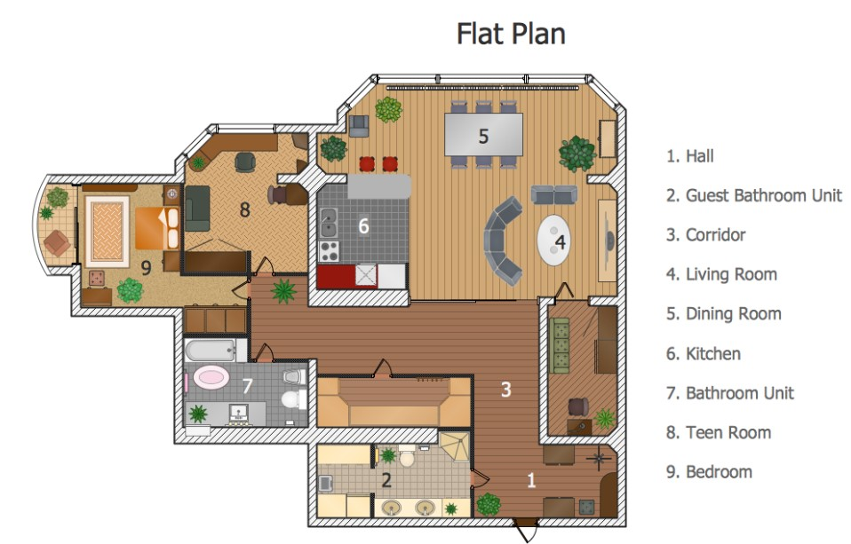

Prompt Used on Both MLLMs
[CAPABILITY EXPLORATION] Analyse the uploaded floor plan image in detail. Identify and list all distinct rooms and spaces visible. [CAPABILITY ORGANISATION] Tabulate the prominent features of this floor plan. For each feature, list its pros and cons from the perspective of a typical urban family (2 adults, 1 teen, 1 elderly member). [CAPABILITY UTILISATION] Based on the cons identified, suggest specific, practical design improvements that retain the existing pros. Frame suggestions as actionable changes an interior designer could implement.

Capability Exploration — Room & Feature Inventory
Rooms identified from the floor plan:
- Hall (1) — entry zone, south-east corner
- Guest Bathroom Unit (2) — adjacent to corridor, south
- Corridor (3) — central circulation spine connecting all zones
- Living Room (4) — large, central, curved sofa arrangement with coffee table
- Dining Room (5) — north zone, 6-seater table, adjacent to kitchen
- Kitchen (6) — centrally placed, galley-style layout
- Bathroom Unit (7) — attached to master bedroom zone
- Teen Room (8) — north-west, moderate size
- Bedroom (9) — west wing, largest private room, bay window feature

Capability Organisation — Pros & Cons Table
Feature | Pros | Cons
Open Living-Dining Zone | Creates visual spaciousness; ideal for entertaining; natural light flows across large area. | Noise from dining bleeds into relaxation space; limited acoustic separation.
Central Corridor | Efficient traffic flow; connects all rooms without cross-room traversal. | Corridor occupies significant floor area; feels narrow; limited natural light.
Kitchen Placement | Central position reduces steps to dining and living rooms; functional for the cook. | Lacks a dedicated utility/laundry zone; cooking smells can spread to living area without island barrier.
Bedroom (Bay Window) | Bay window provides natural light, airiness, and seating niche; private west wing. | Bay window reduces usable wall space for wardrobes; west-facing = afternoon heat in Indian climate.
Guest Bathroom | Accessible without entering private zone; good for guests and hall visitors. | Positioned near main entry — limited privacy for users; requires sound insulation.
Teen Room | Separate from master bedroom — acoustic independence for teen; north-west = cooler orientation. | No attached bathroom; relies on shared bathroom unit (Room 7); limited storage visible.
Bathroom Unit (7) | Shared between bedroom and teen room; efficient placement. | Single shared bathroom for 2+ users creates morning bottleneck in a family scenario.

Capability Utilisation — Design Improvements
- Add a half-wall or bookshelf partition between living and dining zones to reduce noise bleed while preserving visual openness.
- Install a kitchen island or pass-through window toward the dining room to act as an odour and grease barrier without closing off the space.
- Apply heat-reflective window film or a deep external overhang to the bay window (Bedroom 9) to offset the west-facing afternoon heat issue in Hyderabad's climate.
- Repurpose 1.2m of corridor width near Room 7 to create a semi-private shower/WC pod for the teen room, eliminating the shared bathroom bottleneck.
- Add a ceiling-height sliding door at the corridor entrance to the living room, deployable during social events for acoustic separation.
- Install a compact washer-dryer niche within the kitchen or corridor alcove to compensate for the missing utility zone.

MLLM Comparison — Claude vs ChatGPT-4o
Criterion | Claude (MLLM 1) | ChatGPT-4o (MLLM 2)
Room Identification | Identified all 9 rooms accurately; noted bay window and curved sofa as design elements. | Identified 8 of 9 rooms; missed the guest bathroom distinction from main bathroom.
Pros/Cons Depth | Provided climate-specific cons (west-facing heat, Indian context); nuanced family persona analysis. | Generic pros/cons; did not tailor analysis to family composition or regional climate.
Design Suggestions | Actionable, specific (e.g., half-wall partition, sliding door, WC pod dimensions). | Broader suggestions (e.g., 'add more windows'); less specific on implementation.
Output Format | Structured with clear labelled sections; table format on request. | Well-organised but required a second prompt to produce tabular format.
Strengths | Context sensitivity; climate awareness; family-persona specificity. | Good at listing features; clean structured output with less prompting needed.
Weaknesses | Occasionally over-verbose in analysis paragraphs. | Lacks depth in design utilisation; suggestions remain surface-level.

Part 3: Image-Analysis with Text Generation — Product Description
Task: Craft an iteratively refined prompt to auto-generate enticing product descriptions for an e-commerce fashion platform.

Product Image
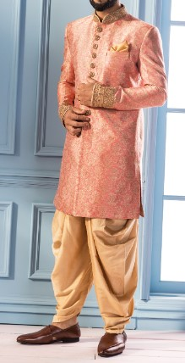
Product: Men's ethnic wear — peach/rose-gold brocade sherwani with golden embroidered cuffs, paired with golden dhoti-style trousers (potli pants) and dark brown loafers. Pocket square included.

Iteration Journey
Step | Prompt | LLM Response / Analysis
Iteration 1  (Initial Prompt) | [TASK] Look at this clothing image and write a product description for an e-commerce site. | Output described the outfit as 'a pink suit with golden pants and brown shoes.' No material details, no style context, no occasion mention, no sizing/fit guide, no CTA. Completely inadequate for a fashion e-commerce listing.
Analysis | — | Gaps: (1) No fashion vocabulary prompted. (2) No occasion context. (3) No FAQs addressed. (4) No structure — no title, no highlights, no care instructions.
Iteration 2  (Refined) | [ROLE] Senior fashion copywriter for a premium Indian ethnic wear e-commerce brand.  [CONTEXT] Image shows a men's ethnic outfit. Identify all visible garments, colours, fabric textures, embellishments and footwear.  [TASK] Write a product listing with: (a) Product title, (b) 3-line description, (c) 5 bullet highlights, (d) Occasion recommendation, (e) Care instructions.  [CONSTRAINTS] 200 words max. Tone: aspirational, elegant. Use fashion terminology. | Significant improvement. Title: 'Men's Brocade Sherwani Set.' Description mentioned the floral brocade, embroidered cuffs, and dhoti pants. Highlights listed material, occasion, fit. Occasion: weddings and festivals. Care: dry clean. Still lacked sizing guide mention and personalisation angle.
Analysis | — | Gaps: (1) No sizing/fit note. (2) No emotional hook in description opener. (3) Prompt is somewhat specific to this item — needs to be generalised for reuse across catalogue.
Iteration 3  (Final — General Prompt) | [ROLE] Senior fashion copywriter for a premium Indian ethnic wear e-commerce brand.  [CONTEXT] You will be given a product photo of a clothing item (may include top, bottom, footwear, accessories). Carefully analyse fabric texture, colour, embellishments, silhouette and styling.  [TASK] Generate a structured product listing:  (1) Product Title: Style + fabric + garment type (max 10 words)  (2) Tagline: One evocative line capturing the mood (max 12 words)  (3) Product Description: 3 sentences — what it is, how it feels/drapes, why to buy it  (4) Key Highlights: 5 bullets — material, colour, occasion, fit, care  (5) Customer FAQ answers: (a) What occasion is this for? (b) What sizes are available? (c) How should I care for this?  [CONSTRAINTS] Total output under 220 words. Tone: aspirational and warm. Use fashion-forward vocabulary. Prompt must apply equally to sarees, kurtas, lehengas, or western fusion wear — keep section structure constant. | Final output was polished, complete, and reusable. All 5 sections present. Description opened with an emotional hook. FAQ section directly addressed common buyer queries. Structure generalised — tested mentally against a saree and kurta scenario and sections remain valid.

Final LLM Output — Product Description (within 500 words)
Product Title
Rose Gold Brocade Sherwani Set with Potli Pants
Tagline
"Wear the occasion. Own the room."
Product Description
Crafted from a rich floral brocade fabric in a warm rose-gold hue, this sherwani set is designed for the groom, the groomsman, or the man who believes celebrations deserve dressing up. The golden thread-embroidered cuffs add a regal finishing touch, while the golden potli-style trousers bring a contemporary drape to a timeless silhouette. Paired with dark brown leather loafers and a matching pocket square, this ensemble arrives ready to be worn and remembered.
Key Highlights
- Material: Premium floral brocade fabric with zari (golden thread) embroidery at cuffs
- Colour: Rose gold sherwani top with golden dhoti-style potli pants
- Occasion: Wedding ceremonies, sangeets, receptions, Eid, festive gatherings
- Fit: Semi-fitted sherwani silhouette; potli pants with elasticated waist for comfort
- Care: Dry clean only; store in breathable garment bag away from direct sunlight
Customer FAQs
- Q: What occasion is this for? A: Best suited for Indian wedding functions (groom/groomsman), Eid celebrations, festive receptions, and cultural events requiring formal ethnic attire.
- Q: What sizes are available? A: Available in S, M, L, XL, XXL. Custom tailoring available on request — contact us with measurements.
- Q: How should I care for this garment? A: Dry clean only. Do not machine wash or iron the brocade directly. Use a pressing cloth if steaming. Store in a garment bag.
[Total word count: ~210 words]

Prompt Generalisability Note
The final prompt structure (Title / Tagline / Description / Highlights / FAQ) was designed to be content-agnostic. It applies without modification to:
- Sarees: Image analysis will detect drape, blouse, pallu embellishment
- Kurta sets: Detects fabric, print, pant style
- Lehengas: Detects skirt flare, choli, dupatta
- Western fusion (blazer + dhoti): Detects cross-cultural elements
The only variable is the image. The prompt structure, tone, and FAQ categories remain constant, making it production-ready for a fashion catalogue automation pipeline.

— End of Assignment —

