Project: Azure SaaS - Multi-College Platform

High-Level Design (HLD)
Overview:
A cross-platform multi-tenant SaaS platform for colleges hosted on Azure.
It supports web, Android, and iOS clients and provides modules like Student Management, Attendance, Exams, Fees, and Notifications.
The architecture is scalable, secure, and designed for high availability.

Architecture Layers
1. Client Layer – Web and Mobile apps
2. Edge Layer – Front Door, CDN, WAF
3. Identity Layer – Entra ID authentication and RBAC
4. API Layer – API Management
5. Application Layer – Microservices (App Service / AKS)
6. Messaging Layer – Service Bus / Event processing
7. Data Layer – SQL Database, Blob Storage, Cache
8. Monitoring & DevOps – Azure Monitor, CI/CD

Architecture Diagram
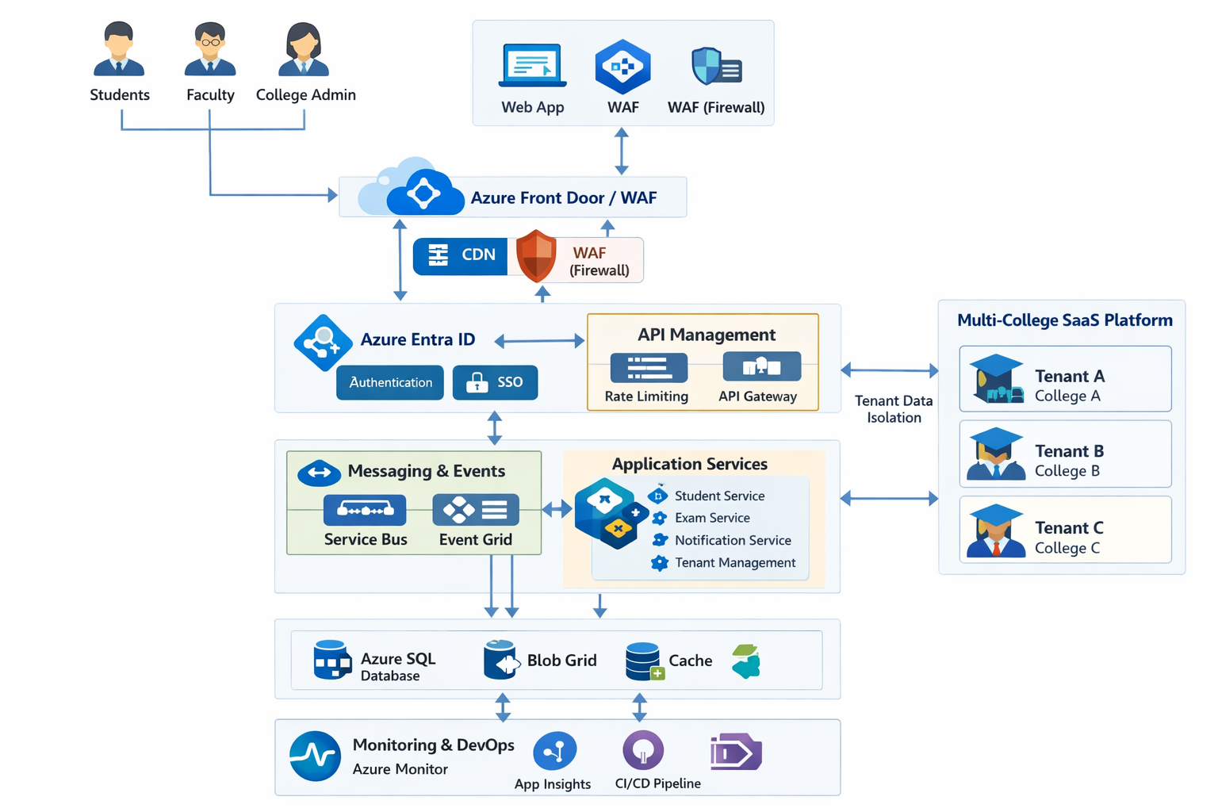

Data Flow (HLD)
User → Front Door → WAF → Authentication → API Management → Microservices → Database/Storage → Response

Deployment Architecture
Multi-region deployment with load balancing.
Auto-scaling for application services.
Database high availability with backups and failover.

Low-Level Design (LLD)

Microservices Design
Student Service – Manage student records
Attendance Service – Track attendance
Exam Service – Manage exams and results
Notification Service – Send alerts
Tenant Service – Manage colleges

API Structure
POST /students
GET /students/{id}
POST /attendance
GET /attendance/report
POST /exams
GET /results

Database Schema
Tenant Table: Tenant_ID, College_Name, Subscription
User Table: User_ID, Tenant_ID, Role, Email
Student Table: Student_ID, Tenant_ID, Name, Course
Attendance Table: Attendance_ID, Student_ID, Date, Status

Sequence Flow
Client Request → API Gateway → Authentication → Student Service → Database Query → Response

Security Implementation
OAuth tokens, RBAC policies, encrypted storage, private networking.

Monitoring and Logging
Metrics, logs, alerts, and application health monitoring.

CI/CD Pipeline
Developer → Repository → Build → Test → Deploy → Monitor

