**Covid-19 Vaccination: Data Analysis & Visualization**

**Aim**

This project aims to analyse and visualize the latest situation of “Covid19 Vaccination “around the world.

Introduction

The novel Coronavirus disease also known as COVID-19, is a new strain of SARS-Cov-2 that has ravaged the world as a global pandemic with its rapid spread and high mortality. This has brought together the different stakeholders in the world from the government to academia to researchers and scientists to curb this virus through vaccine development and testing. Currently, there are varieties of vaccines all around the world in different countries and this analysis seeks to monitor its progression.

Problem Statement

Tracking the progress of the Covid-19 vaccine in

Methodology

Step 1: Data Cleaning

The data cleaning is nothing but preparing the right or perfect data for the Visualization which helps in the better understanding of dataset. Data cleaning includes the following steps they are: -

* **Transform Data (Power Query in Action)**
* **Data Formatting (Check on Column Headers & Names)**
* **Import Data from Excel**
* **Set First Row as Header**
* **Replace Values**

**Step 2: Data Interpretation**

**The Data Interpretation is also known as creating a Report. Some of the important information about the data set are.**

* **The Dataset was almost clear and completed.**
* Assembling the information, you need (like bar graphs and pie charts)
* **I replaced the null values with 0.**
* **There is a total of 86513 Rows and 15 Columns.**

**Benefits of Data Interpretation**

* **Informed decision-making.**
* **Anticipating needs and identifying trends.**
* **Clear foresight.**

**Step 3: Visualization**

Visualizations are used to effectively present your data and are the basic building blocks of any Business Intelligence tool. Power BI contains various default data visualization components that include simple bar charts to pie charts to maps, and also complex models such as waterfalls, funnels, gauges, and many other components. I have used the above-mentioned components to visualize the given dataset.

Visualization includes following steps: -

## Identify messages of the visualization, and generate the most informative indicator.

## Choose the right chart type.

## Use colour, size, scale, shapes and labels to direct attention to the key messages.

**Analysis**

## **What is the number of total vaccinations & daily vaccinations according to countries?**

**Number of total vaccinations according to Countries.**

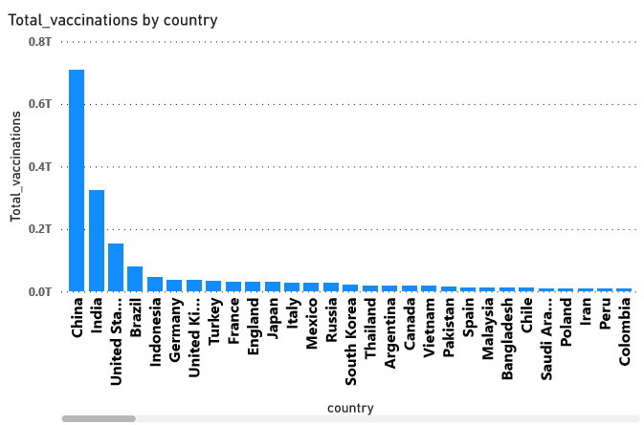

* At 709452663700, China had the highest Total vaccinations and was 2,03,86,57,07,859.77% higher than Pitcairn, which had the lowest Total vaccinations at 348.﻿﻿ ﻿
* ﻿﻿ ﻿﻿ ﻿﻿China accounted for 35.42% of Total vaccinations.﻿﻿ ﻿﻿ ﻿﻿
* Across all 223 country, total vaccinations ranged from 348 to 709452663700.﻿﻿ ﻿﻿ ﻿

**Number of Daily vaccinations according to Countries.**

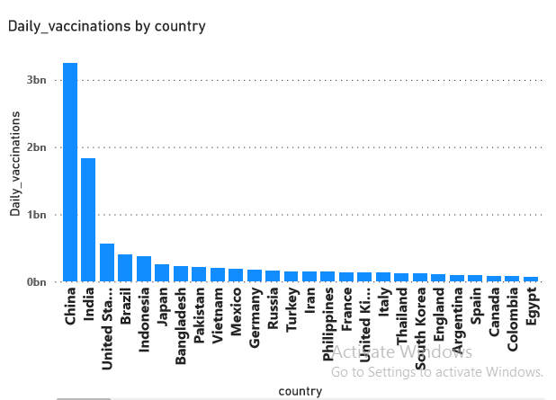

* At 3250342496, China had the highest Sum of daily vaccinations and was 7,55,89,35,937.21% higher than Pitcairn, which had the lowest Sum of daily vaccinations at 43.﻿﻿
* ﻿﻿China accounted for 28.71% of Sum of daily vaccinations.﻿﻿ ﻿﻿ ﻿﻿
* Across all 223 country, Sum of daily vaccinations ranged from 43 to 3250342496.﻿﻿ ﻿﻿ ﻿

**2. Which vaccine is used by which Country?**

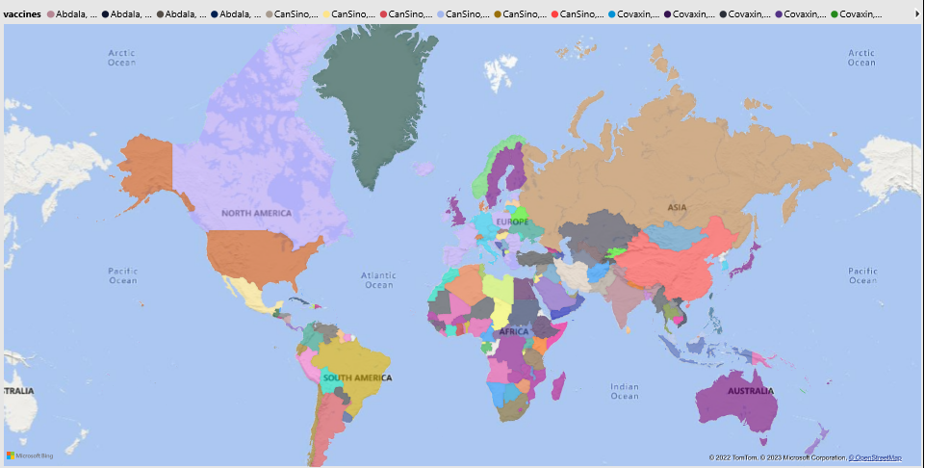

**Which Vaccine is used the most?**

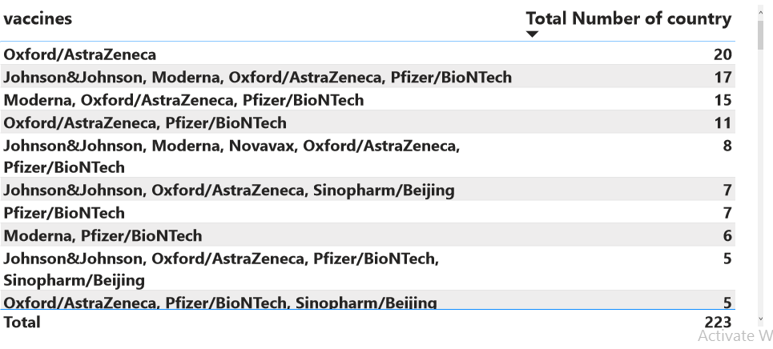

* Oxford/AstraZeneca vaccines is being used in 20 countries
* The Johnson&Johnson, Moderna, Pfizer/BioNTech vaccines are also used in major number of countries like 15 to 17 countries
* Whereas other vaccines are comparatively used in less number of countries.

**Total Vaccinations per country grouped by Vaccines**

# 

* China stands for first rank in total vaccination for about 709452663700 number of peoples were being vaccinated.
* Whereas India stands for second rank in total vaccination for about 323440305798 number of peoples were being vaccinated.
* Then comes the United States, Brazil, Indonesia, Germany etc…

**Daily Vaccinations per country grouped by vaccines.**

# 

* China stands for first rank in Daily vaccination for about 3250342496 number of peoples were being vaccinated.
* Whereas India stands for second rank in Daily vaccination for about 1829085487 number of peoples were being vaccinated.
* Then comes the United States, Brazil, Indonesia, Japan etc…

# Total vs Total vaccinations per hundred grouped by Vaccines and Country

# 

* China had the highest Total vaccinations (709452663700) and Israel had the highest Total vaccinations per hundred (61,816.51). The vaccines with the highest Total vaccinations was CanSino, Sinopharm/Beijing, Sinopharm/Wuhan, Sinovac, ZF2001 and the vaccines with the highest Total vaccinations per hundred was Moderna, Pfizer/BioNTech.﻿﻿
* ﻿﻿Most country were below 8981408133 in Total vaccinations and below 15,680.64 in Total vaccinations per hundred.

**What is the trend of total vaccinations according to countries?**

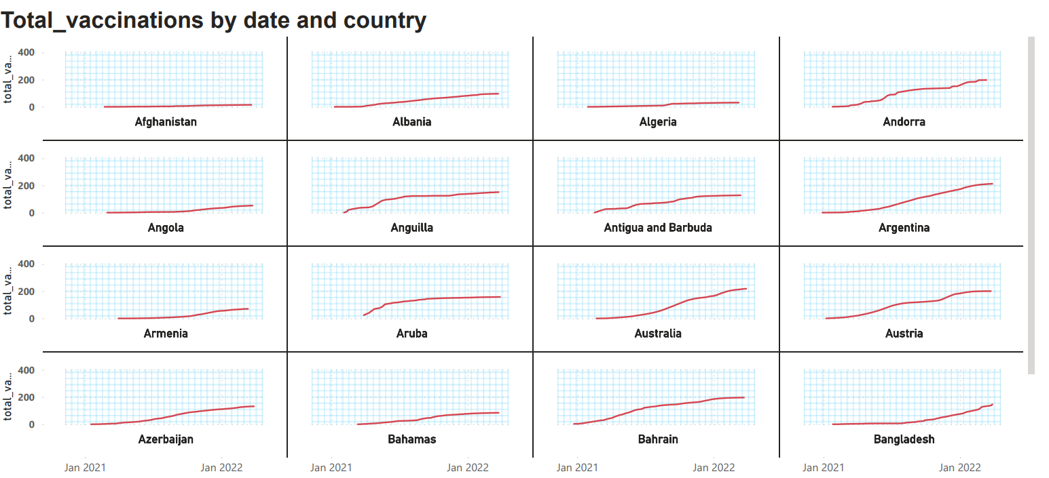

**Number of Total Vaccinations in each country and types of Vaccines used in each country.**

# 

**Number of people fully vaccinated by each Country**

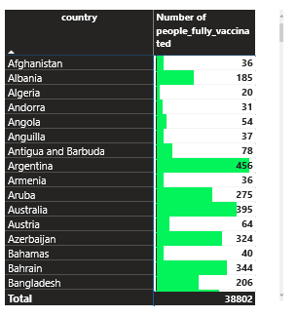

**Percentage of people fully vaccinated in each Year**

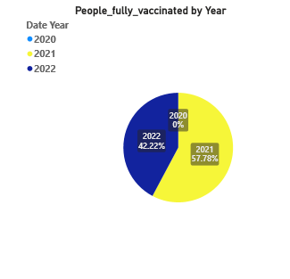

**Number of people vaccinated vs people fully vaccinated in each country**

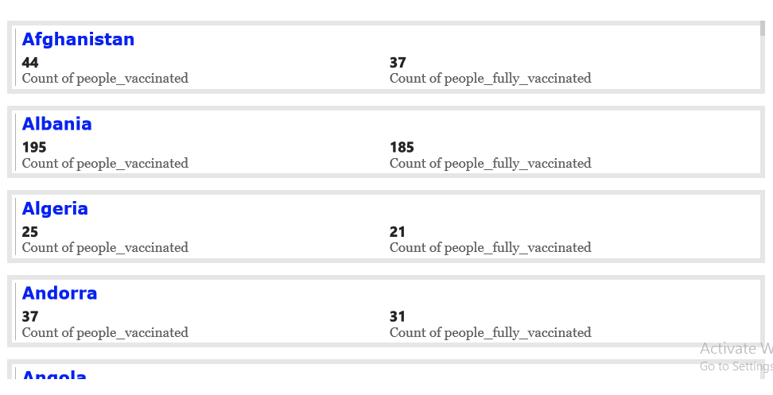

* In the above visualization we can analyse Number of people vaccinated vs people fully vaccinated in each country.
* For example, in Afghanistan 44 people got vaccinated whereas only 37 people of them are fully vaccinated.
* And in Albania 195 people got vaccinated whereas only 185 people of them are fully vaccinated.

# Recommendation:

The Federal Ministry of Health should have a central database that is updated daily with the accurate figures. This will go a long way in tracking both the vaccination progress and the new cases of the virus and will give a clue on how to mitigate the spread in the country.

**Conclusion:**

Analysis on Covid-19 is done we have analysed vaccine according to country and vaccine most used and total people fully vaccinated and final report is done using powerbi.