**PROJECT:**

**BLOOD BANK MANAGEMENT SYSTEM**

PROJECT MEMBERS

Shakeib-e-shaida (Project coordinator)

Tehreem Faheem

Muslima iliyas

**INDEX**

**1: RESEARCH REPORT**

WHAT IS OUR PROJECT? 1.1

WHAT OTHERS HAVE DONE 1.2

What they have done 1.3

MODULES 1.4

ALGORITHIMS 1.5

METHODOLOGIES 1.6

RESOURCES AND TOOLS AVAILABLE 1.7

EVALUATION 1.8

Screenshot 1.8.1

RELAVANT LINKS AND ARITCLES 1.9

**2: TOOLS FOR SDLC LIFE CYCLE**

ANALYSIS AND REQUIREMENT MANAGEMENT TOOLS 2.1

DESIGN TOOLS 2.2

PROTOTYPING TOOLS 2.2.1

UML DESIGNING 2.2.2

PROJECT MANAGEMENT TOOLS 2.3

DATABASE MANAGEMENT TOOLS 2.4

DOCUMENTATION TOOLS 2.5

REQUIREMENT DOCUMENATION 2.6

WRITING APIs 2.6.1

WRITING ARCHITECTURE 2.6.2

WRITING DATABASES 2.6.3

QA TESTING AND TEST MANAGEMENT 2.7

**3: RAD REPORT**

INTRODUCTION 3.1

PURPOSE OF THE SYSTEM 3.1.1

SCOPE OF THE SYSTEM 3.1.2

OBJECTIVE 3.1.3

PROPOSED SYSTEM 3.2

FUNCTIONAL REQUIREMENTS 3.3

ADMIN 3.3.1

USER 3.3.2

NON FUNCTIONAL 3.4

**4: UML DIAGRAMS**

USE CASE DIAGRAM 4.1

CLASS DIAGRAM 4.2

ACTIVITY DIAGRAM 4.3

Activity Diagram For Admin 4.3.1

Activity Diagram For Login 4.3.2

Activity Diagram For User 4.3.3

SEQUANCE DIAGRAM 4.4

Sequence Diagram For Admin 4.4.1

Sequence Diagram For User 4.4.2

1. RESEARCH REPORT:

# WHAT IS OUR PROJECT?

We are making blood bank management system.

## OBJECTIVE:

The main objective of our system is that suppose you are new to the city, and an emergency occurred and you don’t know any blood banks in the city.

So our aim is to manage and centralize all the data of all the blood banks in the city, so user can just use an app and search for the nearest blood bank just by area name or postal code and get the blood from there is they have the availability.

# WHAT OTHERS HAVE DONE:

As far as what others have done is considered, in Pakistan there has been no project done like this before. In Pakistan all the blood banks manage their data separately and it decentralized.

The very big problem because of it is that the time consuming process during emergency.

But I have found one project which resembles mine and it is being managed by Indian government.

## What they have done:

They have done the same job that we want to do.

Following are the concise conclusion of the features of their project:

* User can register
* User can search all the blood banks with respect to area
* User can see the blood availability of the selected blood bank
* User can register as a donor
* User can ask for blood bottles
* Admin can manage the data of the blood banks.

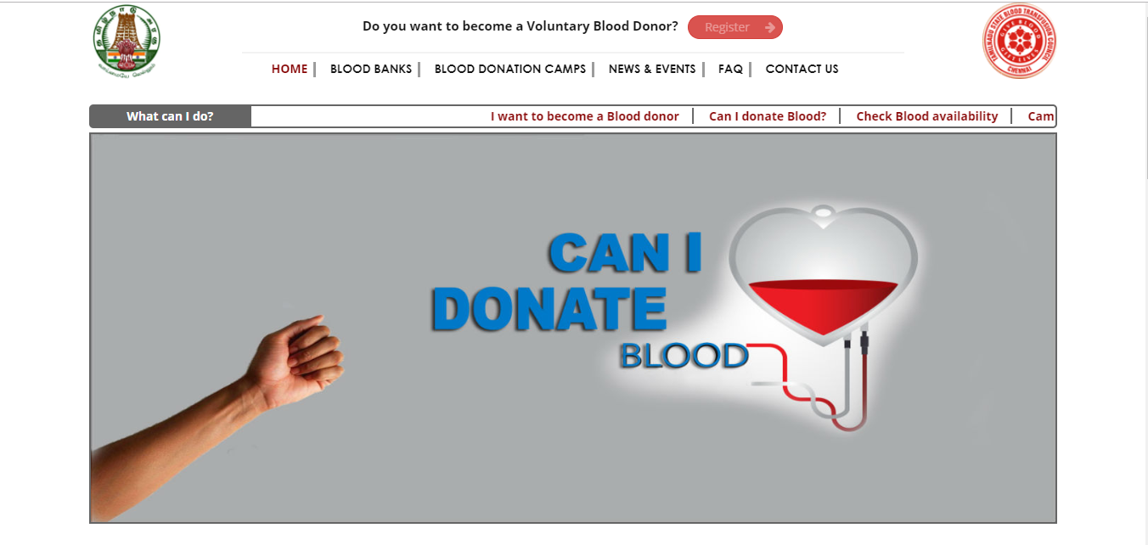

# MODULES:

The functionality of our project is divided into two modules basically:

* Admin
* User

# ALGORITHIMS:

Following are the algorithms we will use:

* Binary search (as user can search for the blood bank just by postal code)
* Basic logics to retrieve data and to insert data in the database

# METHODOLOGIES:

We will use following methodologies and technologies in our project:

* C#
* Visual Studio 2015
* Microsoft SQL Server 2012
* Microsoft SQL Server Management Studio
* Windows form
* SQL
* ADO.NET Framework

# RESOURCES AND TOOLS AVAILABLE:

Well our project can be made also as a web based application.

Tools available are:

* HTML
* CSS
* ASP.NET
* Node.JS
* JavaScript
* Other databases

# EVALUATION:

Our system looks like this:

## Screenshot:

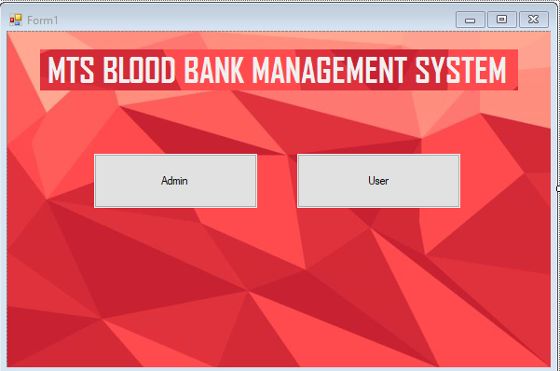

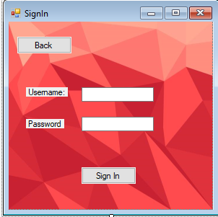

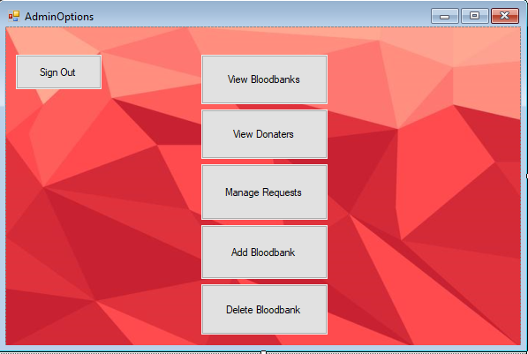

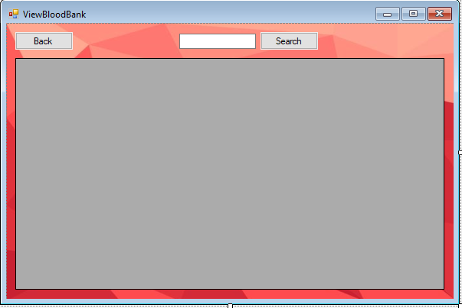

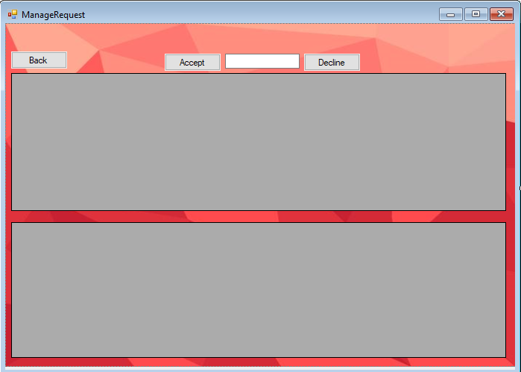

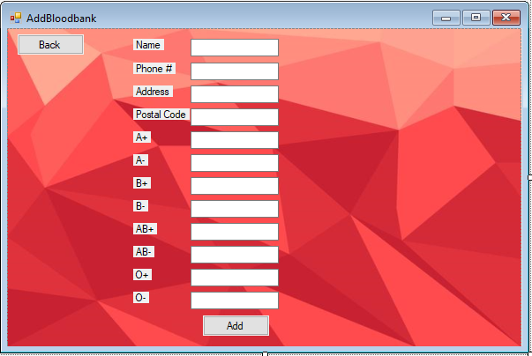

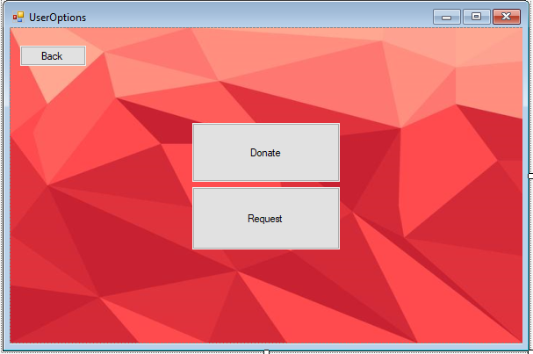

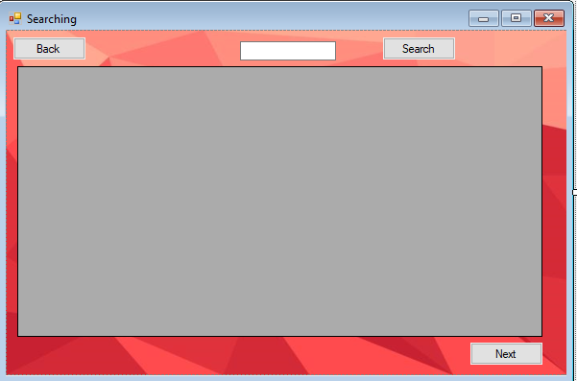

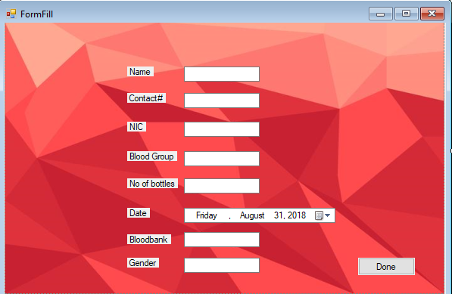

# RELAVANT LINKS AND ARITCLES:

(Scribd link for the article for the conventional blood bank management system)

<https://www.scribd.com/document/335504708/BLOOD-BANK-MANAGEMENT-SYSTEM-PROJECT-REPORT-docx>

(Sciene direct link for the article for the blood bank management system)

<https://www.sciencedirect.com/science/article/pii/S1877042815036940>

(Indian government online web application for centralized blood bank management system)

<http://www.tngovbloodbank.in/blood-bank.php>

**2. TOOLS FOR SDLC LIFE CYCLE:**

# ANALYSIS AND REQUIREMENT MANAGEMENT TOOLS :

Different tools used in analysis and requirement management are as follows:

* Process Street
* Visure
* Visual Trace Spec
* IBM Rational DOORS
* JAMA
* aNimble

Source: <https://www.softwaretestinghelp.com/requirements-management-tools/>

**WE ARE USING ANIMBLE.**

# DESIGN TOOLS:

Design Tools are separated into two categories:

1. Prototyping
2. UML Designing

## PROTOTYPING TOOLS :

* ADOBE XD
* Invision Studio
* Proto.io
* Axure
* Origami Studio

Source: <https://www.creativebloq.com/web-design/top-10-prototyping-tools-2016-21619216>

## UML DESIGNING:

* Microsoft Visio
* Visual paradigm
* Lucid Chart
* Enterprise Architecture

Source: <https://en.wikipedia.org/wiki/List_of_Unified_Modeling_Language_tools>

**WE ARE USING VISUAL PARADIGM**

# PROJECT MANAGEMENT TOOLS:

* Microsoft Project
* Teamwork
* Asana
* Trello

Source: <https://www.webconfs.com/1849/the-7-best-marketing-project-management-tools-for-your-agency/>

**WE ARE USING MICROSOFT PROJECT**

# DATABASE MANAGEMENT TOOLS:

* Oracle RDBMS
* IBM DB2
* Microsoft SQL Server
* MySql
* MongoDB
* Microsoft Access

Source: <https://www.softwaretestinghelp.com/database-management-software/>

**WE ARE USING MS SQL SERVER**

# DOCUMENTATION TOOLS :

## REQUIREMENT DOCUMENATION:

* Stories on board
* Trello
* And above req managing tools are also used for documentation
* UML designing are also included in this area
* Project management tools are also included in this area

## WRITING ARCHITECTURE :

* GenMyModel

## WRITING APIs :

* Swagger
* Slate

## WRITING DATABASES :

* Schema Spy
* Lucid Chart
* And all UML designing apps

## QA TESTING AND TEST MANAGEMENT :

* Xray for Jira
* Test Rail

Source: <https://stepshot.net/21-software-documentation-tools-for-every-stage-of-project-implementation/#section1>

3. RAD REPORT:

# INTRODUCTION:

## PURPOSE OF THE SYSTEM:

The purpose of Blood Banks Management System is to manage and centralize all the data of all the blood banks and provide user with facilities to search the nearest blood banks in any case of emergency or if the user is new to the city or country and don’t know where to go.

## SCOPE OF THE SYSTEM:

The scope of our project for the time being is limited to only 10 blood banks and although admin can add new blood banks but in future we can widen the scope to manage data of all the blood banks in the country.

## OBJECTIVE AND SUCCESS CRITERIA:

Objective of the system is to save time of the user to search for blood banks and search for blood availability in the nearest blood bank. Once we can manage the data of all the blood banks and search blood banks through MAP APIs we can sell it in the market.

# PROPOSED SYSTEM:

## FUNCTIONAL REQUIREMENTS:

The functional requirements of the system is divided into two parts. Admin and user.

## ADMIN:

* Admin can **sign in** and **sign up**
* Admin can **see** all the blood banks data
* Admin can **Add** Blood banks
* Admin can **see** all the donors
* Admin can **Accept** or **Delete** request for blood bottles
* Admin can **Manage** blood requests
* Admin can **Delete** blood bank data
* Admin can **Search** for specific blood bank
* Admin can **Search** for specific donor

## USER:

* User can **Request** for blood bottles
* User can **Search** for the nearest blood bank
* User can **Fill out** the form to make request
* User can directly **Become a donor**
* User can **See** all the basic info of all blood banks
* User can **Select** specific blood bank

**DATA OF THE USER THAT WILL BE USED IN FORM AND DATABASE:**

* Name
* NIC
* Phone Number
* Address
* Blood type
* No. of bottles
* Gender
* Age

**DATA OF BLOOD BANK THAT WILL BE USED IN BLOOD BANK DATABASE:**

* Name of blood bank
* Address
* Postal code
* No of bottles

## NON FUNCTIONAL REQUIREMENTS:

* System UI should be red in color
* Buttons should be placed in center of the form
* UI should be easily understandable
* Every form should pop up in the center of the screen
* Button color should be gray

# **4. UML DIAGRAMS:**

## USE CASE DIAGRAM:

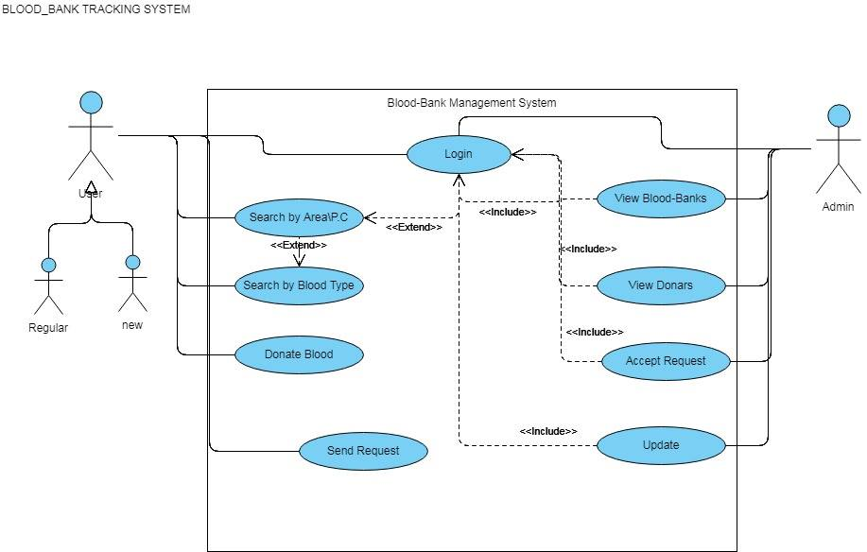

## CLASS DIAGRAM:

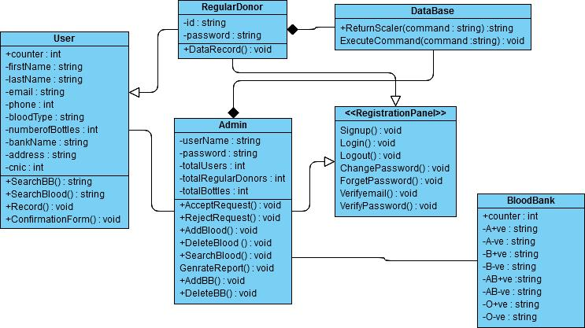

1: ACTIVITY DIAGRAM:

* 1. Activity Diagram For Login:

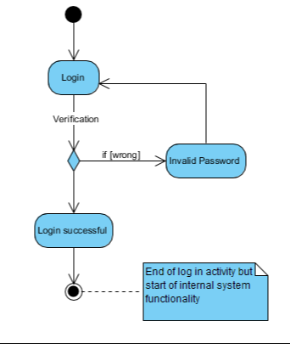

1.2: Activity Diagram For Admin:

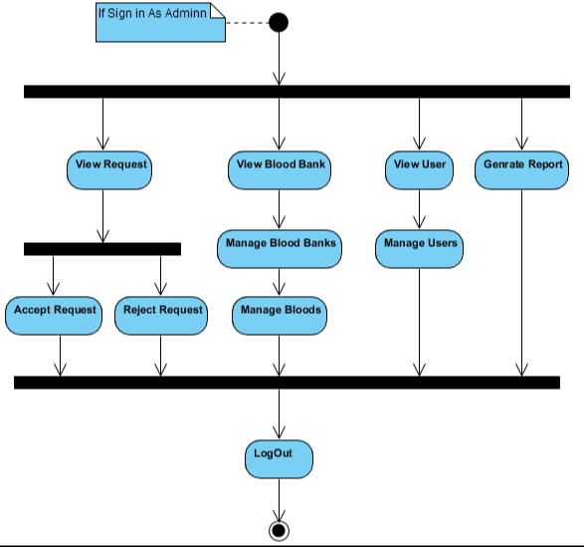

1.3: Activity Diagram For User

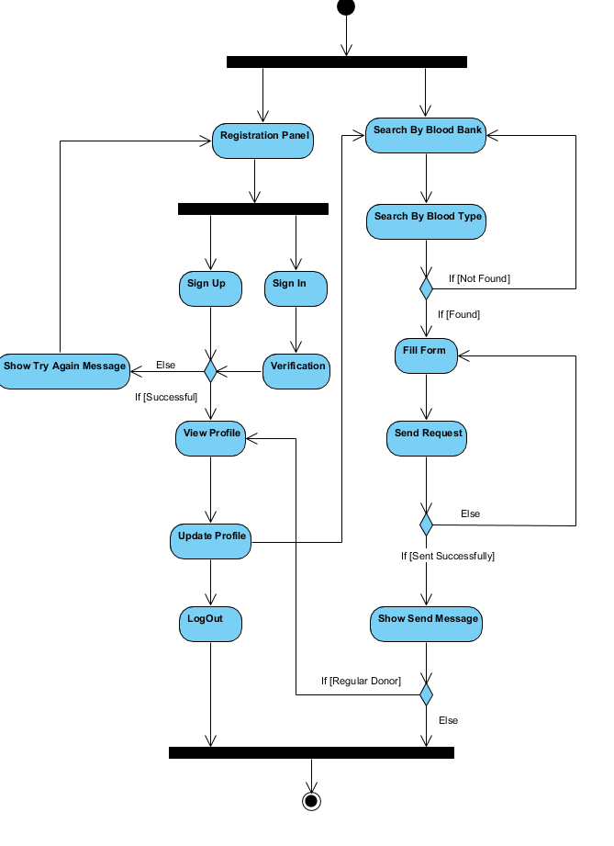

2: SEQUANCE DIAGRAM

2.1: Sequence Diagram For Admin:

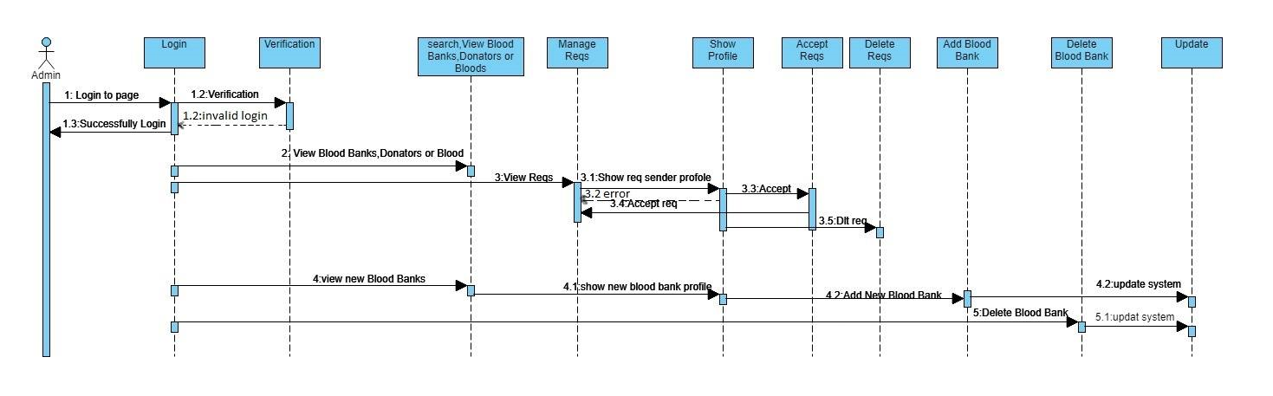

2.2: Sequence Diagram For User:

