UML DIAGRAM

1: ACTIVITY DIAGRAM:

* 1. Activity Diagram For Login:

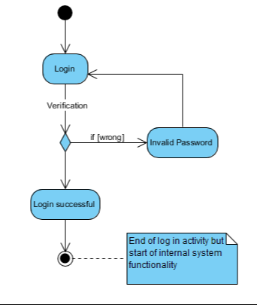

1.2: Activity Diagram For Admin:

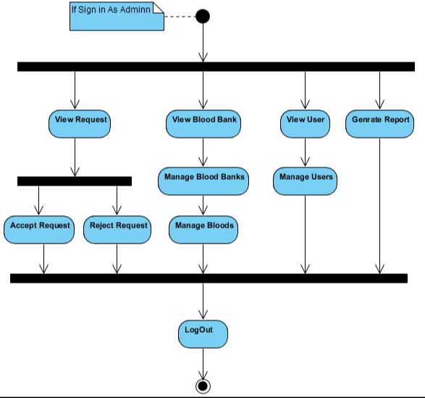

1.3: Activity Diagram For User

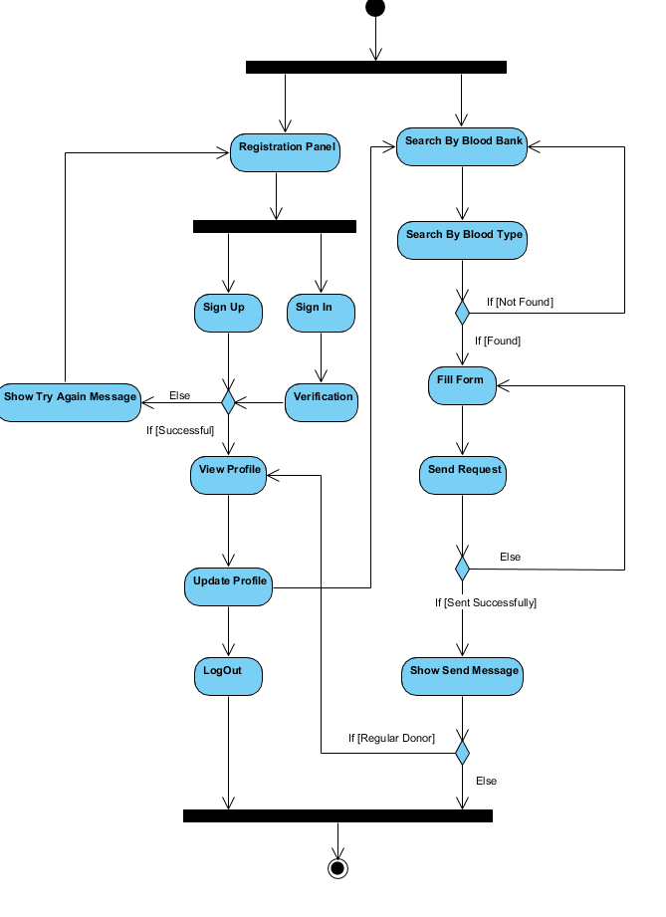

2: SEQUANCE DIAGRAM

2.1: Sequence Diagram For Admin:

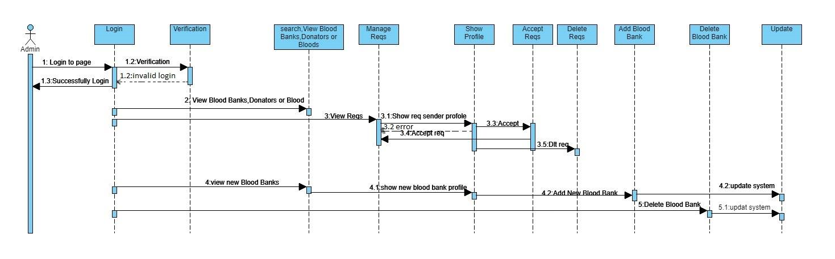

2.2: Sequence Diagram For User:

