**Name:** Amir Zhunussov  
**Instructor:** Kamila Zhakupova  
**Course:** Introduction to Game Development  
**Assignment:** Animation with Buttons (Assignment 4)  
**Date:** 20.04.2025

**Report: Animation with Buttons (Assignment 4)**

**1. Introduction**

This assignment focused on the use of Unity’s animation tools to create interactive and visually expressive animations triggered by UI buttons. The objective was to deepen technical skills in 3D animation within Unity and to explore user interactivity through a simple control interface.

For my project, I chose the topic: **Win & Fail Animation**.

**2. Concept Overview**

The animation consists of two main states:

* **Win Animation**: The character performs a joyful jump with arms raised. Fireworks and "YOU WIN!" text appear on screen with cheerful music.
* **Fail Animation**: The character collapses slowly to the ground, looking disappointed. The environment turns darker with a “GAME OVER” message and somber background music.

These states are triggered through **UI buttons** labeled “Win” and “Fail”.

**3. Development Process**

* **Scene Creation**: I built a simple 3D environment with a character placed at the center. The UI canvas includes two buttons at the bottom of the screen.
* **Animation Clips**: I created two separate animations using Unity’s Animator:
  + VictoryPose – jumping and cheering with added particle system (fireworks).
  + DefeatFall – falling to the knees and head down.
* **Animator Controller**: I used an Animator Controller to manage state transitions between Idle, Win, and Fail.
* **Button Functionality**: Using C# scripts, I assigned each button to trigger transitions between animation states.
* **Audio & Visual FX**: I imported and attached different sound effects for Win and Fail states, and added particle systems for visual enhancement (fireworks and glitching screen).
* **Aesthetics**: I paid attention to camera angles, lighting, and visual feedback to make the animations feel satisfying and immersive.

**4. Screenshots of Development**

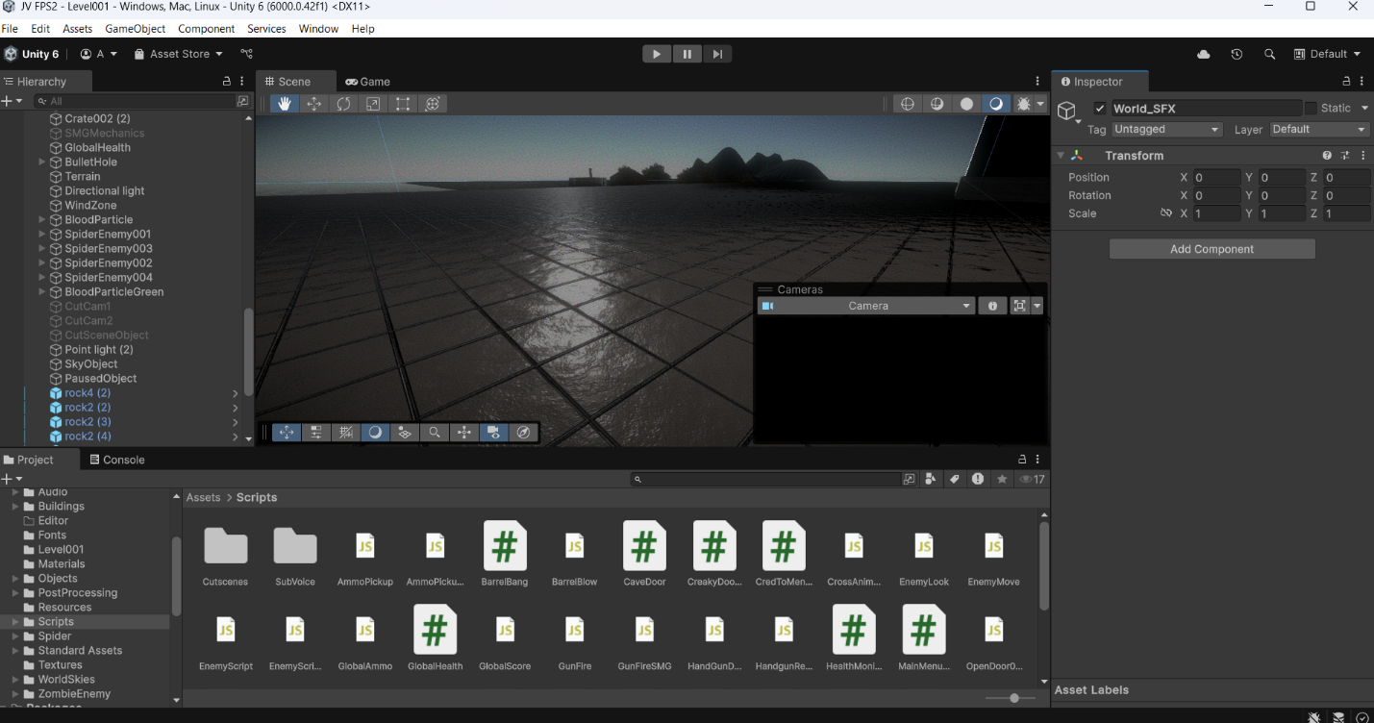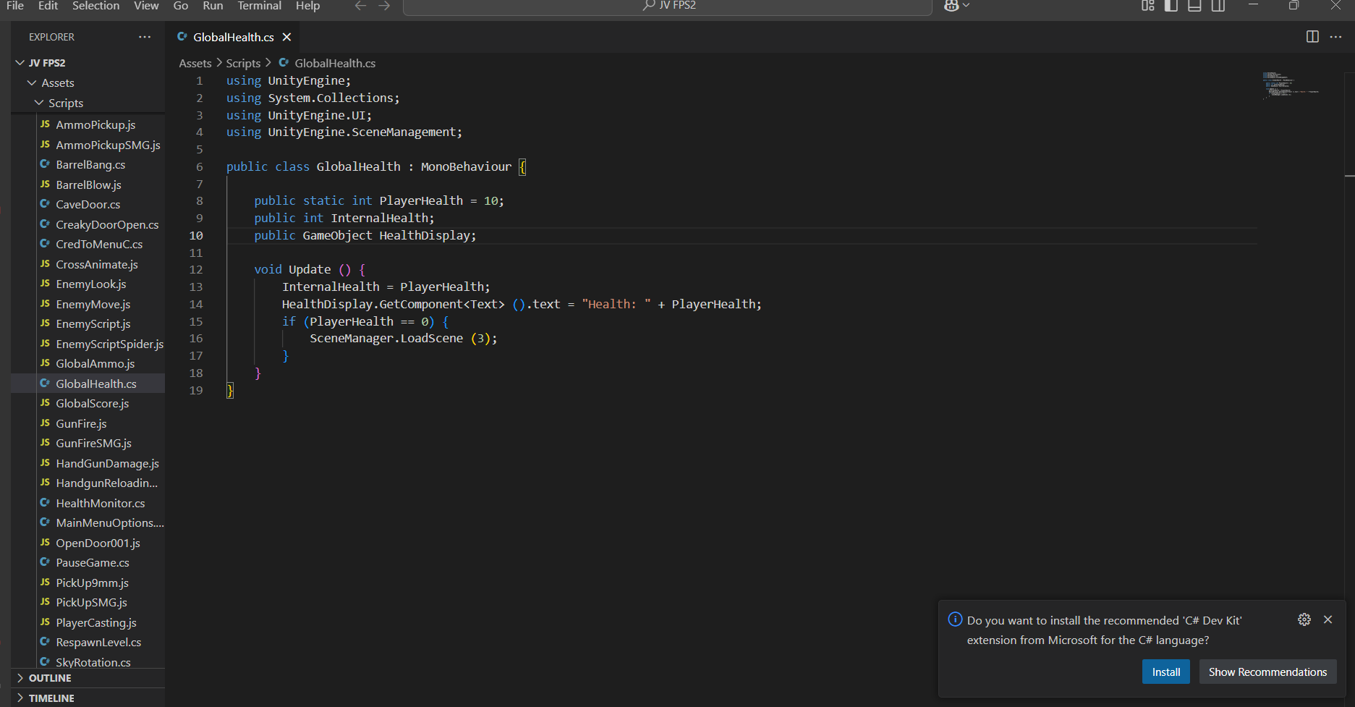

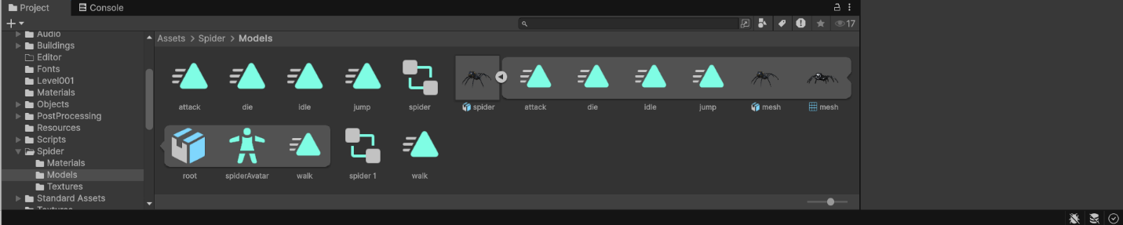

**5. Challenges & Solutions**

* **Challenge:** Synchronizing the animation with UI buttons smoothly.  
  **Solution:** I used Unity Events on buttons and clearly defined transition conditions in the Animator.
* **Challenge:** Adding appropriate feedback for both win and fail states.  
  **Solution:** Implemented particle systems, lighting changes, and custom audio clips to enhance emotional impact.

**6. Conclusion**

This assignment helped me understand the use of Unity’s animation system, how to connect UI elements with gameplay logic, and how to create satisfying feedback for user interaction. I also learned how to combine animations, sound, and visual effects for impactful presentation. I believe this project can be a good foundation for future interactive game mechanics.