**ASSIGNMNET A1_PART A**

1. **Prime sum calculation**

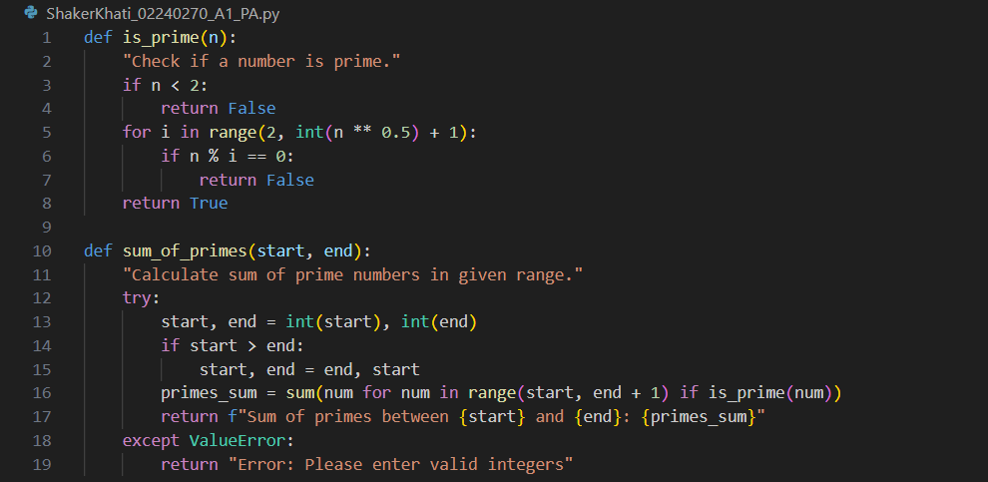

**Code output:**

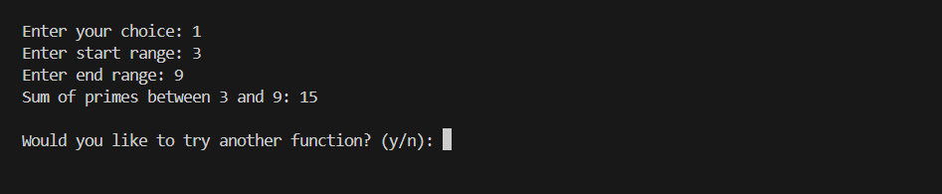

1. **Length converter**

**Code output:**

1. **Consonants Counter**

**Code output:**

1. **Min-Max finder**

**Code output:**

1. **Palindrome checker**

**Code output:**

1. **Word Counter**

**Code output:**

**Display menu**

**

**Code output:**

**ASSIGNMNET A1 PART B**

1. **Guess the number game**

**Code output:**

1. **Rock Paper Scissors Game**

**Code output:**

**

**Code output:**

**Repo Link*:*** *https://github.com/shaker202518/ShakerKhati_02240270_A1.git*