Documentation

Advanced ESP32 Smart Chess Clock

Dev: Shaker02
shbhky@gmail.com

Overview
This project details the construction of a highly customizable, feature-rich Chess Clock using an ESP32 microcontroller and a 16x2 I2C LCD display. Designed for tournament and casual play, it features precision time tracking, Fischer increments, move counting, and an intuitive menu system for adjusting game parameters on the fly without needing to re-flash the hardware.
Key Features
- Custom Time Controls: Adjustable minutes, seconds, and Fischer increment settings.
- Dual-Mode Display: Toggle between viewing the remaining time and the current move count during live play.
- Smart Feedback: Configurable sound alerts (player toggle beeps, 10-second warning ticks, and timeout alarms) alongside active-player LED indicators.
- Arbiter Functions: Built-in pause functionality and a dedicated manual "Draw" declaration system.
- Efficient UI: Debounced 5-button interface with contextual mapping (buttons perform different actions depending on the current screen).

Hardware Requirements
- 1x ESP32 Development Board
- 1x 16x2 LCD Display with I2C Backpack
- 5x Push Buttons (Momentary)
- 2x LEDs (1x Blue for Player 1, 1x Red for Player 2)
- 2x 220Ω Resistors (for LEDs)
- 1x Buzzer (Passive or Active)
- 1x Power Rail / Breadboard setup (for common Ground connections)
- Jumper Wires

Wiring Guide
The system utilizes the ESP32's internal pull-up resistors (INPUT_PULLUP) for all buttons, meaning the buttons are wired directly between the GPIO pin and Ground.
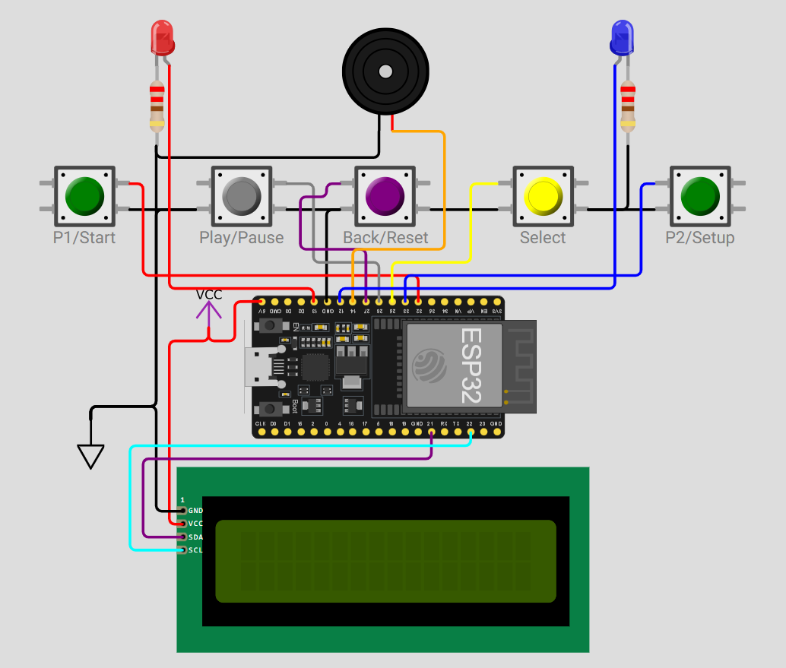
Component | ESP32 Pin | Connection Note
LCD SDA | GPIO 21 | Connect directly
LCD SCL | GPIO 22 | Connect directly
LCD VCC | 5V / VIN | ESP32 3.3V logic is sufficient for I2C data
LCD GND | GND | Connect to Power Rail
B1 (Left/P1) | GPIO 32 | Connect other leg to GND Rail
B2 (Right/P2) | GPIO 33 | Connect other leg to GND Rail
B3 (Select/OK) | GPIO 25 | Connect other leg to GND Rail
B4 (Play/Pause) | GPIO 26 | Connect other leg to GND Rail
B5 (Back/Rst) | GPIO 27 | Connect other leg to GND Rail
LED 1 (P1) | GPIO 13 | Wire through 220Ω* resistor to GND Rail
LED 2 (P2) | GPIO 12 | Wire through 220Ω resistor to GND Rail
Buzzer | GPIO 14 | Connect negative leg to GND Rail
* The 220Ω can also be 100Ω

Interface & Screen Guide
The interface is context-aware. Below are the screen mockups and the exact button mappings for each state.

Boot Screen & Ready State
When powered on, the device awaits a user command to either start a quick game with default/previous settings or enter the configuration menu.
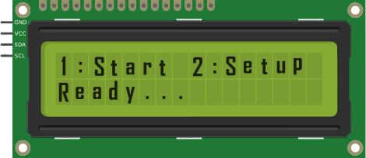
Button | Function
B1 | Proceed to the "Ready to Play!" state.
B2 | Open the Main Setup Menu.
B3 / B4 / B5 | No Action
(In the "Ready to Play" state, B1 starts Player 2's clock, B2 starts Player 1's clock, and B5 returns to Boot).

Main Setup Menu
Allows navigation between the three core configuration areas.
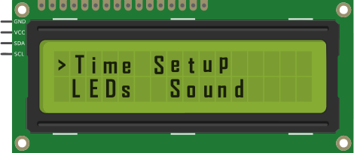
Button | Function
B1 / B2 | Move the cursor (>) to the next menu option.
B3 | Enter the selected configuration screen.
B5 | Exit Setup and return to the Boot Screen.

Time Setup Screen
Adjust game time. A blinking cursor indicates the active field.
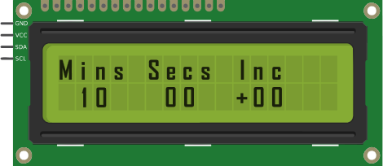
Button | Function
B1 | Decrease the currently selected value.
B2 | Increase the currently selected value.
B3 | Move the cursor to the next field (Mins -> Secs -> Inc -> Exit).
B5 | Exit to Main Setup Menu immediately.

LEDs & Sound Setup Screens
Toggle hardware feedback.
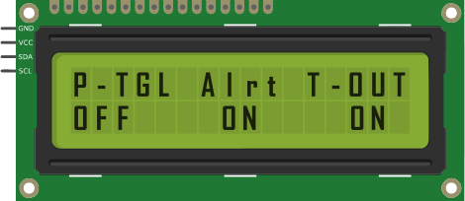
Button | Function
B1 / B2 | Toggle the currently selected setting between ON and OFF.
B3 | Move the cursor to the next setting (or exit if at the end).
B5 | Exit to Main Setup Menu immediately.

Game Running (Clock & Move Counter)
The active game state. Players can toggle between viewing the time and the move count.
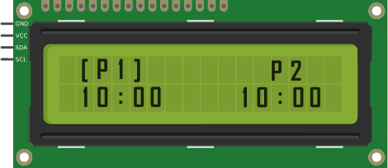
Button | Function
B1 | End P1's turn, add P1 increment, start P2 clock.
B2 | End P2's turn, add P2 increment, start P1 clock.
B3 | Toggle display to show Move Count instead of Time.
B4 | Pause the game.

Paused State
Allows the arbiter/players to halt the clock or declare a draw.
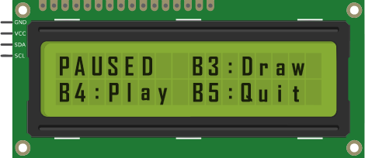
Button | Function
B3 | Declare a Draw (Triggers Draw audio/visual feedback).
B4 | Resume the clock exactly where it stopped.
B5 | Abort the game and return to the Boot Screen.

*See the code below:

Source Code
#include <Wire.h>
#include <LiquidCrystal_I2C.h>

// --- Configuration ---
LiquidCrystal_I2C lcd(0x27, 16, 2);

// Pin Definitions
const int PIN_BTN1 = 32; // P1 / Decrease / Left
const int PIN_BTN2 = 33; // P2 / Increase / Right
const int PIN_BTN3 = 25; // Select / Next / Toggle Moves / Draw
const int PIN_BTN4 = 26; // Play / Pause
const int PIN_BTN5 = 27; // Back / Reset

const int LED_P1 = 13; // P1 LED Pin
const int LED_P2 = 12; // P2 LED Pin
const int BUZZER = 14;

// --- State Machine ---
enum State {
BOOT,
MENU_MAIN,
SETUP_TIME,
SETUP_LEDS,
SETUP_SOUND,
READY,
RUNNING,
PAUSED,
GAME_OVER
};
State currentState = BOOT;

// --- Settings Variables ---
int setMins = 10;
int setSecs = 0;
int setInc = 0;

bool ledsEnabled = true;
bool sndPToggle = false;
bool sndAlert = true;
bool sndTimeout = true;

// --- Game Variables ---
long p1Seconds, p2Seconds;
int movesP1 = 0;
int movesP2 = 0;
bool isP1Turn = true;
unsigned long lastTickMillis = 0;

bool screenNeedsUpdate = true;
int setupCursor = 0; // Tracks field inside menus
int mainMenuCursor = 0; // 0: Time, 1: LEDs, 2: Sound
bool showMovesScreen = false; // Toggles clock vs moves display
int winState = 0; // 1 = P1, 2 = P2, 3 = Draw

void setup() {
pinMode(PIN_BTN1, INPUT_PULLUP);
pinMode(PIN_BTN2, INPUT_PULLUP);
pinMode(PIN_BTN3, INPUT_PULLUP);
pinMode(PIN_BTN4, INPUT_PULLUP);
pinMode(PIN_BTN5, INPUT_PULLUP);

pinMode(LED_P1, OUTPUT);
pinMode(LED_P2, OUTPUT);
pinMode(BUZZER, OUTPUT);

digitalWrite(LED_P1, LOW);
digitalWrite(LED_P2, LOW);

lcd.init();
lcd.backlight();
drawBootScreen();
}

void loop() {
int btn = readButtons();

switch (currentState) {
case BOOT: handleBoot(btn); break;
case MENU_MAIN: handleMainMenu(btn); break;
case SETUP_TIME: handleSetupTime(btn); break;
case SETUP_LEDS: handleSetupLEDs(btn); break;
case SETUP_SOUND: handleSetupSound(btn); break;
case READY: handleReady(btn); break;
case RUNNING: handleRunning(btn); break;
case PAUSED: handlePaused(btn); break;
case GAME_OVER: handleGameOver(btn); break;
}
}

// ==========================================
// STATE HANDLERS
// ==========================================

void handleBoot(int btn) {
if (btn == PIN_BTN1) {
currentState = READY;
lcd.clear();
lcd.setCursor(0, 0); lcd.print(" Ready to Play! ");
lcd.setCursor(0, 1); lcd.print(" Press P1 or P2 ");
digitalWrite(LED_P1, HIGH); // Both LEDs on to signal ready
digitalWrite(LED_P2, HIGH);
} else if (btn == PIN_BTN2) {
currentState = MENU_MAIN;
mainMenuCursor = 0;
screenNeedsUpdate = true;
lcd.clear();
}
}

void handleMainMenu(int btn) {
if (screenNeedsUpdate) {
lcd.setCursor(0, 0);
if (mainMenuCursor == 0) lcd.print("> Time Setup ");
else lcd.print(" Time Setup ");

lcd.setCursor(0, 1);
if (mainMenuCursor == 1) lcd.print("> LEDs Sound ");
else if (mainMenuCursor == 2) lcd.print(" LEDs > Sound ");
else lcd.print(" LEDs Sound ");
screenNeedsUpdate = false;
}

if (btn == PIN_BTN1 || btn == PIN_BTN2) {
mainMenuCursor++;
if (mainMenuCursor > 2) mainMenuCursor = 0;
screenNeedsUpdate = true;
}

if (btn == PIN_BTN3) {
setupCursor = 0;
screenNeedsUpdate = true;
lcd.clear();
if (mainMenuCursor == 0) currentState = SETUP_TIME;
if (mainMenuCursor == 1) currentState = SETUP_LEDS;
if (mainMenuCursor == 2) currentState = SETUP_SOUND;
}

if (btn == PIN_BTN5) drawBootScreen();
}

void handleSetupTime(int btn) {
if (screenNeedsUpdate) {
lcd.setCursor(0, 0); lcd.print("Mins Secs Inc ");
char buf[17];
sprintf(buf, " %02d %02d +%02d ", setMins, setSecs, setInc);
lcd.setCursor(0, 1); lcd.print(buf);

if (setupCursor == 0) lcd.setCursor(2, 1);
else if (setupCursor == 1) lcd.setCursor(8, 1);
else if (setupCursor == 2) lcd.setCursor(14, 1);
lcd.blink();
screenNeedsUpdate = false;
}

if (btn == PIN_BTN1) {
if (setupCursor == 0 && setMins > 0) setMins--;
if (setupCursor == 1 && setSecs > 0) setSecs--;
if (setupCursor == 2 && setInc > 0) setInc--;
screenNeedsUpdate = true;
}
if (btn == PIN_BTN2) {
if (setupCursor == 0 && setMins < 99) setMins++;
if (setupCursor == 1 && setSecs < 59) setSecs++;
if (setupCursor == 2 && setInc < 99) setInc++;
screenNeedsUpdate = true;
}
if (btn == PIN_BTN3) {
setupCursor++;
if (setupCursor > 2) {
exitToMainMenu();
return;
}
screenNeedsUpdate = true;
}
if (btn == PIN_BTN5) exitToMainMenu();
}

void handleSetupLEDs(int btn) {
if (screenNeedsUpdate) {
lcd.setCursor(0, 0); lcd.print("LEDs Setup: ");
lcd.setCursor(0, 1);
if (ledsEnabled) lcd.print(" < ON > ");
else lcd.print(" < OFF > ");
lcd.noBlink();
screenNeedsUpdate = false;
}

if (btn == PIN_BTN1 || btn == PIN_BTN2) {
ledsEnabled = !ledsEnabled;
screenNeedsUpdate = true;
}
if (btn == PIN_BTN3 || btn == PIN_BTN5) exitToMainMenu();
}

void handleSetupSound(int btn) {
if (screenNeedsUpdate) {
lcd.setCursor(0, 0); lcd.print("P-TGL Alrt T-OUT");
lcd.setCursor(0, 1);
lcd.print(sndPToggle ? " ON " : " OFF ");
lcd.print(sndAlert ? " ON " : " OFF ");
lcd.print(sndTimeout ? " ON " : " OFF ");

if (setupCursor == 0) lcd.setCursor(1, 1);
else if (setupCursor == 1) lcd.setCursor(7, 1);
else if (setupCursor == 2) lcd.setCursor(12, 1);
lcd.blink();
screenNeedsUpdate = false;
}

if (btn == PIN_BTN1 || btn == PIN_BTN2) {
if (setupCursor == 0) sndPToggle = !sndPToggle;
if (setupCursor == 1) sndAlert = !sndAlert;
if (setupCursor == 2) sndTimeout = !sndTimeout;
screenNeedsUpdate = true;
}
if (btn == PIN_BTN3) {
setupCursor++;
if (setupCursor > 2) {
exitToMainMenu();
return;
}
screenNeedsUpdate = true;
}
if (btn == PIN_BTN5) exitToMainMenu();
}

void handleReady(int btn) {
if (btn == PIN_BTN1) {
// P1 pressed their button, so P2 starts thinking
isP1Turn = false;
startGameReal();
} else if (btn == PIN_BTN2) {
// P2 pressed their button, so P1 starts thinking
isP1Turn = true;
startGameReal();
} else if (btn == PIN_BTN5) {
drawBootScreen();
}
}

void handleRunning(int btn) {
unsigned long currentMillis = millis();

// Timer Tick
if (currentMillis - lastTickMillis >= 1000) {
lastTickMillis = currentMillis;
if (isP1Turn) p1Seconds--; else p2Seconds--;

// 10-Second Alert
long activeTime = isP1Turn ? p1Seconds : p2Seconds;
if (sndAlert && activeTime > 0 && activeTime <= 10) tone(BUZZER, 2000, 50);

drawGameScreen();

// Timeout Check
if (p1Seconds <= 0 || p2Seconds <= 0) {
winState = (p1Seconds <= 0) ? 2 : 1;
currentState = GAME_OVER;
if (sndTimeout) tone(BUZZER, 500, 2000); // Long timeout beep
digitalWrite(LED_P1, LOW); digitalWrite(LED_P2, LOW);
screenNeedsUpdate = true;
}
}

// Player Moves
if (btn == PIN_BTN1 && isP1Turn) {
isP1Turn = false;
p1Seconds += setInc;
movesP1++;
triggerTurnFeedbacks();
}
else if (btn == PIN_BTN2 && !isP1Turn) {
isP1Turn = true;
p2Seconds += setInc;
movesP2++;
triggerTurnFeedbacks();
}

// Toggle Moves Screen
if (btn == PIN_BTN3) {
showMovesScreen = !showMovesScreen;
drawGameScreen();
}

// Pause
if (btn == PIN_BTN4) {
currentState = PAUSED;
screenNeedsUpdate = true;
}
}

void handlePaused(int btn) {
if (screenNeedsUpdate) {
lcd.clear();
lcd.setCursor(0, 0); lcd.print("PAUSED B3:Draw");
lcd.setCursor(0, 1); lcd.print("B4:Play B5:Quit");
screenNeedsUpdate = false;
}

if (btn == PIN_BTN4) { // Resume
currentState = RUNNING;
lcd.clear();
drawGameScreen();
lastTickMillis = millis();
}

if (btn == PIN_BTN3) { // Draw
winState = 3;
currentState = GAME_OVER;
triggerDrawFeedback();
screenNeedsUpdate = true;
}

if (btn == PIN_BTN5) drawBootScreen(); // Quit
}

void handleGameOver(int btn) {
if (screenNeedsUpdate) {
lcd.clear();
lcd.setCursor(0, 0);
if (winState == 1) lcd.print(" Player 1 Wins! ");
else if (winState == 2) lcd.print(" Player 2 Wins! ");
else if (winState == 3) lcd.print(" Game Drawn ");
screenNeedsUpdate = false;
}
if (btn == PIN_BTN5 || btn == PIN_BTN4) drawBootScreen();
}

// ==========================================
// HELPER FUNCTIONS
// ==========================================

void startGameReal() {
p1Seconds = (setMins * 60) + setSecs;
p2Seconds = p1Seconds;
movesP1 = 0;
movesP2 = 0;
showMovesScreen = false;
winState = 0;
currentState = RUNNING;

updateLEDs();
lcd.clear();
drawGameScreen();
lastTickMillis = millis();
}

void drawBootScreen() {
currentState = BOOT;
lcd.noBlink();
digitalWrite(LED_P1, LOW); digitalWrite(LED_P2, LOW);
lcd.clear();
lcd.setCursor(0, 0); lcd.print("1:Start 2:Setup");
lcd.setCursor(0, 1); lcd.print("Ready... ");
}

void exitToMainMenu() {
lcd.noBlink();
currentState = MENU_MAIN;
screenNeedsUpdate = true;
lcd.clear();
}

void drawGameScreen() {
if (showMovesScreen) {
lcd.setCursor(0, 0);
lcd.print(" Move Count ");
char buf[17];
sprintf(buf, " P1:%03d P2:%03d ", movesP1, movesP2);
lcd.setCursor(0, 1);
lcd.print(buf);
} else {
char buf[17];
sprintf(buf, " %02d:%02d %02d:%02d ", p1Seconds/60, p1Seconds%60, p2Seconds/60, p2Seconds%60);

lcd.setCursor(0, 0);
if (isP1Turn) lcd.print(" [P1] P2 ");
else lcd.print(" P1 [P2] ");

lcd.setCursor(0, 1);
lcd.print(buf);
}
}

void triggerTurnFeedbacks() {
if (sndPToggle) tone(BUZZER, 1000, 50);
updateLEDs();
drawGameScreen();
}

void triggerDrawFeedback() {
digitalWrite(LED_P1, HIGH);
digitalWrite(LED_P2, HIGH);

// Distinct 3-beep sound for Draw
tone(BUZZER, 800, 150); delay(200);
tone(BUZZER, 800, 150); delay(200);
tone(BUZZER, 800, 400);
}

void updateLEDs() {
if (!ledsEnabled) {
digitalWrite(LED_P1, LOW); digitalWrite(LED_P2, LOW);
return;
}
// The LED for the currently active player goes HIGH
if (isP1Turn) {
digitalWrite(LED_P1, HIGH);
digitalWrite(LED_P2, LOW);
} else {
digitalWrite(LED_P1, LOW);
digitalWrite(LED_P2, HIGH);
}
}

int readButtons() {
static unsigned long lastDebounceTime = 0;
if (millis() - lastDebounceTime < 200) return -1;

if (digitalRead(PIN_BTN1) == LOW) { lastDebounceTime = millis(); return PIN_BTN1; }
if (digitalRead(PIN_BTN2) == LOW) { lastDebounceTime = millis(); return PIN_BTN2; }
if (digitalRead(PIN_BTN3) == LOW) { lastDebounceTime = millis(); return PIN_BTN3; }
if (digitalRead(PIN_BTN4) == LOW) { lastDebounceTime = millis(); return PIN_BTN4; }
if (digitalRead(PIN_BTN5) == LOW) { lastDebounceTime = millis(); return PIN_BTN5; }

return -1;
}

