**Effect of Psychotic Drugs on Quantitative EEG**

**Department of Medical Informatics- RWTH Aachen**

**Dr. rer. medic. Ekatarina Kutafina, Daniela Albiez. Haron Shaker**

**Group name:** AP

**Drug:** Olanzapine

|  |  |  |  |  |  |
| --- | --- | --- | --- | --- | --- |
|  | **Delta** | **Theta** | **Alpha** | **Beta** | **Gamma** |
| **Frequency** [Hz] | 1 – 3.5 | 3.5 – 7.5 | 7.5 – 12.5 | 12.5 – 30 | 30 - 60 |

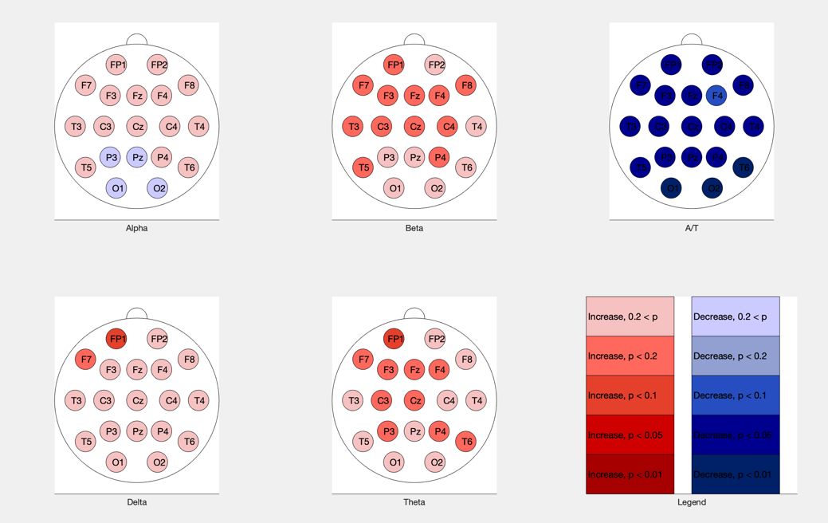

Figure 1- Olanzapine vs Normal p values, absolute

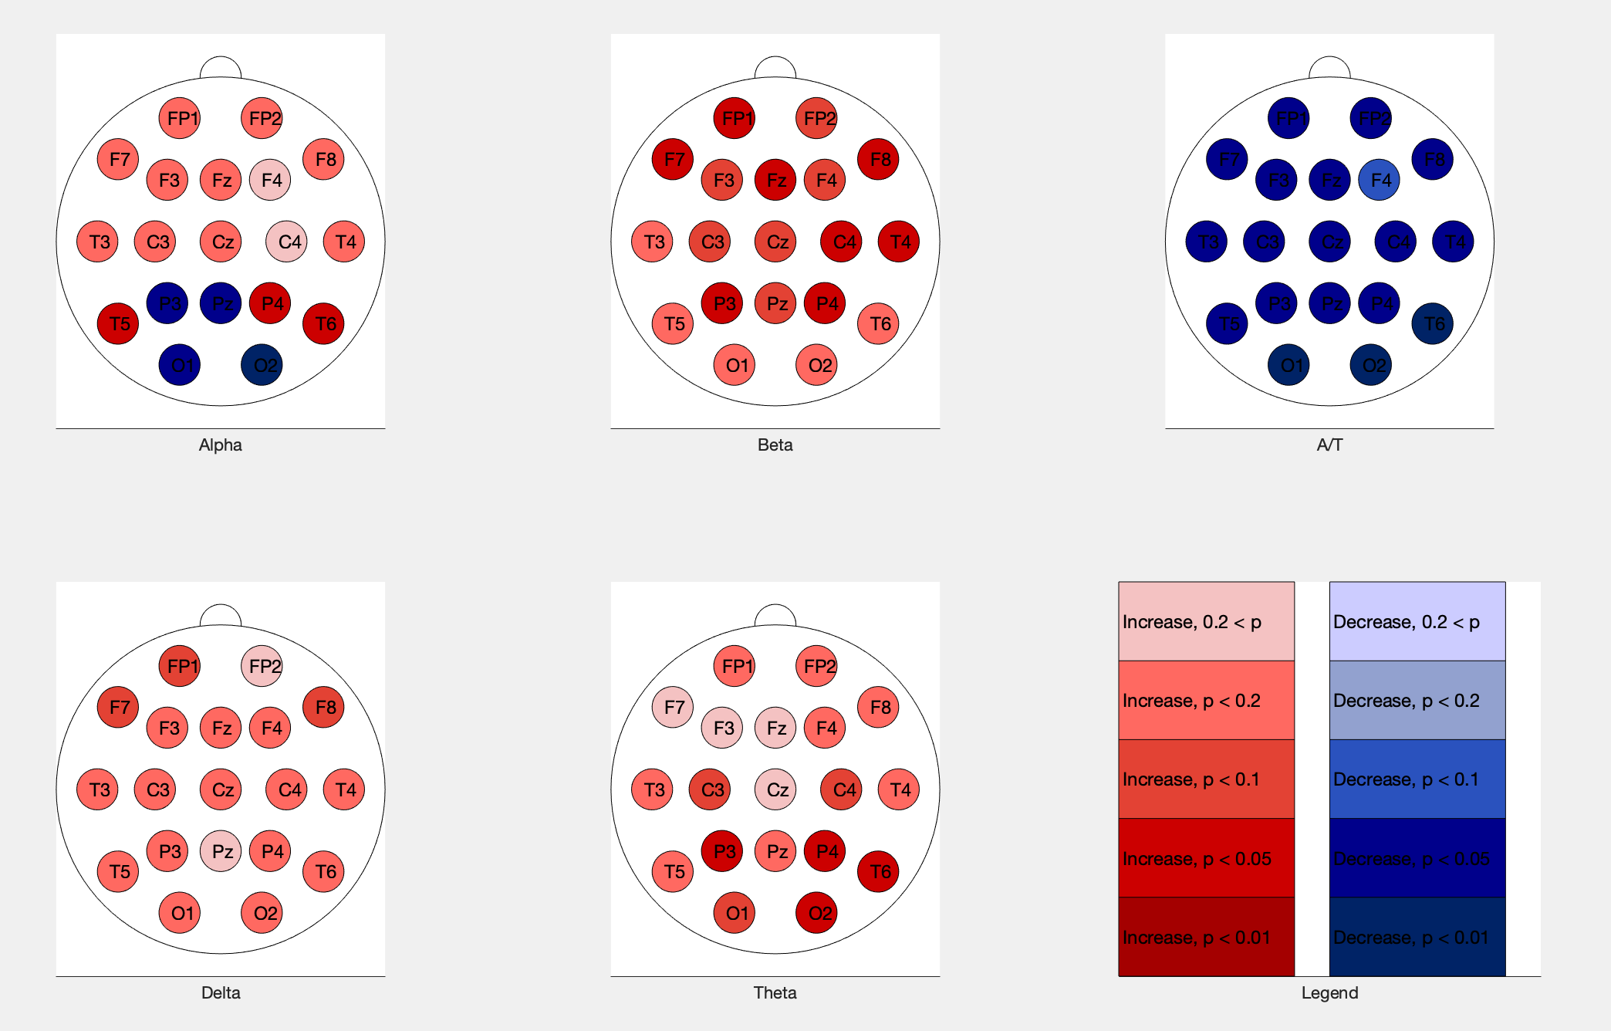

Figure 2 Olanzapine vs Normal p values, relative