Dating with Android app

The application name is HCE (Host Card Emulator)
Logo:

Payment service icon:

Using Android app (step by step)

1. Installing application. There is two ways to install the application.
First of them is installing from External Storage. It doesn“t requires internet connection and any trafic. Installation steps:
- Open the «My Files» application



- Choose «Internal storage»

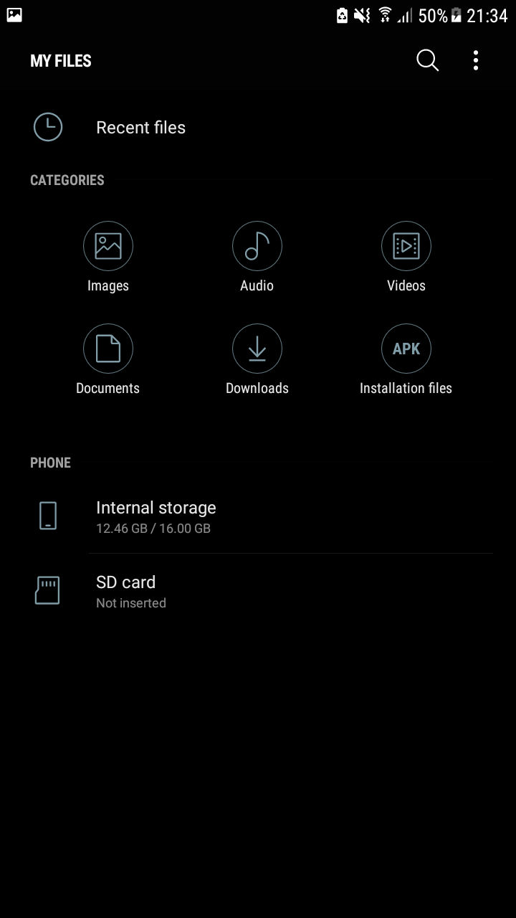
- You“ll find here hce.apk and click on it

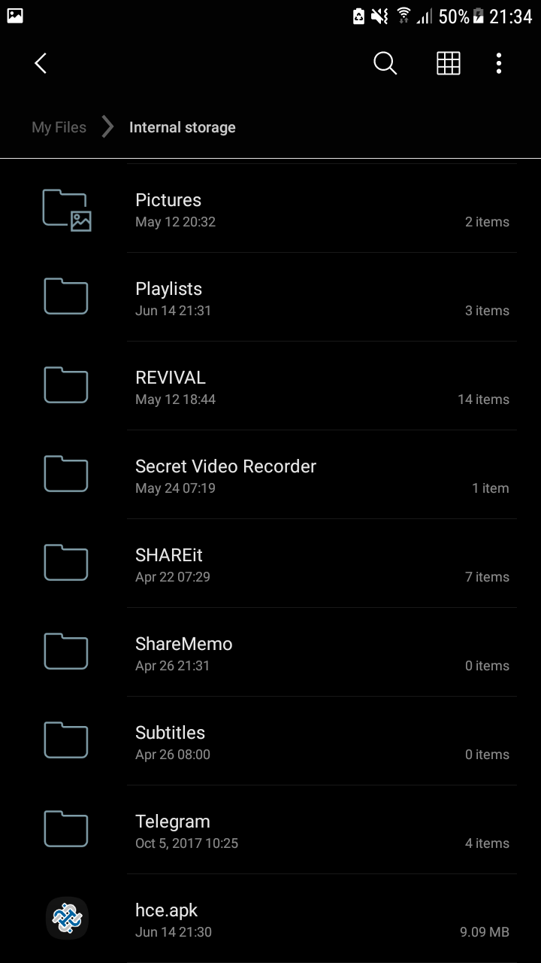

- Opens the Installation activity

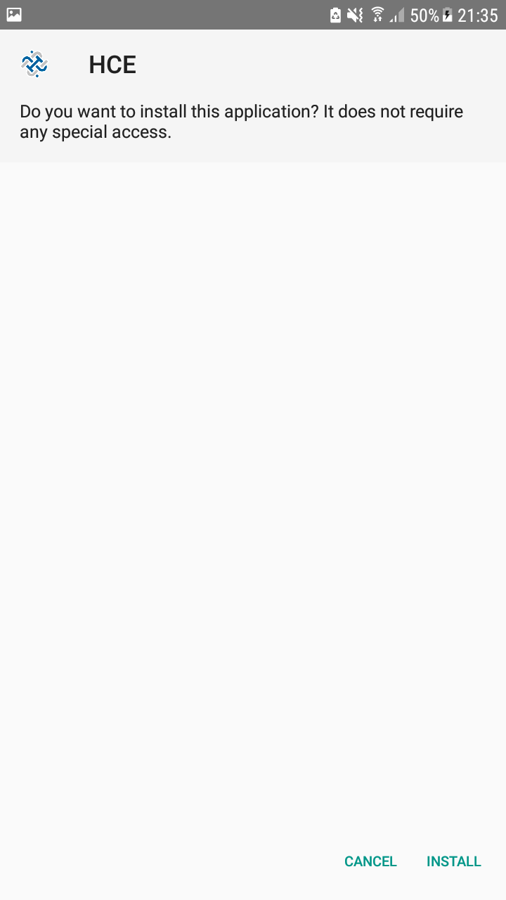
- Press install and you should to allow installing this application

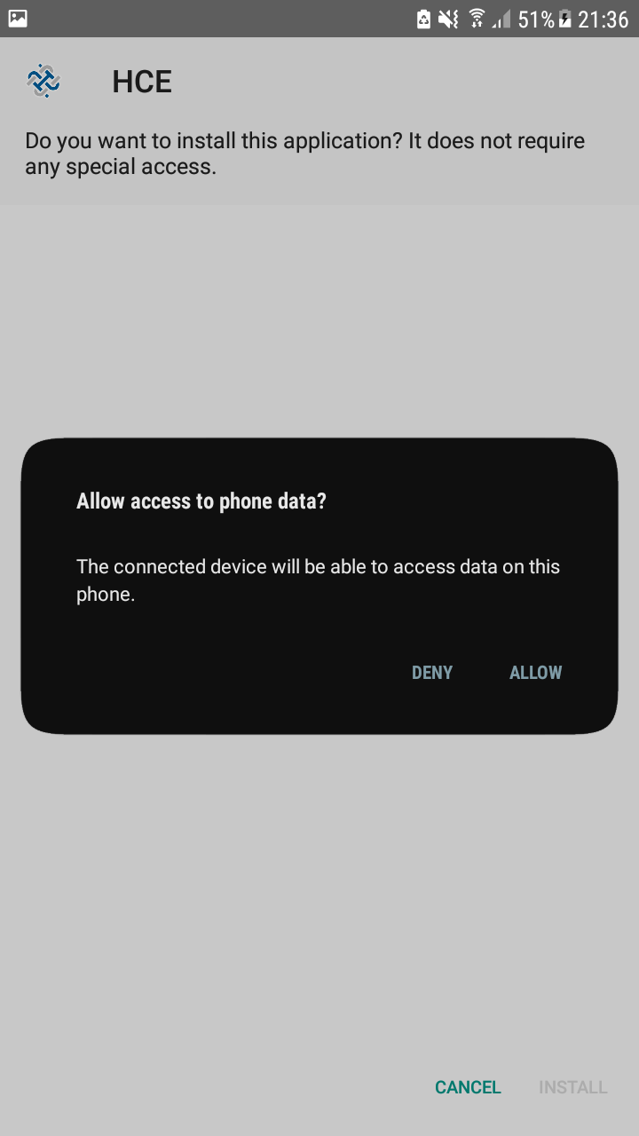

- Installation done
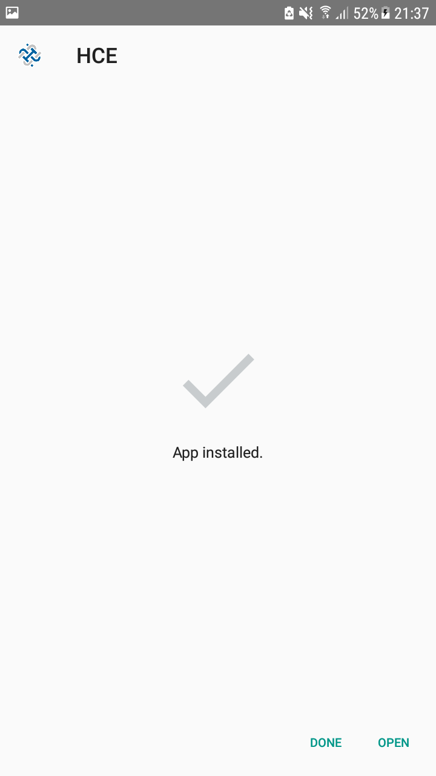

2. Select your default mobile payment service.
Little theory: . „Default card“ is the new „top-of-wallet card“. With the rise of online shopping and mobile payments, customers are now faces with this question: „Which card should I pick as my default card?“. If you have only or two cards or don“t care much about the cash back or rewards points you might earn on each transaction, the decision on whitch card to park in the default slot might be easy. But when you want to optimize your return on a fistfull of rewards/cash back credit cards, to unseat and reseat your default card with some merchants can not only be tought on the thumbs, but costly on your wallet. Default payments account for roughly 84 percent of all digital transactions, according to a 2016 study on the evolution of default card s by the Deloitte Center of Finance Services.
- From the Home screen, touch Apps.
- Touch Settings
- Touch NFC and payment
- Touch Tap and pay

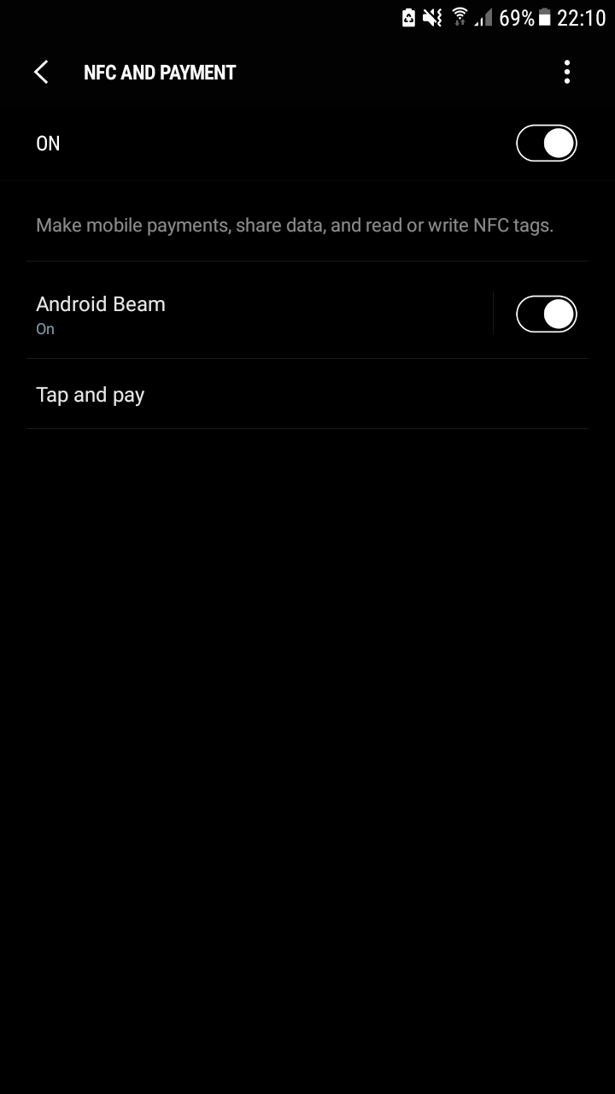

- Touch HCE

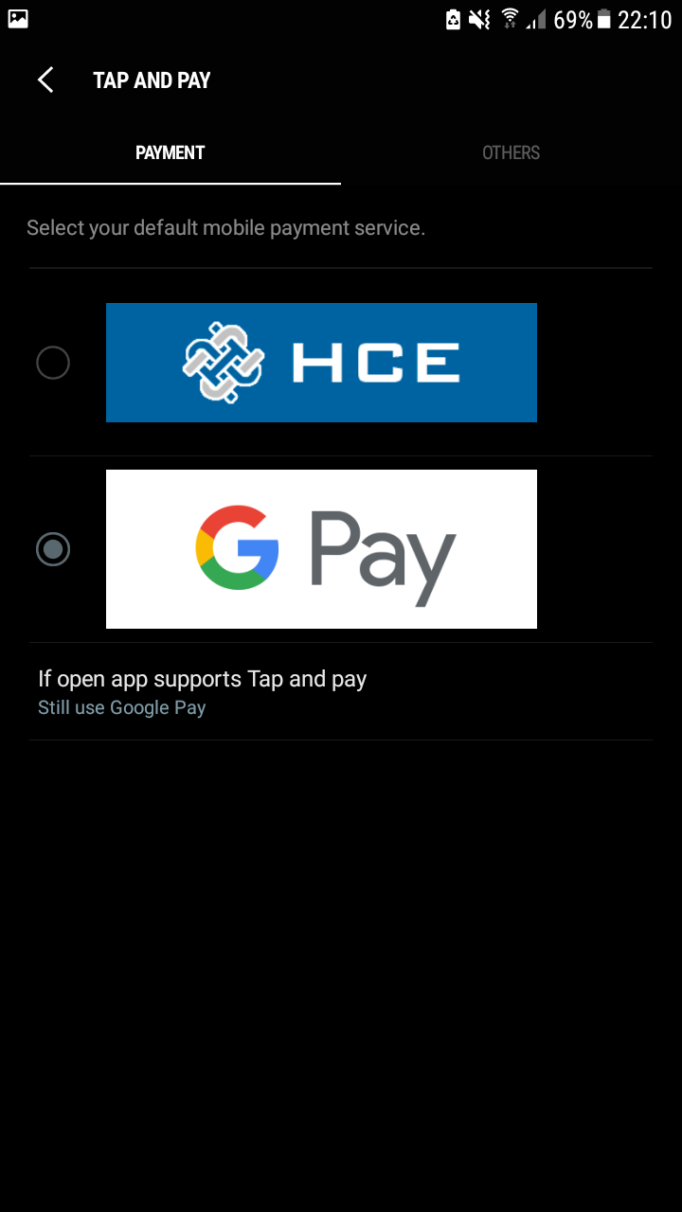

- When HCE is selected, a blue circle will appear

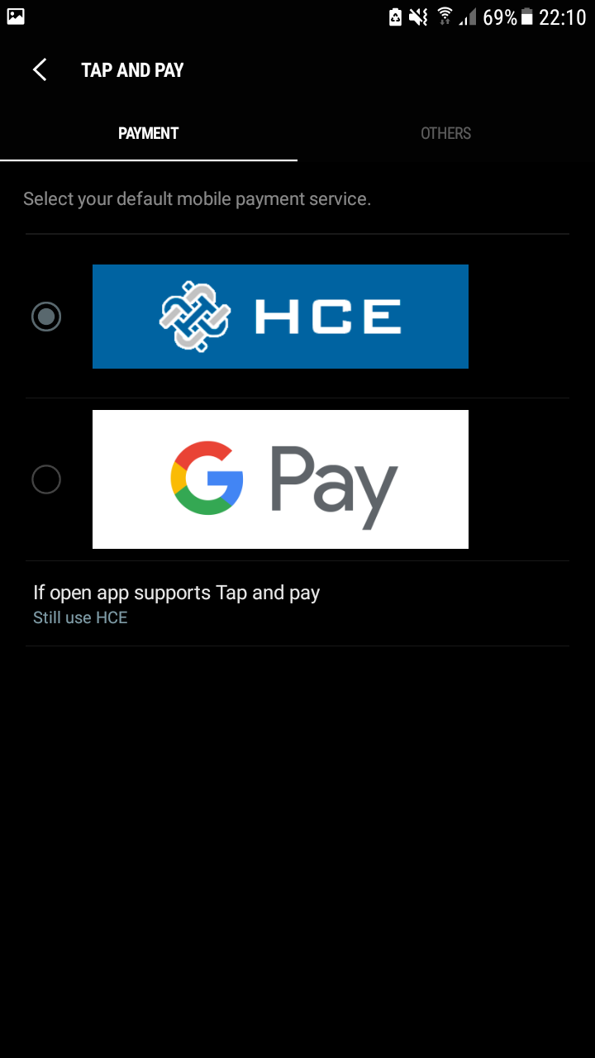

3. Open the app. Home screen » Apps » HCE

In computer security, logging in (or logging on or signing in or signing on) is the process which an individual gains access to a computer system by identifying and authenticating themselves. The user credentials are typically some form „username“ and a matching „password“, and these credentials themselves are sometimes refered as a login, (or a login or a sign-in or a sign-on). In practice, modern secure systems also often require a second factor for extra security. When access is no longer needed, the user can log out (log off, sign out or sign off).

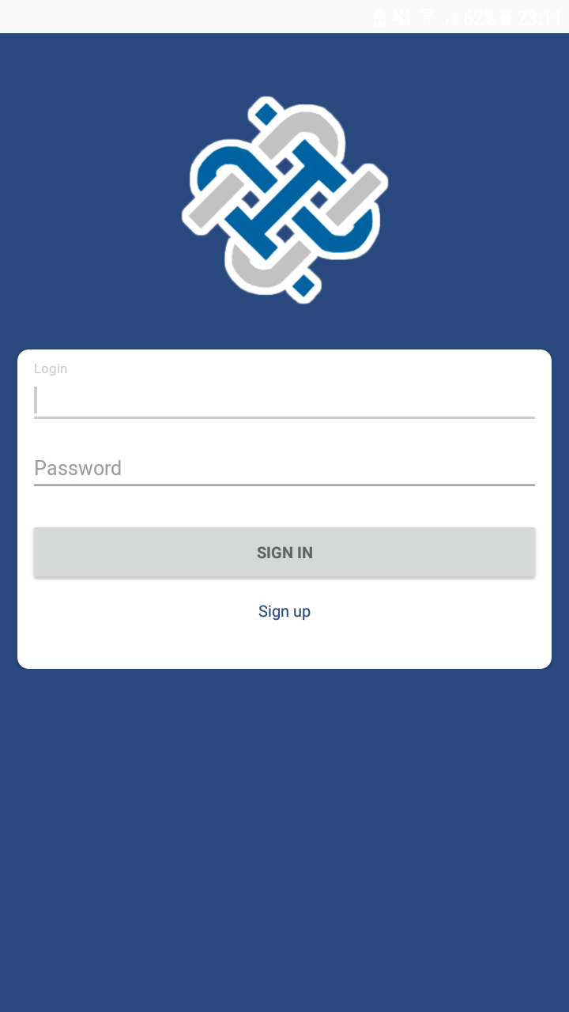

Login activity

Users have to type „username“ and „password“ to login to the system. I used EditText view for enter „username“ and for „password“ EditText with „password“ attribute. After typing „username“ and „password“ users should to press „Sign in“ button.
If user forgeted his/her password or login he/she should to press „Forgot password or login?“

To sign up users must type identify login, password email and phone number. „Login“ must contain more 6 symbols such as letters in lowercase(a-z) and uppercase(A-Z), numbers(0-9) and special chars (_, -, @, *, /, +, - #, $, %, ^, &, !, ~), but not „ , “, and `.

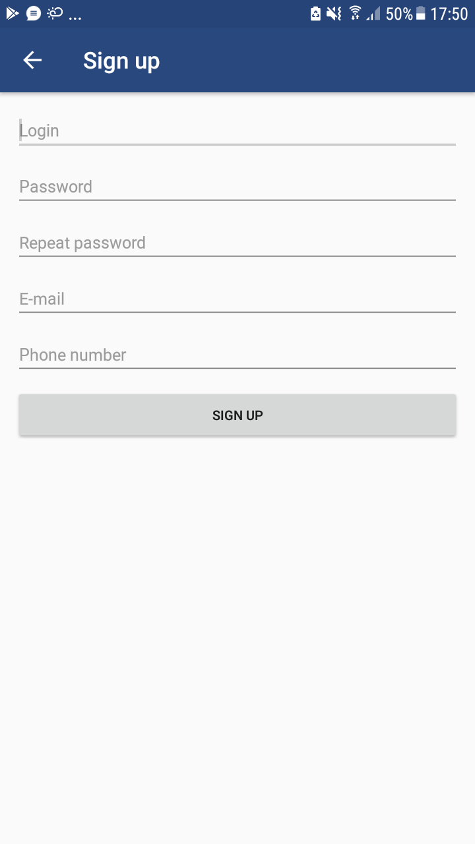
„Sign up“ activity.

