SQL
(Notes and Syntax)

Basics about databases:
stored somewhere hosted by a computer
Data
Server
Host
as a database or any other device

Data: Any numerical/categorical/pictorial or any other kind of data/information.
Database: The systematic structure or logical design using which data is stored.
Server: The physical device where data is stored and the piece of software that connects to the physical storage. ( Hardware to store the data + software to manage the hardware)
Host: The computer or any other device that hosts the server.
DBMS (Database management system): A DBMS is a computerized system to store data, manage databases and to manipulate data in the databases.
[More about DBMS: https://www.guru99.com/what-is-dbms.html]
Relational and Non Relational database:
R-DBMS: A relational database is structured, i.e., data is organized in tables (mostly). Many times, the data within these tables have relationships with one another, or dependencies.
NR-DBMS: A Non Relational Database is a collection of unstructured, structured or semi-structured data and different items in the same or in different collections are not related to each other, although a reference (such as identifier) can be added to an item to refer another item.
Key differences:
R-DBMS | NR-DBMS
Structures data and there is certain relation among different entities. | Mostly unstructured data and there is no relation among different entities.
Uses SQL as query language. | Uses No-SQL  (not only SQL = SQL + something else)
e.g: PostgreSQL, Microsoft SQL Server | e.g: MongoDB

Main structures in a relational database:
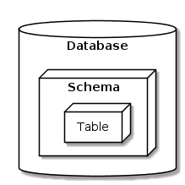

Schema:
- A database schema defines how logically data is organized within a relational database; this is inclusive of logical constraints such as table names, fields, data types, and the relationships between these entities.
- A database schema is considered as the “blueprint” of a database which describes how the data may relate to other tables or other data models. However, the schema does not actually contain data.

Tables:
Table is a structure where data are stored and organized in terms of rows and columns.
-A column represents an entity and the column names are also called fields.
- A row represents a tuple of data also known as records.

ER (Entity relationships) diagrams:
- ER diagrams describes the relationship between entities that need to be stored in the database.
- It is based on some special shapes that describes the main components of ER diagrams namely entities, attributes and relationship between them.
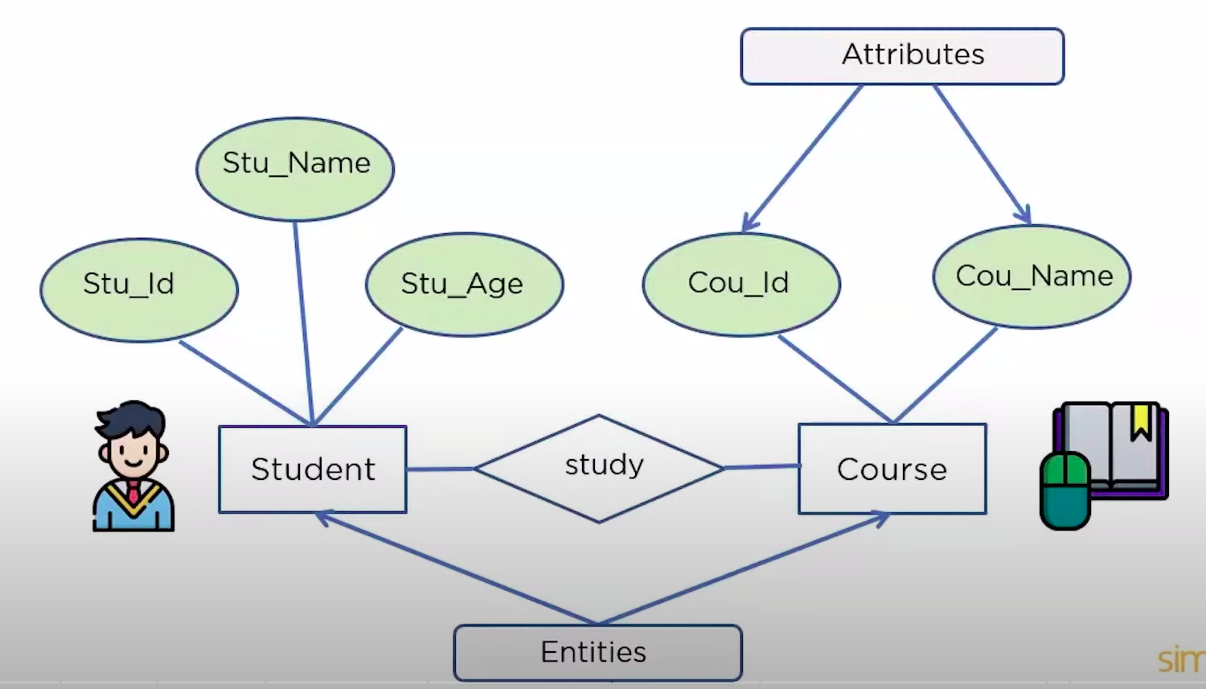
Example:

Main components in an ER diagram:

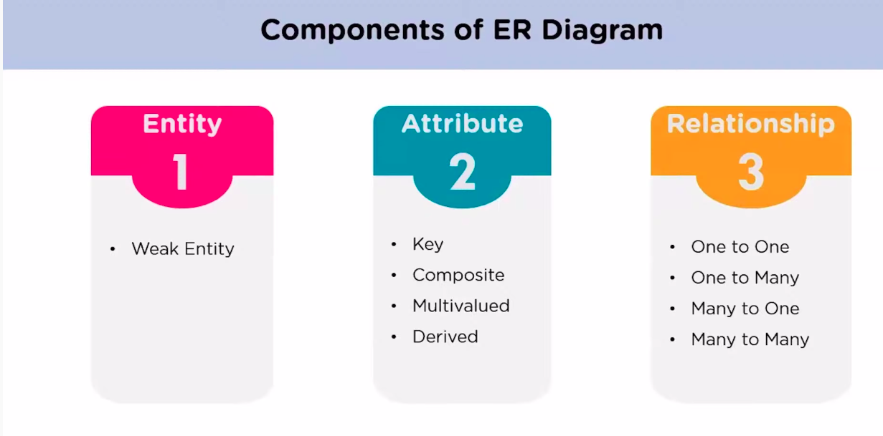
Entity and Weak Entity:
- An entity in ER diagrams represents major components of the data in the database.
- A weak entity is an entity that relies on other entities. For example if School is in entity then department is a weak entity that relies over school.

Attributes and types of attributes:
- An attribute shows the property of an entity.
- A key attribute is the attribute that uniquely represents an entity. e.g. Roll no. is a key attribute for the entity students. The texts for a key attribute is always underlined.
- If an attribute has further division then it is called composite attribute. For example if ‘name’ is an attribute then ‘first_name’,’last_name’, ‘middle_name’ are the possible division of the composite attribute ‘name’.
- An attribute that can have multiple values are termed as multi-valued attributes. For example, if students is the entity and phone_no is the attribute it can have multiple values. So, phone_no is a multi-valued attribute.
- An attribute derived from other attributes are called derived attributes. e.g. ‘students’ is an entity, ‘date_of_birth’ is an attribute and ‘age’ calculated using ‘date_of_birth’ is an example of derived attribute.

Types of relationships:
- One to one relation: A student can have only one id card and an id card represents only one student.
- One to many: A customer can place many orders but a particular order can’t be placed by many customers.
- Many to one: Many students can enroll to a single course.
- Many to many: An employee can be used directed to work on multiple projects and similarly a project can be assigned to many employees at the same time.

Symbols used in ER diagrams

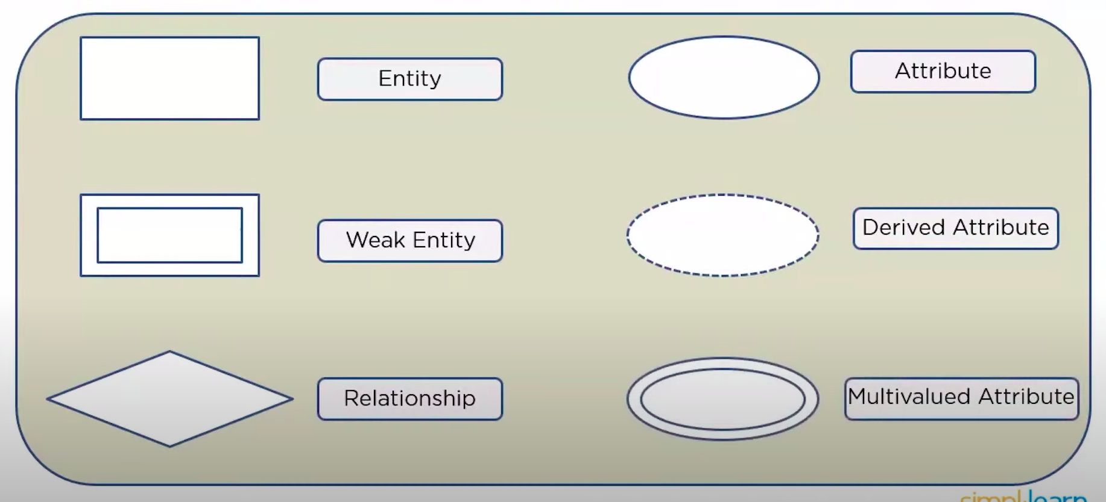

Tips to design the ER diagram:
- Identify the entities carefully and draw them in rectangular box.
- Relate the entities according to their relationship using diamond box.
- Identify the attributes and their types and draw them using respective oval shapes.

Part 1: Starting with SQL
(SQL : Structured Query language, used to interact with structured data or relational databases.)

Types of SQL Commands:
There are basically 4 types of SQL commands. SELECT is actually a DML command but more specifically it is refereed as DQL command.
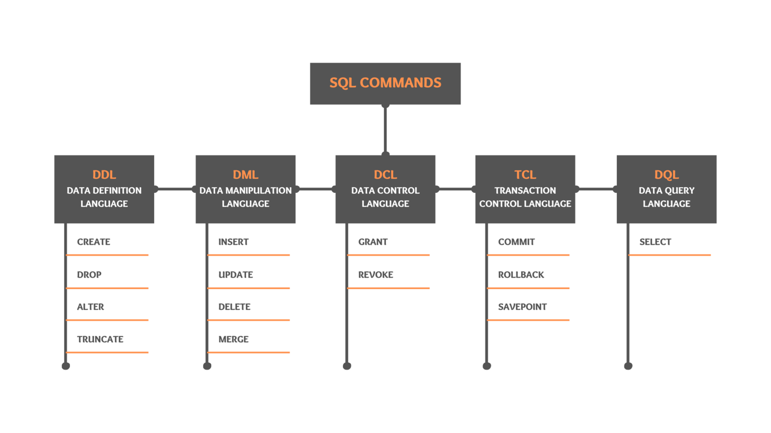
Fig: Types of SQL commands

1. Data definition language: (C-DAT)
Data definition commands are use to create and modify database objects like tables, indices, users etc.

# To see the existing databases.
Show databases ;

# To create a new database
CREATE DATABASE database_name;

# To see the current database working with
SELECT database();

#To switch to another database
USE database_name;

# To see the tables from the present database
SHOW TABLES; or SHOW TABLES FROM database_name;
# To see the structure of the table, describe table_name;
DESC table_name;
Creating tables:
Before creating a table lets know about data types and constrains.

SQL Data types:
Boolean, Numeric, Characters etc.
https://www.w3schools.com/sql/sql_datatypes.asp

Primary and Foreign keys:
Primary Key: A primary key is a field or group of fields that uniquely identify each row in the table. e.g: Student id.
- Simply one or more column of the table with unique and non null entry for each row.
- In a table only one primary key is allowed. But, more than one column can construct a primary key.
Foreign Key:
A foreign key is the field or group of fields that uniquely identifies rows in a different table.
- A foreign key refers to the primary key of the other table(reference table/ parent table).
- The table that contains the foreign key called referencing table or child table.
- A table can have multiple foreign keys.

Constrains:
Constrains are the rules enforced to data columns in a table to ensure data validation.
See more details: https://www.w3schools.com/sql/sql_constraints.asp

Two type of constrains
- Column constrains: Rules applied to the columns.
- Table constrains: Rules applied to the whole table.
Column Constrains type:
- Not Null: To ensure that a column cant have null values.
- Unique: To ensure that each row in a column has unique value. It can’t be null. We can have more than one unique constrain or unique key.
- Primary key and foreign key constrain.
- Check: To ensure that all values in a column satisfy certain conditions. Basically it is for data validation.
Table constrain type:
- Check
- Reference
- Unique(column list)
- Primary key ( column list)

CREATE a Table:

#To create a new table
# To create a table from an existing table
CREATE TABLE new_table_name AS
SELECT column1, column2,…
FROM existing_table_name
WHERE condition;
CREATE TABLE table_name(
column1Name datatype,
column2Name datatype,
column3Name datatype,
.……….
column_Name datatype
);

# Datatype specifies type of the data columns will store.

SERIAL data type: Auto-increment data type. (int AUTO_INCREMENT in mysql)
smallserial, serial, bigserial.

- First create a table with column names, data types of the columns and defining column constrains.
- After creating all the tables, list the created tables.
SELECT * FROM information_schema.tables WHERE table_schema='public'

DROP Table:
The DROP statement is used to permanently drop an existing table from a database.

# To drop a table
DROP TABLE table_name;

ALTER table or table data:
ALTER is used to add, remove, rename columns in a table and to do some modifications like changing column data type, setting default values to a column etc.

# To add new columns:
ALTER TABLE table_name
ADD new_column_name datatype;

# To delete a column
ALTER TABLE table_name
DROP COLUMN column_name;
#We can also add, remove, change also the constrains of the columns.

TRUNCATE a table:
The TRUNCATE TABLE statement is used to delete the data inside a table, but not the table itself.

# To delete the complete data from the table but not the table structure.
TRUNCATE TABLE
table_name;

Differences:
TRUNCATE | DELETE | DROP
Its a DDL command used to remove all the records from a table without removing the table structure and schema. | DELETE is a DML command and used to remove single or multiple rows based on some conditions. When all the rows are deleted the table structure and schema remains the same. | DROP command deletes the data of the table as well as removes the entire schema/structure of the table from the database.
TRUNCATE TABLE statement is a DDL command so it can not be rolled back. | DELETE is a DML Command so it can be rolled back. | DROP is a DDL Command. Objects deleted using DROP are permanently lost and it cannot be rolled back.

--Delete all rows and truncate do the same job but truncate is faster in execution.
--Using delete clause we can delete a single row but using TRUNCATE we can’t delete a single row.
--Data removed using DELETE can be restored but using truncate can’t be restored.
--table or column dropped using DROP command can’t be restored.

2. Data manipulation Language: (IMDU)
INSERT data:
# To insert new data to the table
INSERT INTO table_name (column1, column2,column3, ...)
VALUES (value1,value2,value3, ...);
#If values are inserted to all the columns we don’t need to specify the column names.

UPDATE data:
The UPDATE statement is used to modify the existing records in a table.
# To modify data in a table
UPDATE table_name
SET column1 = value1, column2 =value2, ...
WHERE condition;
RETURNING * # RETURNING is used to see the modified rows.

DELETE data:
The DELETE statement is used to delete existing rows in a table.
# To delete some rows from the table
DELETE FROM table_name
WHERE condition;

# To delete all rows in a table without deleting the table structure.
DELETE FROM table_name;

MERGE new data (not supported in MySQL):
MERGE statements to INSERT new records or UPDATE existing records depending on whether condition matches. Its like combination of INSERT,UPDATE and DELETE commands in a single command.
- Source table contains the updated data and we need to add them in the Target table.
-- Syntax
MERGE [target_table] as T
USING [source_table] as S ON [join_condition]
WHEN MATCHED (--join condition matched for both tables)
THEN (update data )
WHEN NOT MATCHED BY TARGET (--some new rows in the source table)
THEN (insert statements)
WHEN NOT MATCHED BY SOURCE (--unwanted rows in the target table)
THEN (delete statements)

3. DQL and Common SQL Commands

3.1 Data Query Language
SELECT data:
# Select is like print statement to get the output.

# To selct data from a table
SELECTcolumn(s) FROM table_name;

# To select only distinct rows
SELECT DISTINCTcolumn1,column2 FROMtable_name;

3.2 Order of execution of SQL commands
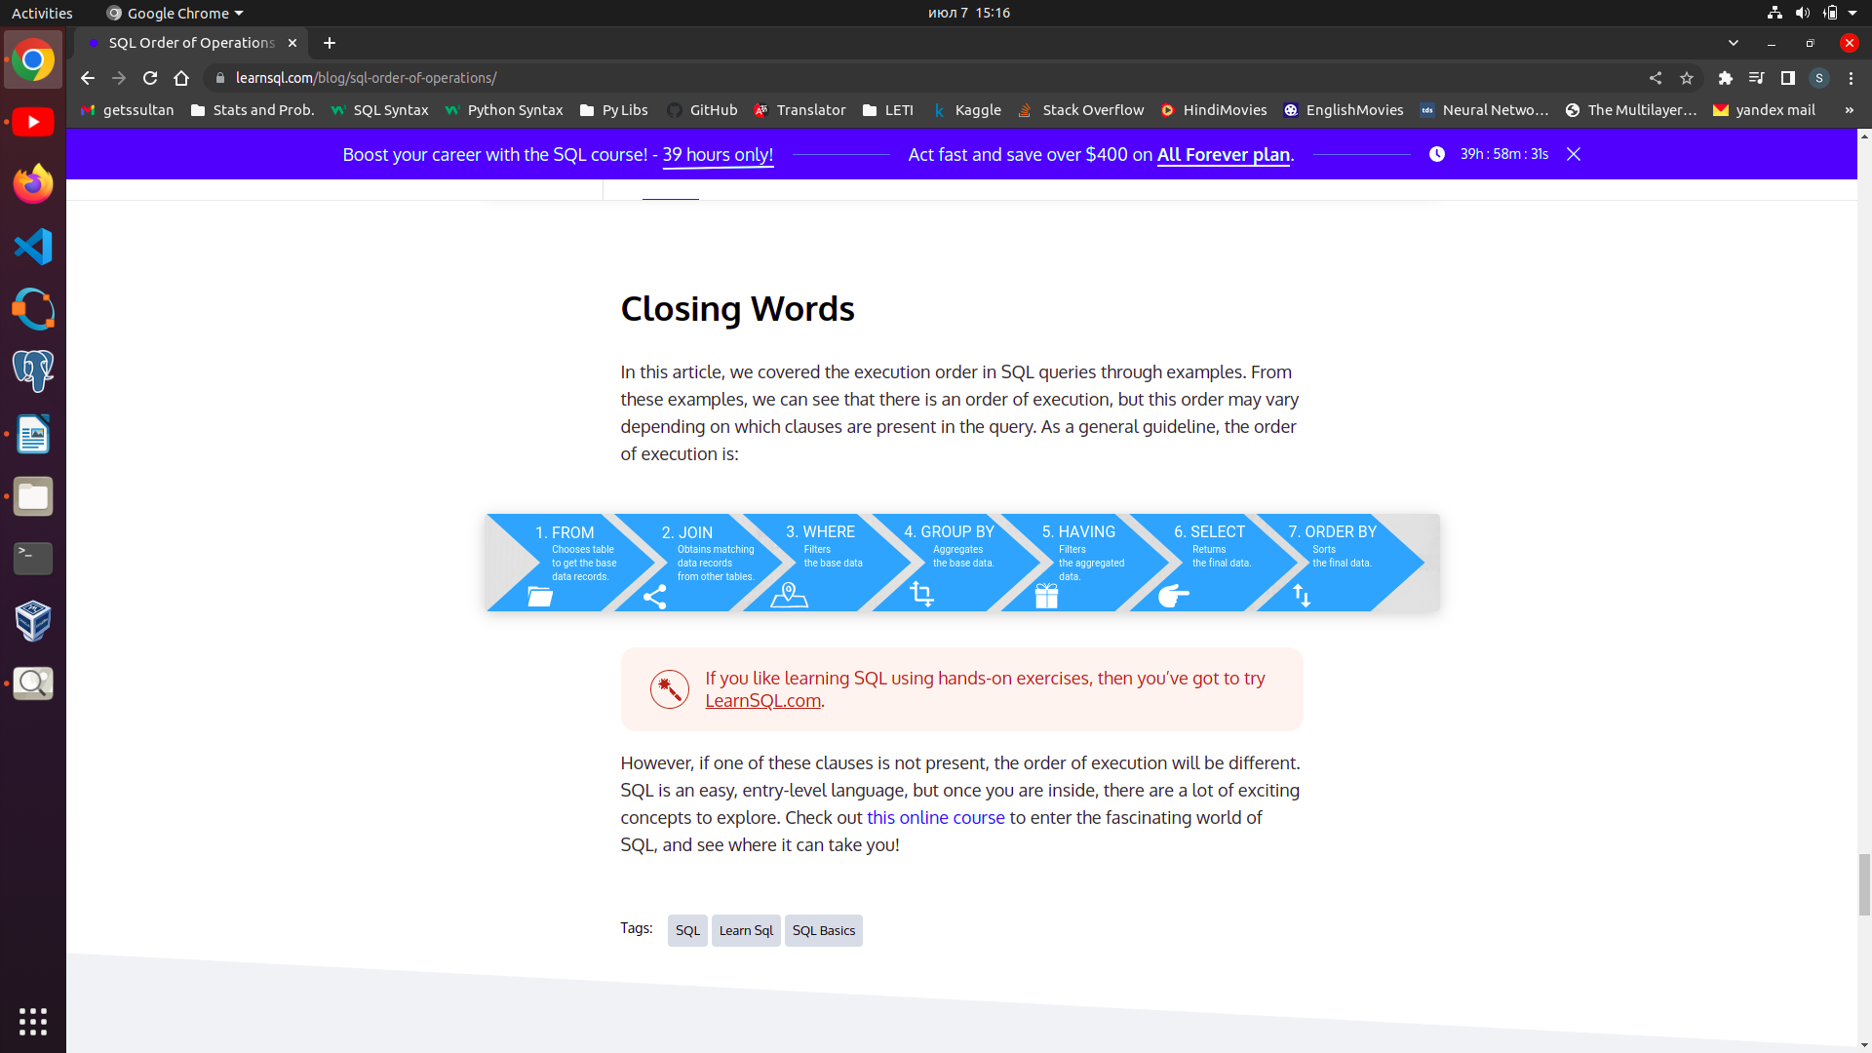
Find a job where given highest salary and opportunities to limitless grow.

3.3 SQL JOINS
Joins are used to combine data (rows) from two or more different tables based on a related field(column) between them.

# To join two different tables

SELECT table1.Col1, table1.col2
FROM table1
INNER JOIN table2 ON table1.common_column = table2.common_column;

Types of JOINS:

INNER JOIN or JOIN: Forms a new table by joining two different tables based on a common column, but contains only records(rows) that have matching values in both tables for the common column,
FULL (OUTER) JOIN: Returns all columns and all rows from two tables based on a common column.
# Following is a visual example of FULL OUTER JOIN or OUTER JOIN.
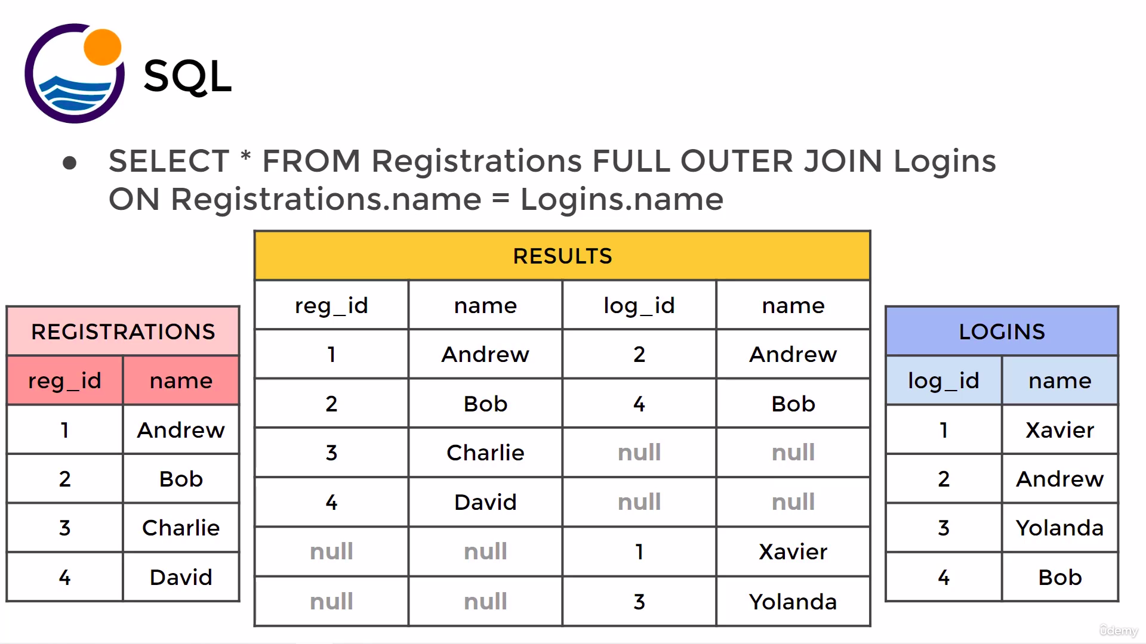
Fig. Full join (full outer join)

LEFT (OUTER) JOIN: Returns all records(rows) from the left table, and the matching rows from the right table.
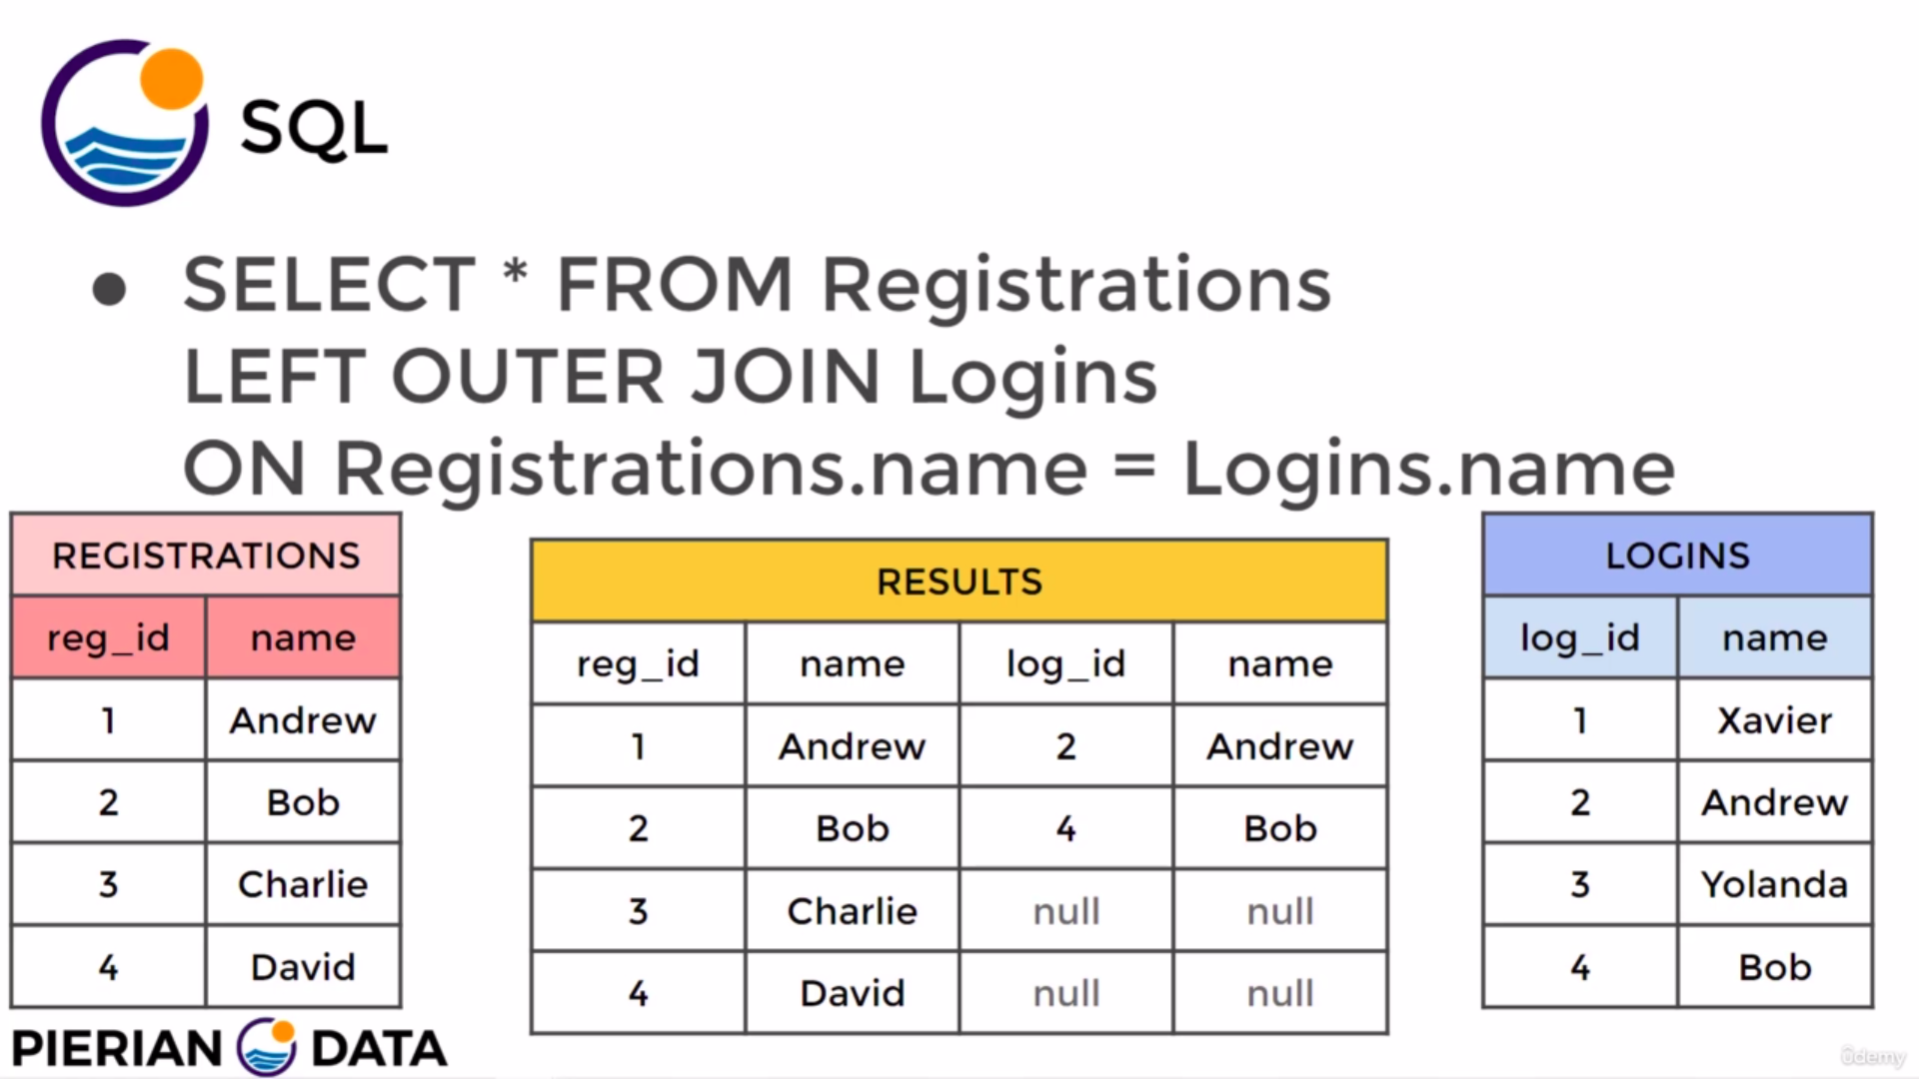
Fig: Left outer join.

RIGHT (OUTER) JOIN: Returns all records(rows) from the right table, and the matched records from the left table.

3.4 SELF JOIN
Self join is a query where a table is joined with itself. It is useful for comparing the values row by row level.
# Syntax
select t1.col1 , t2.col2
from table as t1
join table as t2
on t1.a_Column = t2.a_column

3.5 CROSS JOIN
- Follows row 1-1,2,3,…, row 2- 1,2,3.. this pattern.
- Cross join does not require any common column between the tables.
- A self cross join is very helpful to compare the row values of a table row by row.
#Syntax 1
Select * from table 1
cross join table 2
# Syntax 2
select * from table1 as t1, table 2 as t2
**See the example file in sql-db**

3.6 UNION
It is used to combine the results of two or more SELECT statements.
# Syntax
SELECT column_name(s) FROM table1
UNION
SELECT column_name(s) FROM table2;
--The UNION operator selects only distinct values by default. To allow duplicate values, use UNION ALL.

3.7 SELECT WHERE
# where specifies the condition for selection. AND, OR , NOT are used with WHERE for multiple conditions.

SELECTcolumn1,column2, FROM table_name
WHERE condition;

**Where checks the condition row by row**

Notes about WHERE:
- BETWEEN value1 AND value2 are also used for conditioning.
- IN(--,--,--) is used to specify a list of conditional values.
- LIKE(case sensitive) and ILIKE(case insensitive) is used as condition for selecting like characters from a string variable.
- We can’t use aggregate functions with WHERE clause.
Know more about character matching using wildcard_Characters:
https://www.w3schools.com/sql/sql_wildcards.asp

3.8 GROUP BY
GROUP BY clause is used to group categorical data(columns) into different groups or categories.

# Syntax

SELECT column_name(s) FROM table_name
WHERE condition
GROUP BY column_name(s);

3.9 HAVING
HAVING clause is a conditional clause similar to WHERE but it is used to filter results after aggregating the rows using GROUP BY or other clauses.

# Example of a use of HAVING
select customer_id, sum(amount) from payment
group by customer_id
having sum(amount) > 180

3.10 ORDER BY
ORDER BY keyword is used to sort the result-set in ascending or descending order. By default it is ASC- ascending order.

# Syntax

SELECT column1,column2, ...
FROM table_name
ORDER BY column1, column2, ...ASC or DESC;

3.11 OFFSET m
The OFFSET clause placed after the LIMIT clause but it is executed before LIMIT clause to skip “m” number of rows from the result of order by query.

3.12 LIMIT:
It is commonly used with ORDER BY statement to select specified number of records.
# Example
SELECT column_name(s) FROM table_name
WHERE condition LIMIT 100 offset 20; --what ever is the result delete first 20 rows and then show next 100 rows

3.13 AGGREGATE Functions

COUNT(), SUM(), AVG(), MIN(), MAX() etc. are the aggregate functions that are used GROUP BY and HAVING clause.
- When we use GROUP BY- we must need to use an aggregate function.

3.14 Aliases
Aliases are temporary column(s) or table with a special name created from original columns or tables. Aliases or special names are assigned using AS keyword.

# Syntax to create a column alias
SELECT column_name AS alias_name
FROM table1;

# To create a table alias
SELECT column_name(s)
FROM table_name AS alias_name;

Notes:
- An alias only exists for the duration of that query.
- It is executed after executing all other commands.

4. Advanced concepts and functions

4.1 Sub Query
- A query on the results of another query. Involves two ‘SELECT’ statements. Sub-query is usually used with where condition.
- Sub query is executed first as it is inside the parenthesis.
- A sub-query must be returned as a table with an alias when we use with FROM (sub-query). E.g select * from (sub-query) as innerTable

# An example, how to use sub query
select title, rating from film
where replacement_cost > (select avg(replacement_cost) from film)

4.2 WITH CTE
WITH clause is used to create a virtual/temporary table (known as CTE-common table expression). The temporary table is created to be refereed by the main query during a task.
This is helpful
- When we need a column as a reference for a short time.
- When we need to use multiple sub queries.
- We can use multiple CTEs
Example:
With TempTable(avg_rental_rate) as
(select avg(rental_rate) from film)
--Means using the result of (select avg(rental_rate) from film) from a temporary table TempTable and in the TempTable column name will be ‘avg_rental_rate’
select f.title, f.rental_rate, t_temp.avg_rental_rate
from film as f, TempTable as t_temp
where f.rental_rate > t_temp.avg_rental_rate
The above also can be writen as
With cte1 as --create a temp table with the result of following
(select avg(rental_rate) as avg_rental_rate from film)

select f.title, f.rental_rate, cte1.avg_rental_rate
from film as f, cte1
where f.rental_rate > cte1.avg_rental_rate

Note: The query associated with WITH clause i.e. the CTE is executed first.

4.3 Window functions
Windows functions are those that uses all the rows of the table to compare or analyze and produce some values (rank) for each rows.

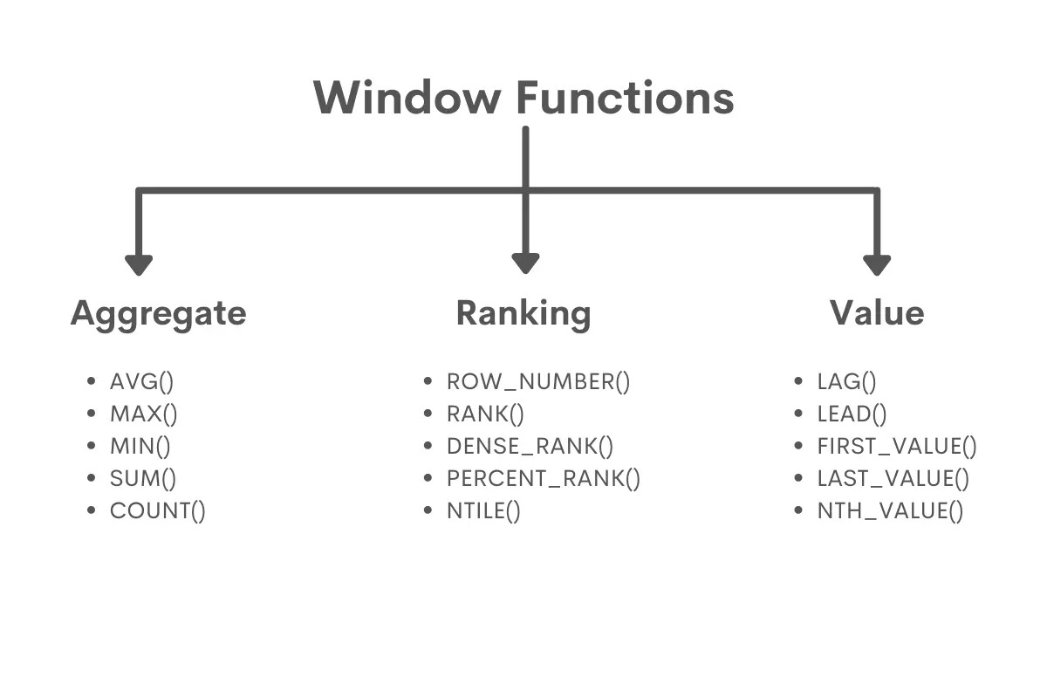
4.3.1 Aggregate windows function
- These functions are same as standard aggregate functions. But standard window functions are normally used with columns when at least one of the columns is used for ‘GROUP BY’ operation.
- Standard aggregate functions return only few rows (only aggregated summary). We can’t select any column if that column is not used for GROUP BY operation. e.g: We can’t use >> SELECT col1, sum(col2) from table Group by col2. But we can SELECT colName1, sum(col2) if we use a window function.
- The window function does not reduce the number of rows, instead assigns the correct value to each row of the data set, even if these values are the same.
- So window functions are useful when the individual values need to be compared to aggregated values.
e.g:
SELECT *,
avg(session_time) OVER () AS duration
FROM twitch_sessions
OVER()
- It is used to define a portion of rows.
- This portion of rows is called a ‘window’.
- So, the OVER() function creates the partition based on the function inside it.

PARTITION BY() (Equivalent to GROUP BY)
- It acts like GROUP BY

4.3.2 Ranking window functions
These are used to rank or order rows.

RANK_NUMBER()
- It assigns consecutive numbers starting from 1 to all rows in the table.
- The order of the rows needs to be defined using an ORDER BY clause inside the OVER clause. This is, in fact, the necessary condition for all the ranking functions that ORDER BY clause must always be there.

RANK()
It is used to rank the rows with some conditions.
Lets say row 1 and row2 follow the same condition then both are given same rank.
Row1 -------→ rank 1 (count = 1)
Row2 -------→ rank 1 (count = 2)
The third row is given the rank as
Row3 ------→ rank 3. (count = 3)
Note: Rows with same rank counted differently.

DENSE_RANK()
It is also used to ranking the rows. But according to this function multiple rows can coexists with one rank.Lets say row 1 and row2 follow the same condition then both are given same rank.
Row1 -------→ rank 1 (count = 1)
Row2 -------→ rank 1 (count = 1)
The third row is given the rank as
Row3 ------→ rank 2 (count = 2)

Note: Rows with same rank counted together.

NTILE(n)
- It divides the rows into total ‘n’ number of groups/buckets.
- If total_number_of_rows / n has some reminder of ‘r’ then the first bucket will have ‘r’ no of more rows than other buckets.
- It is also used with OVER( ORDER BY ) function. Don’t need to specify the PARTITION BY here.

CUME_DIST()
- It shows commutative distribution of each rows in the table. It does not require any argument.
- Formula = current_row_number(position) / total_number_of_rows.
- The rows are assigned number based on the ORDER BY statement. When there more than one rows having same value then ‘for rows with similar values’ cume_dist is same and are calculated using the row number of the last value.
e.g:
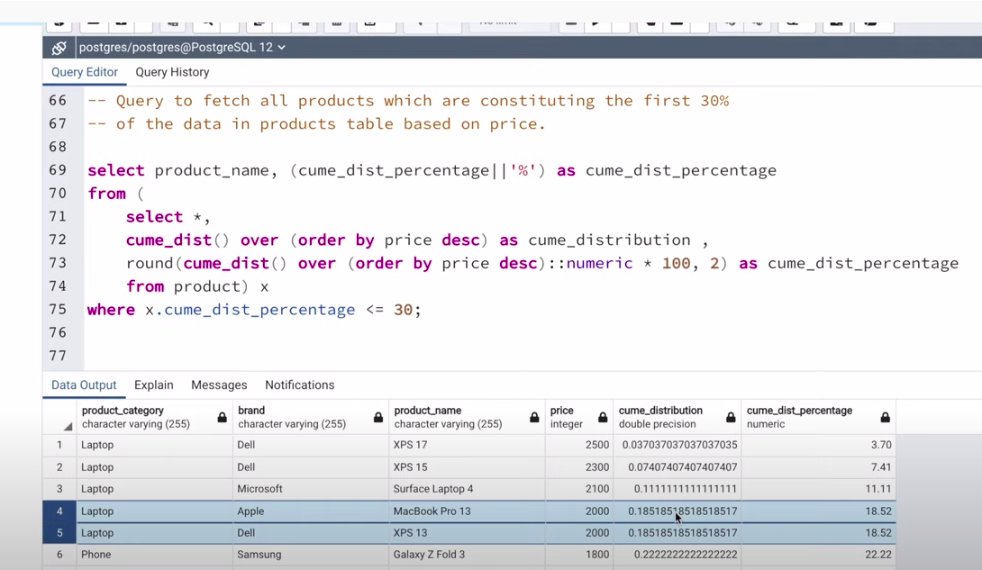
PERCENT RANK()
- It is also a ranking function that ranks the rows using the formula
percent_rank = (current_row_num – 1)/ (total no. of rows -1)

4.3.3 Value window functions
LAG()
- It returns the previous row of the present row in a query.
- LAG() is used before OVER( ORDER BY ---) function.
LEAD()
- It returns the value of the next row.

FIRST_VALUE()
- When we divide data using window function OVER ( PARTITION BY), FIRST_VALUE(a_column) returns the first value of that specified column from the partition list.
- e.g:
select title, rating, replacement_cost , first_value(title)
over (partition by rating order by replacement_cost desc ) as Expensive_One
from film

LAST_VALUE()
- It returns the last row from a partition.
Frame:
- Frame is the subset of partition.
- Default frame: range between unbounded preceding and current row
- To use with last_value(): rows between unbounded preceding and unbounded following.
- Frame is mentioned inside OVER() function.
e.g:
select title, rating, replacement_cost ,
last_value(title)
over (partition by rating order by replacement_cost desc
range between unbounded preceding and unbounded following ) as worst_one
from film
Another way to write window function query:
select *,
over w as firstValue,
over w as LastValue
from table
window as w (partition by ------)
--This is helpful when one over() function is used for different values like first_value, last_value.

NTH_VALUE(from_which_column, N)
- It allows the user to define which value from the order should be assigned to other rows.

4.4 String Functions and Operations
- upper()
e.g: SELECT UPPER(first_name) FROM students
- lower()
--syntax is same as UPPER()

- CONCAT()
UPDATE students
SET first_name = concat(first_name, ' ', last_name)
--here first_name should be an existing column
- String_agg(columnName, ‘separator’)
To aggregate similar rows together into a new column.
E.g:

select string_agg(name , ', ') from table
Group by id --group by is used on what basis we want to aggregate them.

- SPLIT_PART()
select split_part(first_name,' ',1) as first_name,
split_part(first_name,' ',2) as last_name
from students

4.5 Timestamps and extract
Extract(), AGE(), TO_CHAR() functions.

4.6 MATHEMATICAL FUNCTIONS
https://www.postgresql.org/docs/current/functions-math.html

4.7. Conditional Statements in SQL

4.7.1 CASE WHEN THEN ELSE END
- It is used to execute SQL queries only when some conditions are met.
- CASE itself is returned as a column.
# syntax to use CAES:
CASE (We can also use a field name here, if it is common to all conditions)
WHEN condition1 THEN result1
WHEN condition2 THEN result2
WHEN condition_N THEN resultN
ELSE result
END;
Ex. 1:
SELECT OrderID, Quantity,
CASE
WHEN Quantity > 30 THEN 'The quantity is greater than 30'
WHEN Quantity = 30 THEN 'The quantity is 30'
ELSE 'The quantity is under 30'
END AS QuantityText
FROM OrderDetails;

4.7.2 COALESCE
- It takes unlimited number of arguments and returns the first argument that has some value (not null). If all the values are null, it returns null.
e.g:
COALESCE(arg1,arg2,arg3,…)
usecase 1: To replace null values with 0.

select item, price , (price – COALESCE(given_discount,0)) as final_price
from products

4.7.3 CAST
- It is used to convert one data type into another data type.
# syntax to use cast
CAST(expression AS datatype)

e.g:
select payment_id, cast(customer_id as varchar(40))
from payment.

4.7.4 NULLIF
The NULLIF() function compares two expressions and returns NULL if they are equal. Otherwise, the first expression is returned.
--syntax:
NULLIF(expr1, expr2)

4.8 VIEWS
- Views are like virtual tables or pseudo tables that stores the structure of a table without actually storing the data of the table. Later we can extract or manipulate the data from views.
- Views are like stored queries. We cab use them later. Views are database objects.
- We can’t change the column names and datatype of a VIEW once created using CREATE or REPLACE command but it is possible to do using ALTER command.
- Views improves security as we can share the view or grant access for view without allowing to see the actual query.

--To create a view:
CREATE VIEW cusAddjoin as
(select first_name,last_name,address from customer
inner join address
on customer.address_id = address.address_id)

--Then we can use this view as a table for any query.

Procedural SQL

1. Introduction
PL/SQL:Procedural Language extension of SQL (Its like procedural language like C)
- PL/SQL includes procedural language elements like conditions and loops. It allows declaration of constants and variables, procedures and functions, types and variable of those types and triggers.
- It can support Array and handle exceptions (run time errors).
- WE can create PL/SQL units like procedures, functions, cursors and triggers, etc. which are stored in the database for reuse by applications specially for DML operations
- PL/SQL is not case sensitive so you are free to use lower case letters or upper case letters except within string and character literals.

2. Variables

2.1 Variable declaration
- It needs to declare the variable first in the declaration section of a PL/SQL block before using it.
- It is must to declare a variable before referencing it in another statement even if it is a declarative statement.
- It is must to specify the variable data type while variable is declared.
- Variables belonging to the same datatype cannot be declared in the same statement.

# Syntax to declare variables in PostgreSQL
declare
var1 datatype_of_var1;
var2 datatype_of_var2;

How to initialize variables or assign values to the variables
declare
variable1 integer; --by default when no value is assigned a NULL value is assigned
var1 int = 20; --can be changed later
var2 float = 44.58 ;
var3 varchar(100) = ‘This is a variable character’;
var4 varchar(10) DEFAULT ‘The value is default.’ ; --To assign default value, can change later.
var5 CONSTANT float = 3.14; --to define a constant variable, can’t be changed later

2.2 Rules for variable naming
- The name of the variable must begin with ASCII letter. The letter can be followed by more letters, dollar signs, numerals, underscore etc.

By default, variable names are not case sensitive
- A variable should not exceed 30 characters.
- Variable name should not be the same as the table name or table's column of that block.
- Variable name can’t be the same with reserved SQL keywords.

3. Conditional statements

3.1 IF-ELSE
--Only IF-THEN (Only one condition)
IF condtion_is_true
THEN
Execute_this_statement;
END IF;
--IF-THEN-ELSE (For two conditions)
IF condition_is_true
THEN
Execute this statement;

ELSE
Execute statement 2;
END IF;

--IF-THEN ELSEIF-THEN -ELSE (For multiple conditions)

IF condition1_is_true
THEN
Execute statement1;
ELSIF condition2
THEN
Execute statement 2;
ELSE --when both the statements are false
Execute statement 3;
END IF;

3.2 CASE WHEN THEN ELSE END
Refer to section 4.7.1 CASE examples in previous section.
Difference: We can’t use CASE without SELECT clause. But we can use IF independently

4. Control(loop) statements

4.1 Exit loop (Just like basic loop)
--Basic loop and exit loop syntax
LOOP
statements;
EXIT WHEN condition_is_true;
--like break when condition is true otherwise continue
other_statements;
END LOOP;

4.2 WHILE LOOP
Based on a particular condition, it continues until the condition is true.
--while loop syntax
WHILE this_condition_is_true
LOOP
statements; ---Execute the statements
END LOOP; --End the loop/end the while loop

4.3 FOR LOOP
- PL/SQL for loop is used when when we need to execute a set of statements for a predetermined number of times.
- The loop is iterated between the start and end integer values. The counter is always incremented by 1 and once the counter reaches the value of end integer, the loop ends.

--Syntax for FOR LOOP
FOR k IN 1..10 --don’t need to declare k before
LOOP
statement1:
statement2;
statement3;
END LOOP;

WHILE LOOP vs FOR LOOP
- WHILE LOOP works until the condition is true but FOR LOOP works for specified number of times, FOR LOOP is not based on any condition.
- We must declare the variable before if we want to use it with WHILE LOOP which is not required in case of FOR loop.

CONTINUE;
- It stops the current iteration of the loop, and hence the statements of the loop below continue; are not executed and the loop starts the next iteration directly.
- It is used to skip a particular iteration of the loop.

5. Procedures
A stored procedure is a prepared SQL code that we can save, so that we can reuse over and over again.
- We can store a procedure, and then just call it to execute when ever we need.
- You can also pass parameters to a stored procedure, so that the stored procedure can act based on the parameter value(s) that is passed.

--General Syntax to create a procedure in PostgreSQL:

CREATE or REPLACE PROCEDURE procedure_name(parameter_list)
--the above is called header section
language plpgsql --need to specify the language
as $$
--double dollar quotation is used to take care of escape characters
declare --declare section to declare the variables
var1 datatype_var1;
var2 datatype_var2 = value_to_var2 ;
begin --begin the procedure
-- body section
statement1;
end; --end the procedure
$$
--Syntax to pass parameters in procedures/function
procedure-name (IN/OUT/INOUT para1 datatype_para1, para2 datatype_para2)
--by default these are treated as IN parameters.

5.1 Types of Parameters
IN (Input Parameters): Default types of parameter
The parameters parameter can be referenced by the procedure or function. But value of the parameter cannot be overwritten by the procedure or the function.
OUT (Output parameters):
The OUT parameter cannot be referenced by the procedure or function, but the value of the parameter can be overwritten by the procedure or function.
INOUT (input-output parameters):
The INOUT parameter can be referenced by the procedure or function and the value of the parameter can be overwritten by the procedure or function.

Notes: Specific about PostgreSQL
- Parameters in stored procedures can have the in and inout modes. They cannot have the out mode.
- A stored procedure does not return a value. You cannot use the return statement with a value inside a store procedure like this:
return expression; --this is not possible
- However we can use the return statement without the expression to stop the stored procedure immediately:
return;
--To call a procedure
CALL procedureName(arguments for the parameters);

--To drop a procedure
DROP PROCEDURE procedure_name;

6. Functions
- The main difference between procedure and a function is, a function must always return a value, and on the other hand a procedure may or may not return a value.
- Except this, all the other things of PL/SQL procedure are true for PL/SQL function too.
- RETURN clause specifies that data type you are going to return from the function. The return_datatype can be a base, composite, or domain type, or can reference the type of a table column.
--Syntax to create a function.
CREATE OR REPLACE FUNCTION totalRecords()
RETURNS integer AS $total$ --return variable and return type must be mentioned.
declare
total integer; --declare the variable
BEGIN
SELECT count(*) into total --way to assign value if not assigned during declaration
FROM film;
RETURN total; --mention what to return
END;
$total$
LANGUAGE plpgsql;
--When we create a function language is mentioned after the function not in the beginning like in Procedures.

--To call the functions
SELECT functionName(arguments);

7. Cursor
When an SQL statement is processed, the DBMS (lets say PostgreSQL) creates a memory area known as context area. A cursor is a pointer to this context area. The cursor can point to only one row at a time, but can move to other rows of the result set as needed.
(in Procedural programming like C A pointer is a variable which stores the address of another variable.)
Uses:
- A cursor is used to refer to a program to fetch and process the rows returned by a SQL query, one at a time
Cursor

Explicit Cursor
Implicit Cursor

7.1 Types of Cursors
Implicit Cursor
- The implicit cursors are automatically generated if we don’t use an explicit cursor for the statement.

- These are created by default to process the statements when DML statements like INSERT, UPDATE, DELETE etc. are executed.

- When we use pl-SQL for some task, the procedure/function does not show output as SELECT statement shows. So implicit cursors are mainly used to know how many rows are affected by a procedure/function when applied a DML command like INSERT/UPDATE/DELETE/MERGE.

--See the Working of InmplicitCursor.sql script to know how implicit cursorswork.
Example:
create or replace procedure updateSalary()
language plpgsql
as
$$
declare number_of_rows_affected integer;
begin

update emp
set salary = salary + 10000; --The SQL query

IF not found THEN
raise notice 'no customers updated';
ELSIF found THEN
GET DIAGNOSTICS number_of_rows_affected = row_count;
raise notice '% rows updated',number_of_rows_affected;
END IF;

end
$$

Explicit Cursor:
- Explicit cursors are defined by programmers to gain more control over the context area.
- It is defined in the declaration section of the PL/SQL block.
- It is created with a SELECT statement which returns more than one row to take control over the rows one by one returned by the SELECT statement.
- The cursor is by default at the 0th position when we create a cursor.

7.2 Process to create explicit cursor
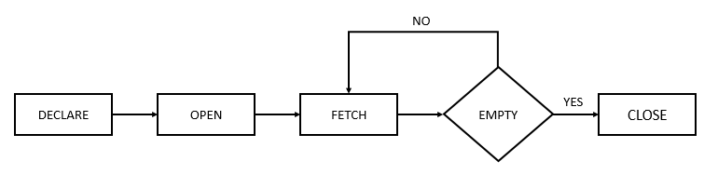
Fetch Options to fetch to a cursor
To move the cursor.

first -The first row.
Last – the last row.
Absolute n – move to the n_th row, does not matter current row.
prior – the previous row to the current row
next – the next of the current row.
Relative 2- move to 2 rows previous.
Relative -3 – move to next 3rd row from the current row.
Forward 3 – move 3 rows aheard
Backward -
first -The first row.
Last – the last row.
Absolute n – go to the n_th row, does not matter current row.
prior – the previous row to the current row
next – the next of the current row.
Relative 2- go to 2 rows previous.
Relative -3 – go to next 3rd row from the current row.

Example: An example of how defined cursor works.
create or replace procedure cursorEx()
language plpgsql as
$$
declare
--declare the variable and the cursor
c1 cursor for select * from emp;
--CursorName cursor (c1 ia a variable and its type is cursor.)
--for which query ?? for this query --> select * from cars;
r1 emp%rowtype;
begin
--Now open the cursor
open c1;
--fetch a row using the cursor
fetch first from c1 into r1;
--fetch the first row and assign it to r1
--So r1 contains the first row of the returned query
--Use the fetched data for some tasks
raise notice 'Employee name: % ' , r1.name;
raise notice 'Salary % ', r1.salary;
--Now close the cursor
close c1;
end
$$
--Now call the function
call cursorEx();

Notes:
We can create multiple cursors: See the example in Procedural Folder.

7.3 Cursors with parameters
We can create cursors with parameters. This process is faster and we don’t need to use if-else.
e.g:
c1 cursor(x varchar(20)) for select * from table where table.name = x;
We can use this cursor by passing an argument to the parameter as
open c1(r1.name) --this cursor will go only those rows one by one where table.name = r1.name
--what ever value is in name in r1 row will be passed as x as a parameter to the cursor c1

8. Errors and Exceptions handling
An exception is a PL/SQL run time error (not syntax error) that is raised during program execution, either implicitly by or explicitly by our program. Exception handling is a way to by pass that error/exception.

Exception handling
To handle exceptions, there should be exceptions/errors and exceptions must be raised first.

8.1 Handling Implicit/Built in Exceptions
There are many pre-defined exception in PL/SQL which are raised when any database rule is violated by the programs.
e.g: NO_DATA_FOUND is a pre-defined exception which is raised when a SELECT INTO statement returns no rows.
--Syntax for handling in-built exceptions
DECLARE
<declarations section>
BEGIN
statement1; --Execute this
--If there is an error in execution section then go to exception handling section.
EXCEPTION
WHEN exception1 THEN --exception1 is an in-built exception as we did not define it.
exception1-handling-statements;
END;

e.g 1: Handling in-built exception
create or replace procedure ImplicitExeptionEx(givenid int)
language plpgsql
as $$
DECLARE
emp_id int = givenid;
emp_name emp.name%type;
sal emp.salary%type;

BEGIN
SELECT name, salary INTO strict emp_name, sal
FROM emp
WHERE id = emp_id ;
raise notice 'Name: % Salary: %', emp_name,sal;

exception
when no_data_found then --we are catching a pre-defined exception
--if this exception happens do the following.
raise notice 'Sorry! no data found';
END;
$$

8.2 Explicit/User defined Exceptions and exception handling
We can define or raise an exception according to our need.
--An example, how defined exception works inPostgreSQL
create or replace procedure userExeptionEx(givenid int)
language plpgsql as $$
DECLARE
emp_id int = givenid;
emp_name emp.name%type;
sal emp.salary%type;
BEGIN
SELECT name, salary INTO strict emp_name, sal
FROM emp
WHERE id = emp_id ;
if sal < 90000 then
raise exception using errcode =50001;
else
raise notice 'Name: % Salary: %', emp_name,sal;
end if;
exception
when no_data_found then --the implicit exception
raise notice 'Implicit exception message: No data found';
when sqlstate '50001' then
raise exception 'Explicit exception: Ah! Poor guy';
END; $$

Note: If we define an explicit exception and that is similar to a implicit exception, the implicit exception will be given preference.

9. Triggers
Triggers are stored programs, which are automatically executed or fired when some event occurs in a database.
Triggers could be defined on the table, view, schema, or database with which the event is associated.
Triggers are used to to automatically execute a response when following happens-
- A database manipulation (DML) statement (DELETE, INSERT, or UPDATE).
- A database definition (DDL) statement (CREATE, ALTER, or DROP).
- A database operation (SERVERERROR, LOGON, LOGOFF, STARTUP, or SHUTDOWN).
E.g: We can use triggers for data validation.

9.1 Triggers in PostgreSQL
PostgreSQL requires to define a user-defined function as the action of the trigger, while the SQL standard allows you to use any SQL commands.
Step 1: create a trigger
--Syntax to implement the trigger
CREATE TRIGGER trigger_name
BEFORE/AFTER INSERT/UPDATE/DELETE
ON table_name
FOR EACH ROW/ STATEMENT
EXECUTE PROCEDURE trigger_action_function
Step 2: Define what the trigger will do
--Syntax to define the action function
CREATE FUNCTION trigger_action_function()
RETURNS TRIGGER
LANGUAGE PLPGSQL
AS $$
BEGIN
-- trigger action logic
END;
$$
Step 3: Then first compile the function and then the trigger.
Example:
-- create a trigger
create trigger validate_salary
before insert on emp
for each row
execute procedure checksalaryEntry();

--Create a trigger action function that stops the wrong entry of salary data
create or replace function checksalaryEntry()
returns trigger
as
$$
declare
begin

-- define the trigger action
if new.salary <= 0 then
raise notice 'Salary can not be negative';
return null;
end if;
return new;
end;
$$
LANGUAGE plpgsql;

DROP a trigger
PostgreSQL doesn’t support the OR REPLACE statement to modify the trigger definition like the function that will be executed when the trigger is fired.So first we need to drop it
--Syntax to drop a trigger
DROP TRIGGER IF EXISTS trigger_name
ON tableName;

But we can ALTER a triggers
ALTER TRIGGER trigger_name
ON table_name
RENAME TO new_trigger_name;

Disable/Enable triggers on a table
ALTER TABLE tableName
DISABLE/ENABLE TRIGGER a_particular_trigger/ALL;

