Anisul islam tutorial: 03

1. App create korar jonno : command **npx create-react-app my-app**

2. Go to my-app dir command = **cd my-app**

3. Start the app cmd= **npm start**

**File structure**

|  |  |
| --- | --- |
| File name | Why and what |
| Src/Package.json | All the dependencies to run the app |
| Delete files(public and src) except | Public/index.html, src/ index.js |
| Connect **index.js with index.html** | Clear index.html and clear js file |

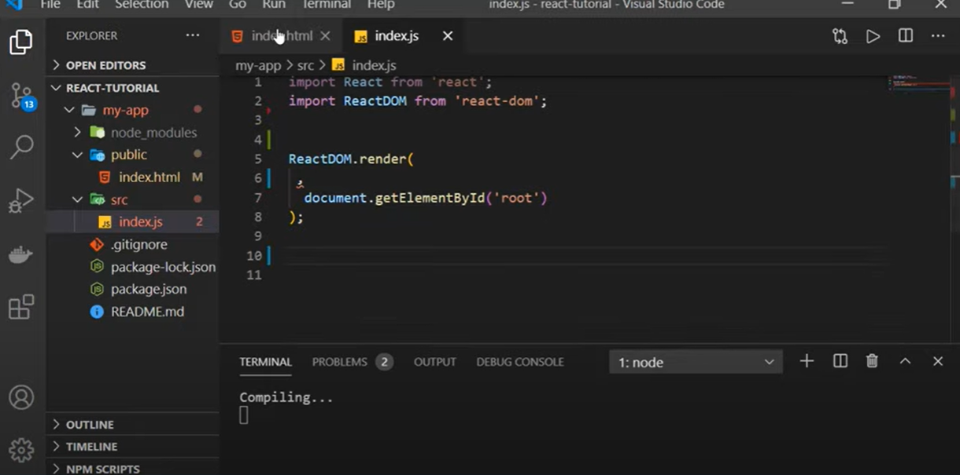

ReactDOM.render() takes two params, 1. Output message 2. In which element.

# React Bangla Tutorial 4: JSX and JS Expression

JSX = javascript xml

Jsx r jonno html code javascript e use kora jai.

Render can render one element at a time, so

<div>

<h1> head 1</h1> <h2> head 2</h2>

</div>

Use variable in html use {variable name}

Ex: var name = “shakib”;

Render(

<h1> {name} </h1>, document.getElementById('root')

);

String concate korte “+” sign use koro.

Const date = new Date(); date.getDate, getMonth, getFullYear

# React Bangla Tutorial 5 : CSS Styling in JSX

1. inline css

2. css stylesheet

Inline css r jonno style e object add korte hobe <h1 style={{color: “red”, “fontSize: 30px”}}>

By creating object:

Const headStyle = { color: “green”, bgcolor: “red”, padding: “30px”}

<h1 style=”{headStyle}”> </h1>

>> css stylesheet

Add the classname to the className attribute.

<h1 className=”head-style”>my name is {name} </h1>

Jodi src folder theke css ke access korte chai..

Import ‘./index.css’; then add className attribute