ASSIGNMENT 3
Q1
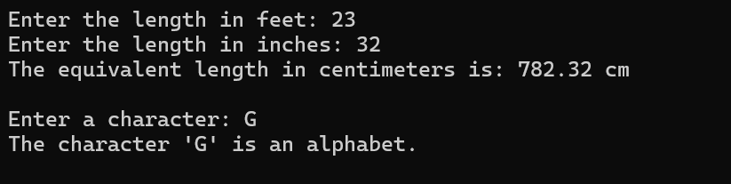

Q2
